PORT ST MARY COMMISSIONERS
ORDINARY BOARD MEETING
14th June 2017 at 7.30 pm
AGENDA – OPEN PUBLIC SESSION

1. Welcome, Apologies and Declarations
2. Minutes for Adoption:
2.1 Consideration of the Minute of the Ordinary Board Meeting on 24th May 2017
3. Matters Arising:
3.1 Matters arising from the Minute of the Meeting on the 24th May 2017
3.1.1 Ratification requested on Motion received from Mr Kinley; “that we replace the existing Standing Orders with the new Standing Orders made under SO40.1. This will constitute the annual review of the Standing Orders required under SO40.2”
3.1.2 Reply from Highways re Village Zone
3.1.3 Reply from Port Erin Commissioners re Joint Refuse Agreement
3.1.4 Report from Events Meeting held on Mon 12th June at 4 pm
4. Motions: None
5. Finance:
5.1 Approval of invoices for payment June 2017
5.2 Invoices paid in May for noting
6. Special Projects:
6.1 Manxonia House (adjourned to private)
6.2 Skate Park
6.3 Chapel Beach historical photos and notes

7. Public Correspondence:
7.1 Seaweed on the beach
7.1.1 Email from DP re beach
7.1.2 Facebook message from JA re beach
7.1.3 Email from NC re beach
7.2 Correspondence from DEFA re DNA
7.3 Correspondence from KB re Golf Course
7.4 Correspondence from Planning & Building Control
7.5 Correspondence re a footpath from Ratepayer
8. Consultations: - None
9. Planning Matters:
9.1 Planning Applications
9.2 Planning Approvals
9.3 Planning Amendments
10. Policy and Resources
10.1
11. Invitations
11.1 Invitation from Armed Forces Day Committee to the celebrations at the Villa Marina on Sunday 25th June
12. Any other business of an urgent nature (by permission of the Chairman)

Item 3.1.2
Subject: RE: Port St Mary- a Home Zone
Dear Mr Hamilton,

Thank you for your email in connection with the above. As you are aware to introduce a new speed limit, especially for an entire village will require extensive assessment, such as speeds, accident data, traffic flow, consultation with all residents and the Police. To introduce a speed limit of 20mph it would either have to be self-enforcing or would require engineering methods to reduce speeds to 20mph, changing signage only would only reduce speeds possibly by 1 or 2 mph.

From the accident data provided over the last five years, there have been 17 recorded incidents, none relating to speed, for a breakdown please see below:

Location | Date | Severity | Causation | Summary
Bay View Road | 30/5/16 | Damage Only | Misjudging Distance | V2 parked V1 reversed into V2
 | 21/2/15 | Damage Only | Misjudging Distance | V1 parked V2 scrapped V1 overnight
 | 21/2/16 | Slight | Misjudging Distance
 | 17/11/15 | Damage Only | Misjudging Distance | V1 rear shunt into V2
 | 29/3/15 | Damage Only | Collides with stationary vehicle | V2 parked V1 clipped V2
 | 29/11/14 | Damage | Misjudging Distance | V2 parked V1 clipped V2
 | 24/1/14 | Damage | Error of judgement | V2 travelling along Bay View Road, V1 travelling in opposite direction V2 clips V1
 | 20/4/12 | Damage | Misjudging Distance | V2 parked unattended unknown vehicle hit V2
 | 10/4/12 | Damage | Misjudging Distance | V2 clipped V1 whilst passing parked cars
Park Road | 6/10/15 | Damage | Failing to keep to nearside of lane | V1 parallel parking V2 collided with V1
Fistard Road | 26/11/16 | Damage | Ice/Snow | V1 skidded on ice
 | 25/5/14 | Damage | Mechanical Defect | V1 pulling boat, trailer mech broken
Lime Street | 20/7/15 | Animal | Animal not under control | Dog ran out of property and collided with V1
Athol Street | 18/12/12 | Damage | Due Car and Attention | V1 parked and unattended V2 reversed into V1
Beach Road | 25/10/16 | Animal |  | Dog ran off lead and collided with V1
 | 17/11/15 | Damage Only |  | V1 at junction V2 rear shunt V1
Promenade | 14/7/15 | Damage | Misjudging Distance | V2 collided with V1

I have taken the data from the main routes, as the speed within individual estates will, I imagine, be nearer the requested 20mph than the current imposed 30mph limit. Therefore, as you can see from above, there have been 17 reported incidents over the last five years, none as a result of speeding vehicles. The fatal accident you mentioned (some time ago – not within the last five years) would not be counted within our assessments as we only look at current data (5 years).

I can assure you that we take road safety matters very seriously and that any requests made to the Department for traffic calming measures or reduced speed limits are treated fairly and individually. In the Isle of Man Government Business Plan it is one of the Department’s objectives to reduce road traffic accidents, particularly fatal and serious accidents by at least 2% per year. In order to achieve this reduction we continually target the locations where accidents regularly occur. Accordingly, we must always respond to accident reduction as our priority before moving to the areas where accident prevention is desired. In the case of Port St Mary, there have been no accidents involving pedestrians, fatal or serious, within the last five years, so based on this evidence; the Department believes that the existing speed limit is correct for this location. However, we will arrange for traffic counts to be placed, and look at improving the lining and signing when the works within Port St Mary are undertaken and look at your Boards request further in the future.

Kind regards

Traffic Technician & Customer Services Supervisor
Highway Services
Department of Infrastructure
Ellerslie Depot
Crosby

Item 3.1.3
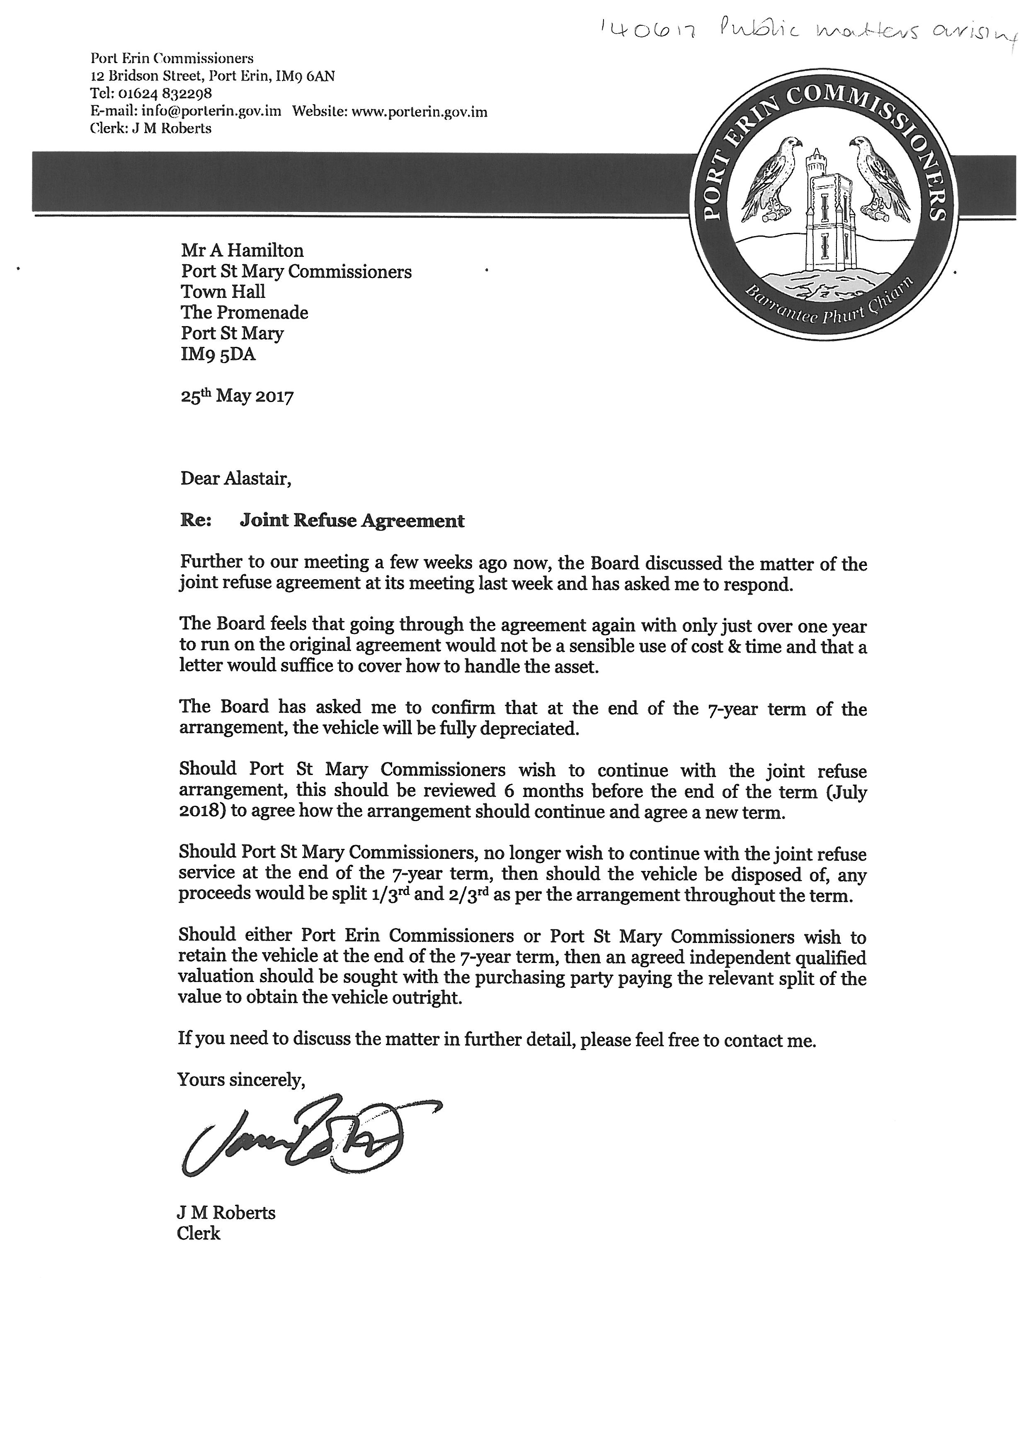
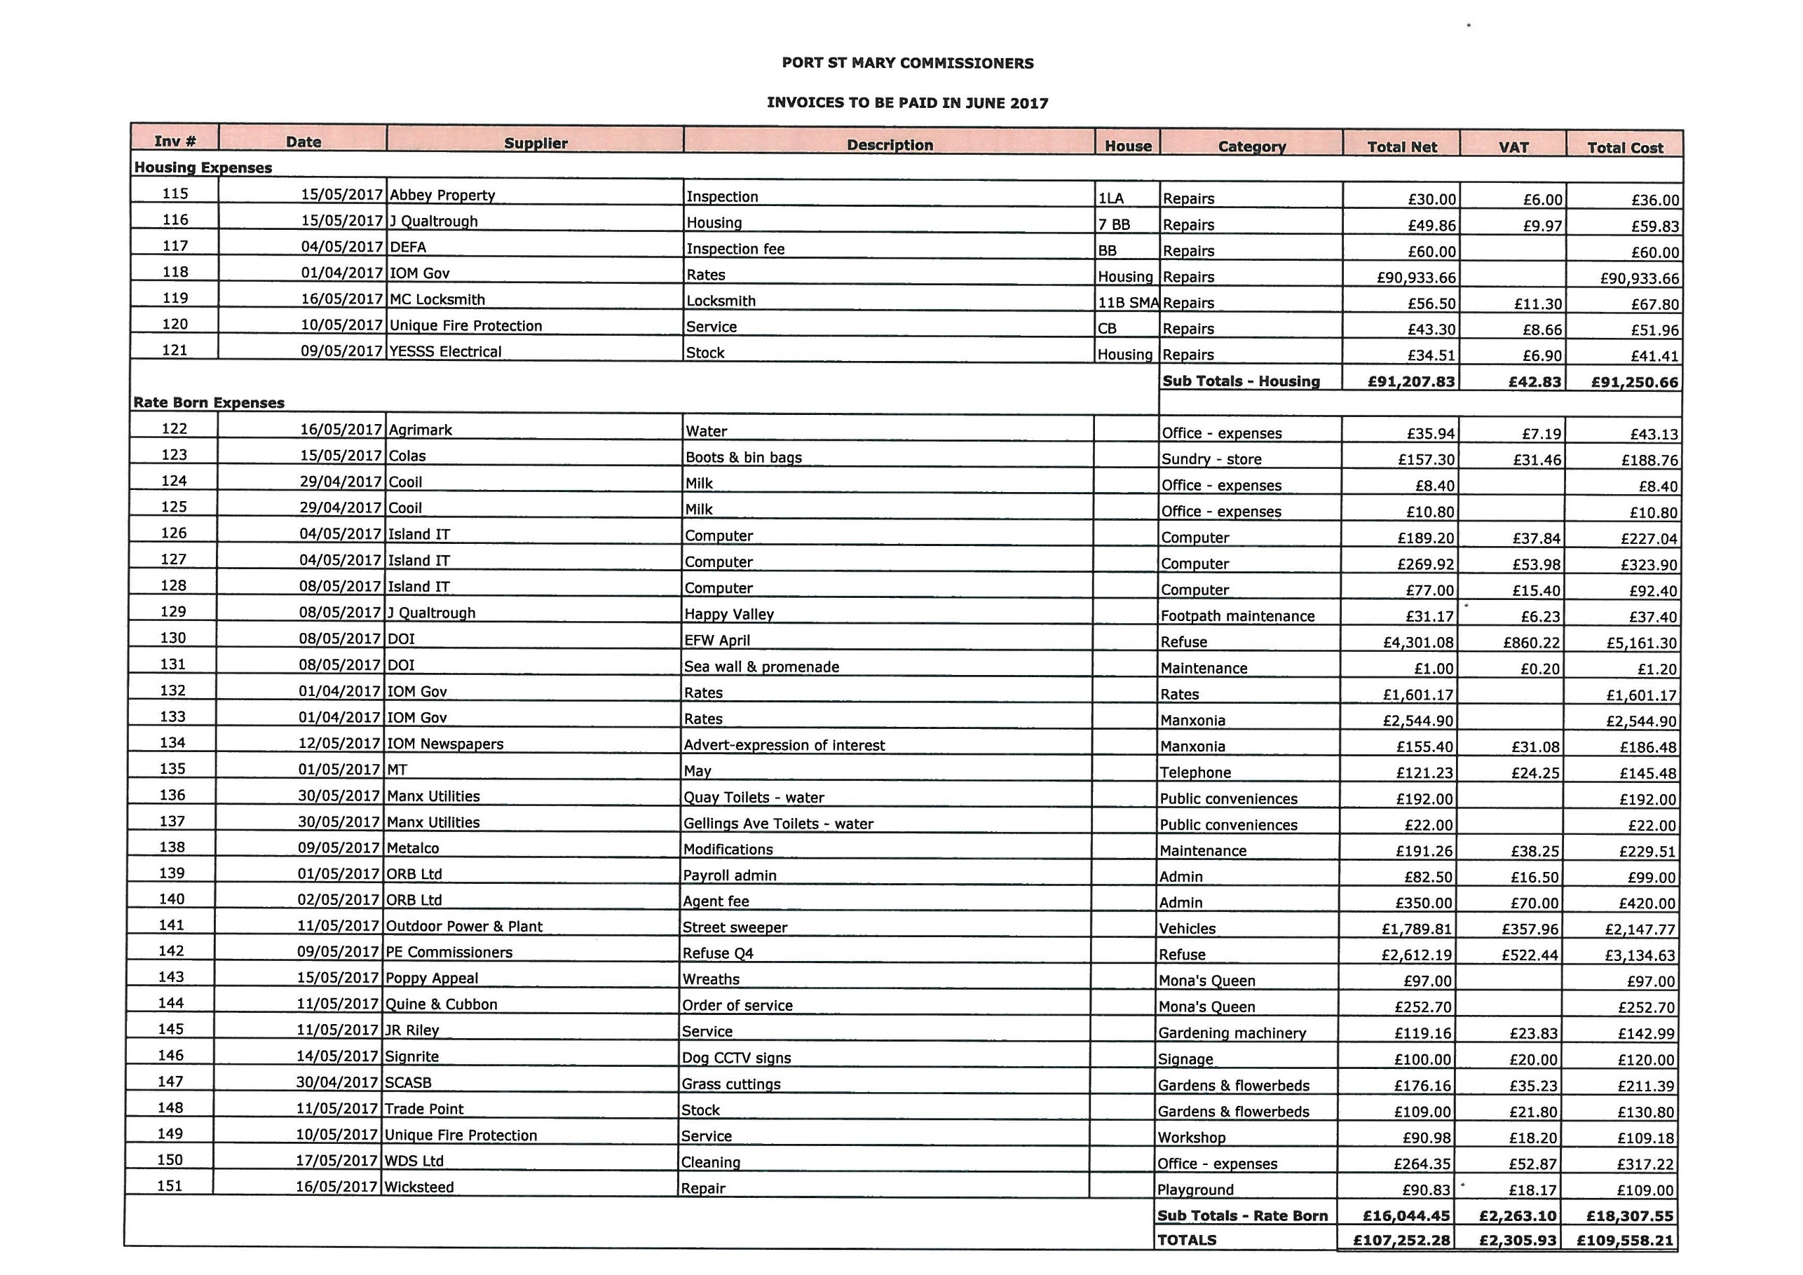
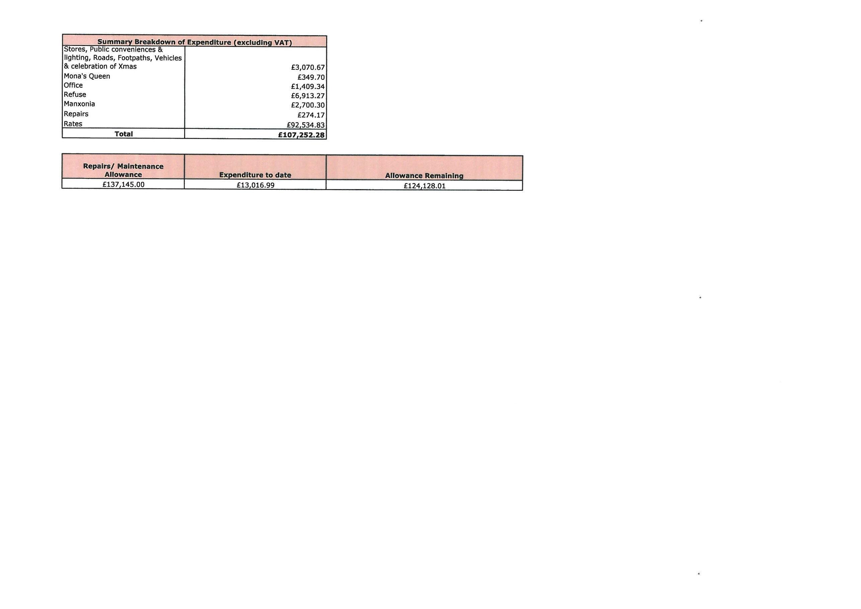

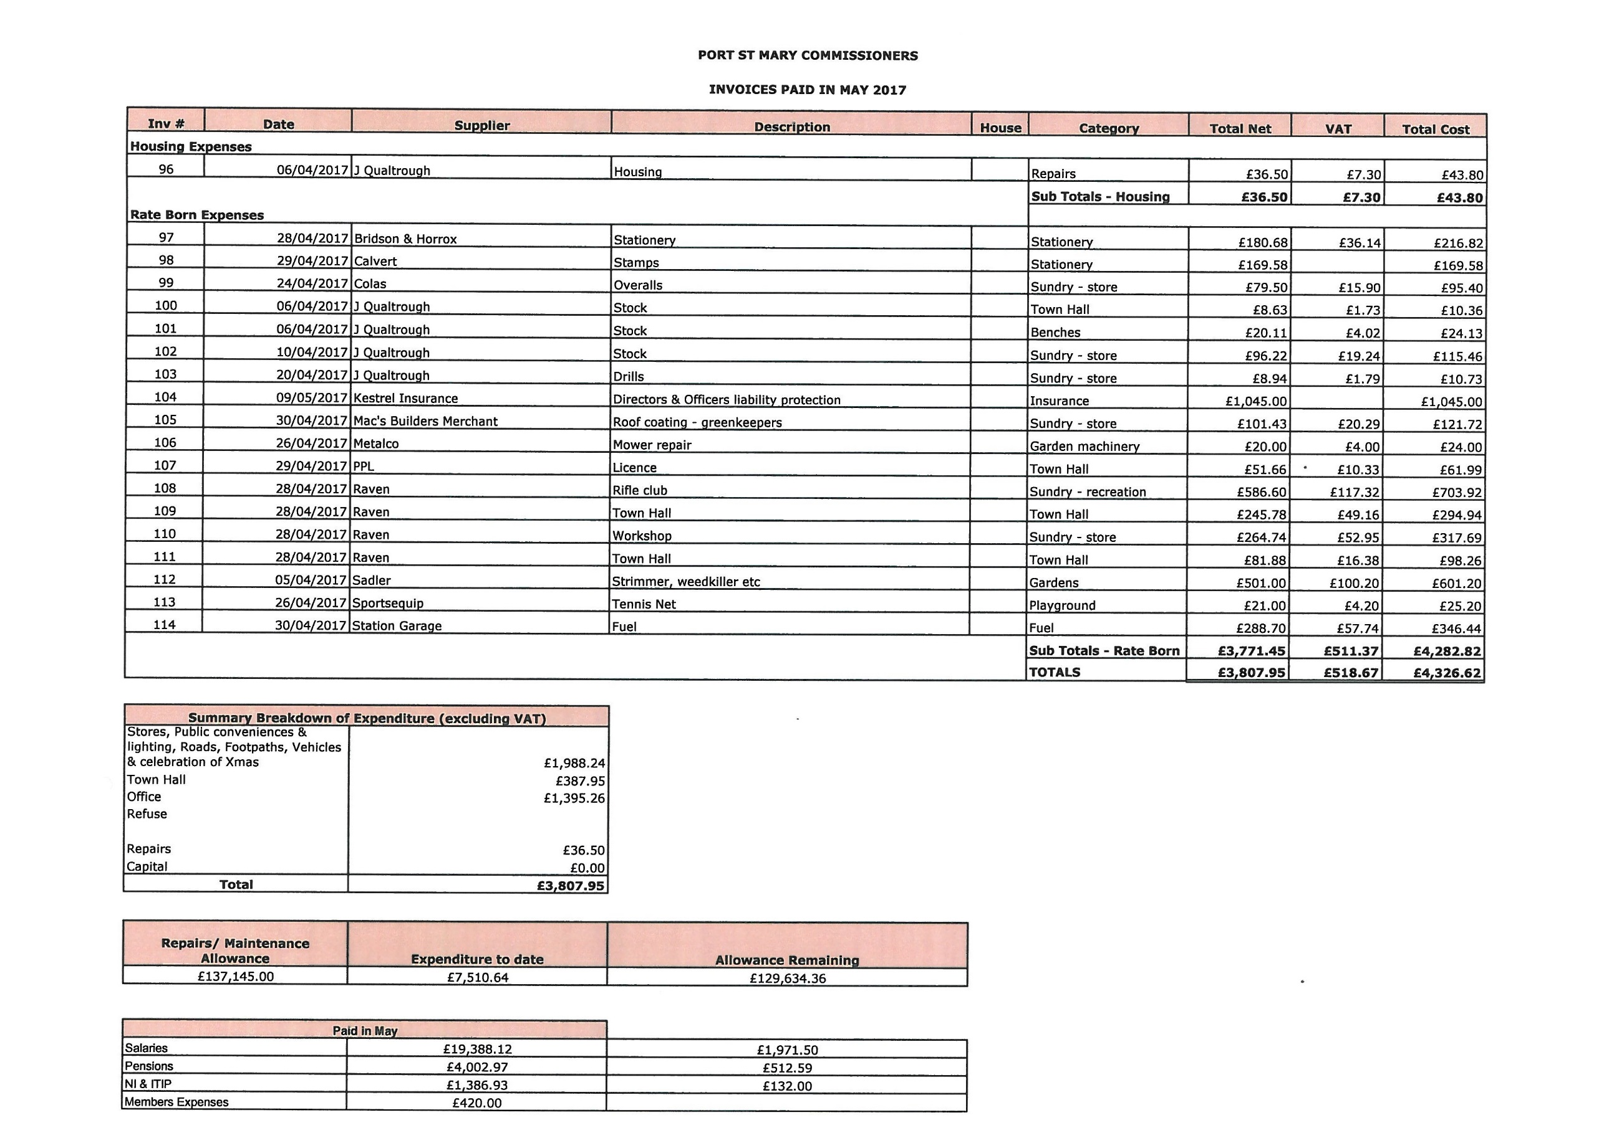
Item 6.3
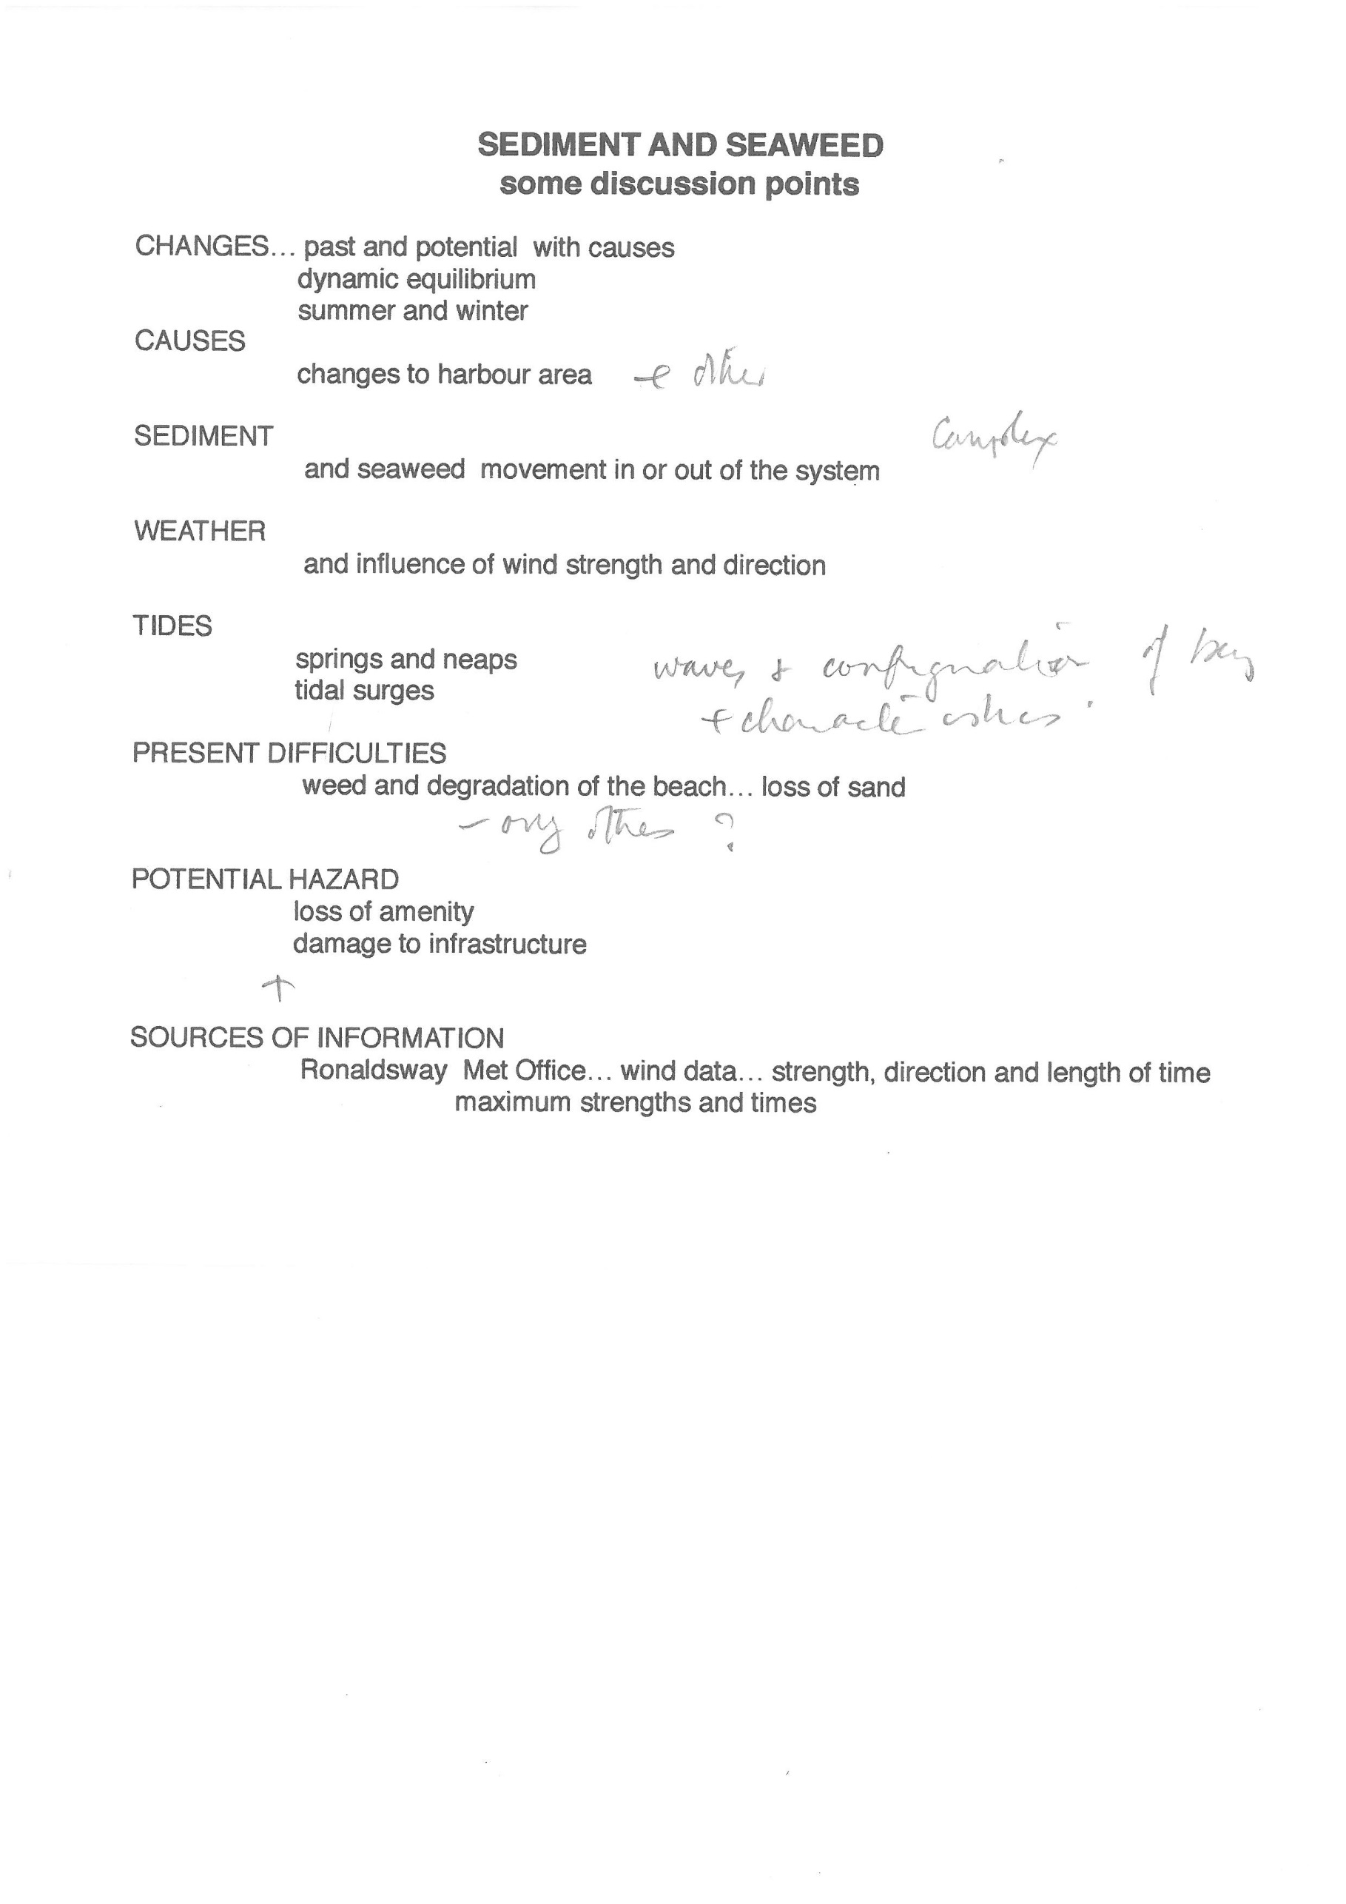

Item 7.1.1
From:
Subject: Port St Mary Chapel Beach
Message Body:
I'm hoping you have seen the comments on Facebook about the state of Port St Mary Chapel beach. I live at the beach end of Victoria Road and most times cannot have my windows open because of the drains/sewerage smell. My husband and I like to walk along the Underway but the flies around the path from the beach by Happy Valley are horrendous and must be carrying diseases as well as feeling disgusting when they fly in your face. I have been advised by other residents that there are rats running on the beach too. This problem has got worse over the last few years and no one at the Commissioners has made any effort to do anything about it despite numerous complaints. As our rates have gone up this year I would hope there is money in the pot to address this problem. We have a few new businesses trying to attract customers to Port St Mary but we the residents feel that Chapel Beach is dragging the village down and everyone would rather go to Port Erin as their beach is amazing. Please please take our concerns seriously and start making our Beach suitable for children and everyone else again.

Item 7.1.2
Good morning. You will more than likely ignor this message as you have with others that I sent you. In fact it's damn right rude that you don't get back to people and there requests. Ok let's see how this goes? I have as usual taken my digs for a walk down to the front prom only to be attack by millions of flys. These days live and bread in the seaweed that is left to fester on our beautiful beach. Why can't the commission's have it moved any farmer would love this. However the issue is (apart from the flat and seaweed. This is our only attraction in port st mary. Why don't you look after it. We pay the highest rates I think we deserve better than this. Regards

Fri 12:36pm

Port St Mary
Good afternoon and thank you for your message.

Port St Mary
I have checked our facebook account as far back as 2016 and cannot find any messages from you. I acknowledge that the seaweed on the beach has become a problem over the last week or so. I shall put your comments before the next meeting of this Board. Meantime my direct email address is a.hamilton@portstmary.gov.im Please feel free to contact me directly there. Alastair

Fri 2:43pm

John
Thank you so much for getting back to me. It's not too important that you can't find my last email. But just for reference it was regarding the work being carried out on the old home maker store in the lane at the back of the coop. Whoever was working on it. They totally blocked the kabe for over 4 months.? And the work is still going on. My issue was that I couldn't get access to the far of my property? Anyway like I say. My marine issue was the seaweed I appreciate your it that you will put this to the comity for there attention. I hope something can be done to address this. Many thanks.

Item 7.1.3
From:
Sent: 25 May 2017 11:35
To: Port St Mary Commissioners
Subject: Chapel Beach

In regards to the Current state of Chapel beach and the ongoing seaweed problem we have I feel it prudent as a Port St. Mary resident and rate payer to ask why, as a seaside village nothing is being done to address the seaweed problem and the health and safety issues that it causes to the general public?
We should be attracting visitors and residents to the beach in droves, we live in a beautiful Port that is unique and like no other place on the Island. With fantastic eateries and shop scattered throughout the village, wonderful lighting and floral displays that create vibrancy, a beautiful anchor monument that tributes the monas queen and not forgetting to mention the spectacular views, the Commissioners should be doing their utmost to assist with trade and visitors to the village. However, the state of our once beautiful beach is letting our beautiful village down. It sticks out like a rancid, smelly sore thumb.
Everyone that I know and have spoken with in relation to this matter agree, the beach is letting the village down. At this time of year and with the 2017 TT imminent we should be doing all we can to bring trade into our little village. This should include having a tidy and clean beach. One that isn’t covered in rodent encouraging rotting seaweed that poses a potential risk to our health. Those that do brave the beach sit huddled up at one end (all very few of them) sat in the one small area that isn’t covered in seaweed – how they manage the awful smell I don’t know!
It seems that in recent times no effort has been made to provide a solution to this ongoing bone of contention. In my personal opinion, I find that the only thing that has been provided in chapel beaches regards is excuses as to why certain things won’t work. How about we as a village together look for a solution to this matter? Expenditure shouldn’t be an issue given the large amount of money recently found and the level of rates funding received.
Ways which may assist in providing a solution could be:
• Looking to other local authorities for advice on how they deal with similar issues
• Finding a bespoke and manageable way to keep our beach clear and danger free
• Holding a local forum for residents to ask for suggestions in keeping our beach clear
• Using social media as a tool to your advantage and asking for advice. Yes, this could result in some off-putting remarks but it could also provide the perfect solution to the issue.
• Ask for advice from independents. People who have knowledge and can provide a suitable answer to the issues. There are plenty of them out there and if you put out a tender for the work and request a work plan for the tender I am sure there will be many willing to assist.
• Ask local businesses for their honest opinion on the matter and what they might suggest to improve the current state of the beach.
• Look into what was done historically to keep the beach clean and ask if this can be implemented in present day?
• Gauge interest from residents if they would be willing to help – make a day of it, get children of SPLM to design and place posters around the village. The 4 B’s Bring our Beautiful Beach Back!
• Look at chapel beach as a focal point of the port. Restore it to its former beauty. We are a seaside village and should be using Chapel Beach to our advantage. Currently it is a huge disadvantage.
I would be more than happy to assist in this project going forward. I can be contacted on xxx if you wish to discuss further.

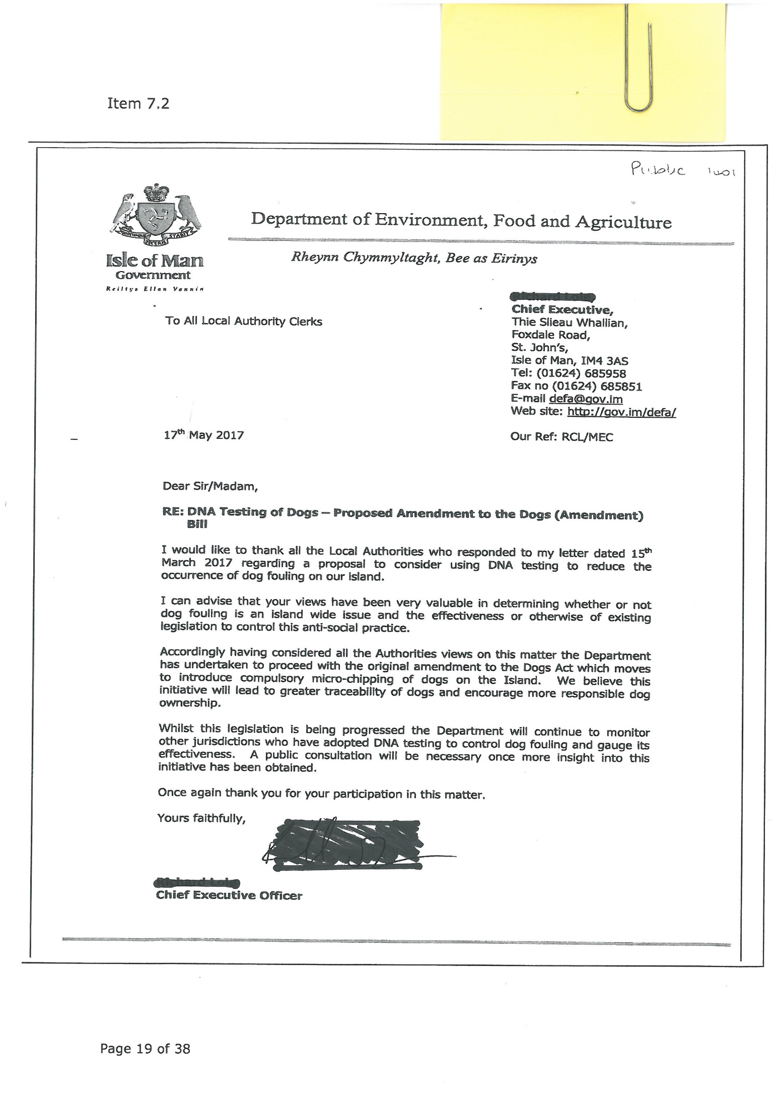
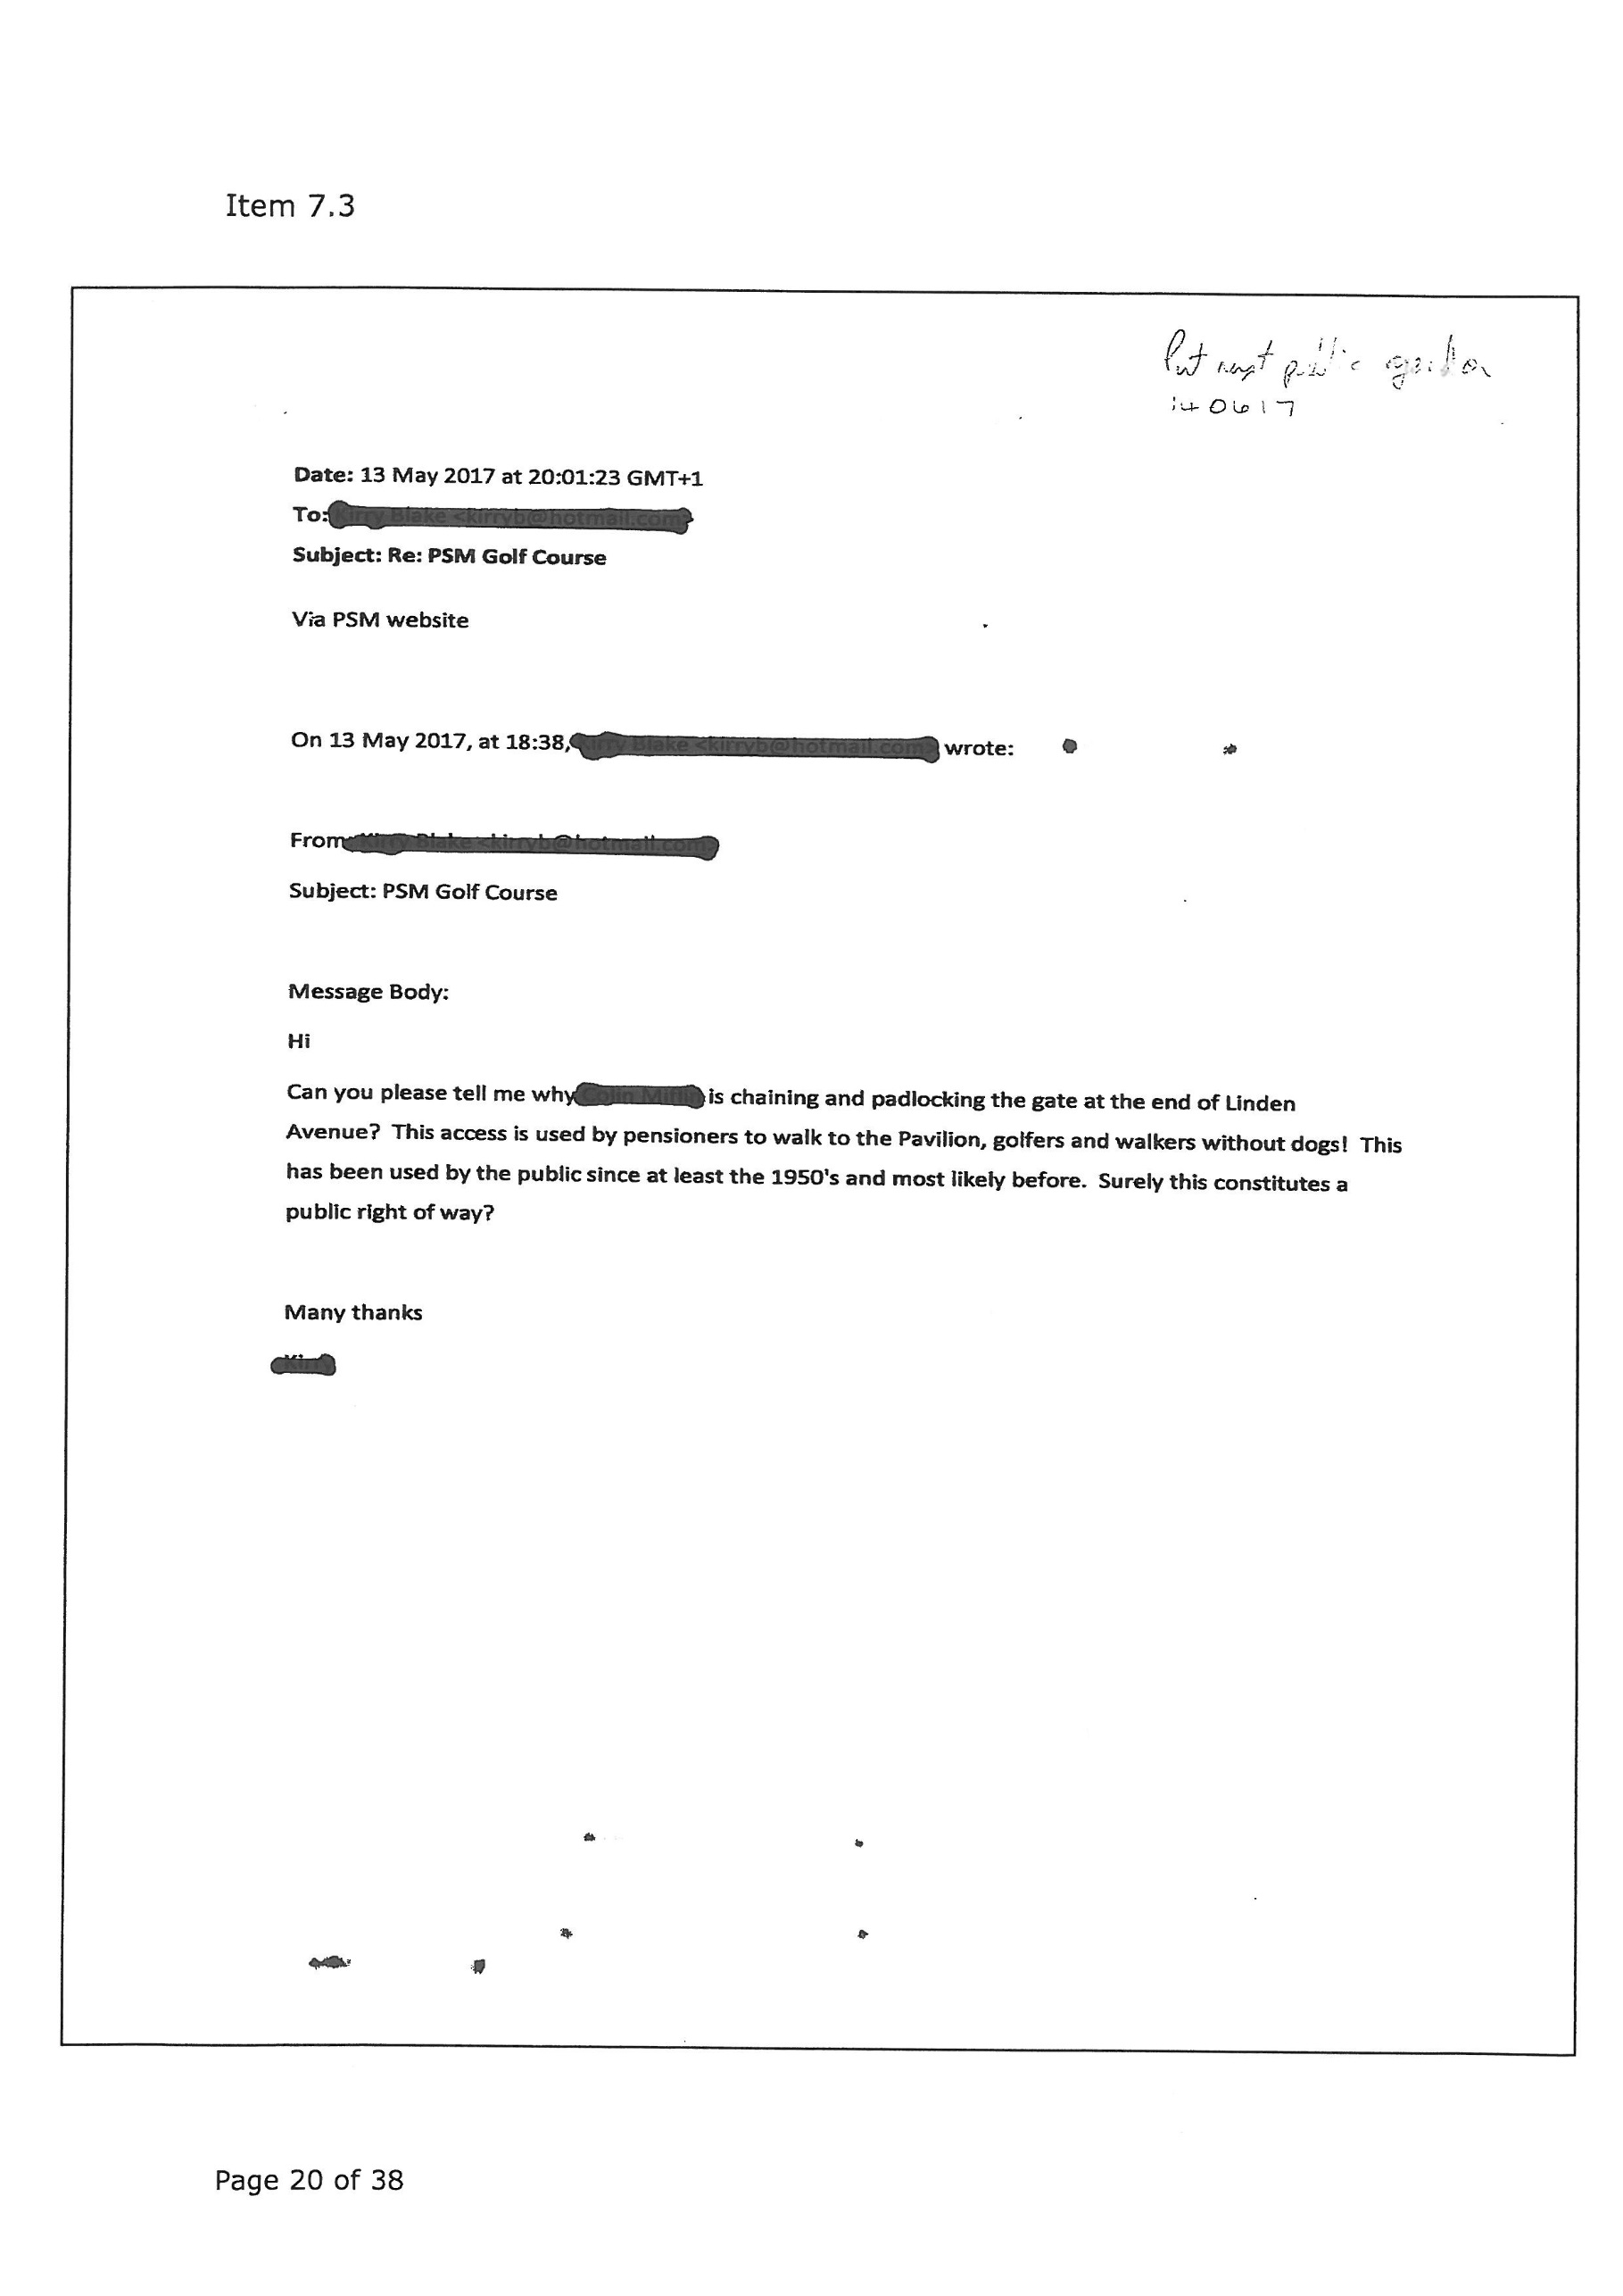
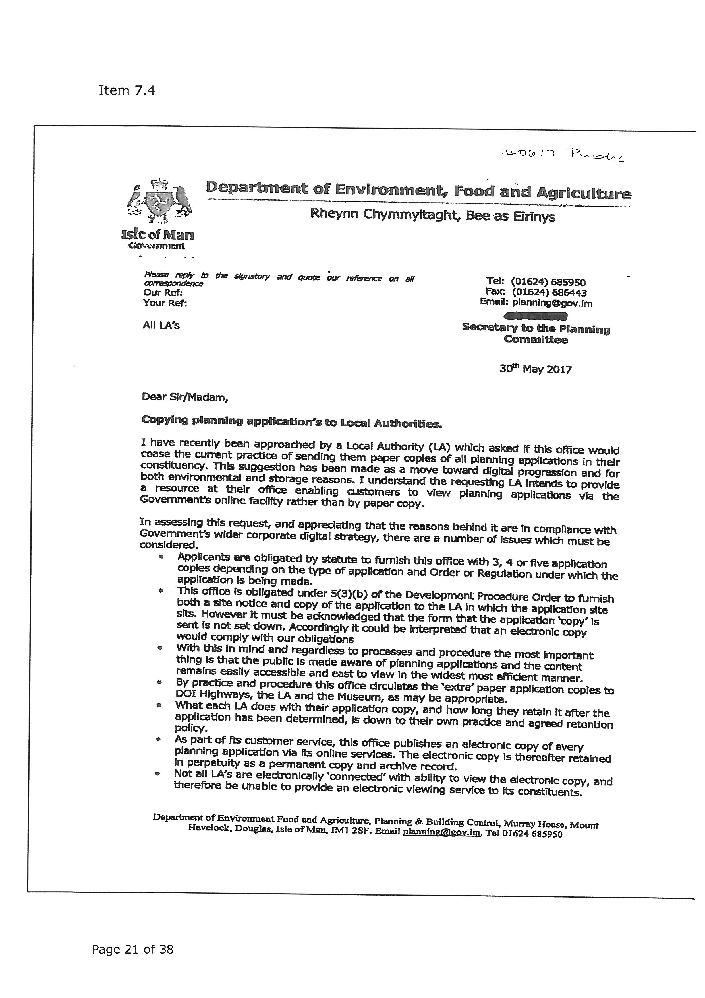
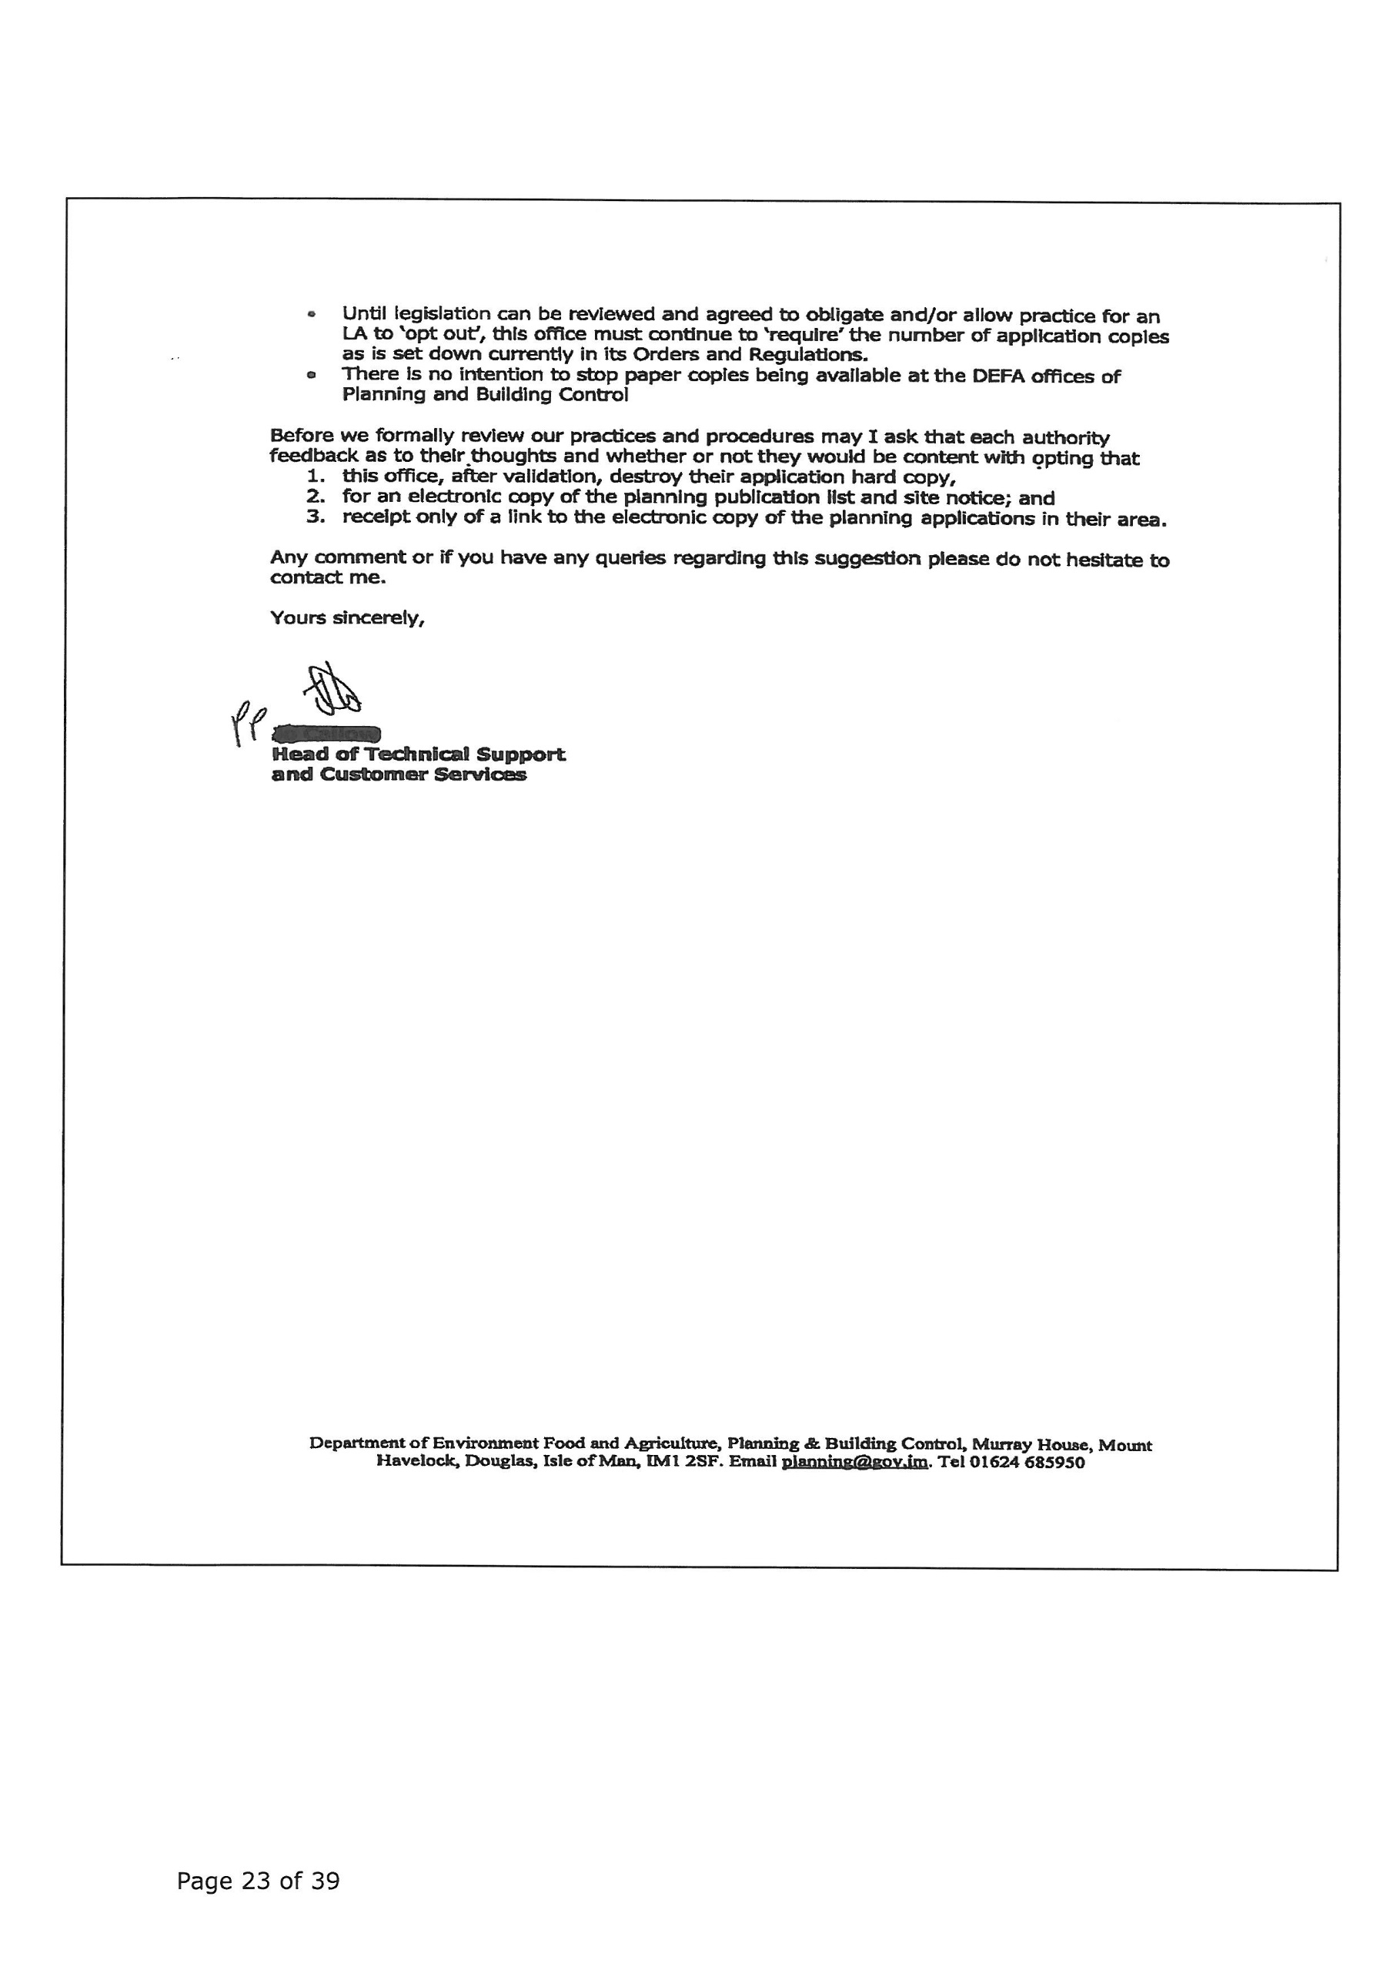

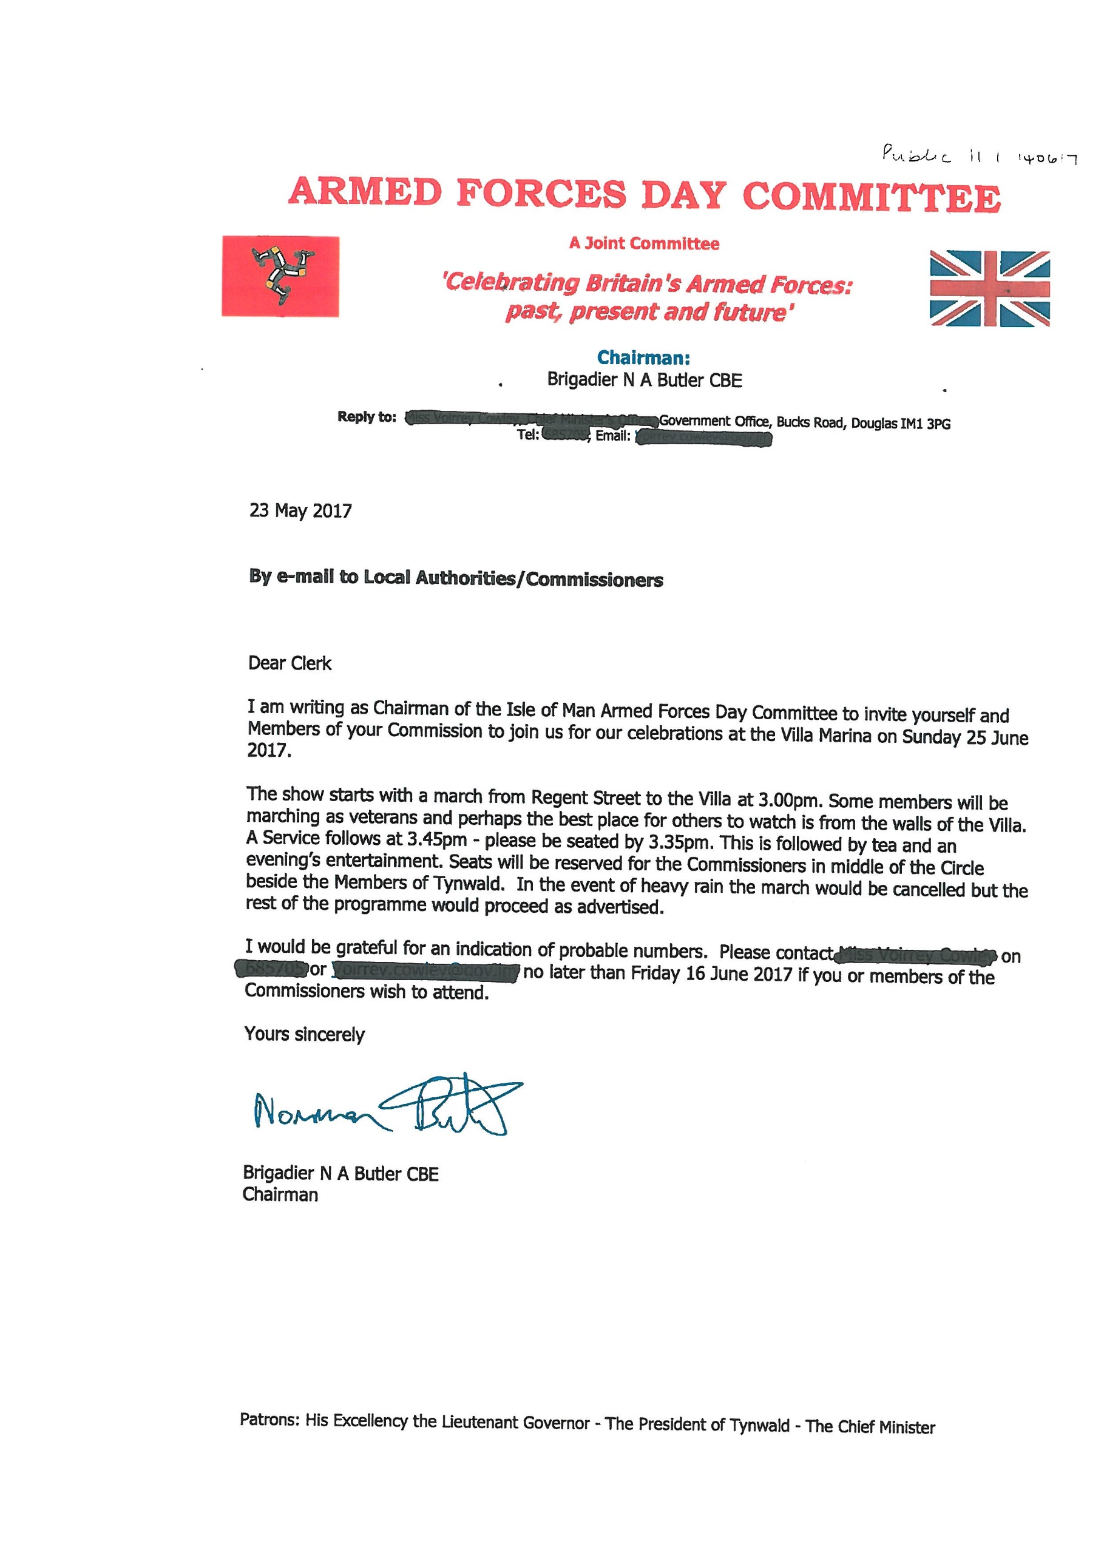
PORT ST MARY COMMISSIONERS
ORDINARY BOARD MEETING
14th June 2017
AGENDA – PRIVATE SESSION
1. Minutes for adoption
1.2 Consideration of the minute of the Private Meeting of 24th May 2017
2. Matters Arising
2.1 Matters arising from the Minute of 24th May 2017
3. Health, Safety and Environmental Performance
4. Housing
5. Finance
6. Special Projects
7. Policy and Resources
8. Staffing
9. Representative Confidential Reports
10. Private Correspondence
11. Any other business of an urgent nature (by permission of the Chairman)
12. Date of next meeting

