PORT ST MARY COMMISSIONERS
ORDINARY BOARD MEETING
26th April 2017
AGENDA – OPEN PUBLIC SESSION

1. Welcome, Apologies and Declarations
2. Minutes for Adoption:
2.1 Consideration of the Minute of the meeting of 12th March 2017
3. Matters Arising:
3.1 Matters arising from the Minute of 12th March 2017
3.1.1 Draft Dog Byelaws – update from Department of Infrastructure Local Government Unit
3.1.2 Provision of a Dog Warden. Item requested by the Chairman deferred.
4. Motions: None
5. Finance:
5.1 Approval of invoices for payment April 2017
6. Special Projects:
6.1 Report on Events Committee meeting held on 19th April 2017
7. Public Correspondence:
7.1 Correspondence from DoI re Local Authority Capital Schemes
7.2 Correspondence from IOM Cyclefest
7.3 Correspondence from Southern Vintage Engine and Tractor Club
7.4 Correspondence from the Office of the Clerk of Tynwald
8. Consultations: None
9. Planning Matters:

9.1 Planning Applications
9.1.1 PA17/00410/B Frank Worral (IOM) Ltd. Mevania, Lewthwaites Way, Port St Mary. Erection of detached dwelling with associated parking on land adjacent to existing house.
9.2 Planning Approvals
9.2.1 PA16/01383/B Mr R Best. Colwood, Beach Road, Port St Mary. Installation of flat roof dormer to rear elevation and pitched roof dormer to front elevation and erection of a single storey extension to replace existing garage. Approved.
9.2.2 PA17/00181/B Mrs Gillian Stephens. 3 Creggan Lea, Port St Mary. Installation of flue outlet from log burner. Approved.
9.3 Planning Amendments - none
10. Policy and Resources
10.1 MUA Public Lighting Maintenance Contract
11. Invitations
11.1 Advance notice of Borough of Douglas Civic Sunday Service on 11th June at 10.30 at St Georges Church
11.2 Invitation to Municipal Association AGM on 25th May 2017
12. Any other business of an urgent nature (by permission of the Chairman)

Item 3.1.1
Subject: PortStMaryDogControlByelaws2017_V01

Hi Alastair

I have been working on your Dog Control Byelaws. These are now in the Mannlex format as discussed. They have also been amended to reflect the current draft wording that we now use. Hopefully I have not altered the meaning of any of the byelaws! You may also notice that I have changed the schedules, as the places named in Schedule 2 and 3, I have combined the two, see attached. In the schedules I have removed references to “throughout the year” or other times /dates and put them instead actually into the Byelaws themselves, that hopefully will be more clear and be supported by the Attorney General’s Office when I check with them.

I have not done anything about the map as yet, the best thing to do is to contact the mapping section for their assistance, and you can contact them direct.

I will need to run the attached past the Attorney General’s drafters to see if they are content or have any comments but I wanted to let you know where I was with it.

Oh by the way I have put 1st June 2017 as a more likely coming into operation date but that can change if it is felt that everything can be sorted before then.

Once we have had comments from the AGs and made any subsequent changes (including to the new map) it will be ready for your Commissioners to make. We will then approve them and submit them to a future sitting of Tynwald as per the process set out in the Dogs Act 1990.

Please review these and let me have any comments on the attached.

Kind Regards

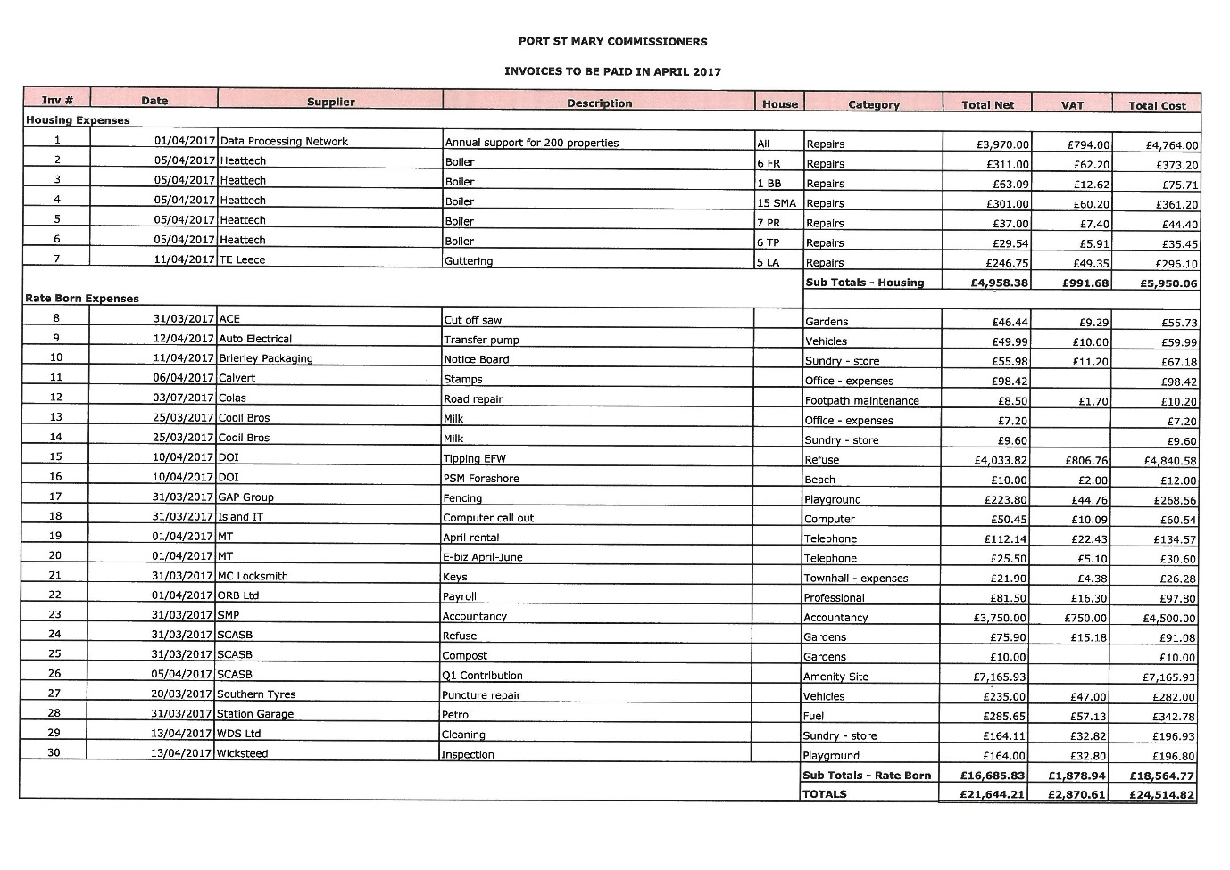

Item 6.1
Report on Events Meeting. Board Member volunteers needed to usher at Mona’s Queen III ceremony, and also to serve guests at Town Hall afterwards.
The Pavilion confirmed to Darleen that they will provide enough sandwiches for 75 people but only charge us for 50. There would be 2 half mini-scones per person. If we were really short of servers they may be able to provide one person to help, at an additional cost.
Village in Bloom event will be cancelled this year as there were only 9 entries in 2016. Consideration to be given to replacing with a photographic competition commencing in 2018.

Item 7.1
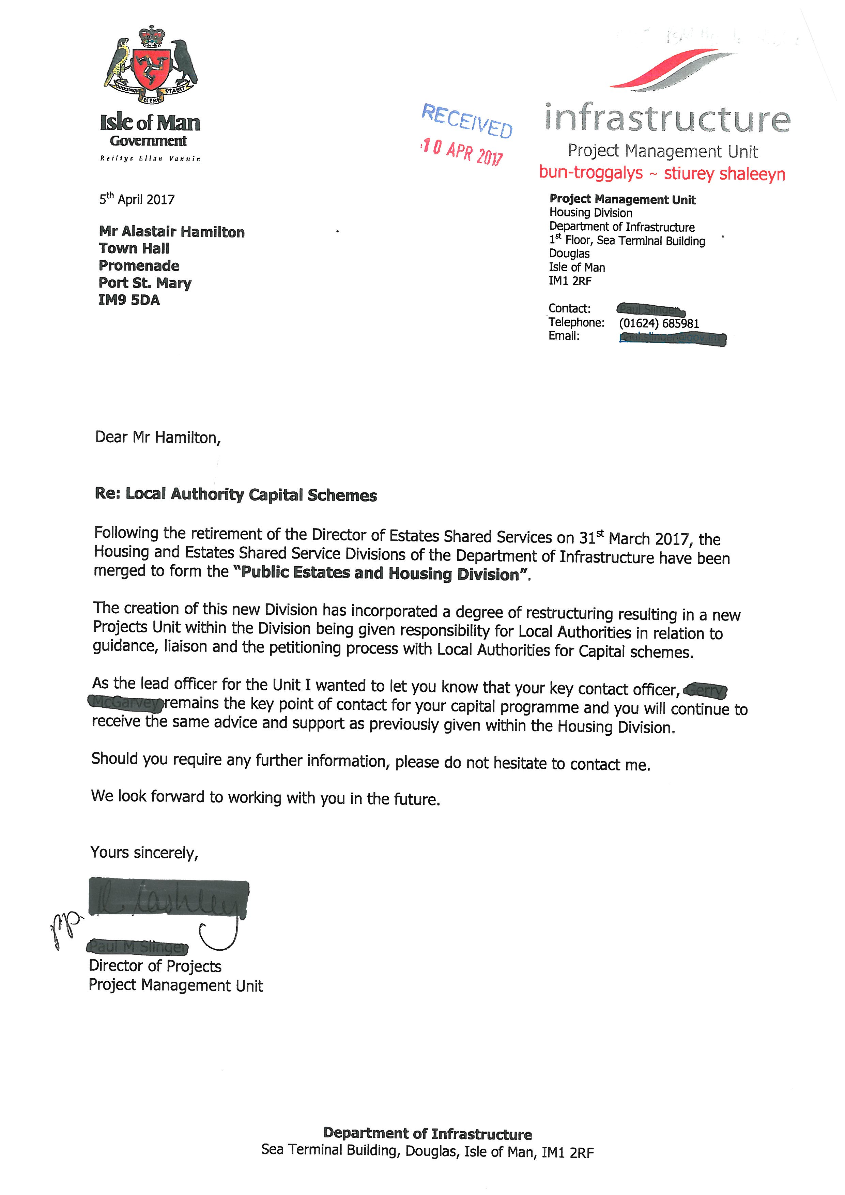
Item 7.2
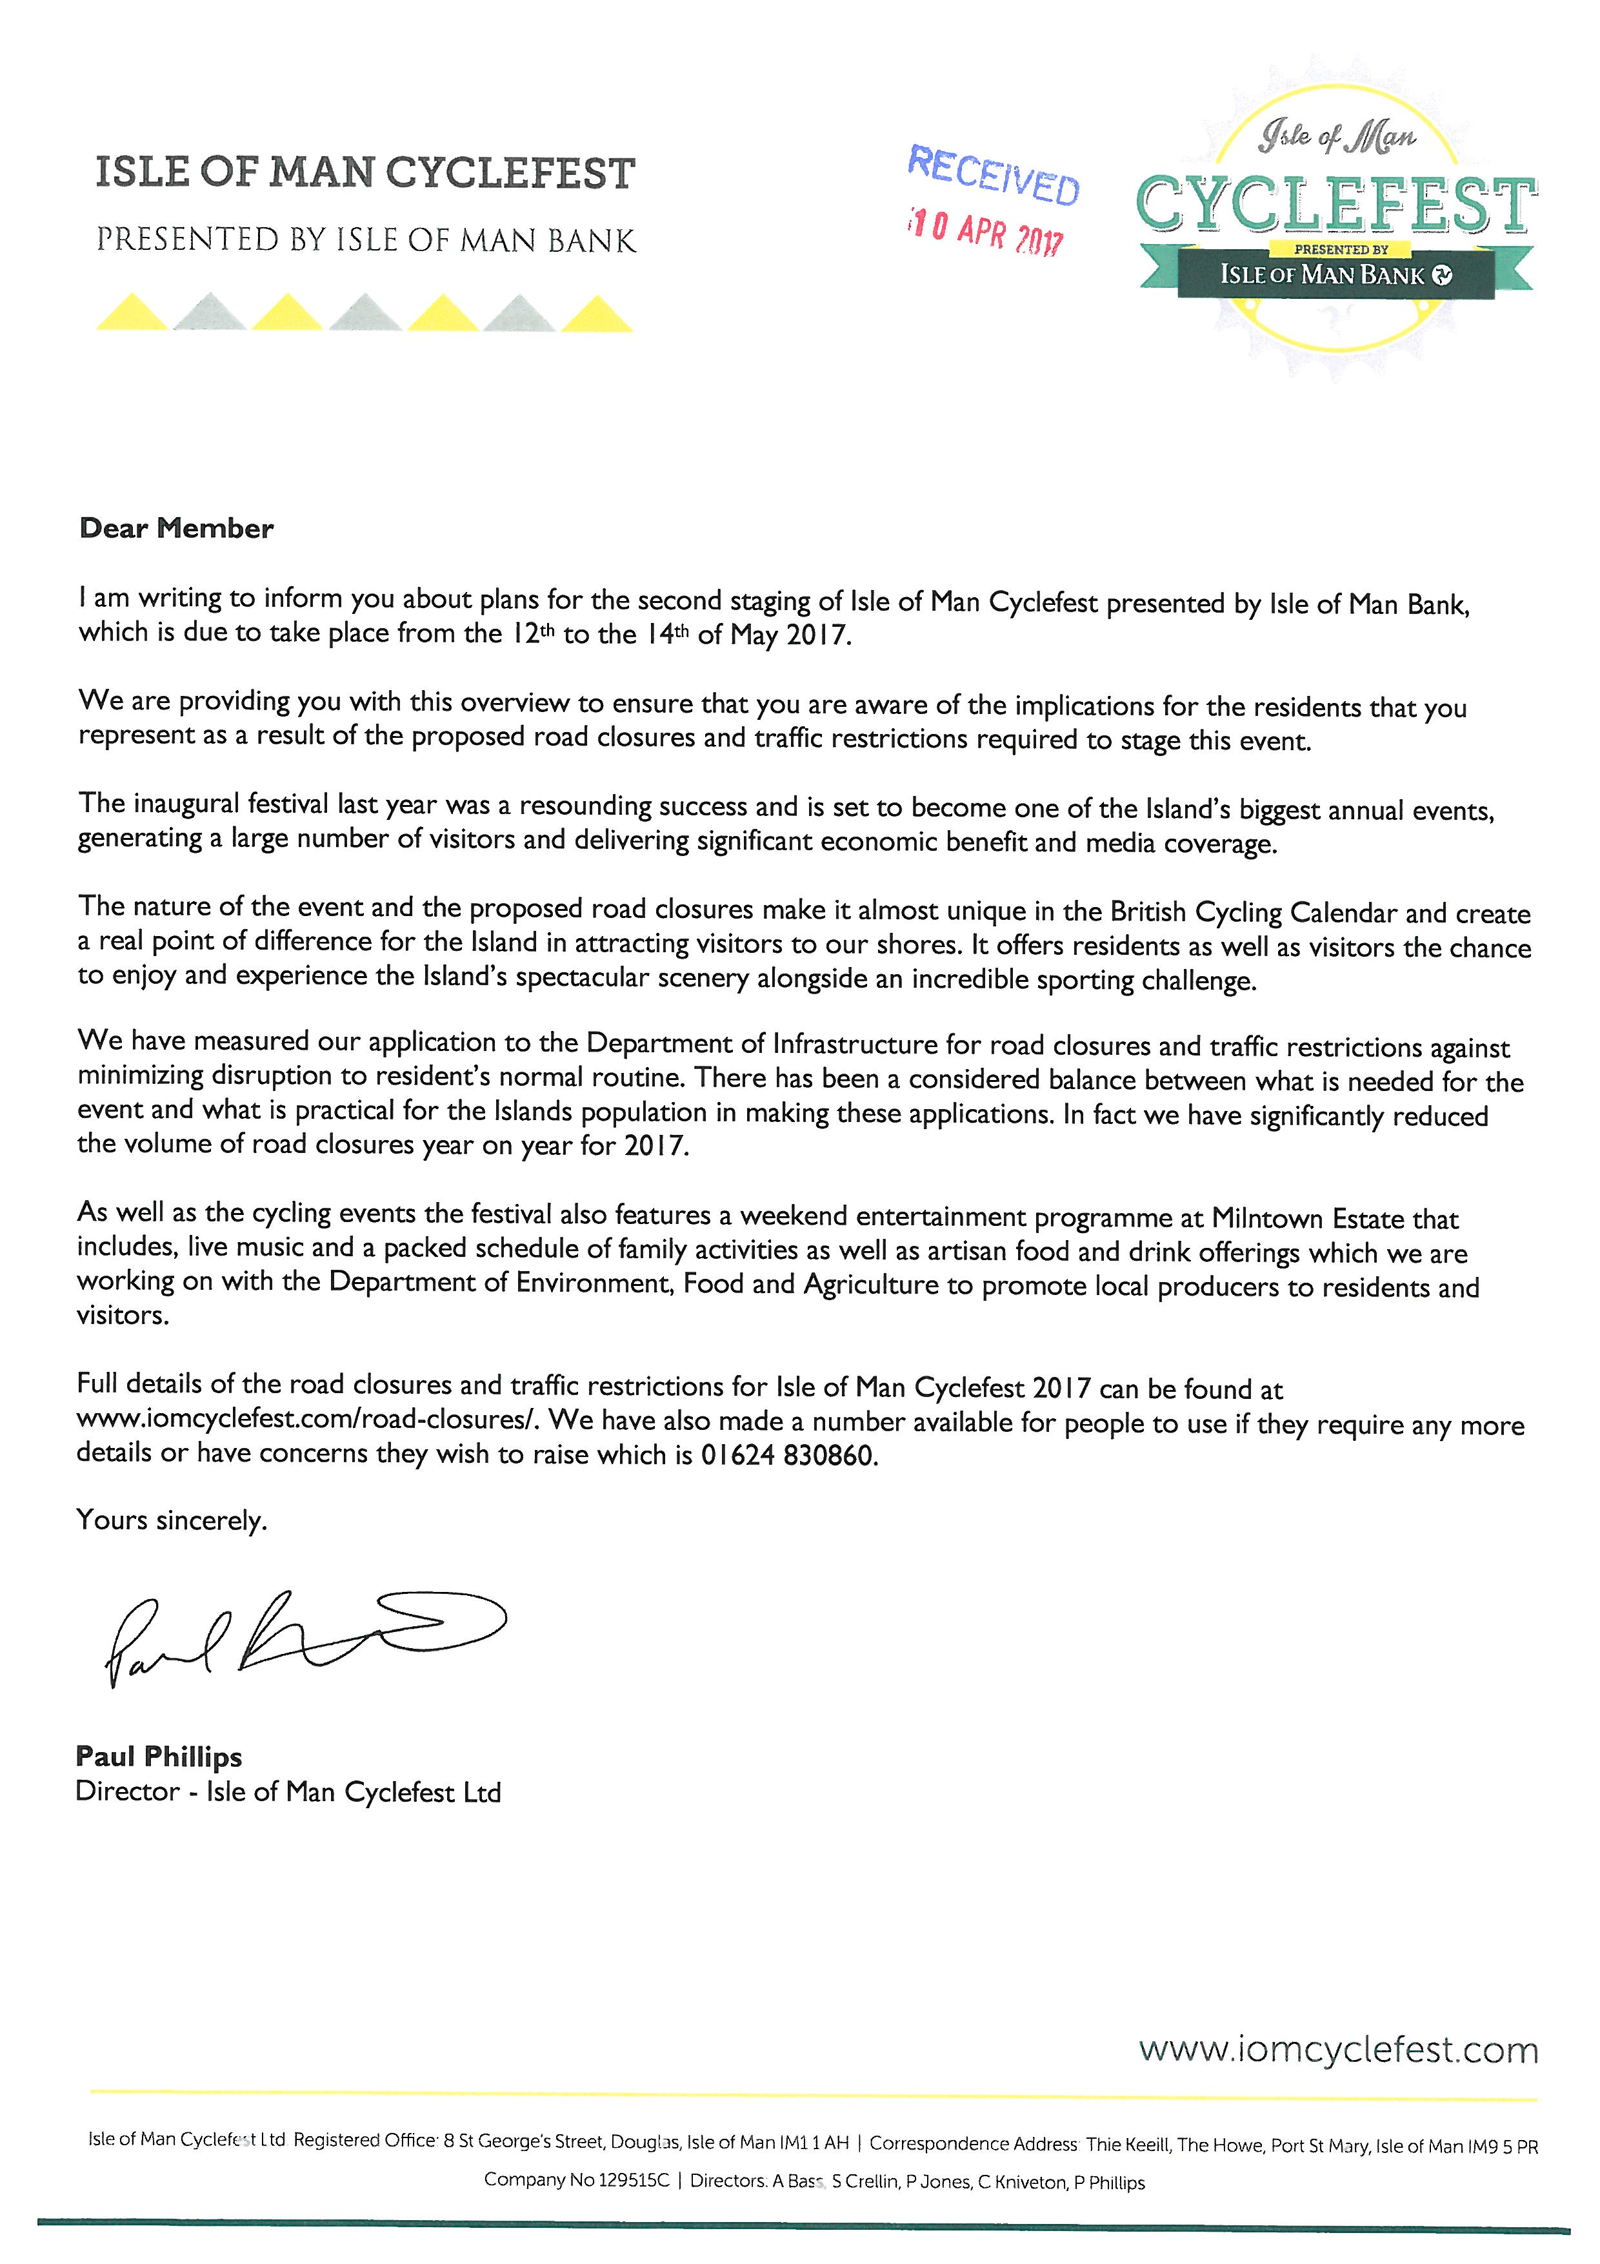

Item 7.3
Southern Vintage Engine and Tractor Club
Formed 1984
Chairman Secretary
Orry Mitchell Robin Settrey
‘Silverdale’ 80 Magherbreekyn
10 Silverburn Drive Pony Fields
Ballasalla Port Erin
Isle of Man Isle of Man
IM9 2DR IM9 6DD

Tel: 07624-496870 Tel: 01624-836188
Email: marshallman@manx.net

12th April 2017

A Hamilton - The Clerk
Port St Mary Commissioners
Town Hall, Promenade
Port St Mary

Dear Sir,

Mad Sunday Vintage Rally 4th June 2017

The Southern Vintage Engine and Tractor Club will be holding their annual Mad Sunday Vintage Rally on the 4th June 2017 on the ‘Cartshed Field’ which is at the side/rear of Ballacreggan Farm bounded by Plantation Road, courtesy of the Cooil family. Unfortunately the Stonefield is not available this year.

We wish to ask again that the Southern Vintage Engine and Tractor Club could use two of your portable toilets for our Vintage Rally on Mad Sunday, which will be serviced by Ian Henderson of A1 Cabin & Toilet Hire, who now works for JW Engineering who took over A1.

If this is acceptable can the portable toilets please be delivered to the Cartshed Field on Friday afternoon, 2nd June?

The Club would also like the use of two large wheelie bins and 4 normal size ones.

The Southern Vintage Engine and Tractor Club wishes to thank the Port St Mary Commissioners for their continued support.

Yours faithfully

Orry Mitchell
On behalf of the Southern Vintage Engine and Tractor Club

Item 7.4
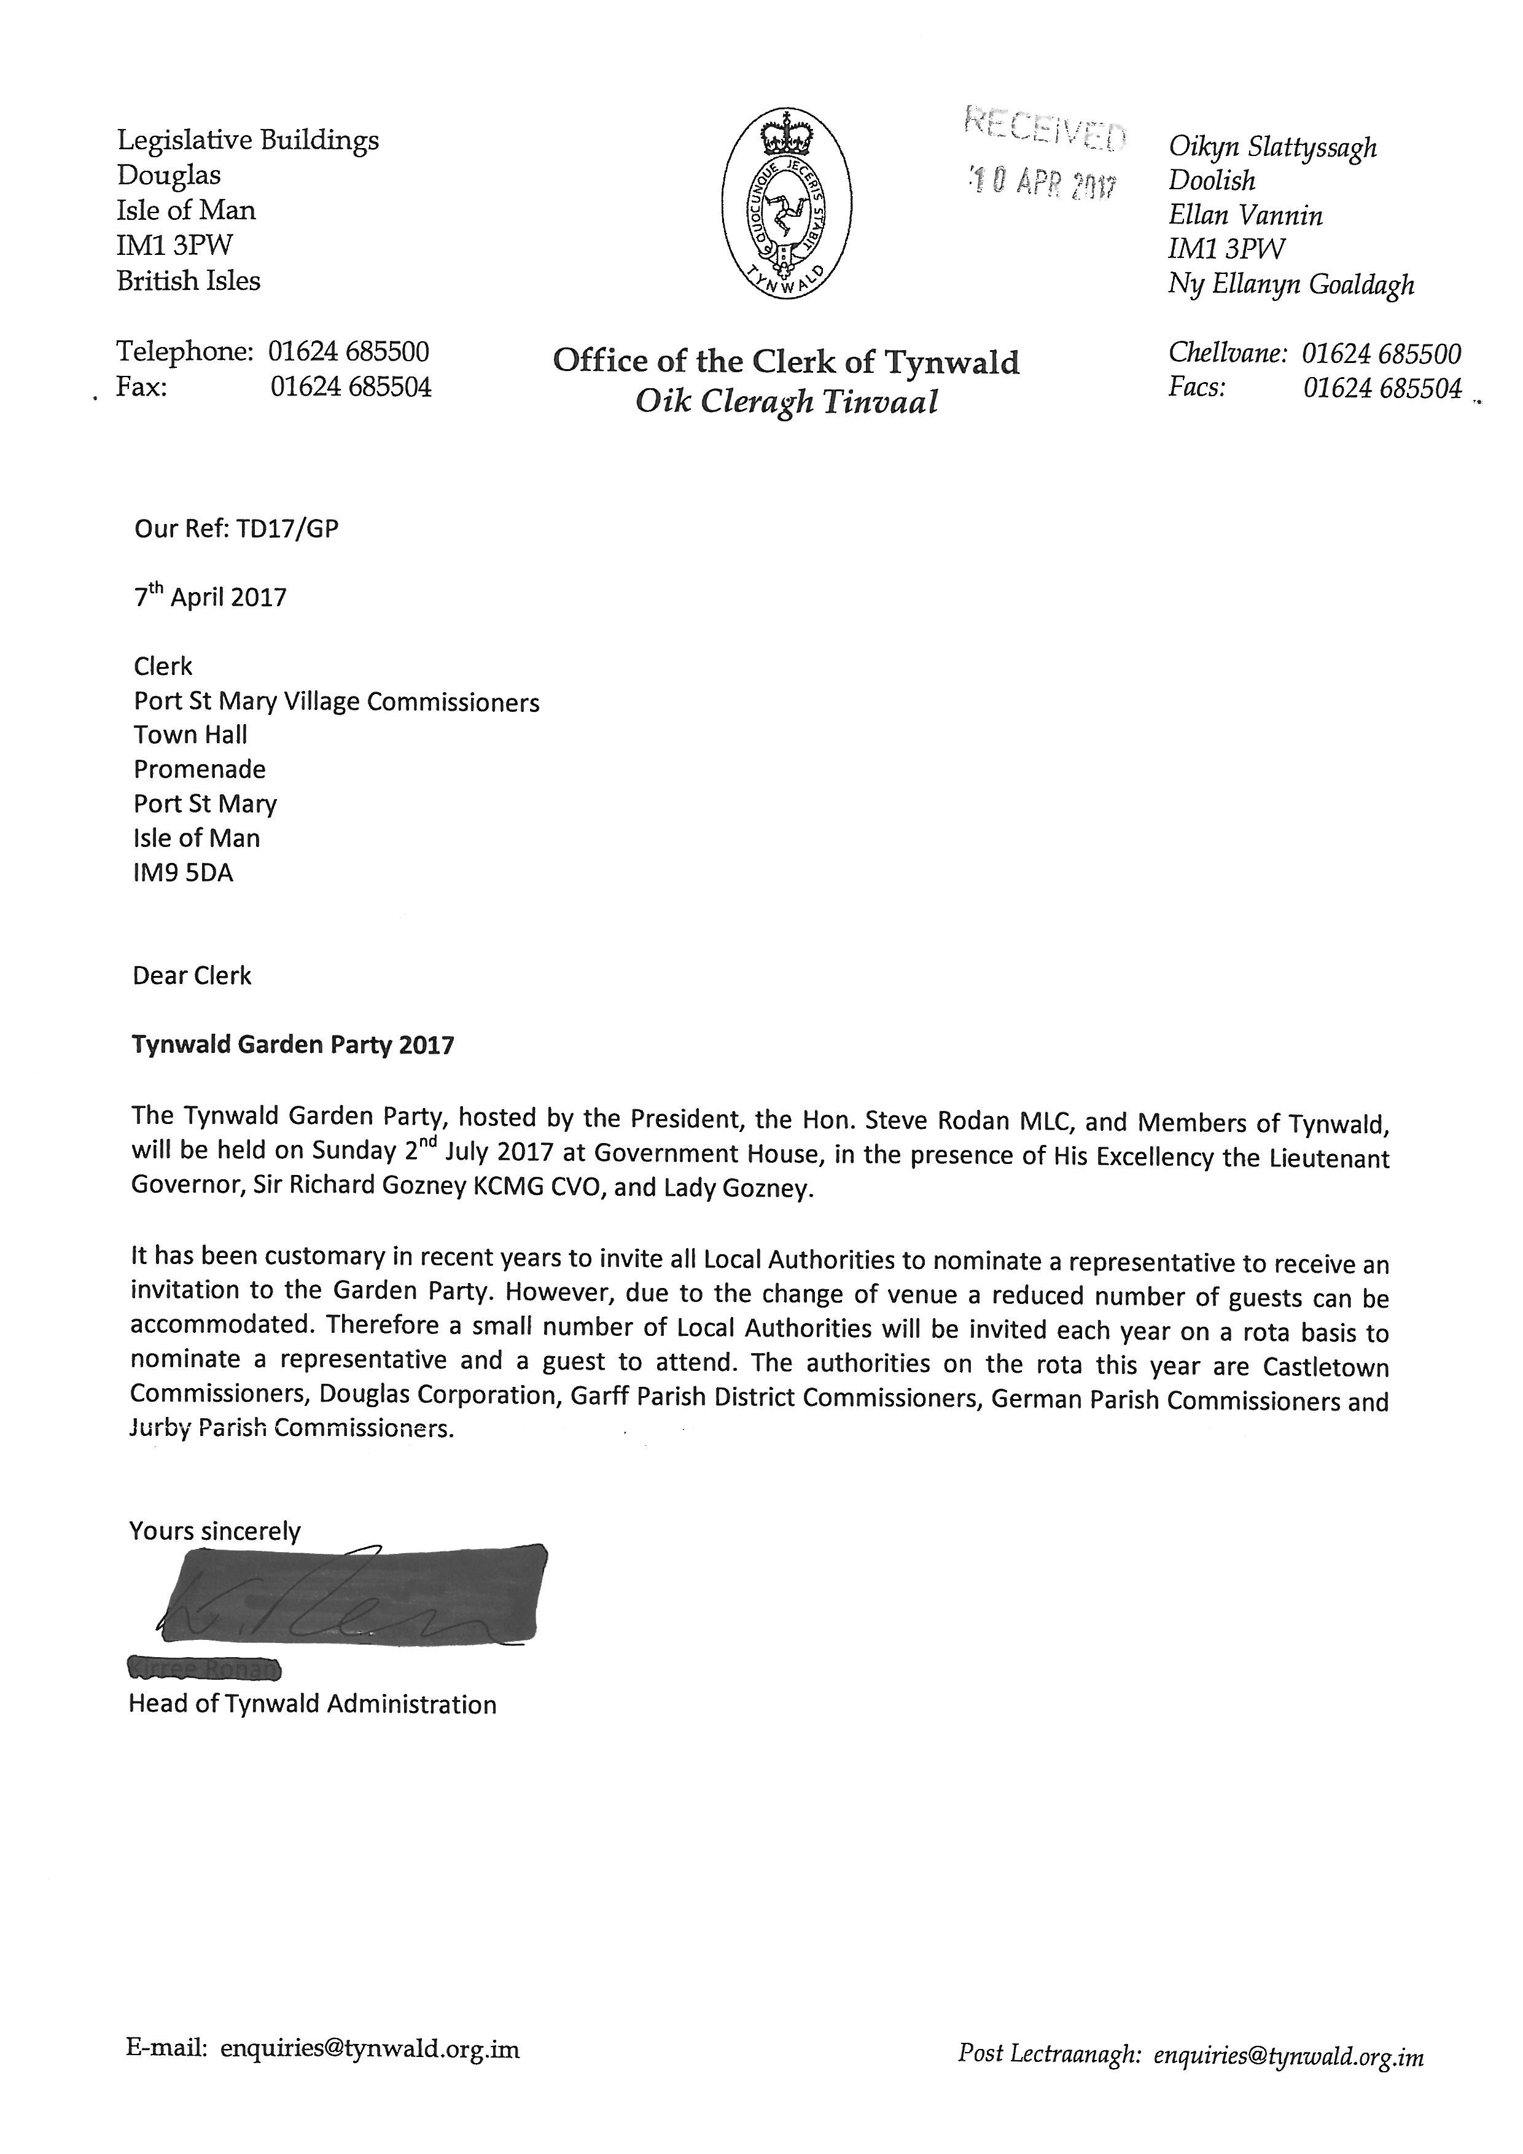
Item 10.1
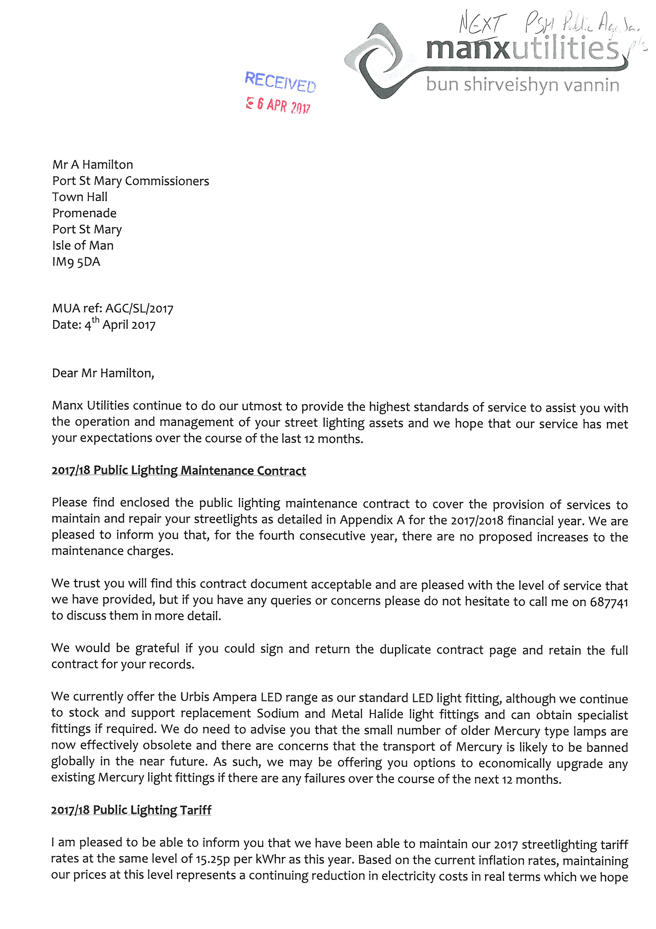

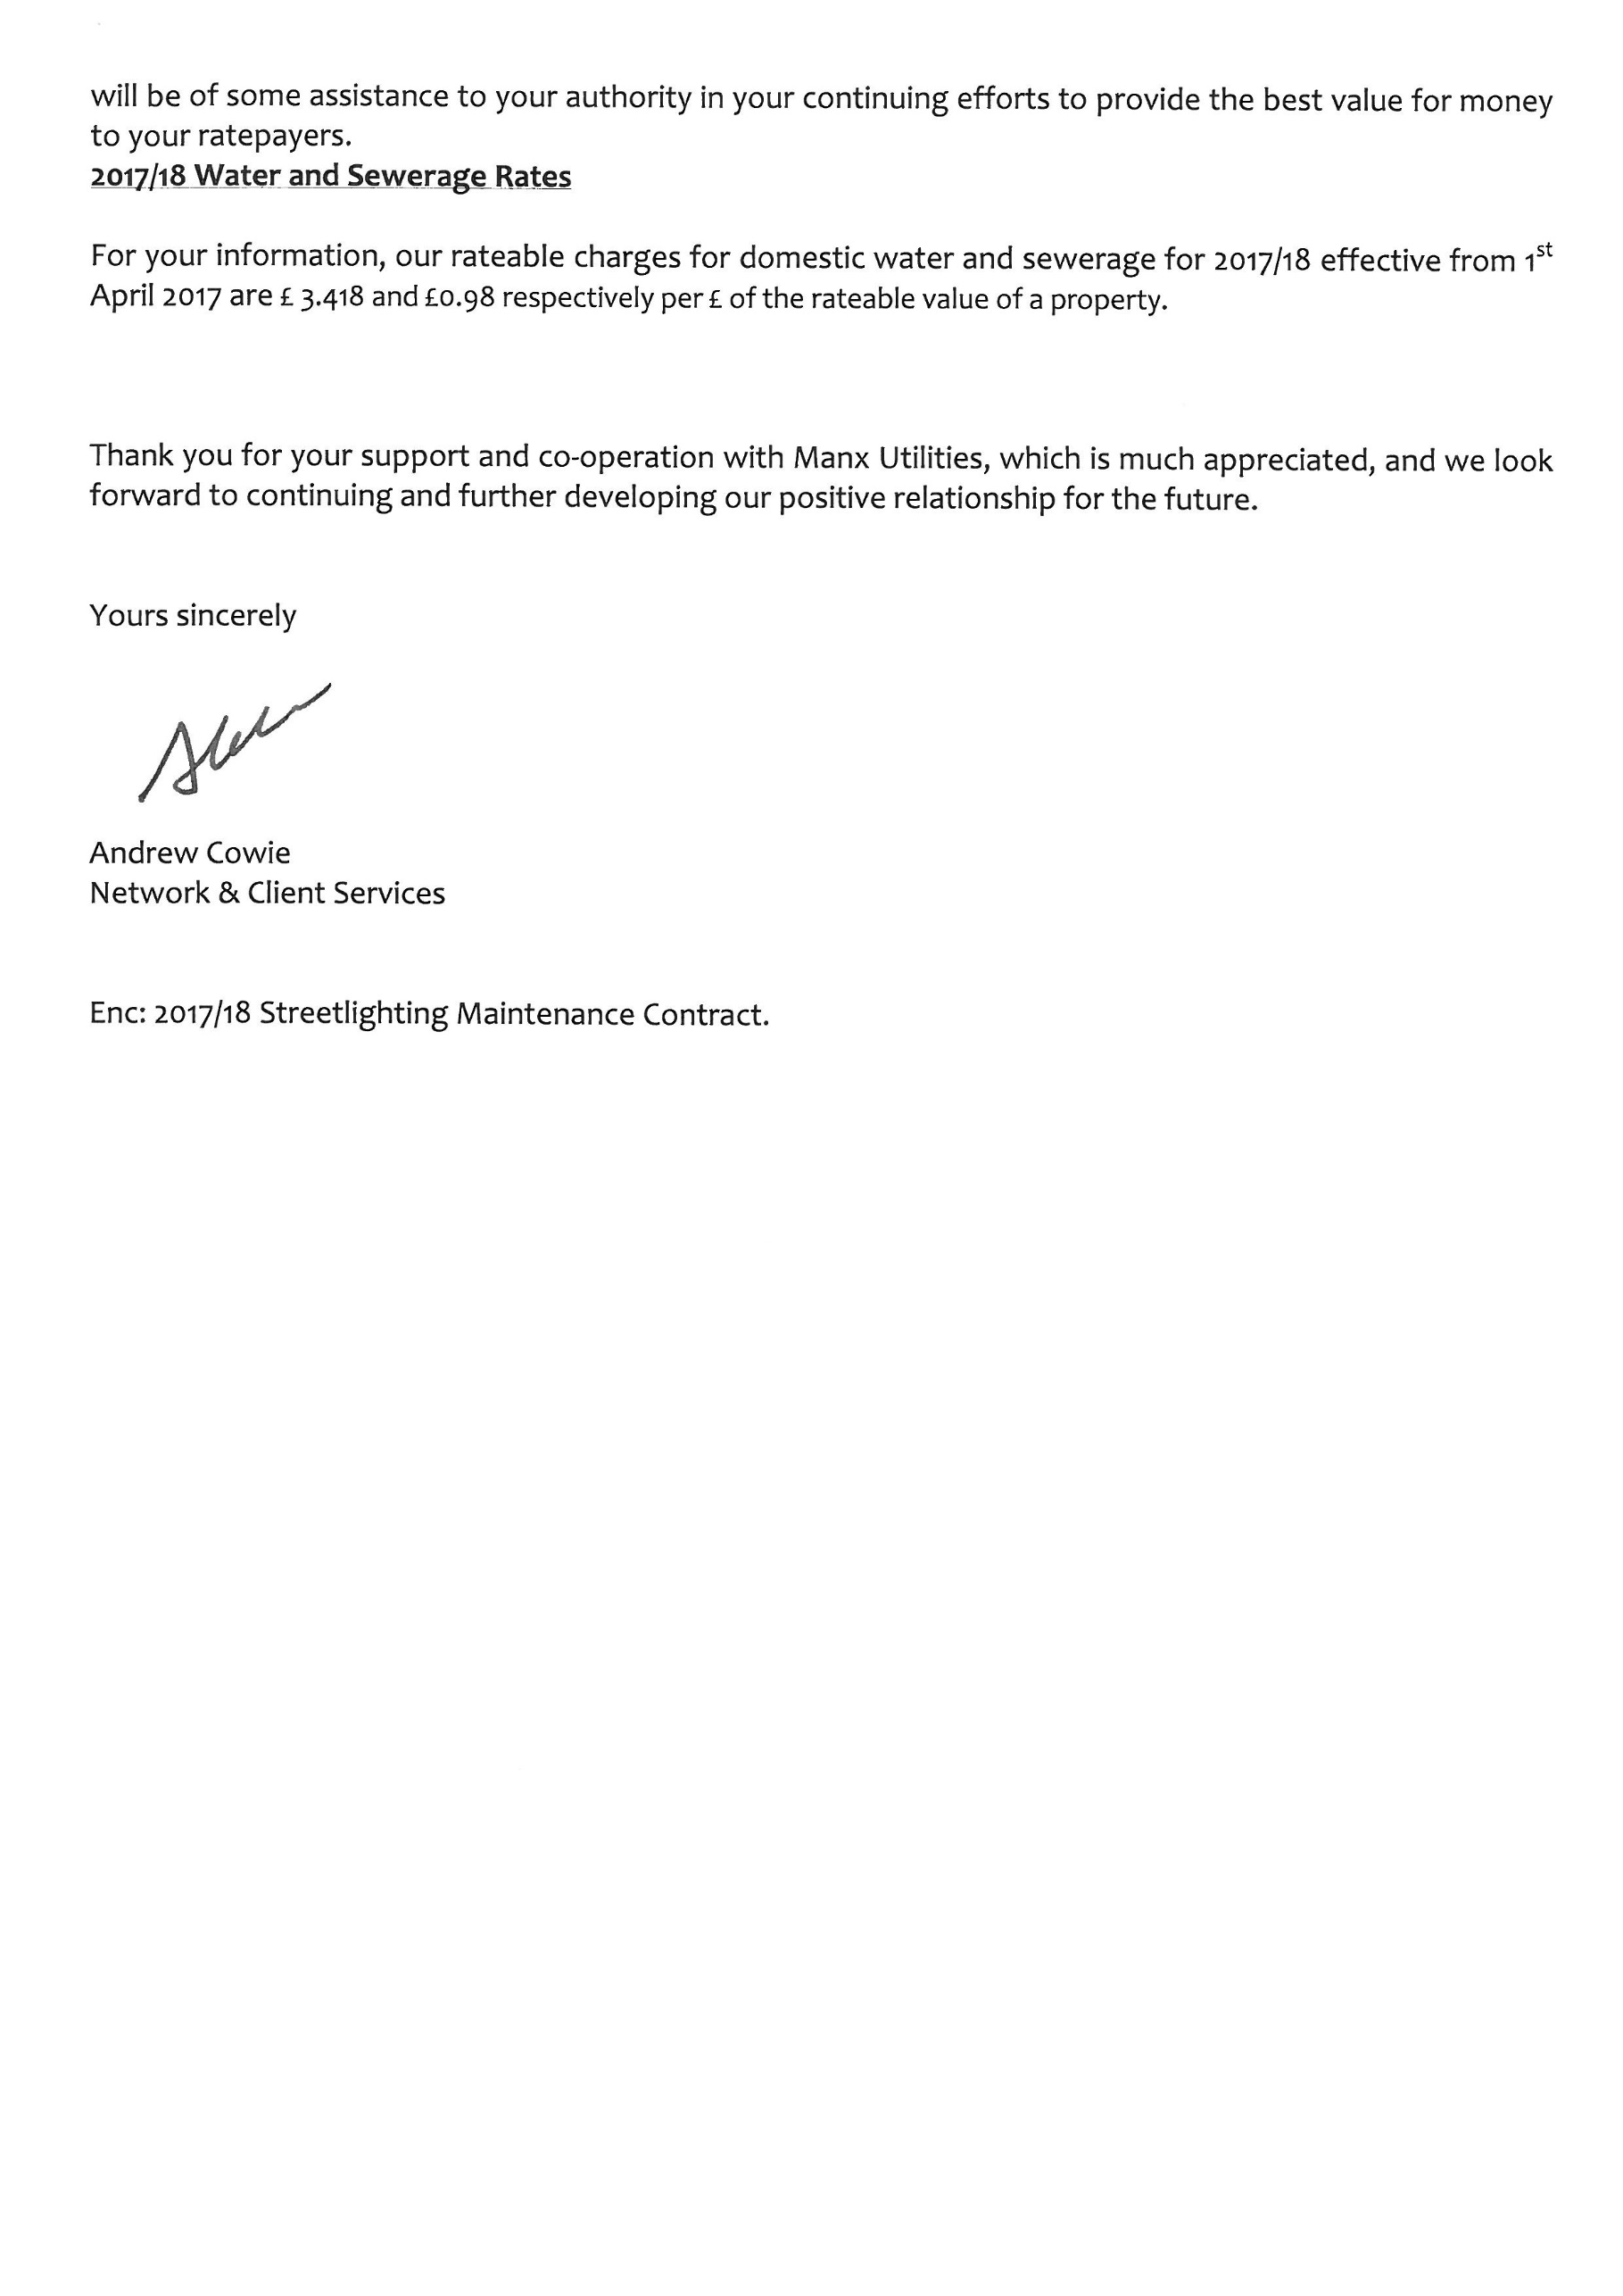

Item 11.2

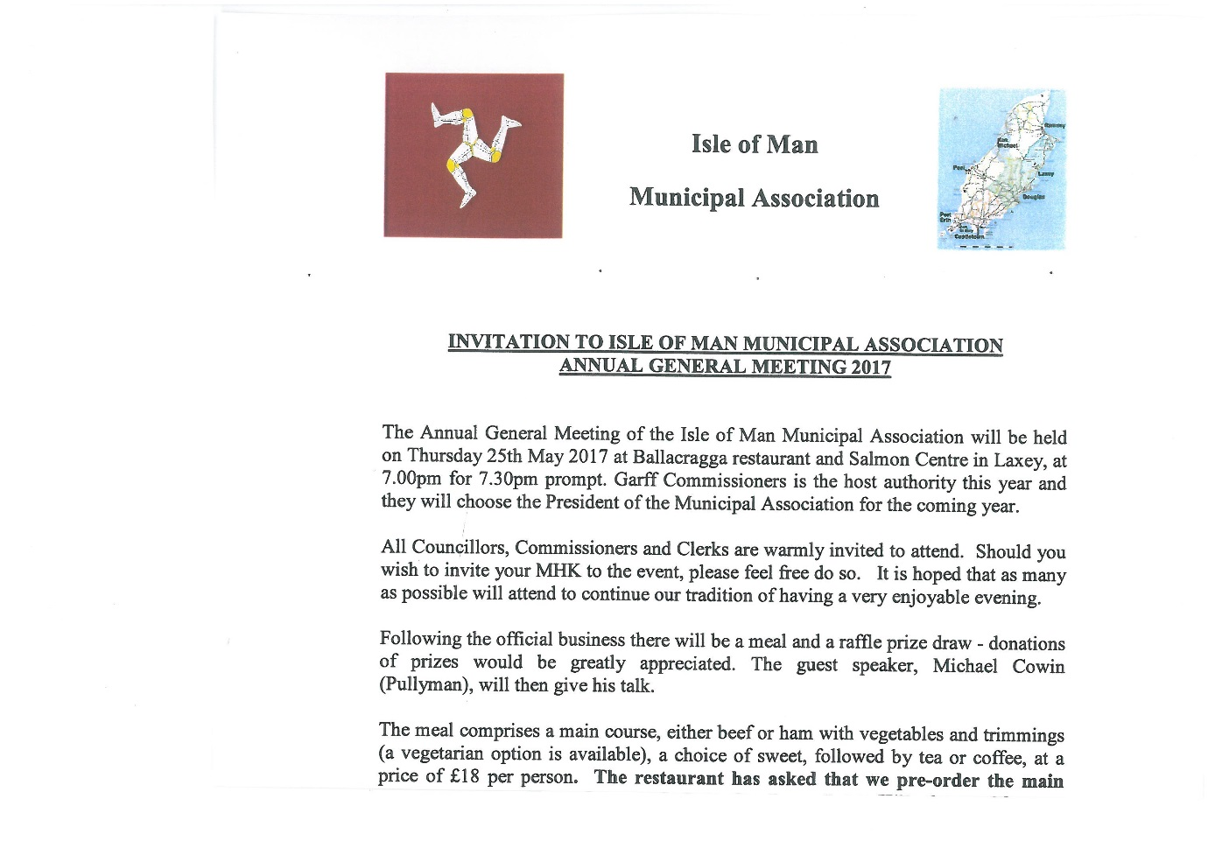

PORT ST MARY COMMISSIONERS
ORDINARY BOARD MEETING
26th April 2017
AGENDA – PRIVATE SESSION
1. Minutes for adoption
1.1 Consideration of the minute of the Private Meeting of 12th April 2017
2. Matters Arising
2.1 Matters arising from the Minute of 12th April 2017
3. Health, Safety and Environmental Performance
4. Housing
5. Finance
6. Special Projects
7. Policy and Resources
8. Staffing
9. Representative Confidential Reports
10. Private Correspondence
11. Date of next meeting
11.1 Dates of Board Meetings 2017/18 for approval
12. Any other business of an urgent nature (by permission of the Chairman)

