Date: 1st August 2018

NOTICE OF ORDINARY BOARD MEETING

In accordance with Schedule 1 of the Local Government Act 1985, Notice is hereby given that the next Board Meeting of Port St Mary Commissioners will be held in the Board Room of Port St Mary Town Hall on Wednesday 8th August at 7.30 p.m. Private session of Port St Mary Commissioners will be held following conclusion of the Public Board Meeting.
- Only business of a formal nature as defined in the Agenda for the meeting which is set out below, may be discussed as defined in Port St Mary Commissioners Standing Orders governed by Section 27 of the Local Government Act 1985 [as amended by Section 8 Local Government Act 2006]. All Commissioners are urged to attend and bring with them their copy of Standing Orders.

Prior to the Board Meeting there will be a Public Forum in the Board Room from 7 pm to 7.25 pm. (Beach Mission will be in the West Room & Town Hall)
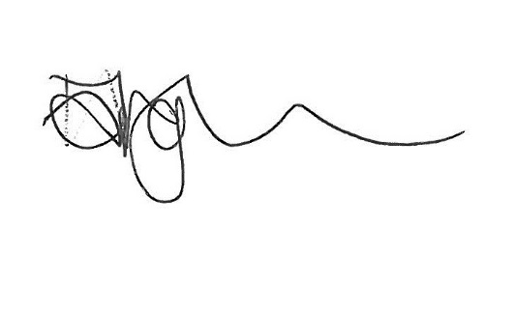

PORT ST MARY COMMISSIONERS
ORDINARY BOARD MEETING
8th AUGUST 2018
AGENDA – OPEN PUBLIC SESSION
Item Number | Item | Action Required
1. | OPENING OF THE MEETING
1.1 | Welcome, Apologies & Declarations | As required by Board members
2. | MINUTES
2.1 | Minutes of the Ordinary Meeting held on the 25th July 2018 | For Board approval
3. | MATTERS ARISING
3.1 | Matters arising from previous meetings | Acting Clerk to provide necessary updates
3.2 | Ratification of E-mail votes | For Board approval
4. | MOTIONS
 | None submitted | N/A
5. | FINANCE
5.1 | Invoices for payment early August 2018 | For Board approval
6. | PROJECTS
6.1 | Mariners Shelter | N/A
6.2 | Manxonia House | For noting
6.3 | Remembrance Garden | N/A
6.4 | Skate Park | N/A
6.5 | Public Conveniences | For Board approval
6.6 | Traffic Consultations | For Board discussion and noting
6.7 | Jetty Restoration | N/A
6.8 | Playground | For Board discussion and approval
7. | PUBLIC CORRESPONDENCE
7.1 | E-mail from ratepayer regarding dog bins | For Board discussion & response
7.2 | E-mail from ratepayer regarding bins at Gansey Beach | For Board discussion & response
7.3 | Correspondence from ratepayer regarding traffic at Gansey | For Board discussion & noting
7.4 | Correspondence from Castletown Commissioner J Cubbon | For Board discussion & response
7.5 | Correspondence from Tynwald Select Committee on Poverty | For Board discussion & response
7.6 | Correspondence re traffic on Lewthwaites Way/Bay View Road junction | For Board discussion & response
7.7 | Correspondence from Ratepayer re recycling | For Board discussion & response
7.8 | Correspondence from visitor to Chapel Beach | For Board discussion and response
7.9 | 2nd Supplemental List | For noting
8. | PUBLIC CONSULTATIONS
 | None | N/A
9. | PLANNING MATTERS
9.1 | Planning Applications:  PA18/00688/C  PA18/00764/A  PA18/00762/B | For Board approval
9.2 | Planning Approvals:  PA18/00534/B (Manxonia House windows)  PA18/00584/B  PA18/00503/B  PA17/00875/B | For noting
9.3 | Planning Refusals: None | N/A
9.4 | Planning Amendments:  PA18/00676/B | For noting
10. | POLICY & RESOURCES
10.1 | Bye Election | Acting Clerk to provide update
10.2 | 2018 /19 Meeting Dates | For noting
10.3 | Declaration of Interests | Tabled forms to be completed by Board members
11. | INVITATIONS
 | None | N/A
12. | ANY OTHER BUSINESS OF AN URGENT NATURE  (BY PERMISSION OF THE CHAIR)

PORT ST MARY COMMISSIONERS
ORDINARY BOARD MEETING
25th July 2018 at 7.30pm
MINUTE – OPEN PUBLIC SESSION

Present: | Dr M Haywood (Chair), Mr A Grace (Vice-Chairman),  Mrs B Williams, Mr L Vaughan Williams, Mr I Skelly,  Mr Merchant & Mr Phair
Apologies: | Mr R Hirst, Ms H Fargher (Acting Clerk)
In Attendance: | Mrs D Greenwood (taking minutes)

1. | 1.1 The Chairman welcomed the Board, declared the meeting open, noted the apologies and sought Declarations of Interest. None were made.
2. | 2.1 Minute of the Ordinary Board Meeting held on 18th July 2018 was circulated.  AG/LVW proposed that the Minute of the Ordinary Board Meeting held on 18th July 2018 be approved and signed as a correct record. BW, AP, AM, IS & MH in favour. Carried. | MD
3. | Matters Arising:  3.1 PSM Beach Mission - DG confirmed they had been requested to conduct a thorough risk assessment. Noted  PSM18/358 3.2 Bathing Water Quality Report – DG advised they had been contacted to request a footnote be added regarding one poor water quality result. Noted.  3.3 Running Event – DG reported email had been received confirming the change of start time to 9am.
4. | Motions: None
5. | Finance: None
6. | Projects: None
7. | Public Correspondence:  7.1 Correspondence from ratepayer re action by the Board at their last meeting was circulated. It was noted events had overtaken the concern raised.
8. | Consultations: None
9. | Planning Matters: None
10. | Policy & Resources: None
11. | Invitations: None
12. | Any Other Business:  PSM18/359 12.1 Election – IS asked if it was possible to get the names of the two ratepayers who wrote in requesting an election. He expressed his concern regarding costs to the ratepayer and raised the point of the Boards vote to reduce the number of members from nine to five. MH offered to contact the Local Government Unit to see if the information can be released. AG asked how much it would cost to run an election. MH confirmed the cost to be £3,500 to £4,000. LVW expressed his support for holding an election as he was against the reduction of board members. MH advised that the process for reducing board numbers was already in motion.  PSM18/360 12.2 Board Members – IS raised his displeasure of board members writing letters of accusation. He stated that if it continued, he would write to the Chief Minister requesting disbandment of the Board or for the Board to be placed under special measures. BW sympathised adding, the main role of the Board should be the business of Port St Mary as this was what they were elected for. A line needed to be drawn under past events.

There being no further business the Public Session of the meeting closed at 7.43pm.

Item 3.1
PORT ST MARY COMMISISONERS

MATTERS ARISING & PUBLIC CORRESPONDENCE REPORT

Matters Arising from the minutes of 18th July 2018

Highways
Highways have been requested to carry out traffic management checks at the entrance to Barna Beg.

Mariners Shelter
The Structural Report is still to be issued to the Ports Manager and a costing to refurbish the plaques has been requested.

Jetty Restoration
Quotations are awaited from contractors.

Castletown Skate Park
Further information has been requested and is awaited.

Truggan Road street light
Manx Utilities have been requested to replace the street light but ensure the fitting is in keeping.

Reduction in Board members
The requested report comparing all Local Authority data will be on the next agenda.

Public Correspondence from the minutes of 18th July 2018

Ratepayer regarding concern re rate rise (IS declared interest)
The Chair responded directly to the ratepayer, no further correspondence has been received.

PSM Beach Mission request for bouncy castle
Permission was granted providing a thorough risk assessment was carried out by the Beach Mission organisers. The event took place with no reported issues.

RNLI request for street collection
Permission was granted & the tug of war trophy offered to be returned for the event.

IOM Newspapers Letter
A response was issued and the matter is now considered resolved.

Matters Arising from the minutes of 25th July 2018

Bathing Water Quality Report
The below response has been received with regards to the request to add the storm information to the data.
Currently, the Department does not investigate individual reasons for Bathing Water Quality failures which would be a difficult task given the varied potential point and diffuse sources. A project is underway to model and better understand what would be required to comply with the Bathing Water Directive 2006 standards in the Douglas, Laxey and Baldrine coastal area, but not Port St Mary.
The samples are collect by the Environment Directorate, analysed and charts produced by the Government Lab reported at https://www.gov.im/about-the-government/departments/environment-food-and-agriculture/government-laboratory/bathing-water-quality/ .
No notes in respect of any of the failures are put on the results which are for public information, so sorry but we will not be able to assist you in respect of this request.
Kind regards,
Simon
Simon Renton
Environmental Protection Unit Manager
Department of Environment, Food & Agriculture

Public Correspondence from the minutes of 25th July 2018

E-mail from ratepayer regarding IOM newspapers response
No action was required to be taken.

Item 3.2
PORT ST MARY COMMISSIONERS

RATIFICATION OF E-MAIL VOTES

Events Committee Requests

- The Committee have requested free use of the West Room on times where no other bookings have been made, if a booking comes in, they will cancel. This is to make items (shell necklaces etc) for the Beach Day and also to make poppies for the Remembrance Event. They will need use up until the November event and it will monitored by the office.
- They have purchased 6 jolly roger flags which they would like to put up the morning of the event, and take down at the end of the day. 3 at Happy Valley and 3 along the beach.
- They have requested permission for a mini marquee to be erected outside the Town Hall to judge the dog competition.

Votes received in favour; MH, AG, BW, IS & LVW.
Events Committee advised of outcome 12th July.

Recycling Press Release

Press release circulated for comment and agreement.

Votes received in favour; MH, BW, RH, IS & AP.
Tender applicants notified 11th July, press release issued 12th July.

Port Erin Commissioners banner at Four Roads

Request for Port Erin Beach Festival banner to be erected at the Four Roads, Port Erin Traders will be donating any funds after costs to the Autism charity.

Votes received in favour; MH, BW, RH, IS & AP.
Port Erin Commissioners representative notified of approval 12th July.

Item 5.1
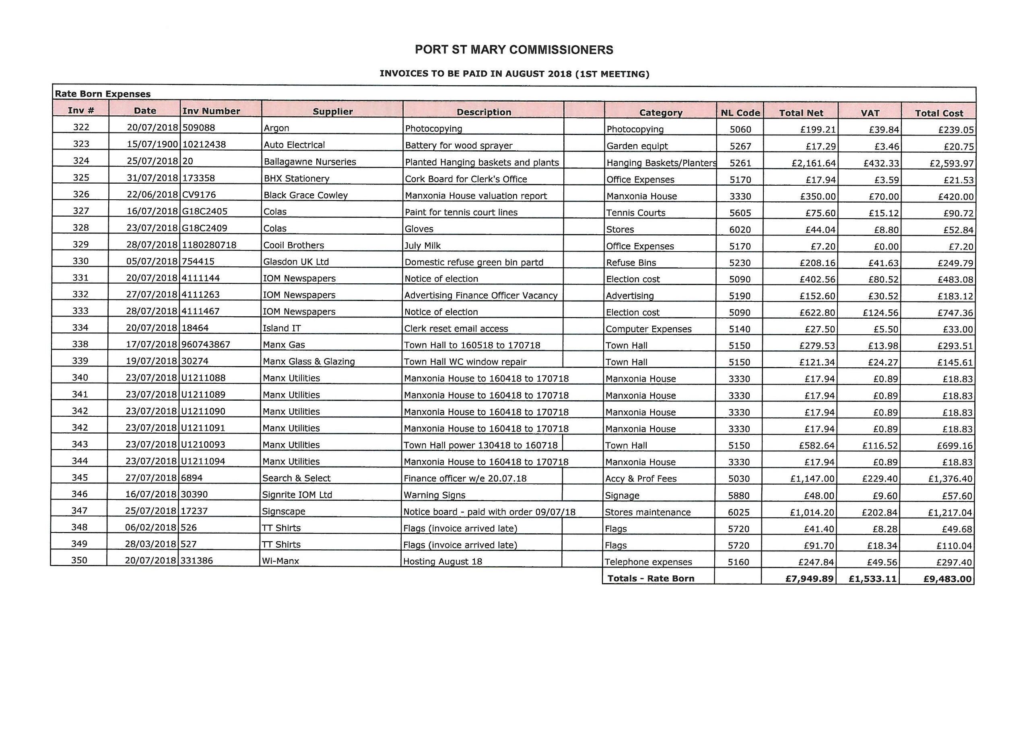

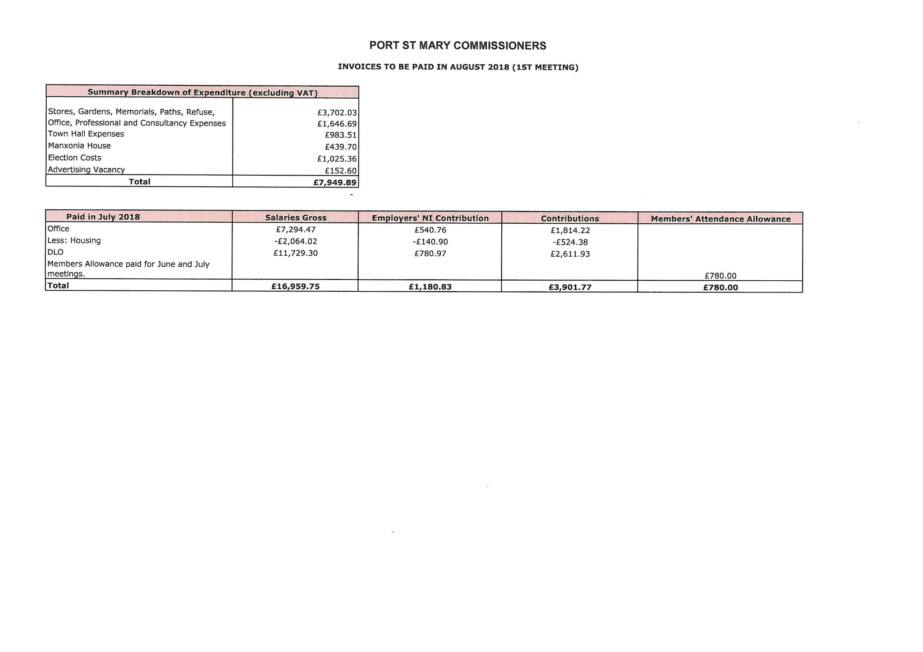

Item 6.2
PORT ST MARY COMMISSIONERS

MANXONIA HOUSE

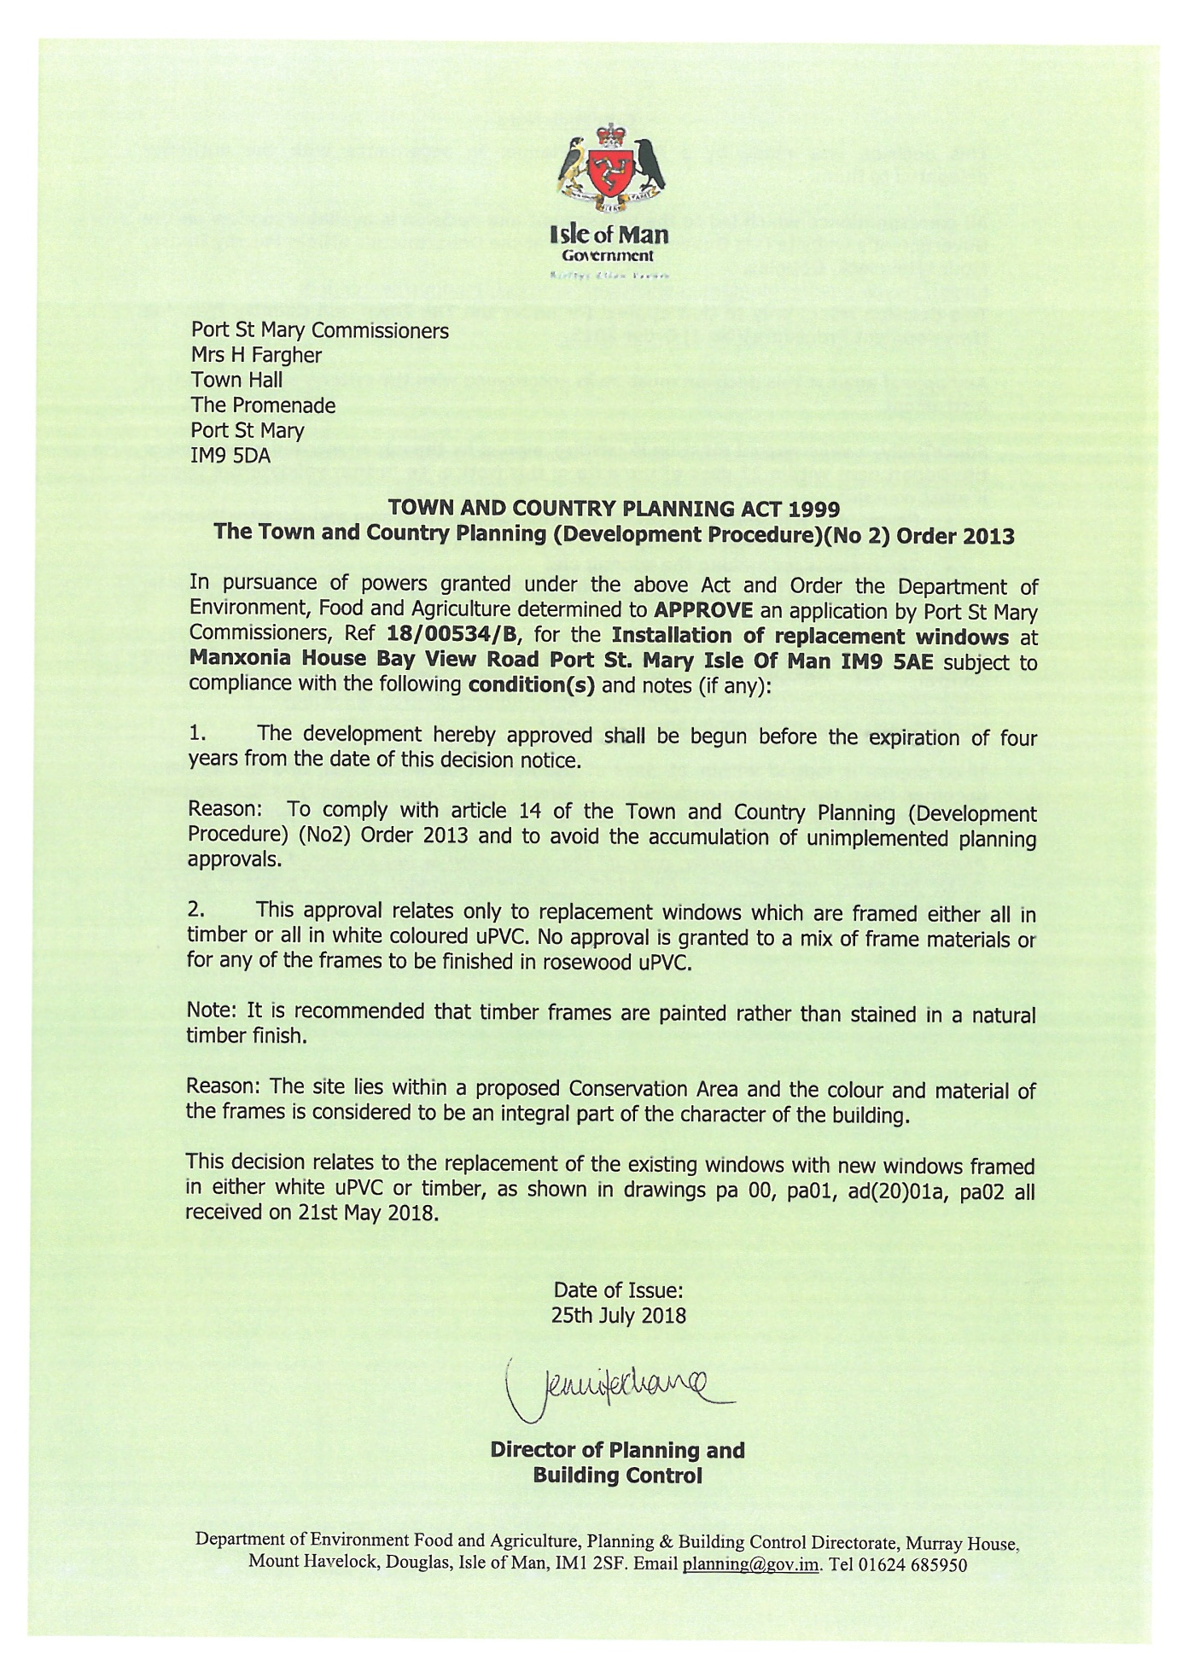

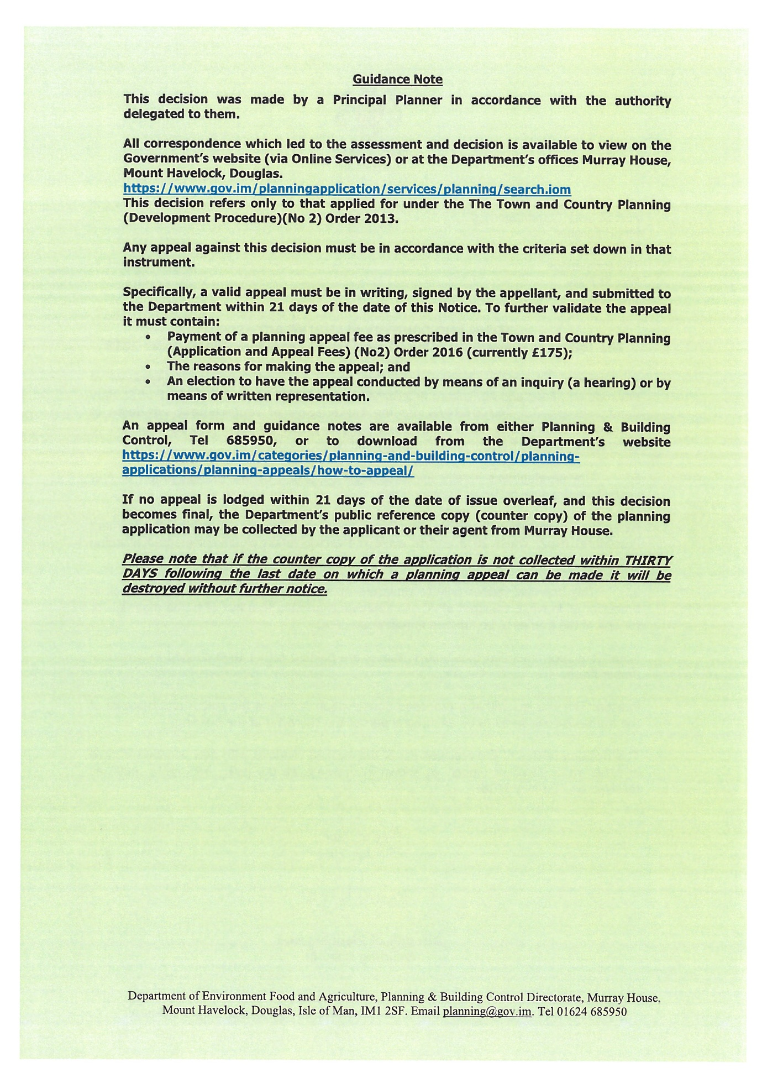

Item 6.5
PORT ST MARY COMMISSIONERS

PUBLIC CONVENIENCES

A representative of the Insurance Brokers undertook a site inspection of the West Room entrance with regards to opening the facilities to public use during office opening hours, the below feedback was received.

Entrance to Toilet Access

Door frame ledge at ground level presents a trip hazard – install warning signage

Access of Utility Room in Hallway

Access door to utility cupboard and cleaning product storage – install deadlock and have secured during periods of public access

Double Timber Town Hall Access Doors

Timber access doors between bathroom entrance and town hall facilities – install drop bolts to internal side of the access doors and ensure the doors is locked during periods of public access.

Permission is sought from the Board to carry out the above requirements and open the facility for use during office opening hours.

A meeting has been set with an architect to explore the possibility of gaining external access to the downstairs Town Hall toilets.

A further two Gellings Avenue valuations are awaited from Estate Agents, a report on the findings will be provided to the Board upon receipt.

Item 6.6
PORT ST MARY COMMISSIONERS

HIGHWAYS

The following feedback has been received by Highways in regards to the recent inspection carried out;

Hello Hayley,
I have finally been able to put together a short report based on our inspector’s information regarding the areas of maintenance we discussed.

• The road from the promenade to Gansey Point:
The sloping embankment supporting the road does not appear to be moving and looks in reasonable condition. The road however is in very poor condition so I conclude that the road itself has failed. Manx Utilities tankers and local authority bin wagons currently use this road and its condition is causing concern to the drivers. I have asked Bill Corlett (highway engineer) for a road reconstruction scheme to be designed and placed in our Capital Maintenance Programme as a matter of urgency.

• The bank below the remembrance garden & Primrose Terrace:
This is privately owned land and as such is not the responsibility of DOI. The land owner should be contacted to ensure that the area is maintained as safe.

• Steps from the top of Chapel Beach:
A works order (RO1600045) was issued for the repair of these steps, but this has been put on hold as Ports do not see a requirement for them for harbour access, as there is an alternative beach access close by.

• Steps from Primrose Terrace to the Shore Road. Willow Cottage Steps:
A works order (WMH1800127) for the repair of the hand rail has been issued

• Concrete columns and beams supporting the pavement at Bay View Road:
This is not in the ownership of the DOI and as such is not the Departments responsibility to maintain. However, having inspected the structure recently I believe that the Commissioners should have something done about its condition. The beams and columns are almost all showing signs of serious spalling of the concrete due to water ingress and expansion of the reinforcement through rusting. This is only going to get worse and it should be addressed before it becomes an unsafe structure. I recommend that Port St Mary Commissioners have a structural engineer undertake a full inspection and prepare a design for repair options to be implemented by a contractor as soon as possible.

• Catwalk railings. Chapel Bay Catwalk:
A works order (RO1600226) has been issued for the painting of these railings

• The jetties:
All piers and jetties within the harbour boundary are part of the inspection programme, and are inspected regularly. However, Ports have deemed that the two small jetties to the West (outside of the main harbour) are no longer of use to harbour users and do not see a need to maintain them.

• Kallow Point erosion:
A schedule of work has been drawn up to repair a number of areas of damage around Kallow Point including underpinning of voids, minor concrete works to walls and slipway, and reconstruction of steps. This will be sent out as one scheme to be undertaken in the 2019 – 2020 Capital Strategic Maintenance programme

I hope this is helpful to you,

Regards,

Graham Smith – Senior Asset Engineer

Permission is sought from the Board to instruct a structural engineer to provide a report on Happy Valley.

A number of additional areas causing concern which were visited have not been included on the report, an update on these areas has been requested and a response is awaited.

Item 6.8
PORT ST MARY COMMISSIONERS

PLAYGROUND – CLIFTON ROAD

The below report was last tabled in April. The Board requested to review the report along with the first quarter accounts to establish what further work could be carried out in line with available finances.

Areas with a medium risk have already been repaired.

The seesaw has not worked for a considerable period of time and some complaints have been received with regards to the black flooring marking clothes. While it is appreciated that funding is not available to replace the floor at this time, permission is requested to obtain quotations for budget referencing for the coming years.

Permission is sought from the Board to repair the seesaw at a cost of £820 and to obtain quotations to replace the flooring.

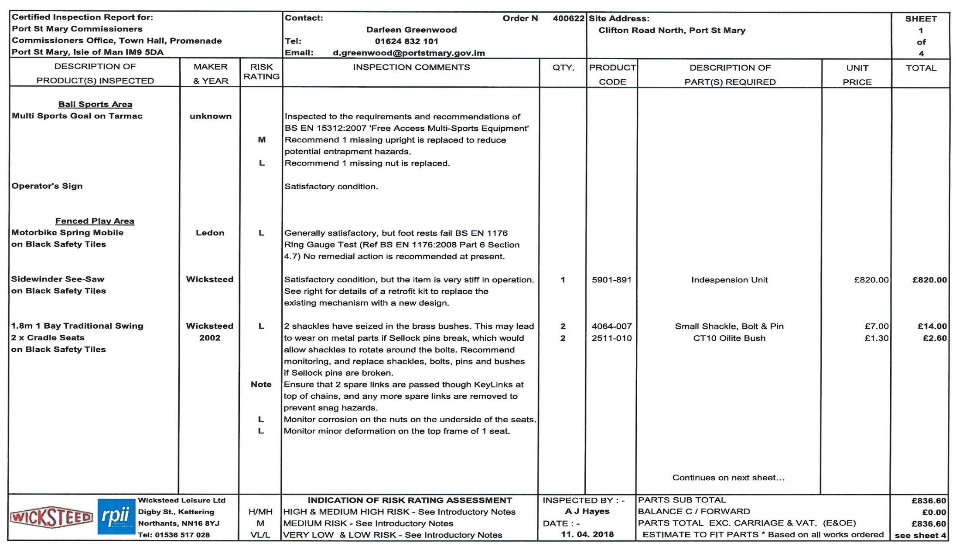
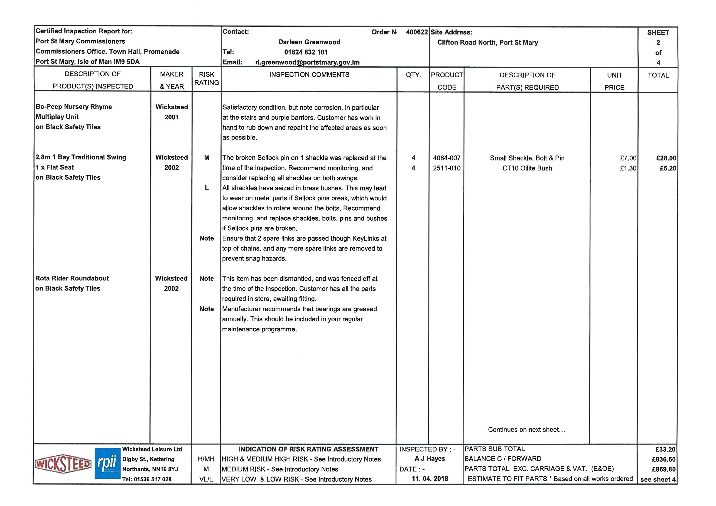

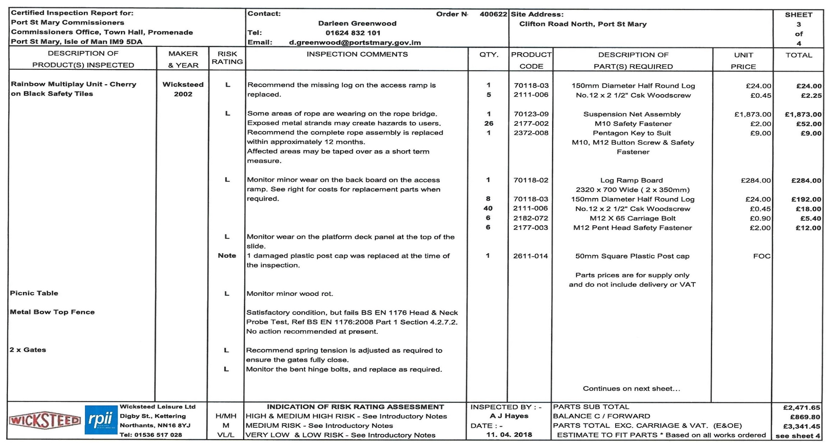

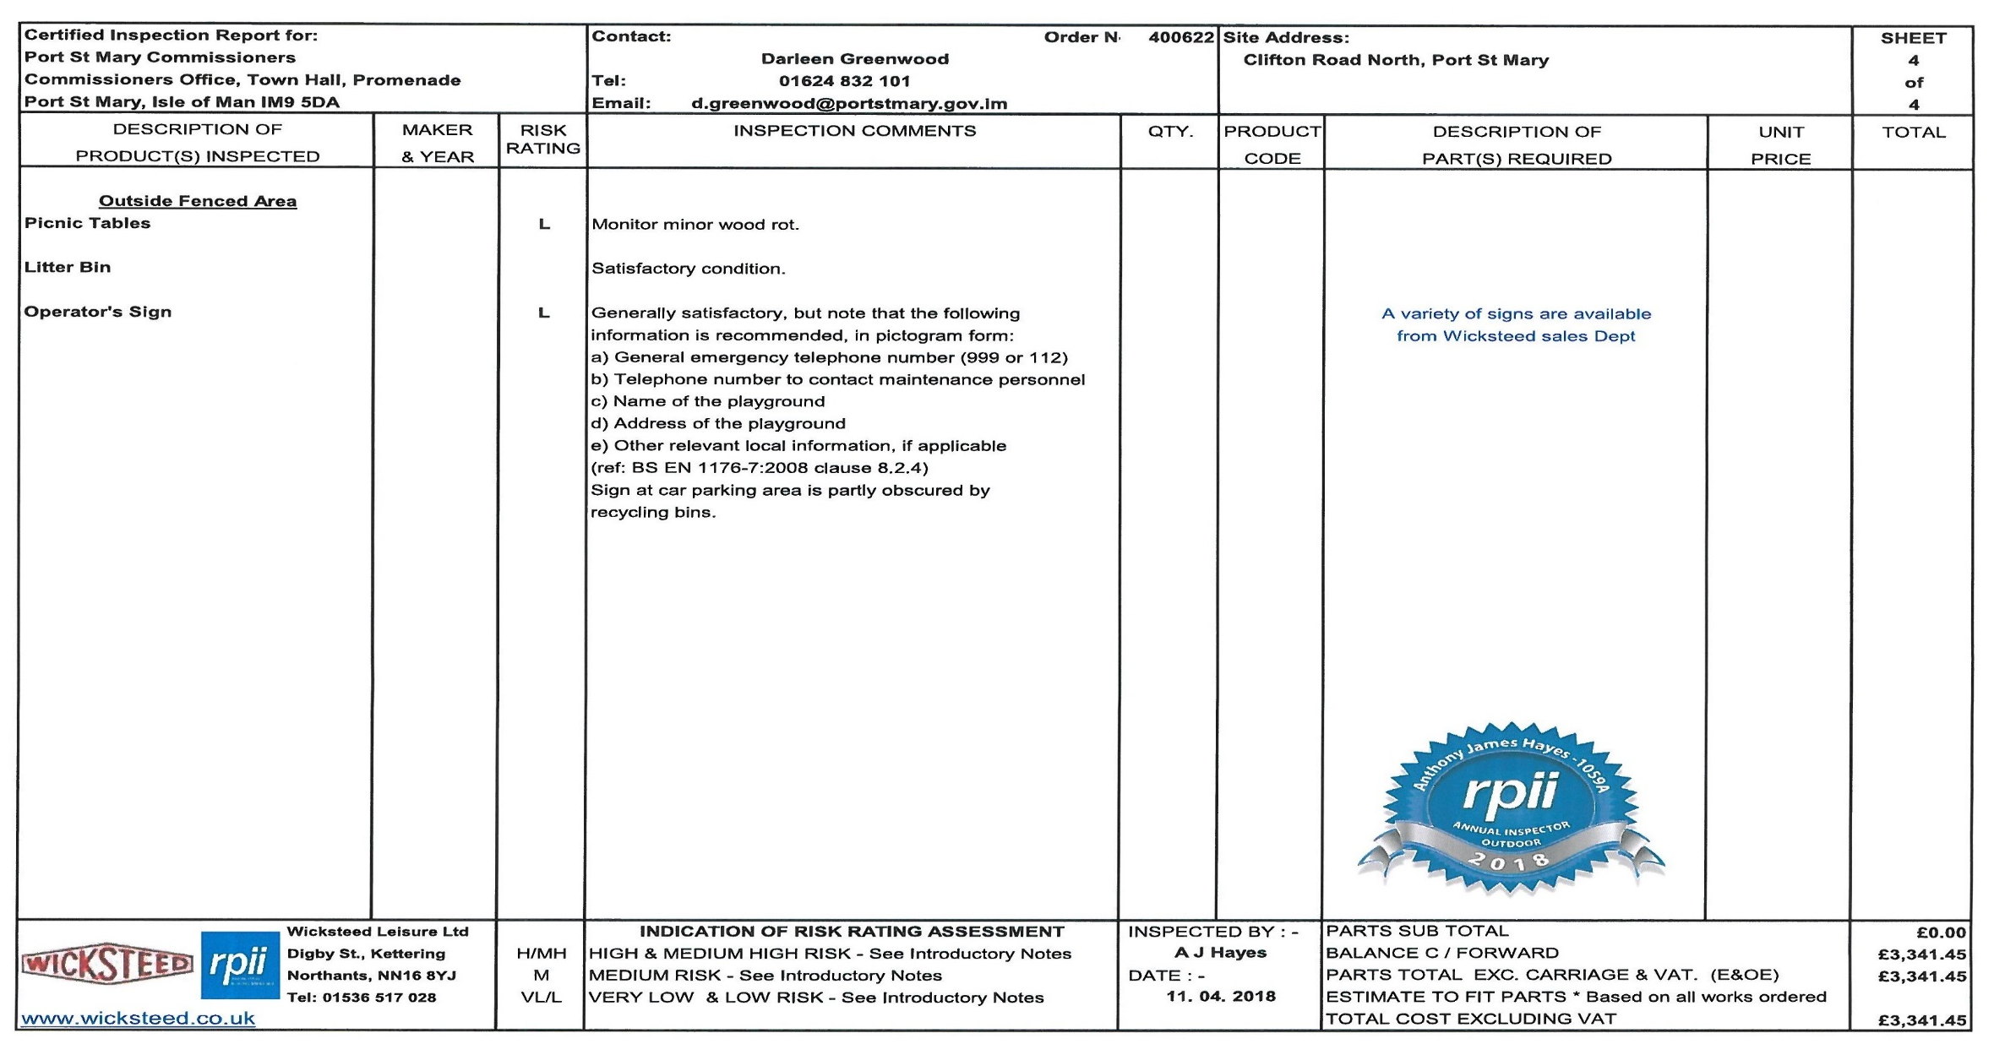

Item 7.1
PORT ST MARY COMMISSIONERS

PUBLIC CORRESPONDENCE

From: Andrew <beeman@iom.com>
Sent: 11 July 2018 12:15
To: Port St Mary Commissioners
Subject: <no subject>

FOR THE ATTENTION OF THE COMMISSIONERS ( for their meeting on 8th AUGUST, 2018)

I am contacting you in the interests of promoting within your boundaries more responsible dog ownership ( thus assisting both responsible dog owners and hopefully controlling irresponsible ones).

I attach a simple MAP of the roundabout area near Rushen Primary School/Southlands Care Home; I also attach two photographs, one of a dedicated green coloured dog litter bin, the other one of a red coloured dog glove/waste bag container, both of which are pole mounted.

You will see from within the details in the MAP I have highlighted a tall black street lamp and a metal five bar gate ( silver coloured) that I understand fall within your Commissioner’s boundaries. Through my prior approach around Easter this year to the management at Southlands Care Home, they kindly replaced the previous rusting metal five gate and cleared the general rubbish behind it (which from my assessment included bagged or unbagged dog foul/faeces) ; all that rubbish represented an eyesore to the community/visitors and equally importantly was environmentally unfriendly. I suspect that because in that immediate area there are limited dog friendly facilities of the types photographed , both dog litter and other rubbish will continue to accumulate behind that “ new “ five bar gate; that said Southlands have agreed to clear that rubbish away, from time to time.

To encourage dog owners to act responsibly going forward by not randomly disposing of dog foul/faeces in the specific area I have described, I’d be very grateful if both a dog litter bin and a dog glove /waste bag container( of similar types to those illustrated in the attached two respective photographs) could be please installed on the black painted street lamp pole, outlined on the attached MAP.

I very much look forward to hearing from you,

Yours faithfully,

Andrew Beeman

Andrew Beeman, FLIBF,C Dip AF, FCMI
5, Ballakilley Lane,
Port St Mary,
Rushen,
Isle of Man,
IM9 5NP

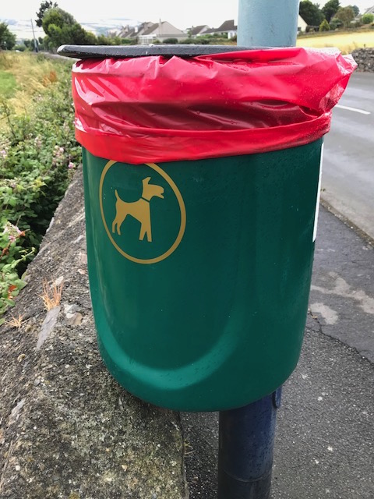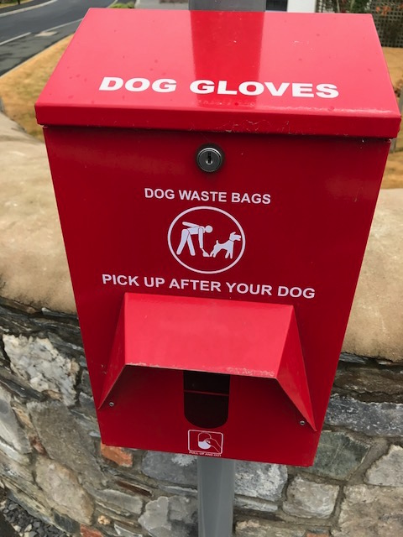

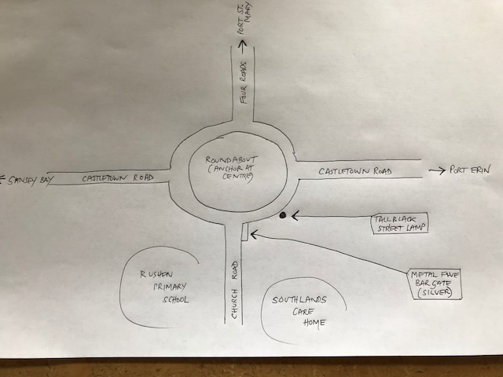

Item 7.2
PORT ST MARY COMMISSIONERS

PUBLIC CORRESPONDENCE

From: Geraldine hi <geraldinehi@hotmail.com>
Sent: 27 July 2018 16:57
To: Port St Mary Commissioners
Subject: Bin

Hi,

I wondered if it would be possible to put a bin next to the steps down to the beach at Gansey.
There is a large amount of dog poo bags left on the beach, usually next to the rocks or in drain pipes or next to the steps. The bin is near the mill and is nor always visible from the beach nor is it accessible without having to go off the beach and along the road. I thought this might help dog walkers keep the beach clean. With the problems with the plastic bag waste, plus the school holidays and children playing in the sandy area, i thought this would a good idea. Some signs alerting people to the dangers of dog waste might help too.

I do not have a dog but love to spend time on the beach, everyday there are at least three dog poo bags left there. I have removed loads over the years plus other rubbish and I think a visible bin near the steps where people exit the beach and can deposit their rubbish would help keep the beach clean and protect wild birds and sea creatures.

I look forward to your comments.

kind regards

Geraldine

Item 7.3
PORT ST MARY COMMISSIONERS

PUBLIC CORRESPONDENCE

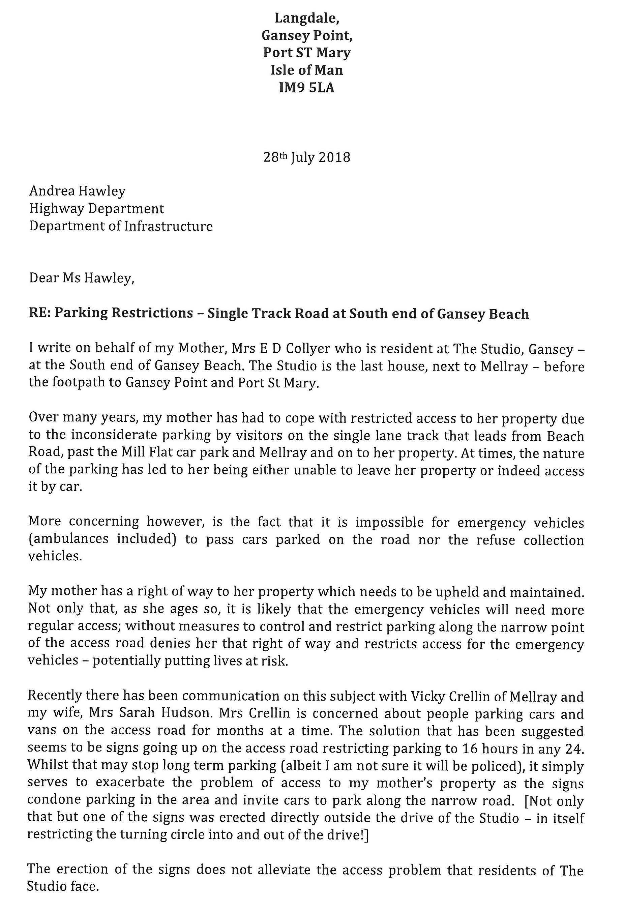

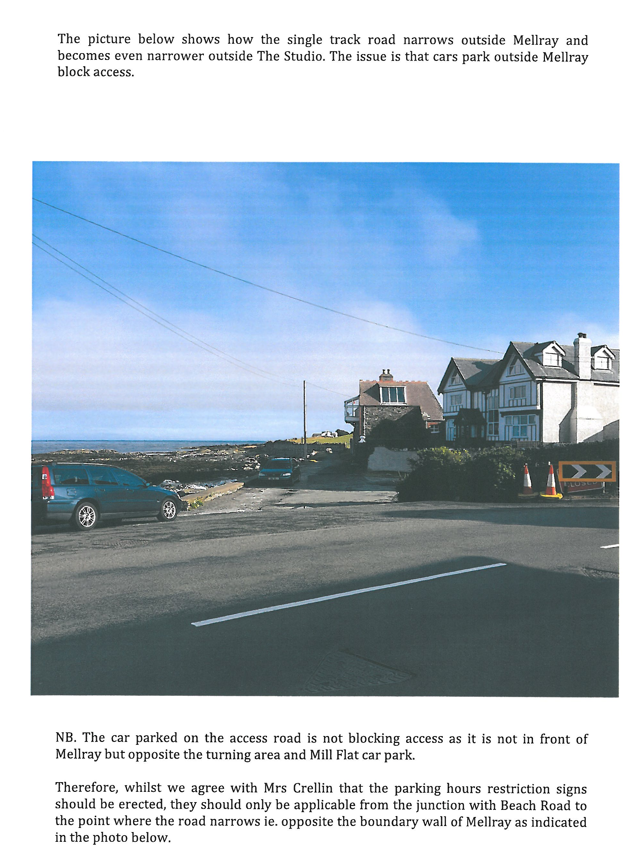

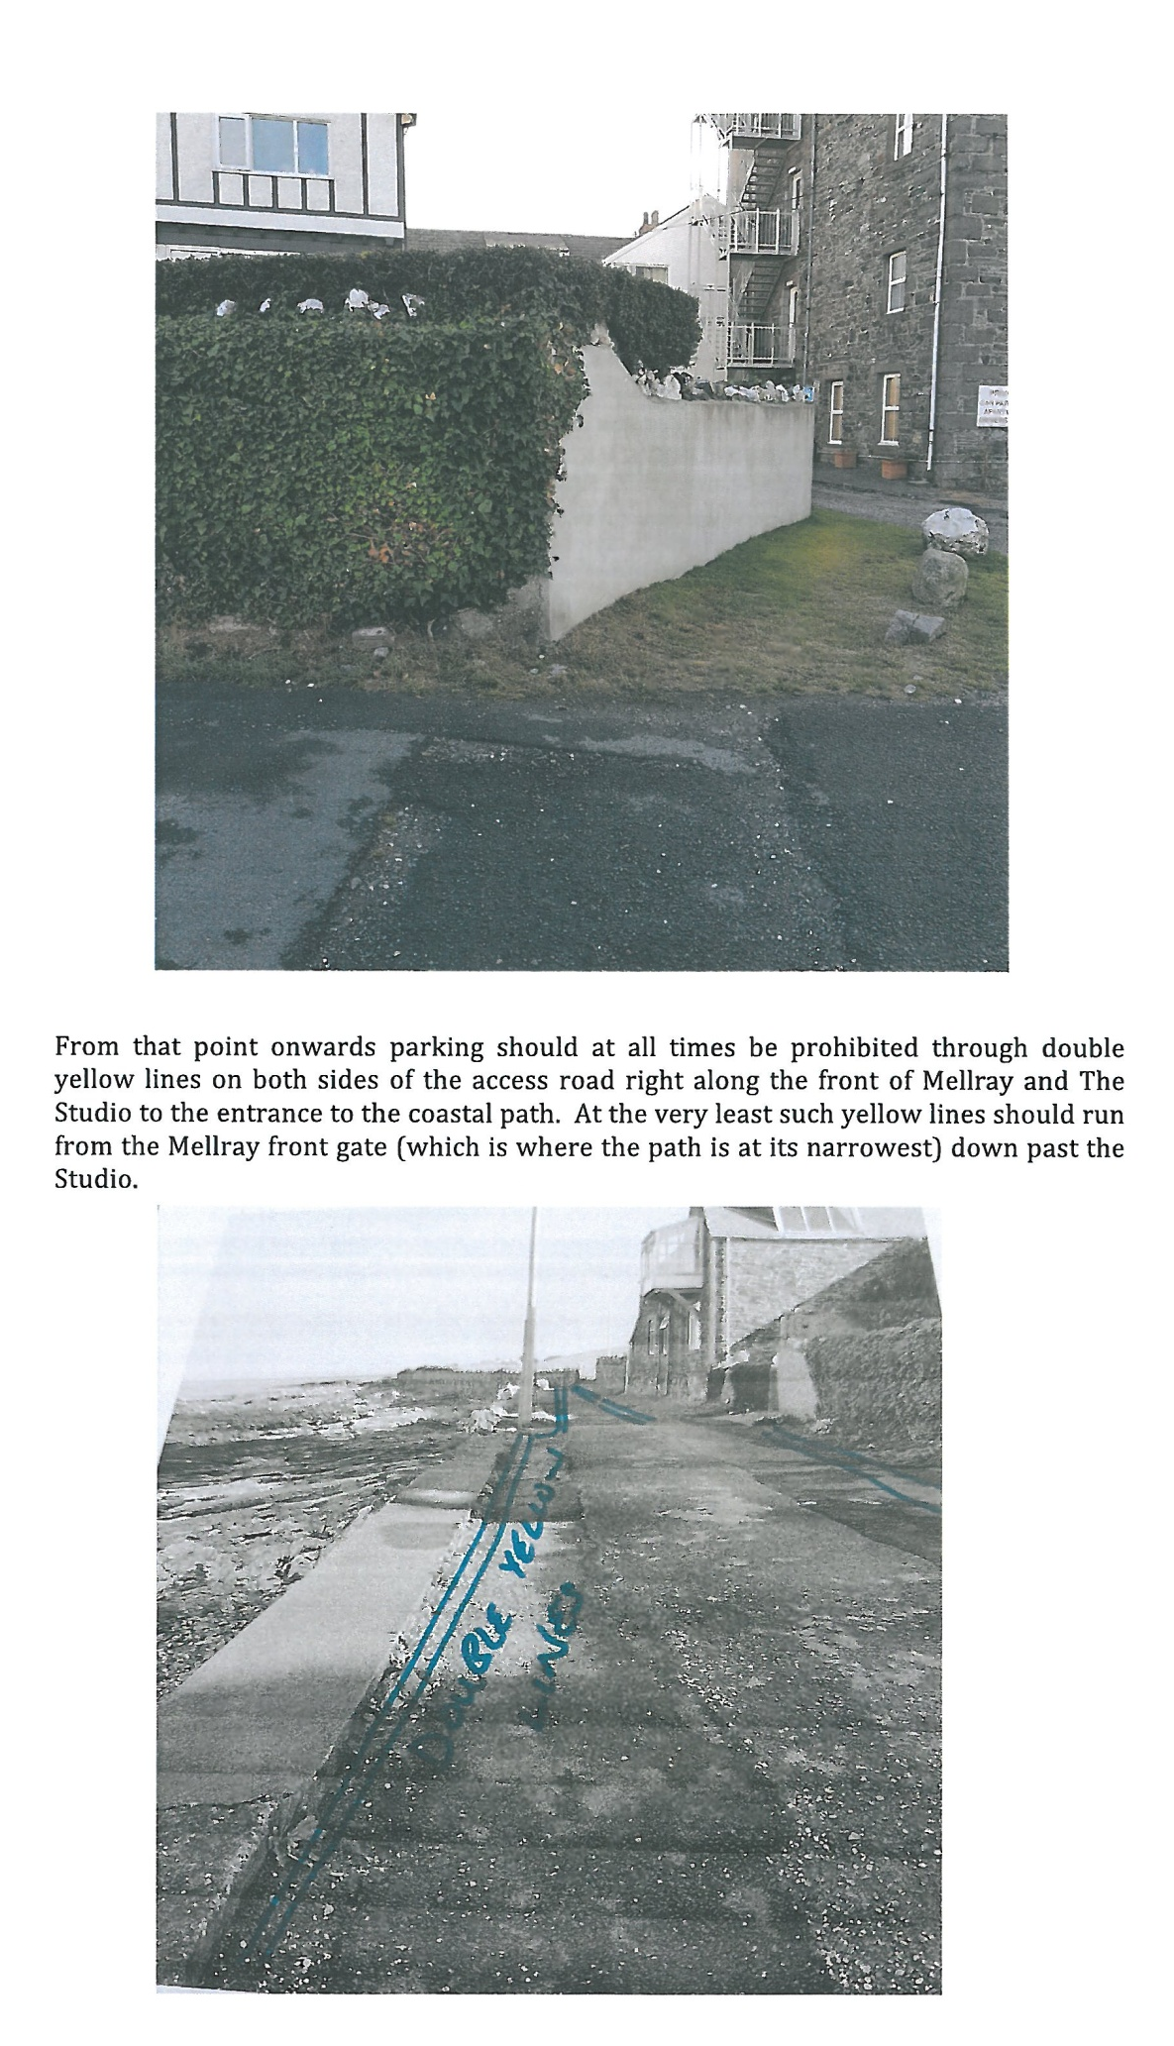

Item 7.4
PORT ST MARY COMMISSIONERS

PUBLIC CORRESPONDENCE

From: Jimmy Cubbon <jimmycubbon@gmail.com>
Sent: 18 July 2018 12:48
To: castletownclerk@gmail.com; barry.powell@malewcommissioners.im; clerk@arbory.gov.im; rushencommissioners@manx.net; j.roberts@porterin.gov.im; Port St Mary Commissioners
Subject: Southern local government survey results

Good afternoon, please see the attached survey results that I conducted in May 2018 in relation to local government and the provision of free recreational facilities in the south of the Island. I’ve sent in pdf and hopefully you should be able to interpret them okay but if not let me know and I’ll drop in some paper copies. The results are very interesting and I respectfully request that the Southern boards discuss the results in a public meeting. Can you please let me know when the discussion will be so that I can inform interested parties who reside in your areas. I appreciate that I am an Arbory resident so if you won’t discuss my request, please let me know and I’ll get one of your residents to write to you to request that the survey be discussed. This does not relate to any particular project, but what I view as a long term, joined up where necessary better south. Many thanks in advance, Jimmy Cubbon

Only the Port St Mary results are included within the pack, results for other Local Authorities can be requested from the Acting Clerk.

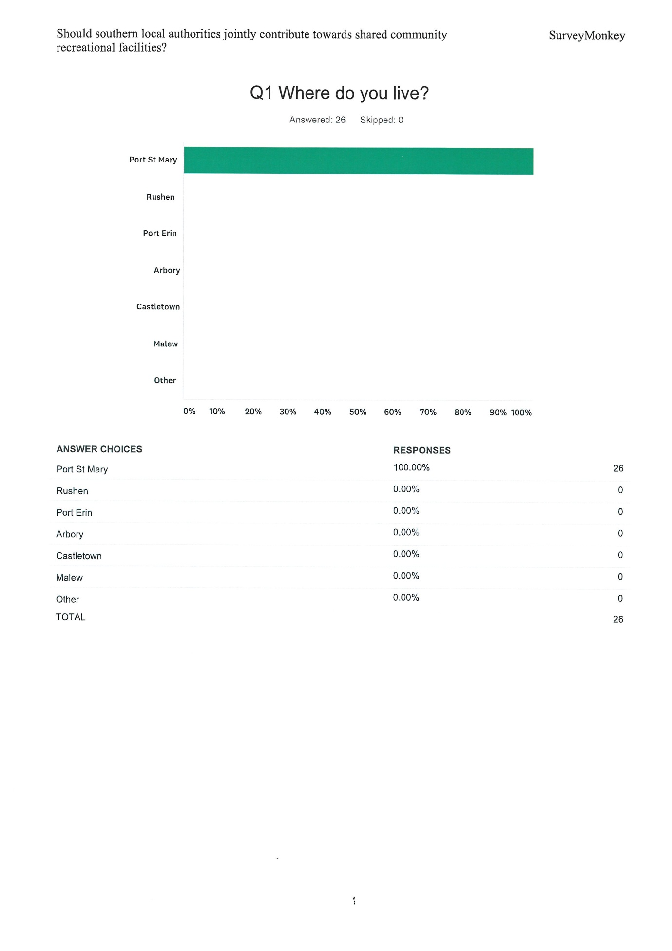

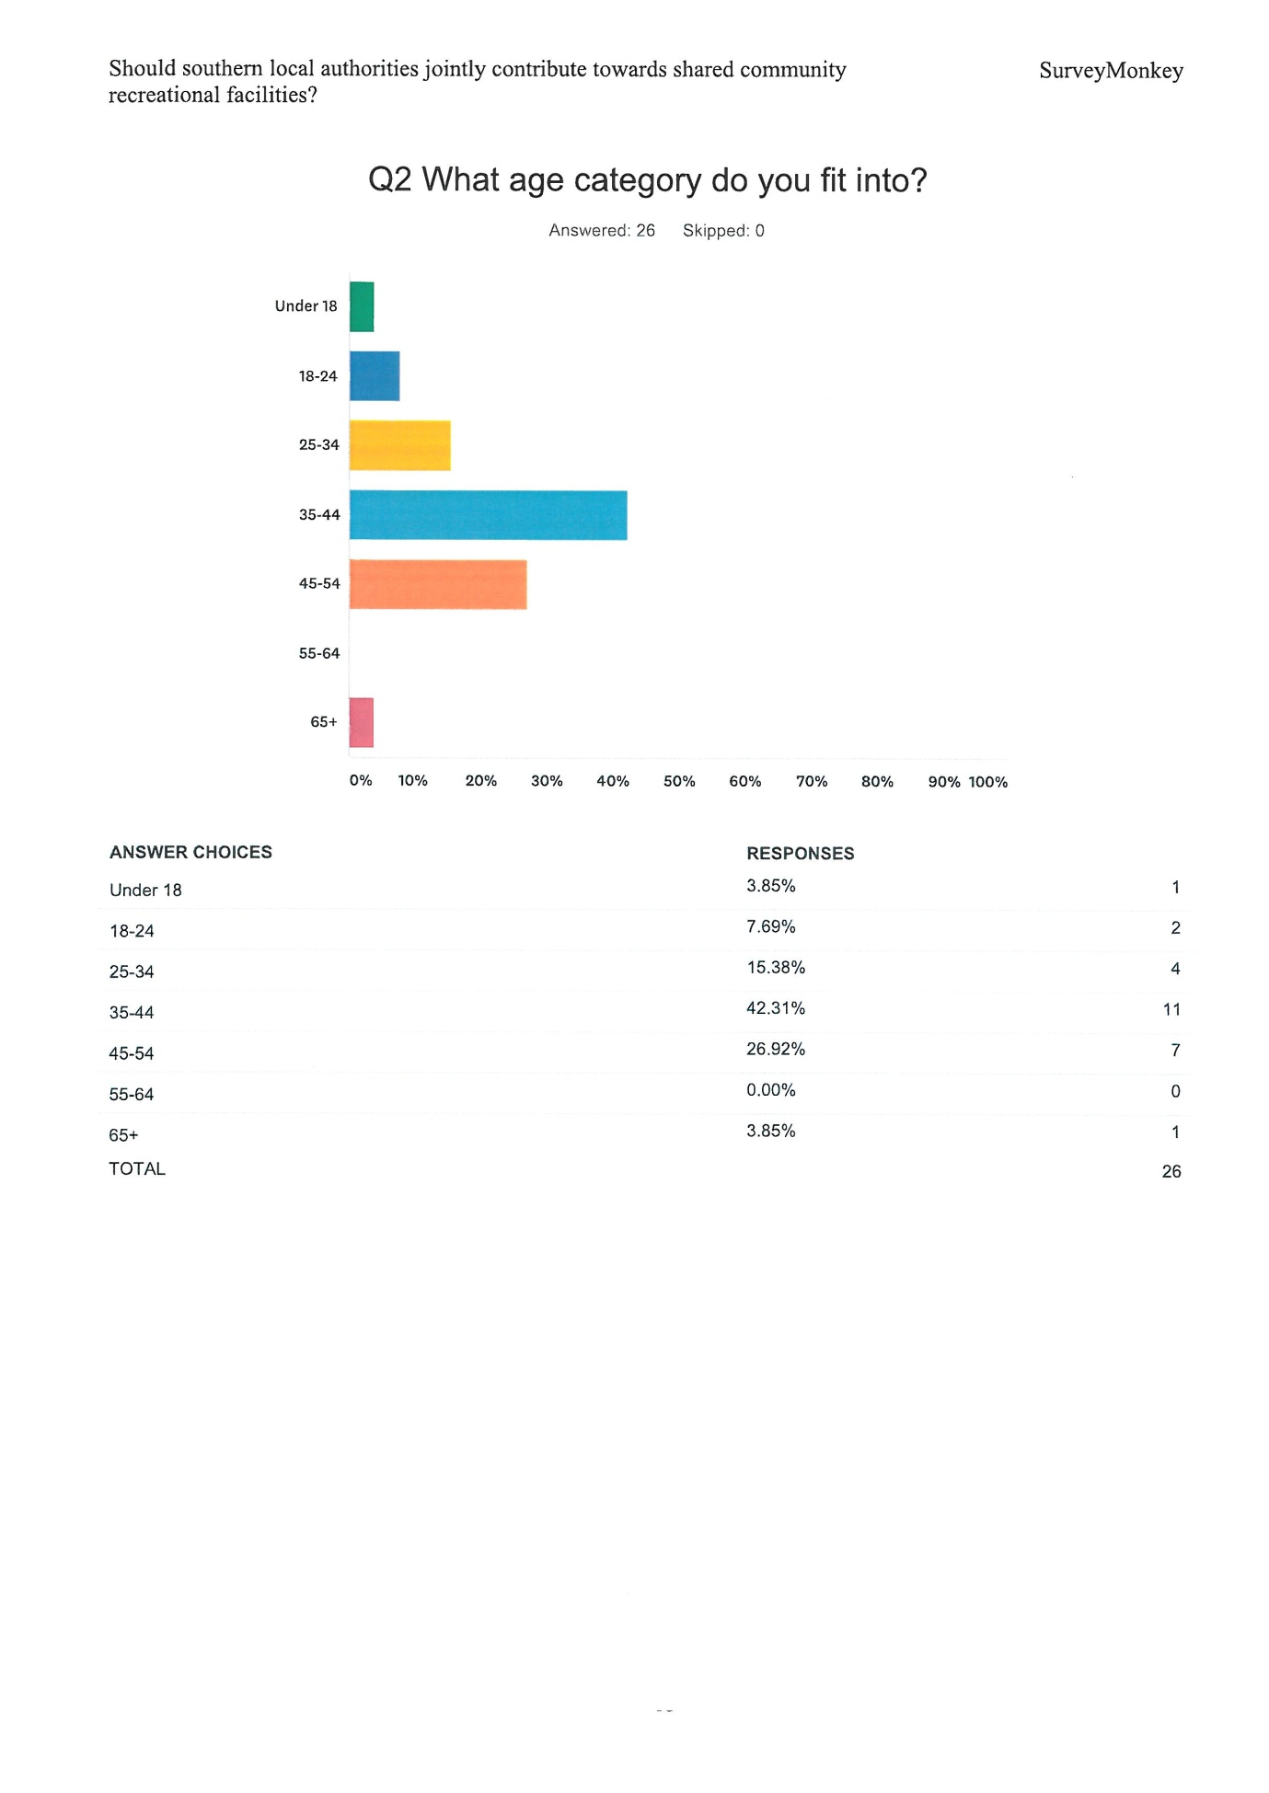

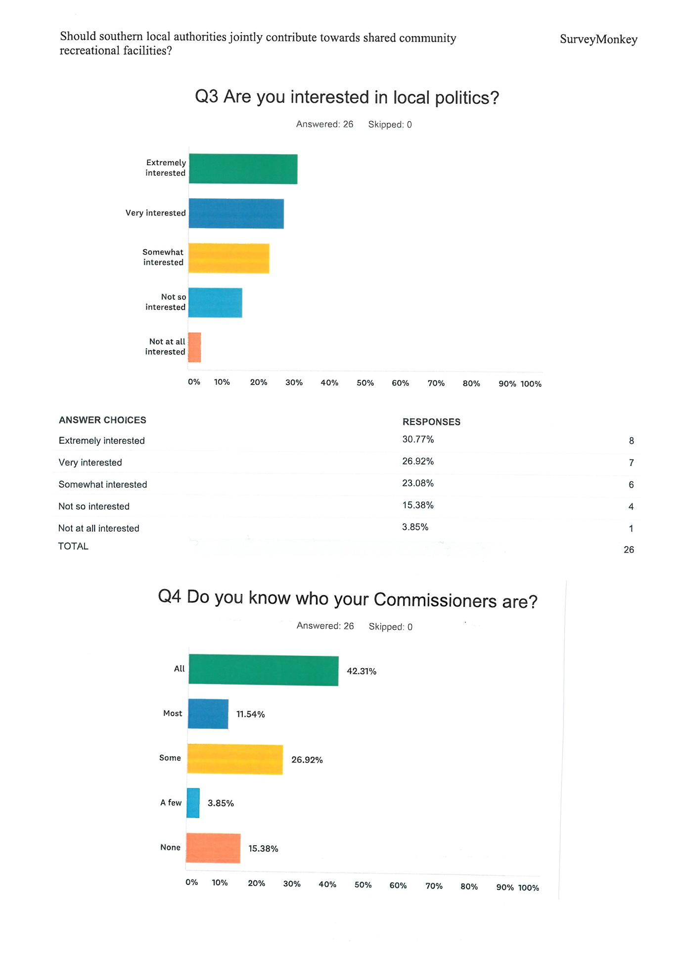

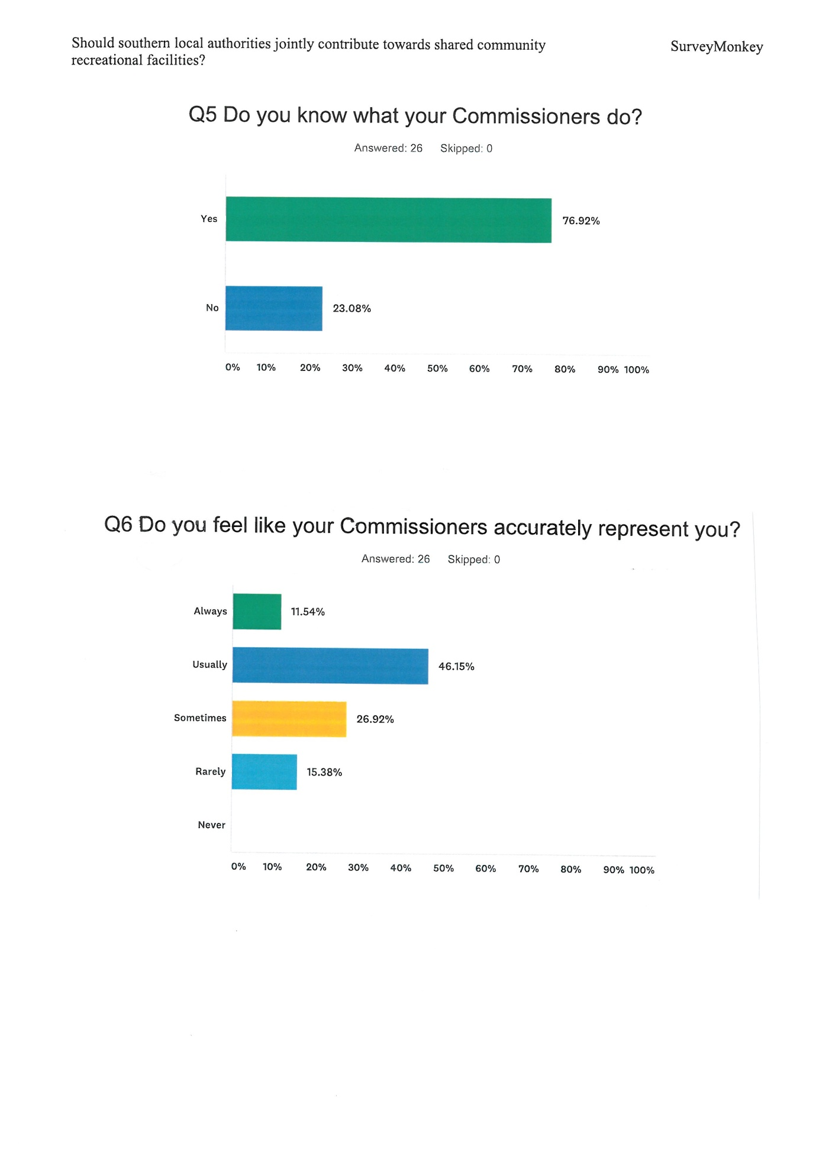

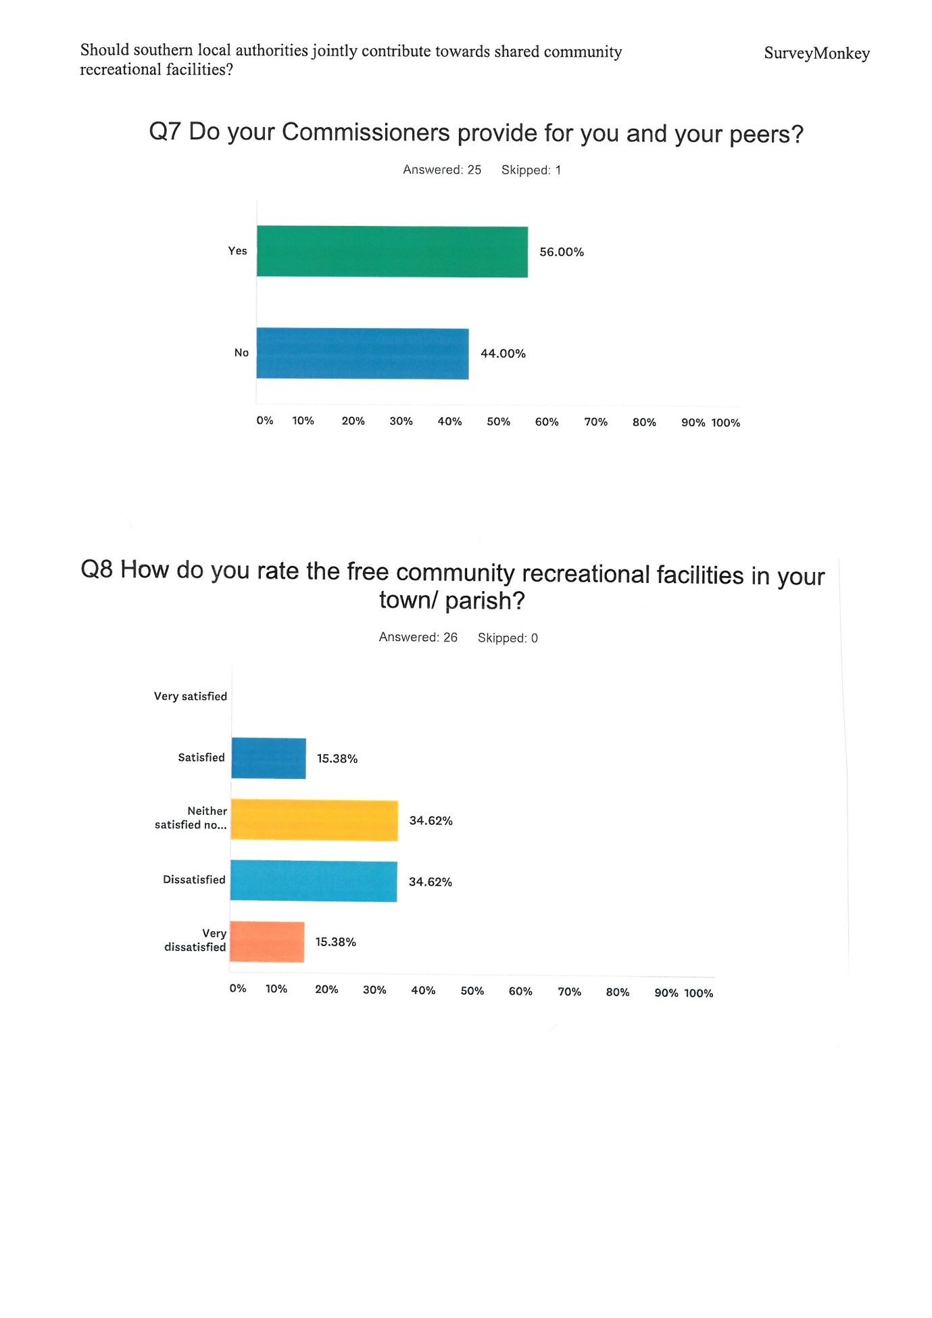

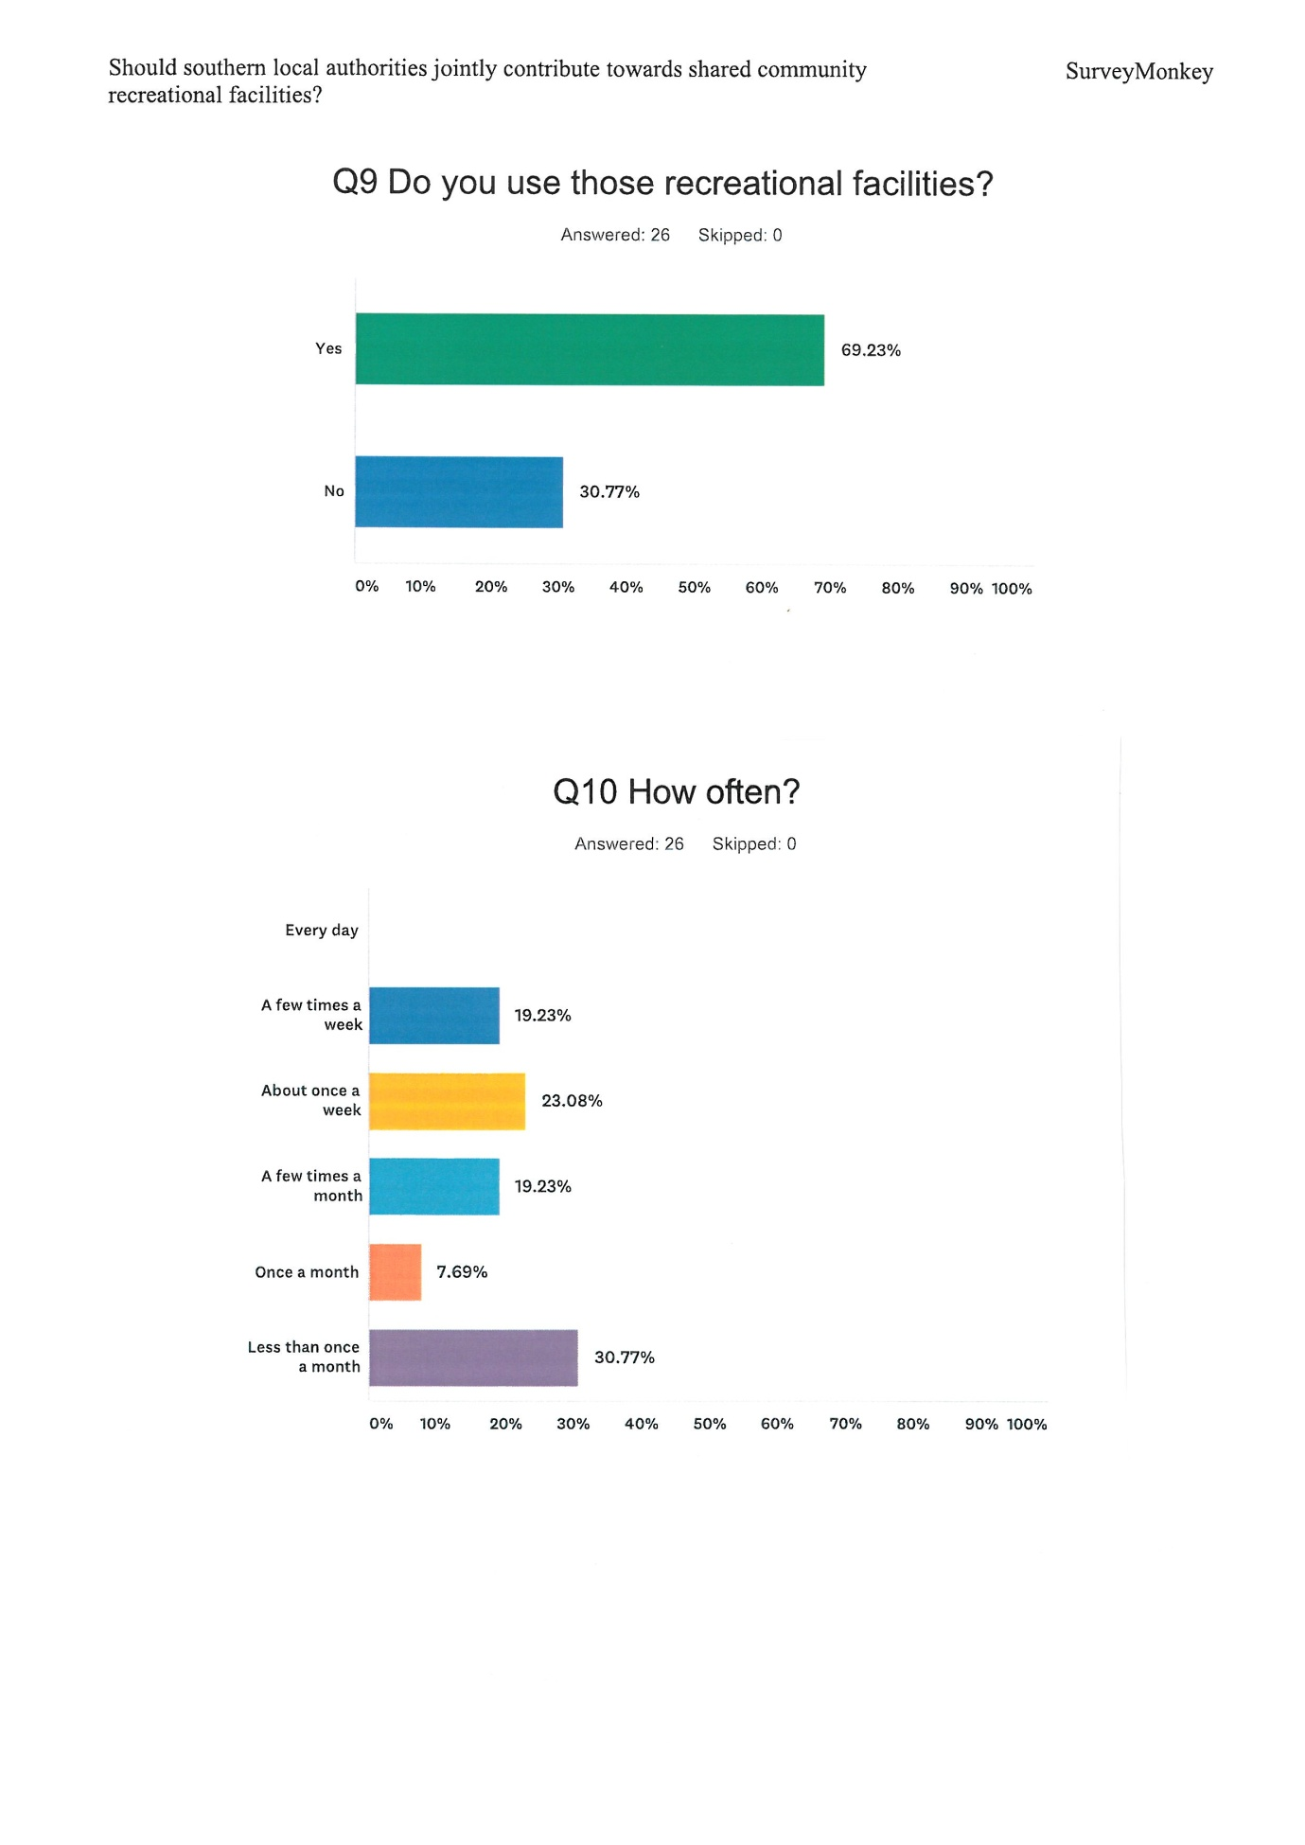

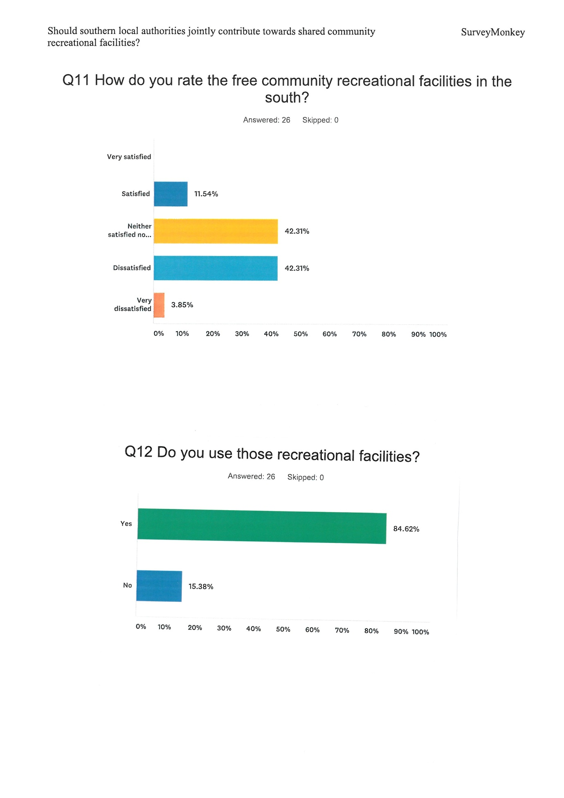

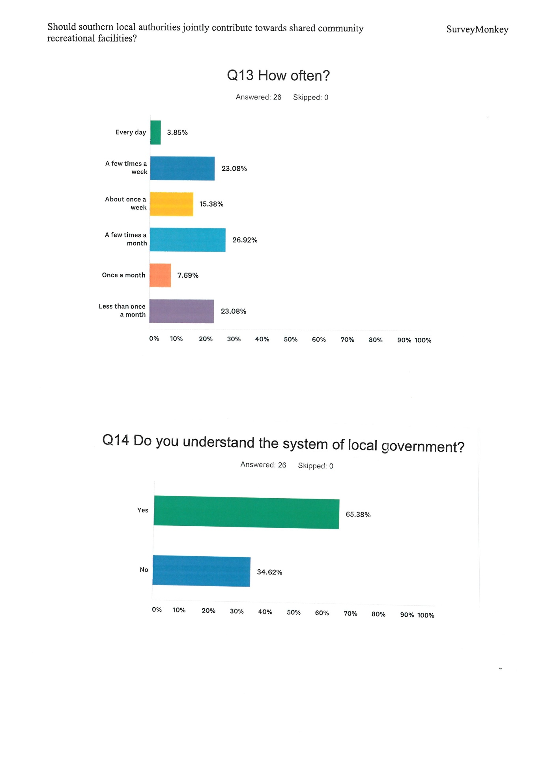

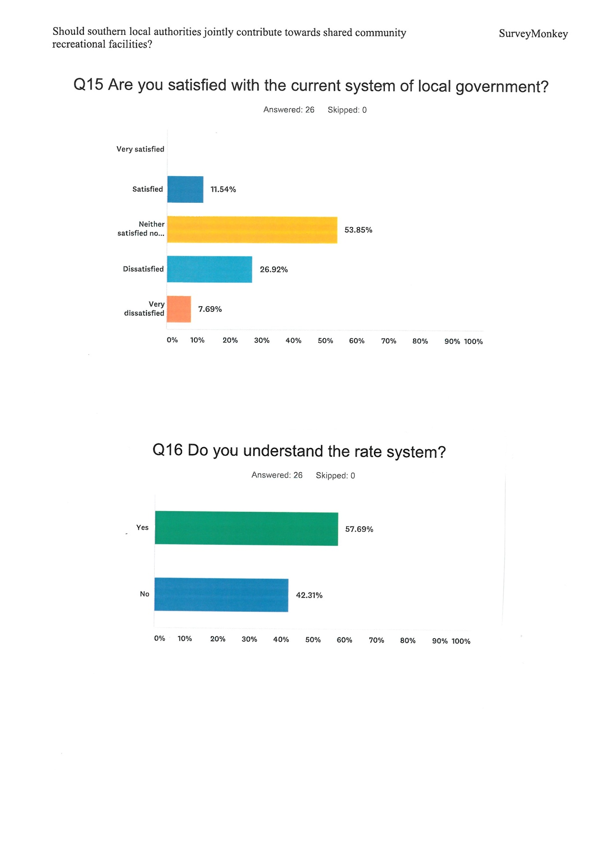

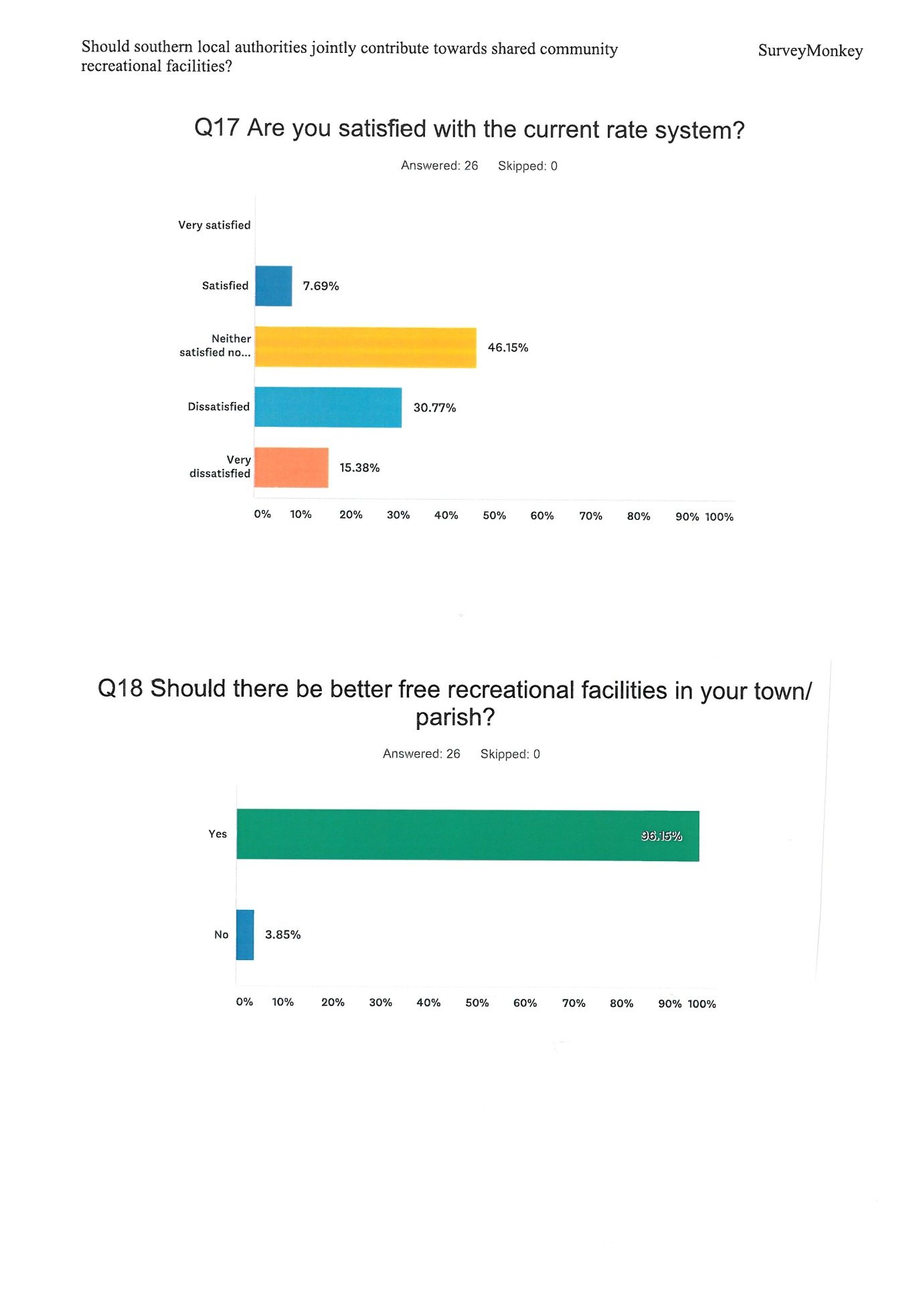

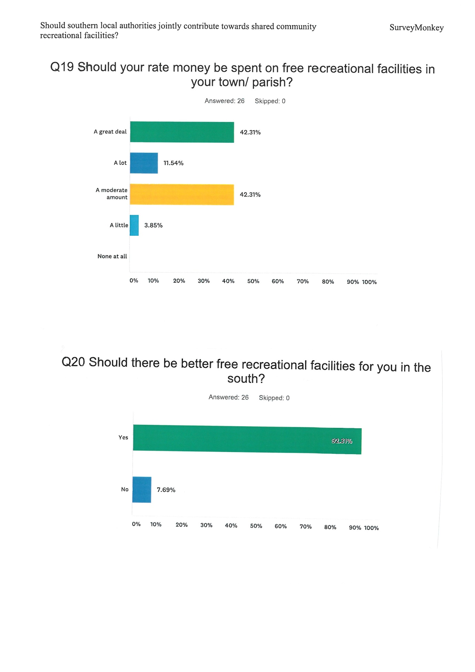

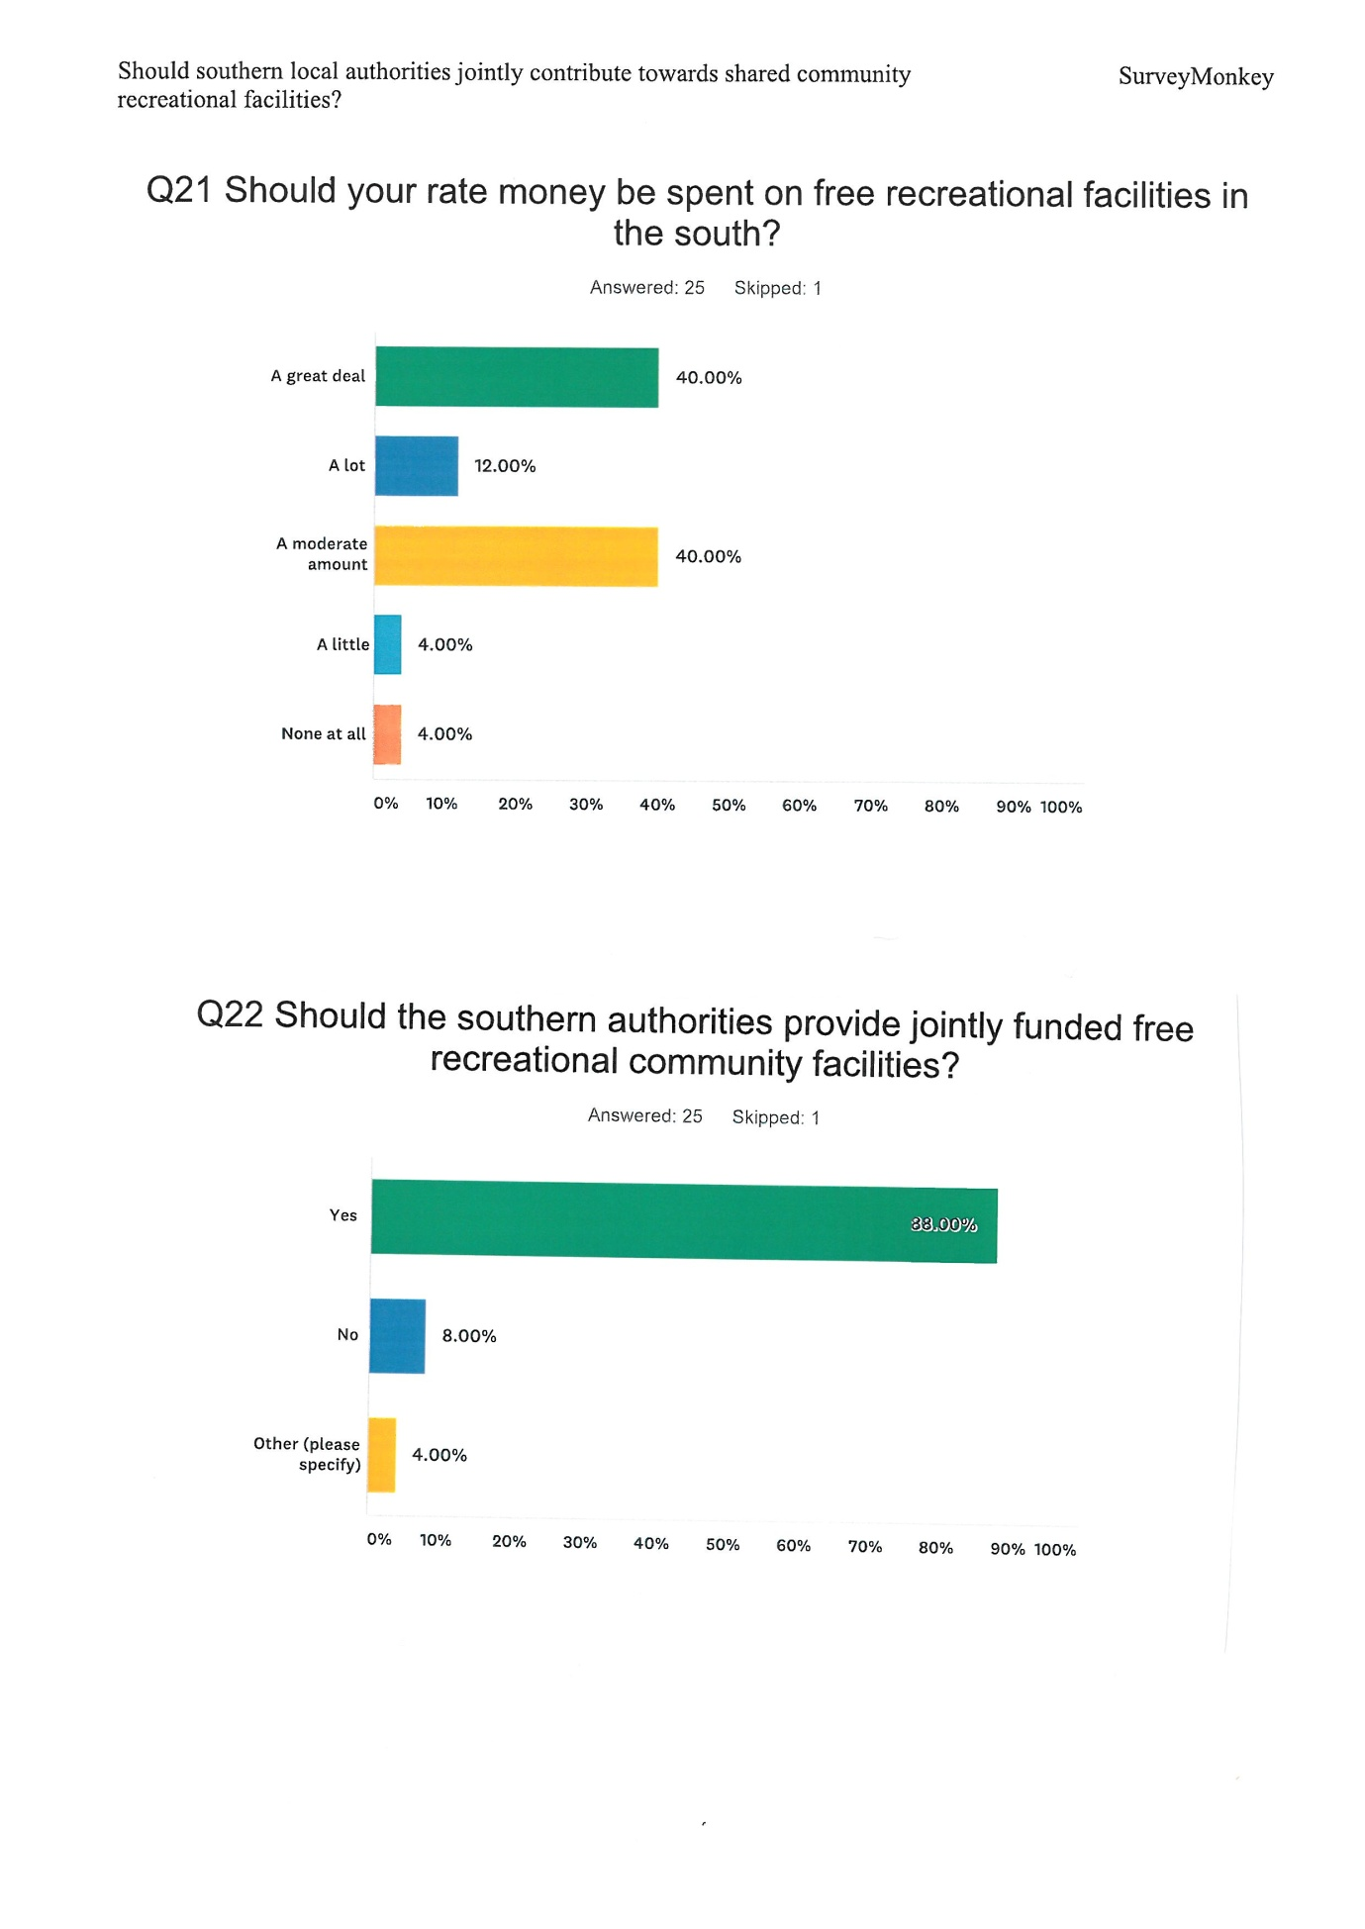

Q23 Any other comments?
- Swimming Pool already shared contributions. How could you justify spending PSM rates in Castletown!

- Port St Mary is distinctly poor in terms of facilities for young children.

- More skate parks because people of all ages use them.

- Facilities in the south could better be provided with a joint fund allowing better prices, co-ordination of developments, co-ordination of applications for government planning/land use approval. The south is small and therefore people from different parishes will use facilities from other parishes. Joint ownership would assist with maintenance and promotion. I believe in the long run a single southern set of commissioners would make more sense. Such as would be in a medium sized mainland town. More efficiency, less overheads and more consistently spent funds across the south. Some parishes have very low commercial income and therefore limited rate potential. Others seem to be more affluent from more rates and therefore able to spend more freely. Port st mary are really making effort now to increase the facility offering but it has been a battle rather than a proactive consideration from the commissioners to suggest it to the public.

- Invest in the future.

Item 7.5
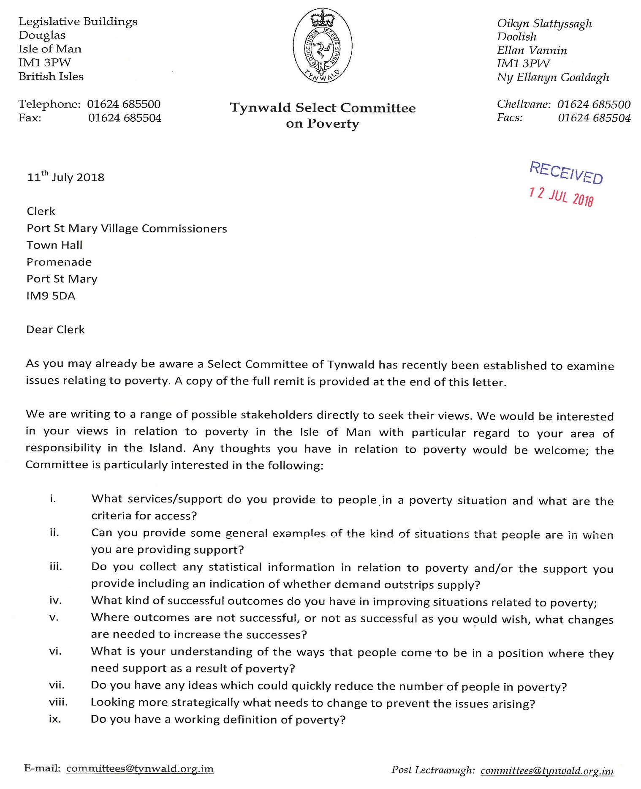
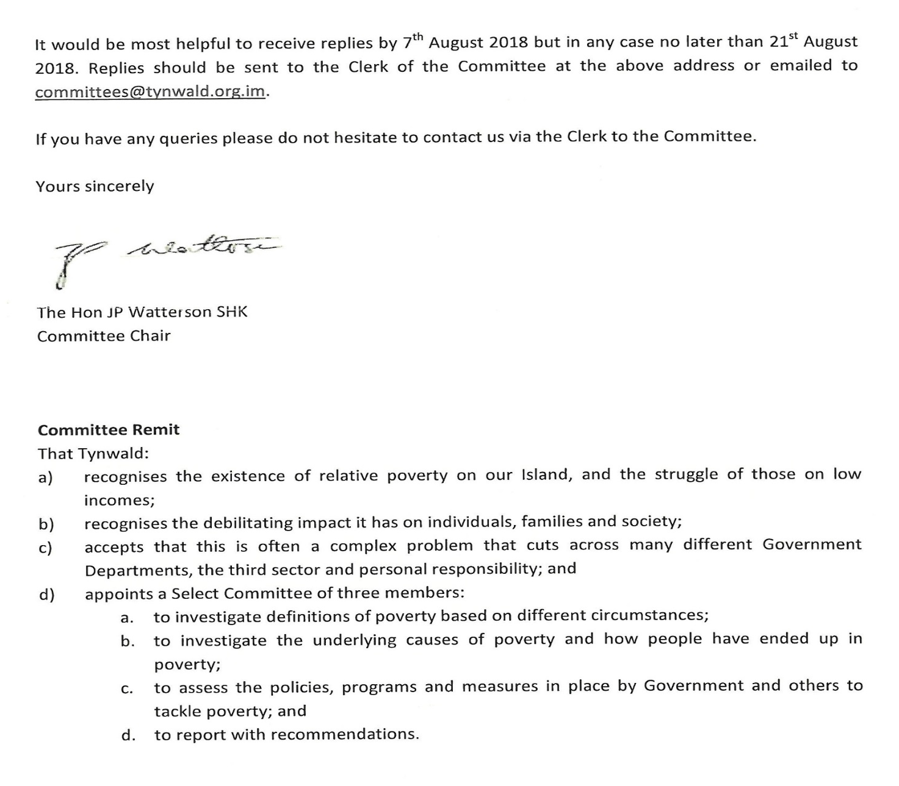
Item 7.6
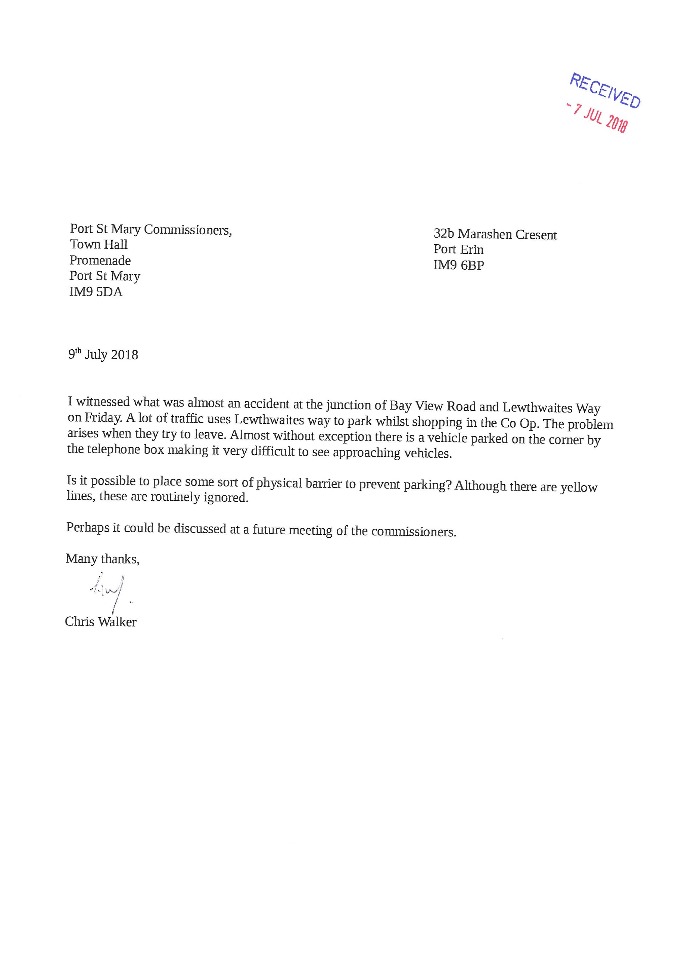

Item 7.7
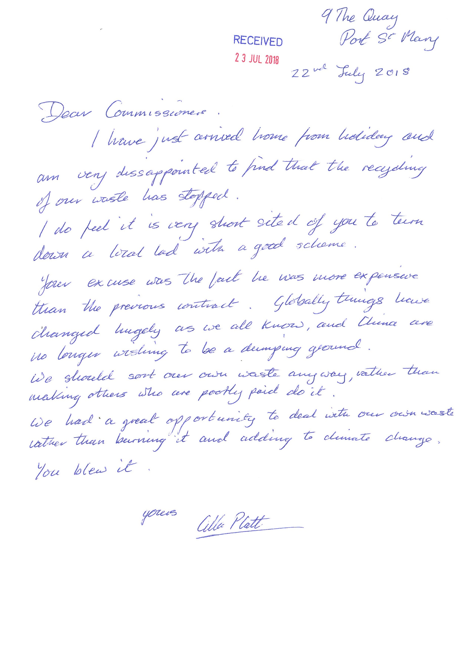
Item 7.8
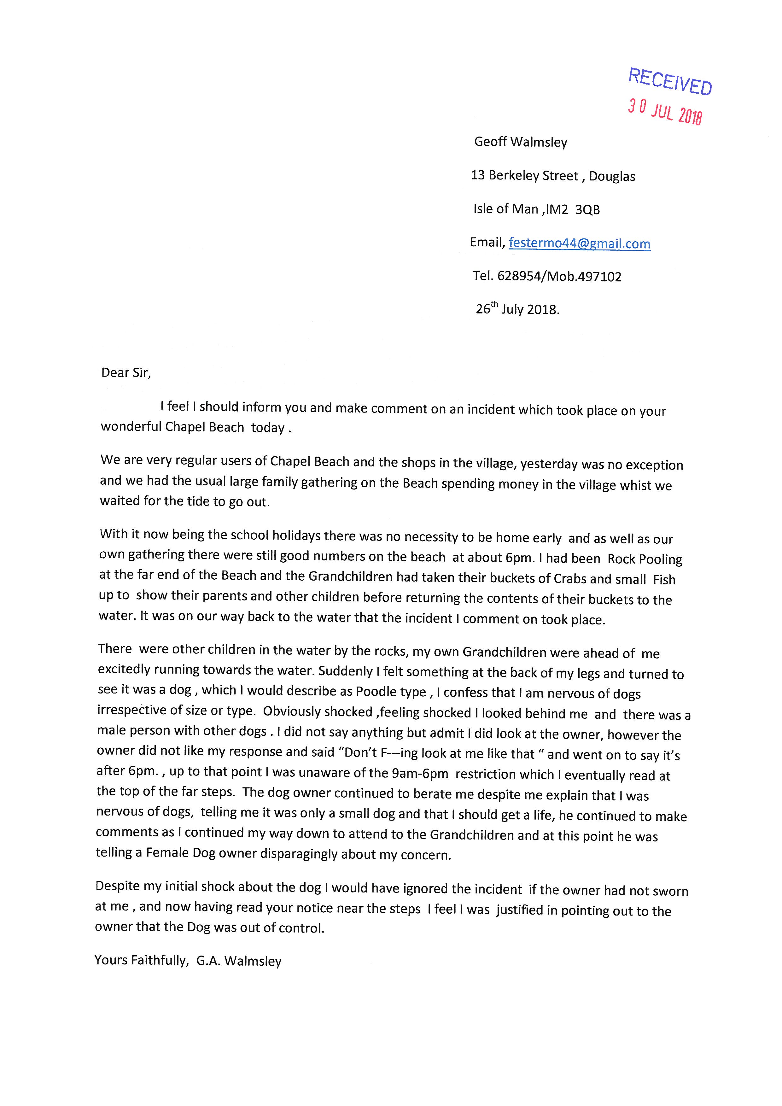

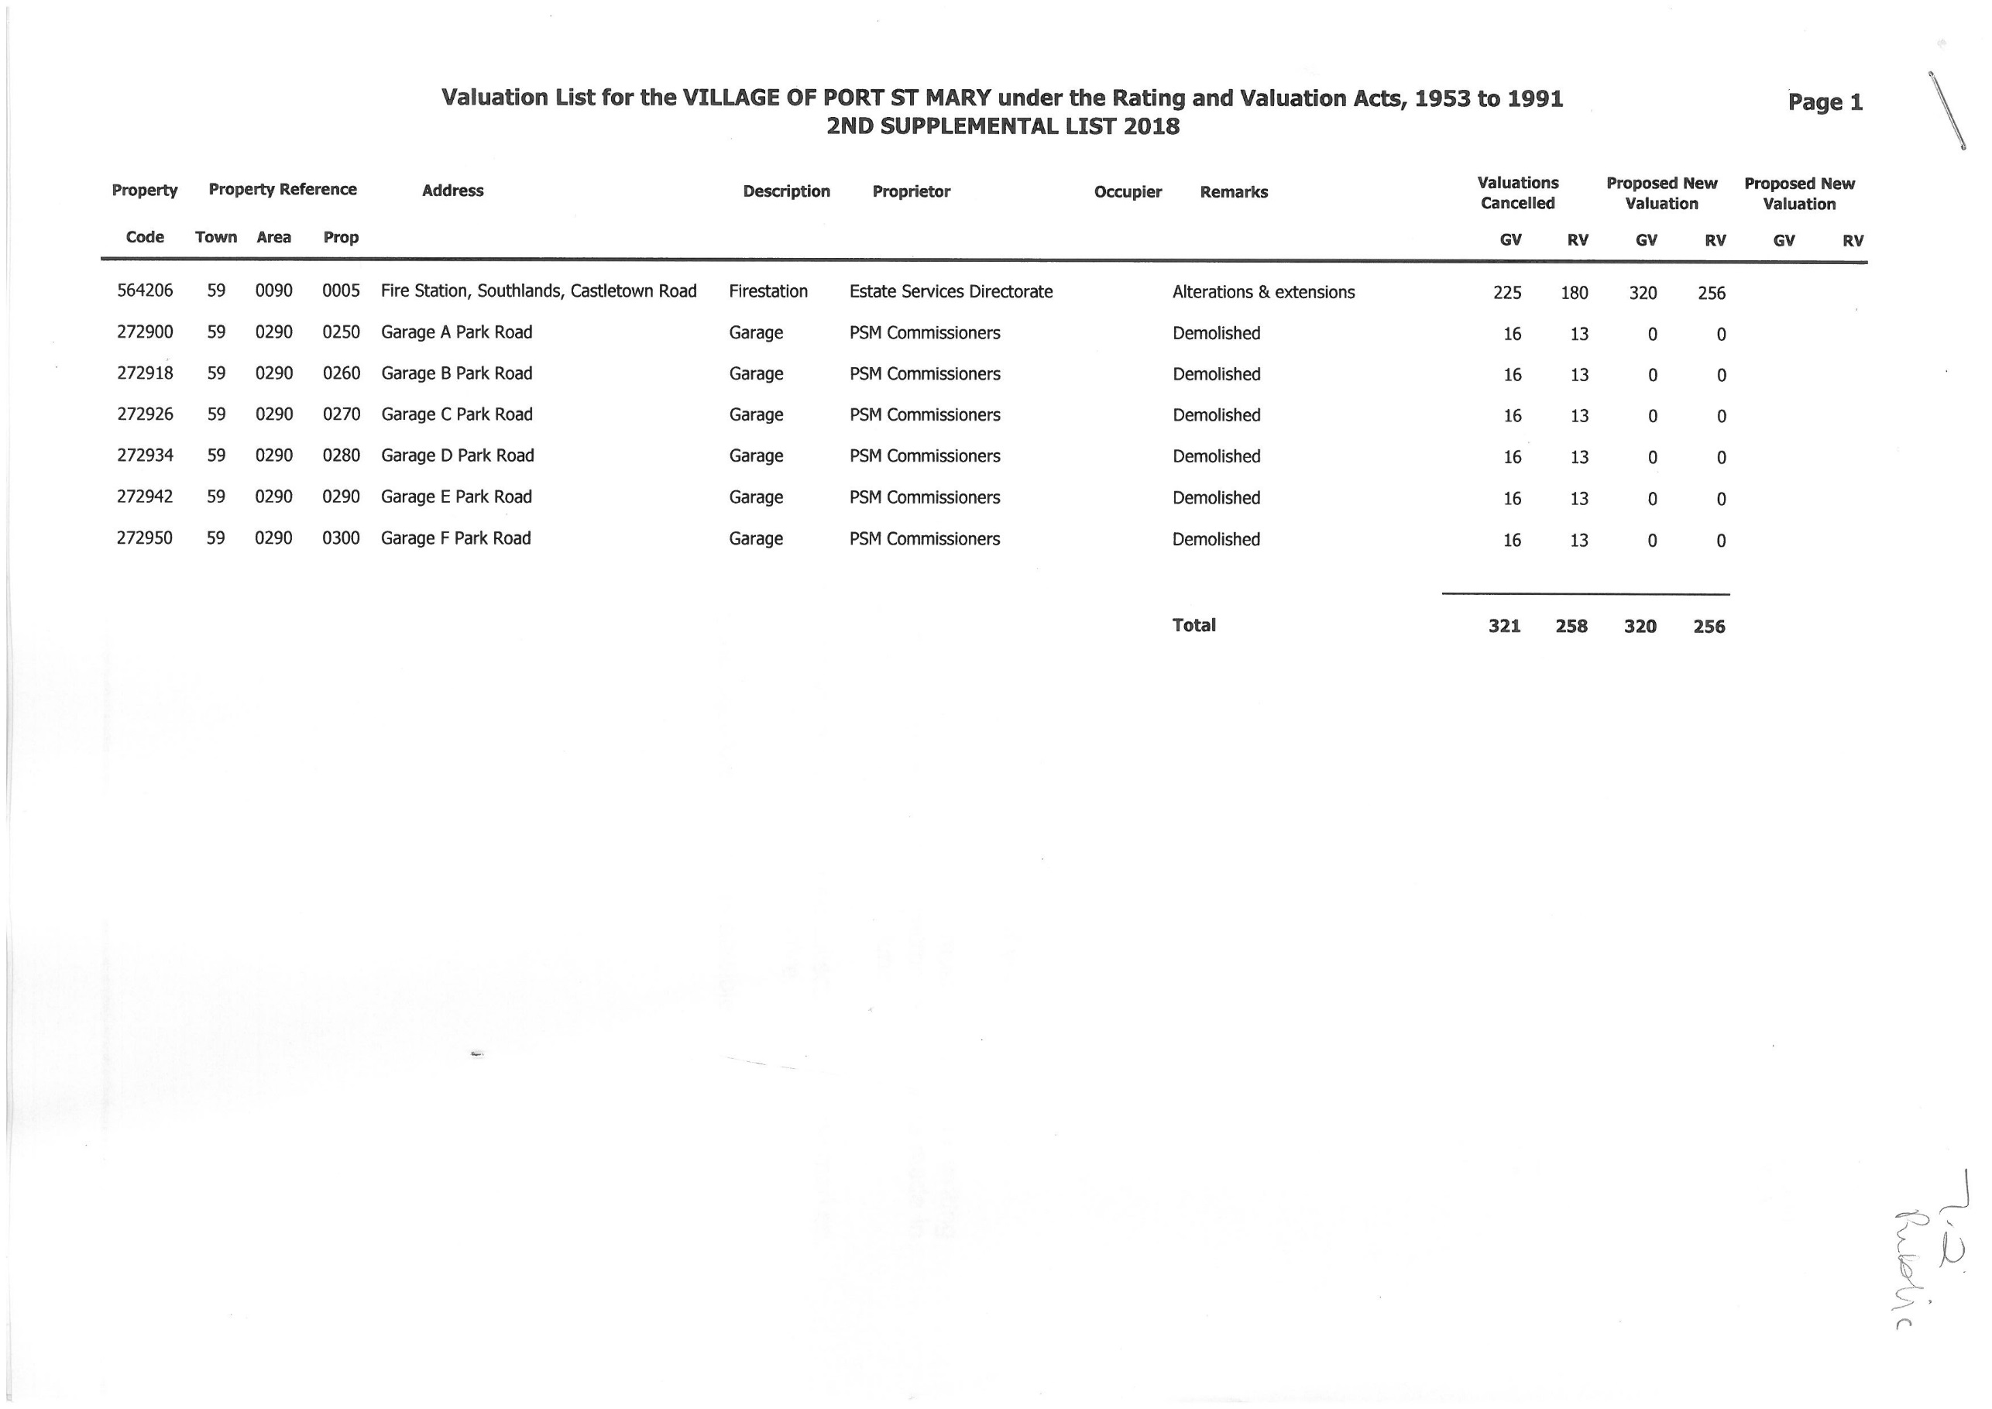
Items 9.1-9.4

PORT ST MARY COMMISSIONERS

PLANNING

9.1 Planning Applications

9.1.1 18/00688/C The Loft, rear of 2 Victoria Road, Port St Mary. Ms H Latham. Additional use of dwelling as self-catering tourist accommodation

9.1.2 18/00764/A Waitara, and site to north, Clifton Road, Port St Mary. Mr D Tomlinson. Approval in principal for the demolition of existing dwelling and construction of 3 detached dwellings with garages

9.1.3 18/00762/B Hillcliffe, Bay View Road, Port St Mary. Mr and Mrs D Price. Internal alterations to convert existing upholstery workshop and showroom into a self—contained apartment for permanent and/or tourist use

9.2 Planning Approvals
PA18/00534/B Manxonia House, Bay View Road, Port St Mary. Port St Mary Commissioners. Approval granted for installation of replacement windows. Please note this approval relates only to replacement windows which are framed either all in timber or all in white coloured uPVC. No approval is granted to a mix of frame materials or for any of the frames to be finished in rosewood uPVC.
PA18/00584/B 2 The Lhargan, Port St Mary. Mr A Derbyshire. Approval granted for rendering works (retrospective).
PA18/00503/B 16 Creggan Lea, Port St Mary. Mr and Mrs P Wiseman. Approval granted for alterations and erection of an extension.
PA17/00875/B Teen Kai, Clifton Road, Port St Mary. Mr and Mrs C Davies. Erection of a cat port and retrospective alterations to previously installed PA13/00589/B including variation of windows and doors and the installation of a flue.
9.3 Planning Refusals - None
9.4 Planning Appeals
PA18/00676/B 3 Lime Street, Port St Mary. Mrs M Rish. Amendment to confirm applicants preferred design.

Item 10.1
PORT ST MARY COMMISSIONERS

BYE ELECTION

The Local Government Unit has advised that it would not be wise to release the names of ratepayers who have requested the bye election.
The closing date for nomination papers is Friday, 3rd August 2018. The Acting Clerk will provide a verbal update with regards to if a bye election is required to be held at the meeting.
Should a bye election be required, the attached timeline will be adhered to. This has been agreed by the Local Government Unit.

Local Authority General Elections – Timetable 2018
DAY |  | DATE | TIME LIMITS
Tuesday |  | 17th July |  | 1
Wednesday |  | 18th July |  | 2
Thursday |  | 19th July | Local Authorities display election notices within district | 3
Friday |  | 20th July |  | 4
Saturday |  | 21st July |  | 5 | 14
Sunday |  | 22^{rnd} July |  | 6 | 13
Monday |  | 23rd July |  | 7 | 12
Tuesday |  | 24th July | Publish Notice of Election in press (Examiner) | 8 | 11
Wednesday |  | 25th July |  | 9 | 10
Thursday |  | 26th July |  | 10 | 9
Friday |  | 27th July | Publish Notice of Election in press (Courier) | 11 | 28 8
Saturday |  | 28th July |  | 12 | 27 7
Sunday |  | 29th July |  | 13 | 26 6
Monday |  | 30th July |  | 14 | 25 5
Tuesday |  | 31st July |  | 15 | 24 4
Wednesday |  | 1st August |  | 16 | 23 3
Thursday |  | 2nd August |  | 17 | 22 2
Friday |  | 3rd August | (Suggested) last date for delivery of nomination papers | 18 | 21 1
Saturday |  | 4th August |  | 19 | 20
Sunday |  | 5th August |  | 20 | 19
Monday |  | 6th August | Delivery of withdrawal of candidature/making objections (2pm) | 21 | 18
Tuesday |  | 7th August |  | 22 | 17
Wednesday |  | 8th August |  | 23 | 16
Thursday |  | 9th August |  | 24 | 15
Friday |  | 10th August | Last day for receipt of absent voter applications (off-IOM) | 25 | 14
Saturday |  | 11th August |  | 26 | 13
Sunday |  | 12th August |  | 27 | 12
Monday |  | 13th August |  | 28 | 11
Tuesday |  | 14th August | Last day for issue of Absent Voter ballot papers (off IOM)  Last date for receipt of Absent Voter applications (on-IOM) | 9 29 | 10
Wednesday |  | 15th August* |  | 30 | 9
Thursday |  | 16th August* | Last day for issue of absent voter ballot papers (on-IOM) | 31 | 8
Friday | 17th August |  |  | “ “  8 32 | 7
Saturday | 18th August |  |  |  | 6
Sunday |  | 19th August |  | 7 33 | 5
Monday |  | 20th August |  | 6 34 | 4
Tuesday |  | 21st August |  | 5 35 | 3
Wednesday |  | 22nd August |  | 4 36 | 2
Thursday |  | 23rd August* |  | 37 | 1
Friday |  | 24th August* | ELECTION – Polling Day – 8.00am to 8.00pm | 38
Saturday |  | 25th August |  | 3 39
Sunday |  | 26th August |  | 2 40
Monday |  | 27th August | Bank holiday | 1 41
Tuesday |  | 28th August | DEADLINE | 42

*‘Excluded days’ for calculation of Absent Voters Timetable
Highlighted dates indicate dates allowed for delivery of nomination papers under Rule 3 (not more than 28 and not less than 21 days before date fixed for poll.
_____________________________________________________________________________

The local elections timetable above has been calculated in accordance with Rule 3 of the Local Election Rules 2003 (“the Local Election Rules”)
Note that Regulation 5 and 13 of the Local Election (Absent Voters) Regulations 2008 sets out the closing dates, both on and off-Island, for the receipt of applications to be treated as an absent voter, and the issuing of absent voter’s ballot papers.
Rule 4 and Regulation 5(2) sets out legislation surrounding the computation of time.

Item 10.2
PORT ST MARY COMMISSIONERS

MEETING DATES 2018/19

Below is a list of scheduled meeting dates for the coming financial year along with holiday dates booked for the Acting Clerk.

2018/19 Meeting Dates
13th June 2018 | Public Forum from 7pm
27th June 2018 | Ian Begley attending at 7pm
11th July 2018 | Internal Auditors attending 7pm
25th July 2018 | Urgent business only if required
8th August 2018 | Public Forum from 7pm
22nd August 2018 | Local Democracy Reporter attending 7pm
12th September 2018
26th September 2018
10th October 2018 | Public Forum from 7pm
24th October 2018
14th November 2018
28th November 2018
12th December 2018 | Public Forum from 7pm
9th January 2019
23rd January 2019
13th February 2019 | Public Forum from 7pm
27th February 2019
13th March 2019
27th March 2019

The Acting Clerk has the following annual leave booked; 19/7/18 – 30/7/18
29/10/18 – 2/11/18
24/12/18 – 28/12/18
18/2/18 – 22/2/18

PORT ST MARY COMMISSIONERS
ORDINARY BOARD MEETING
8th AUGUST 2018
AGENDA – PRIVATE SESSION
Item Number | Item | Action Required
1. | MINUTES
1.1 | Minutes of the Private Meeting held on the 25th July 2018 | For Board approval
2. | MATTERS ARISING
2.1 | Matters arising from previous meetings | Acting Clerk to provide necessary updates
3. | FINANCE
3.1 | Quarterly Management Accounts | For noting
3.2 | Tenancy Arrears Report | For Board approval & noting
4. | HOUSING
4.1 | Housing Report | For Board approval & noting
5. | HEALTH, SAFETY & ENVIRONMENTAL PERFORMANCE
 | None | N/A
6. | PROJECTS
6.1 | Manxonia House | N/A
6.2 | Remembrance Garden | N/A
6.3 | Public Conveniences | N/A
6.4 | Golf Club | N/A
6.5 | Chapel Beach | N/A
7. | POLICY & RESOURCES
7.1 | Internal Audit Report | For Board discussion and noting
8. | STAFFING
8.1 | Clerk/RFO | For noting
8.2 | Finance Officer Recruitment | For Board discussion & decision
8.3 | DLO Staff Update | For noting
9. | REPRESENTATIVE CONFIDENTIAL REPORTS
9.1 | Southern Civic Amenity Site Board | Relevant member to provide update
9.2 | Marashen Crescent Housing Committee | Relevant member to provide update
9.3 | Southern Swimming Pool Board | Relevant member to provide update
9.4 | IoM Municipal Association | Relevant member to provide update
9.5 | Rushen Emergency Ambulance Committee | Relevant member to provide update
9.6 | Southern Authorities Health Care Committee | Relevant member to provide update
9.7 | Youth Liaison Officer | Relevant member to provide update
9.8 | Port St Mary & District Allotments Committee | Relevant member to provide update
9.9 | Events Committee | Relevant member to provide update
11. | PRIVATE CORRESPONDENCE
11.1 | Correspondence from Southern Recycling Centre re The Clerk | For noting
12. | ANY OTHER BUSINESS OF AN URGENT NATURE  (BY PERMISSION OF THE CHAIR)

PORT ST MARY COMMISSIONERS
ORDINARY BOARD MEETING
25th JULY 2018 at 7.48pm
MINUTE – CLOSED PRIVATE SESSION

Present: | Dr M Haywood (Chair), Mr A Grace (Vice-Chairman),  Mrs B Williams, Mr L Vaughan Williams, Mr I Skelly,  Mr Merchant & Mr Phair
Apologies: | Mr R Hirst
In Attendance: | Mrs D Greenwood (Taking Minutes)

1. | 1.1 The Chairman welcomed the Board, declared the meeting open, noted the apologies and sought Declarations of Interest. None were made.
2. | Minutes for Adoption:  2.1 Minutes of the Private Meeting of 18th July 2018.  PSM16/129 Item 7.1 Manxonia House - LVW stated he had voted against the decision, this was added to the vote. BW/AP proposed that the Minutes of the Private meeting held on 18th July 2018 as amended be approved and signed as a correct record. IS, LVW, AM, AG & MH in favour. Carried | MD
3. | Matters Arising:  3.1 Letter 16.7.18 from Mr A Hamilton re Defamation of Character was circulated & response letter 19.7.18 from the Chairman to Mr Hamilton was tabled. MH confirmed there had been no response from Mr Hamilton. Noted. BW stated she did not attend the recycling centre as mentioned in the statement made by the recycling centre’s manager. MH requested this item is left on the agenda for the next meeting.  3.2 Letter 16.7.18 from the Chairman to Mr L Vaughan Williams was tabled and email 17.7.18 from Mr L Vaughan Williams to the Acting Clerk circulated re the letter he had received from the Chairman. AP requested an adjournment under Section 19 paragraph (w) this was seconded by IS. MH requested BW is permitted to give an Events Committee report before the adjournment. AG, IS, AP, BW & MH in favour, LVW & AM against. Motion Carried. | MD
4. | Finance: None
5. | Housing: None
6. | Health, Safety & Environmental Performance: None.
7. | Projects: None
8. | Policy & Resources: None
9. | Staffing: None
10. | Representatives Confidential Reports:  PSM18/354 10.1 BW reported on recent Events Committee meeting re Beach Day. The Committee requested permission for the parking of PSM Van for overnight storage on Lower Promenade, use of a generator and foam party/water slide on the beach. There were no concerns regarding the foam/water slide. Permission was not granted for use of van and generator. DG was requested to liaise with organisers re alternatives. MH requested the risk assessment for the event is sent to Commissioners Insurers to check.
11. | Private Correspondence: None
12. | Any Other Business: None

There being no further business the meeting closed at 8pm

Item 2.1
PORT ST MARY COMMISISONERS

MATTERS ARISING & PRIVATE CORRESPONDENCE REPORT

Matters Arising from the minutes of 18th July 2018

Allotment Road
The Golf Club have approved the request to use the hardcore located at the entrance to the tennis courts for the allotment road. The DLO team are due to commence work on the road next week.

Manxonia House
The Acting Clerk is due to meet with an independent surveyor to inspect the phase 1 works carried out on Manxonia House and is awaiting feedback from Chrystals and Deanwood Estate Agents regarding their terms.

Golf Club Shed
Finance options are currently being explored and will be provided to the Board once obtained.

Private Correspondence from the minutes of 18th July 2018

Letter from Architect re Gellings Avenue dwellings
No action required to be taken.

Matters Arising from the minutes of 25th July 2018

Letter from Mr Hamilton
As of yet no further correspondence has been received.

Events Committee
Risk Assessment was issued to the Insurers and agreed prior to the event.

Item 3.1
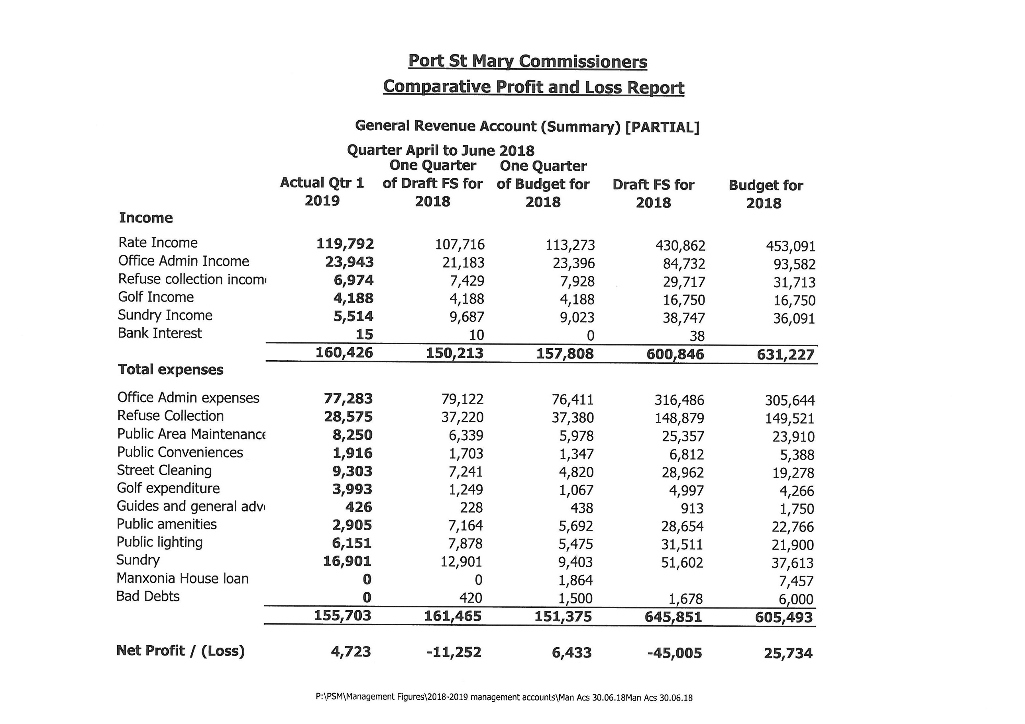
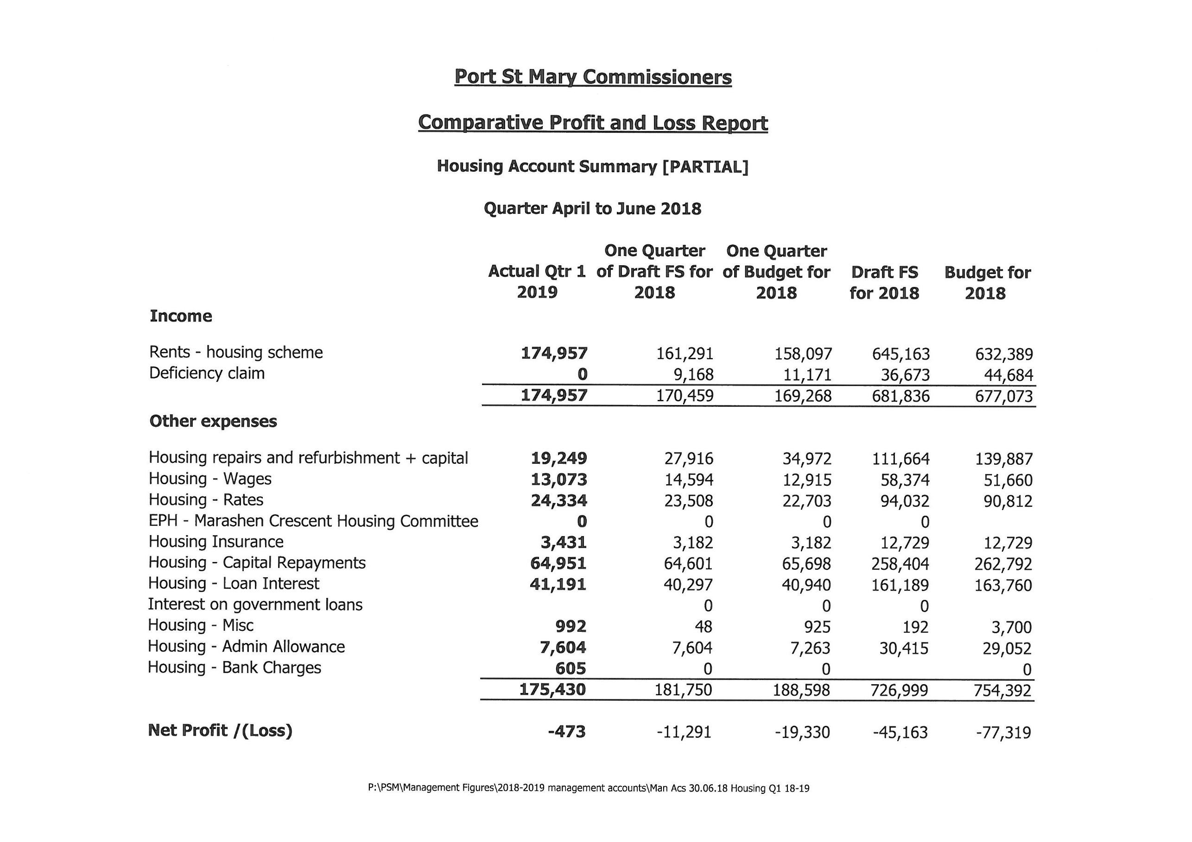

Item 3.2
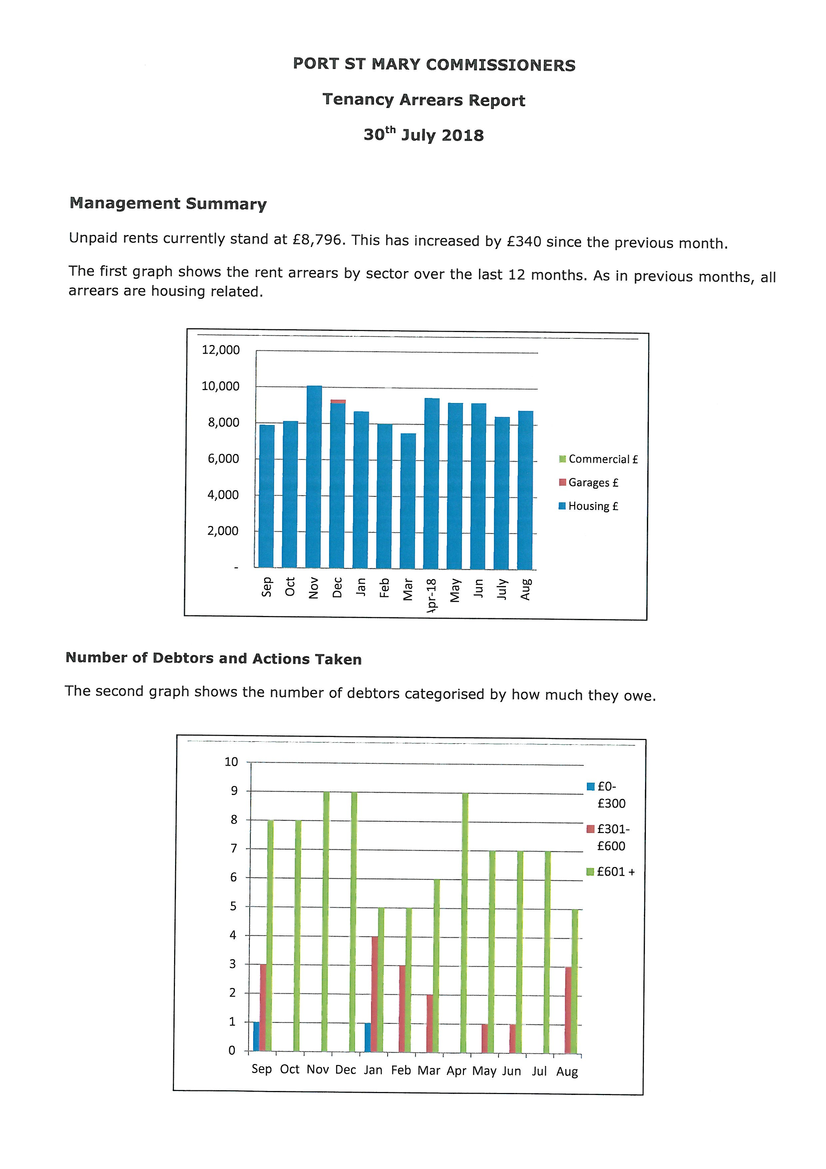
Item 4.1
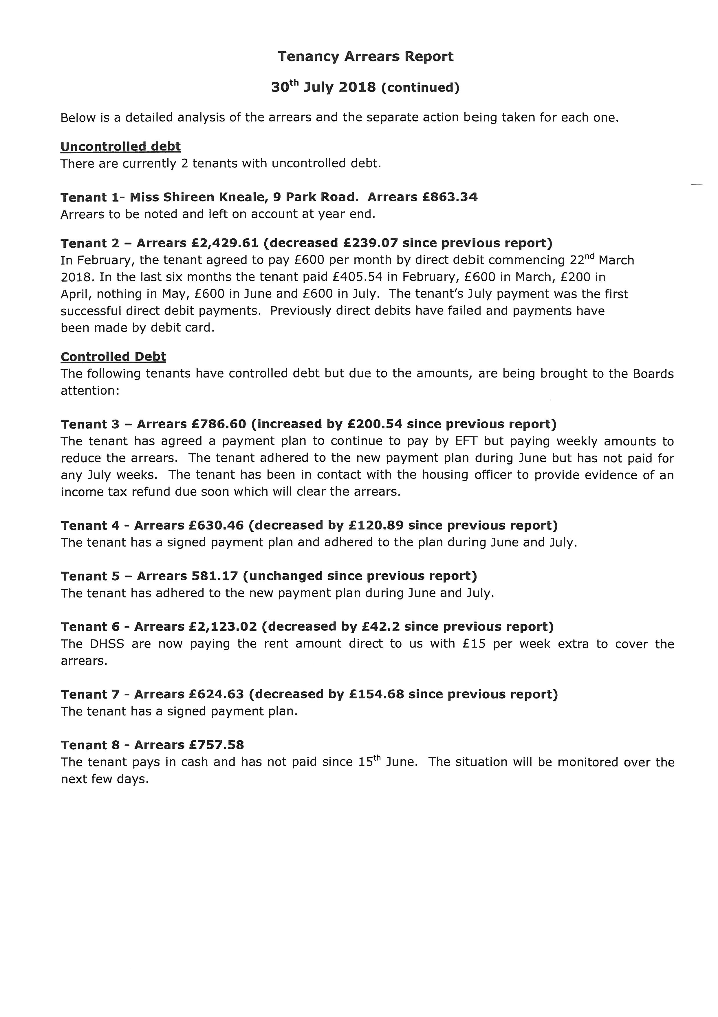
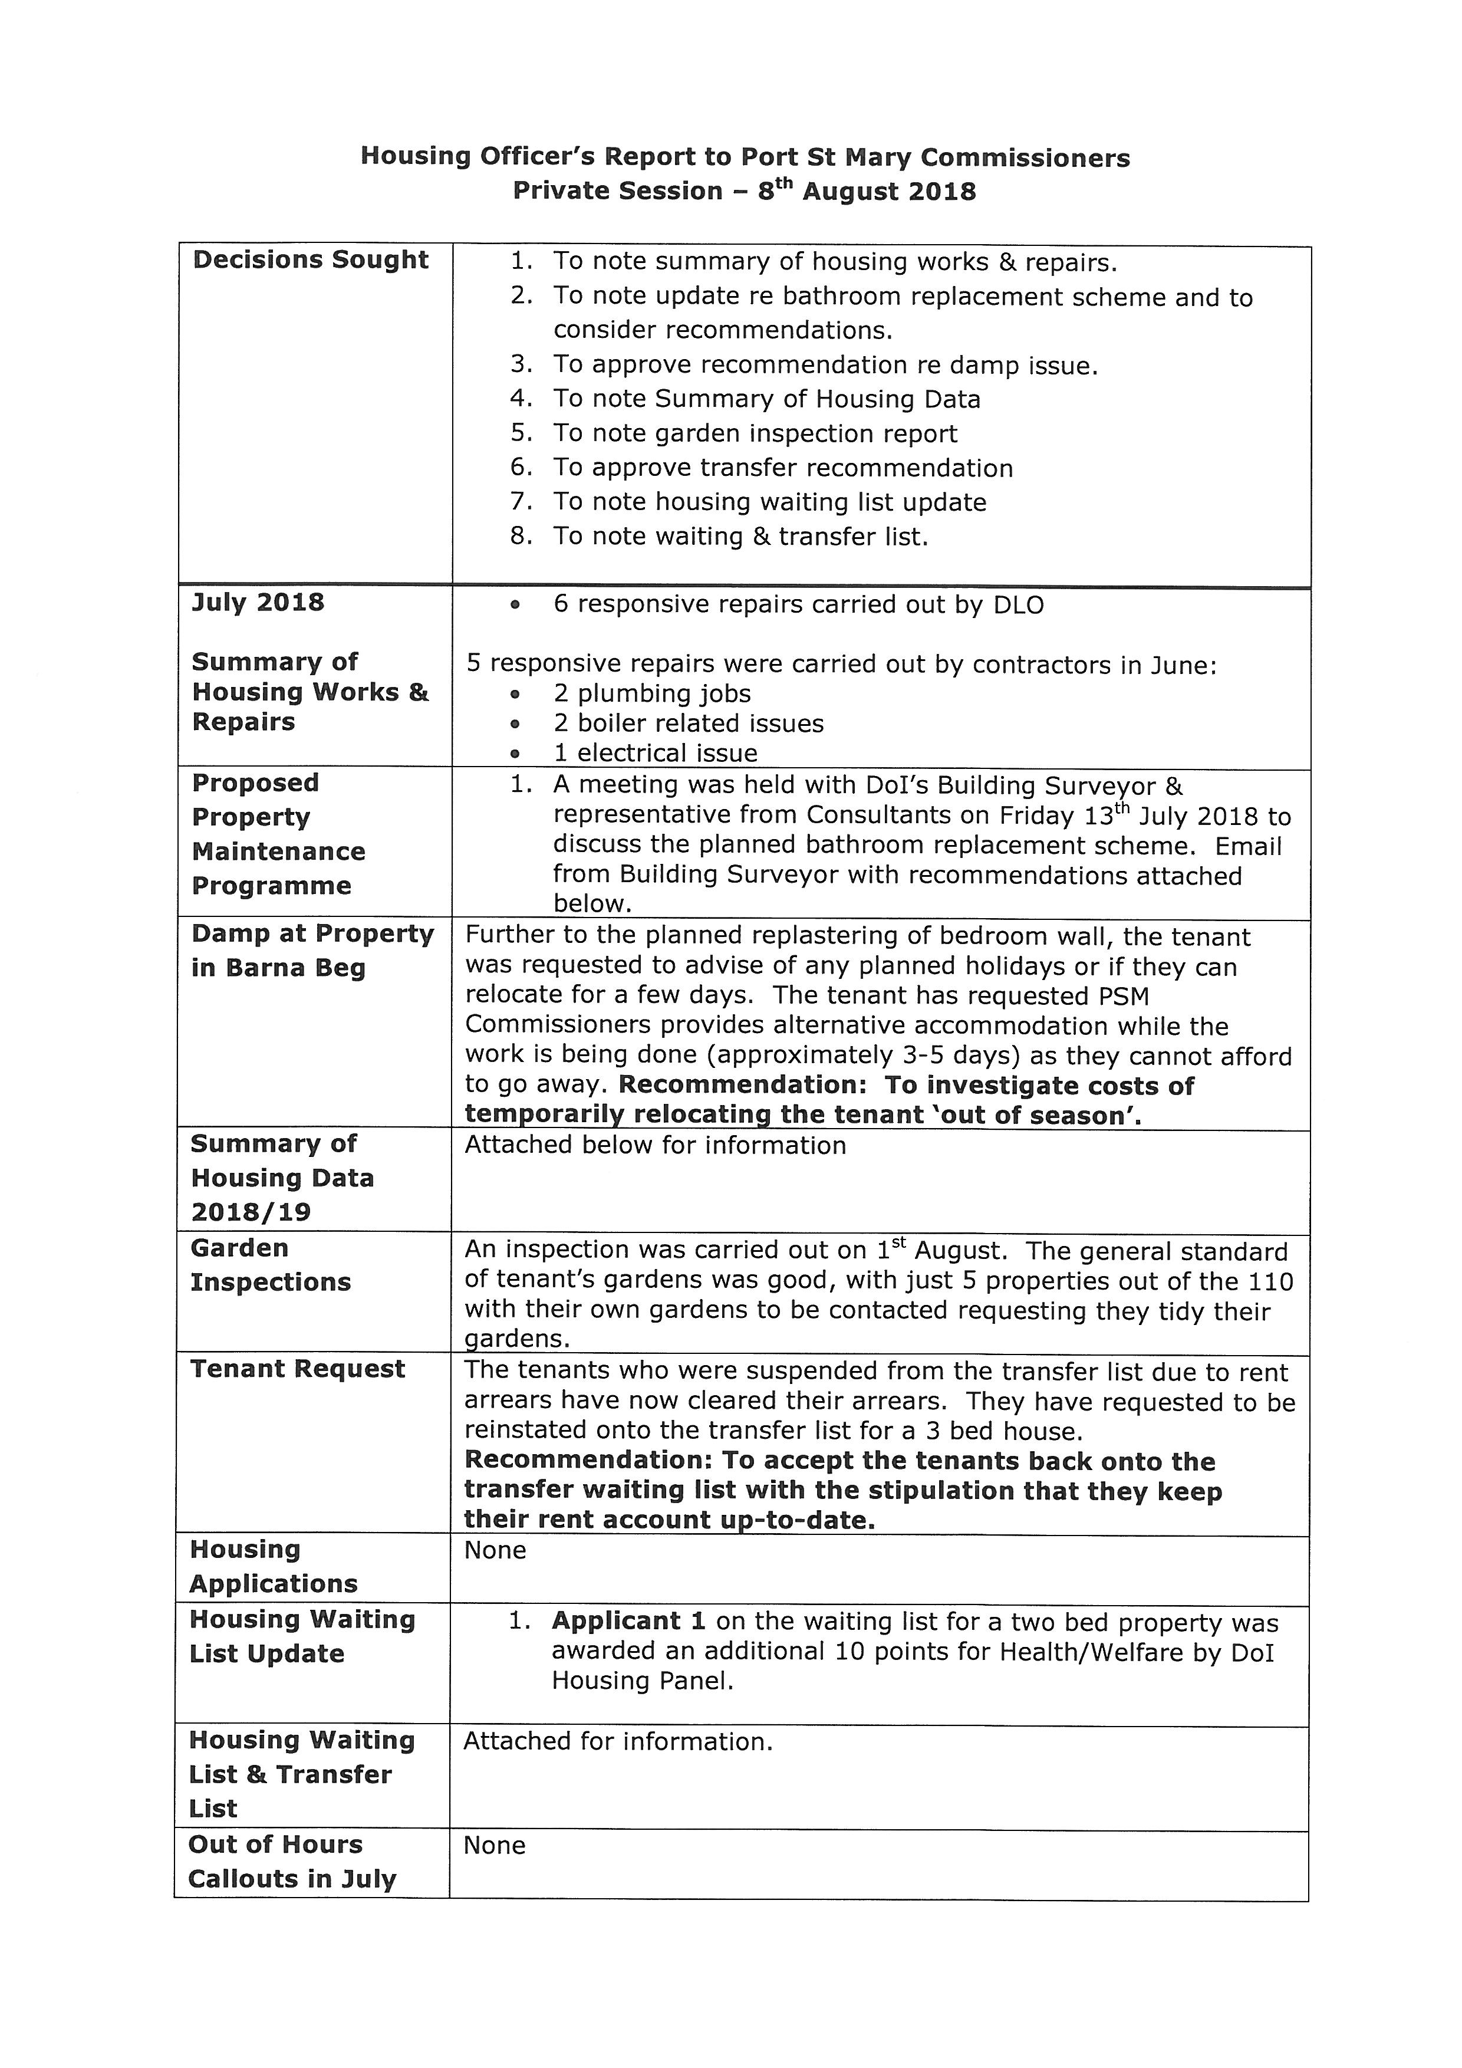
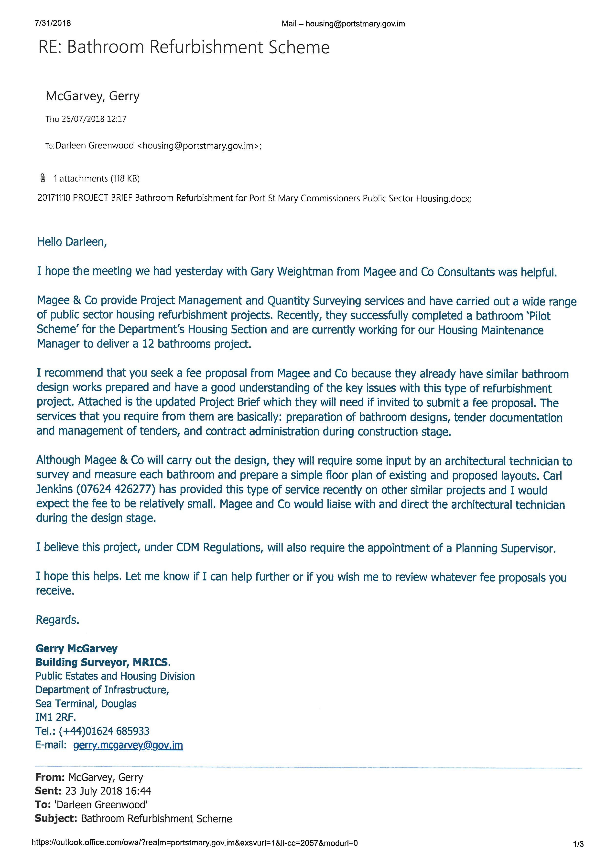
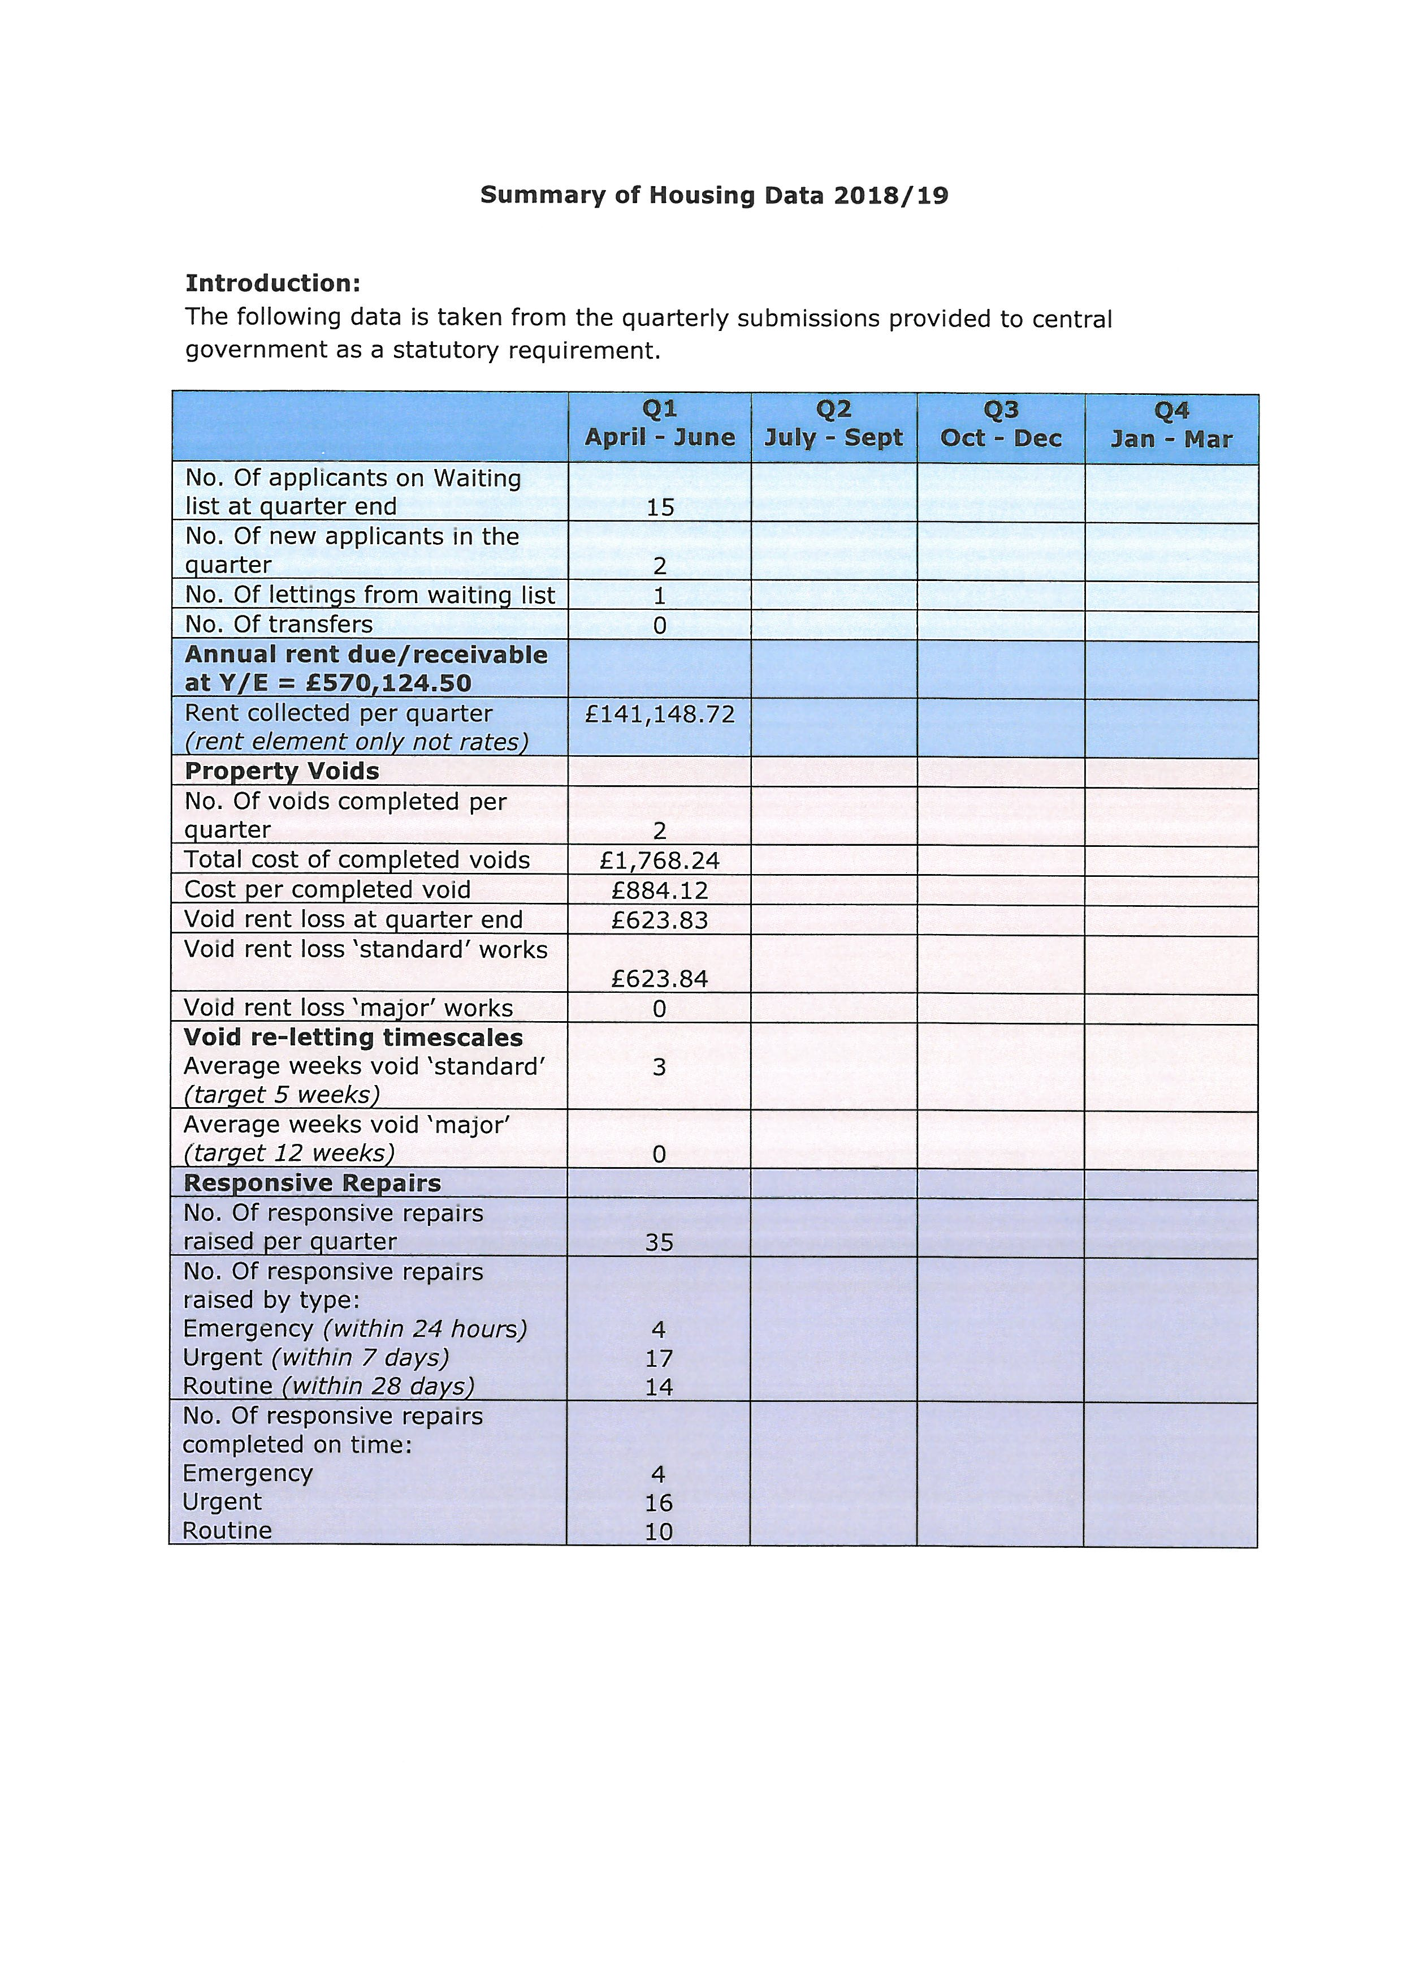
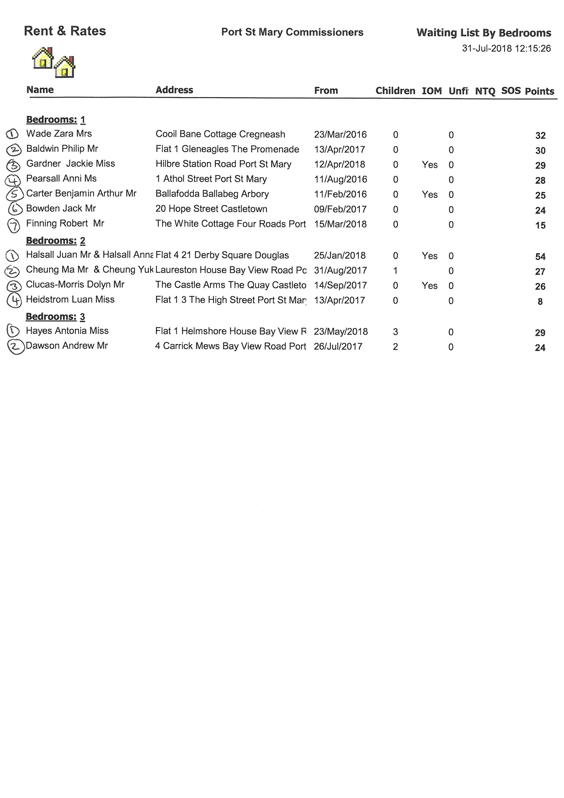
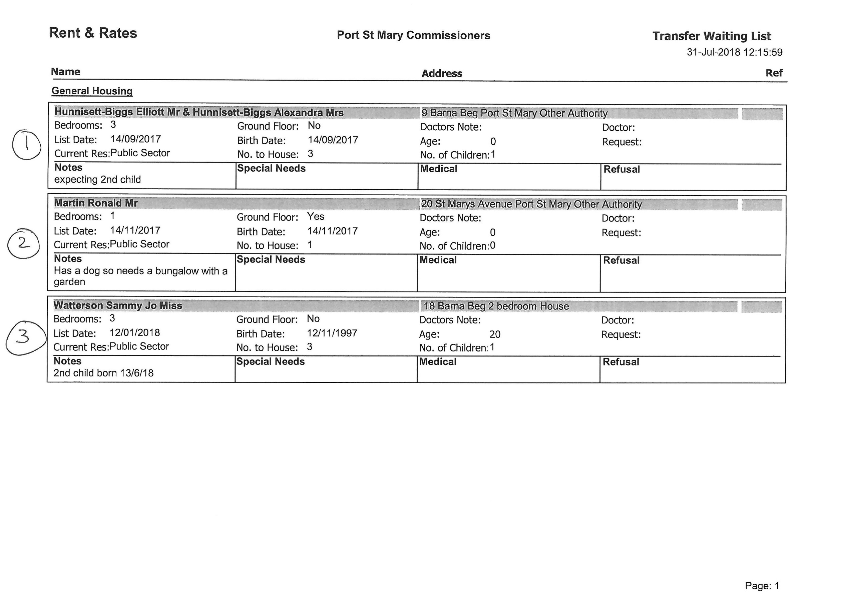

Item 7.1
PORT ST MARY COMMISSIONERS

INTERNAL AUDIT

The below report sets out the priority order of identified areas from the Internal Audit which need to be dealt with and the action to be taken.

High Risk Areas
Area Identified | Recommendation | Action to be taken
Personal Risk | Attendance of courses in relation to risk for Board members and senior staff to be encouraged | Courses currently being investigated in conjunction with the DOI.  Media coverage effects risk area, never categorised below moderate for Local Authorities.
GDPR | DPO to be appointed  PSM email accounts to be used  Personal information still contained in minutes and would require redacting for public release | The Board have appointed Alexander Elliot as DPO. Resolved.  To be implemented by the office staff.  Minimise use of names as much as possible.
Long-Term Absence of Clerk | Appointment of new Clark should eliminate area of risk. | Appointment currently pending DOI approval.

Moderate Risk Areas
Area Identified | Recommendation | Action to be taken
Freedom of Information | Publishing of FOI request information | The section of the website is currently being updated. Resolved.
Changes in Legislation | Advice of changes should be filed and, where necessary, evidence kept that the relevant party has been notified. | A file has been created to note any changes in legislation. Resolved.
Interruption to Services/Contingency Planning | There is no agreement in place regarding an alternative place of operation for a skeleton clerical staff in case of emergency  There is no arrangement for the provision of computers or software. | Discussions are to be had with another Local Authority with regards to facilitating the use of space in case of an emergency and a plan be put in place for Board approval.  Discussion to be had with the IT provider regarding options.
Disability Discrimination Act 2006 | Legislation to be reviewed by the Acting Clerk and Board | Self-assessment checklist to be carried out by the Acting Clerk & Foreman and a report on the results to be prepared for the Board. Talk to be provided by Central Government at the next Clerks Forum in October.
Conflict of Interest | Board members and staff to declare interests. | Ensure all staff and Board members declarations are up to date and the website updated where necessary. To be reviewed on an annual basis after the AGM.
Standing Orders | Section 40.2 of Standing Orders states that they will be reviewed annually in April. | To be reviewed by the Board at an upcoming meeting and again annually after the AGM.

Mitigated Risks are not included on this report as it is accepted that they are as controlled as possible, but a risk is still present (for example the handling of cash).
This report will be brought back to the Board for review on a quarterly basis with updates on progress provided.

Item 8.1
PORT ST MARY COMMISSIONERS

CLERK/RFO RECRUITMENT

The Department have advised that the approval for the role of Clerk/RFO is in the system and will advise the Acting Clerk when an outcome is determined.

The Board are requested to make any required amendments or approve the below press release for issue upon receipt of Departments approval.

The Board of Port St Mary Commissioners are pleased to announce the appointment of Hayley Fargher as Clerk to the Commissioners following a competitive recruitment process.
Hayley has been with the Commissioners in the role of Finance Officer since June 2015 and was promoted to Deputy Clerk in January of this year.
The Board look forward to working with Hayley going forward and wish her luck in her new role.

Item 8.2
PORT ST MARY COMMISSIONERS

FINANCE OFFICER RECRUITMENT

The recruitment process has commenced for the Finance Officer role, a salary scale is still to be set to assist the interview panel.

This will be largely down to experience; however the previous permanent Finance Officer was allocated spine points 22-27. The temporary Finance Officer employed when the FO initially went on maternity leave received spine point 27 due to qualifications.

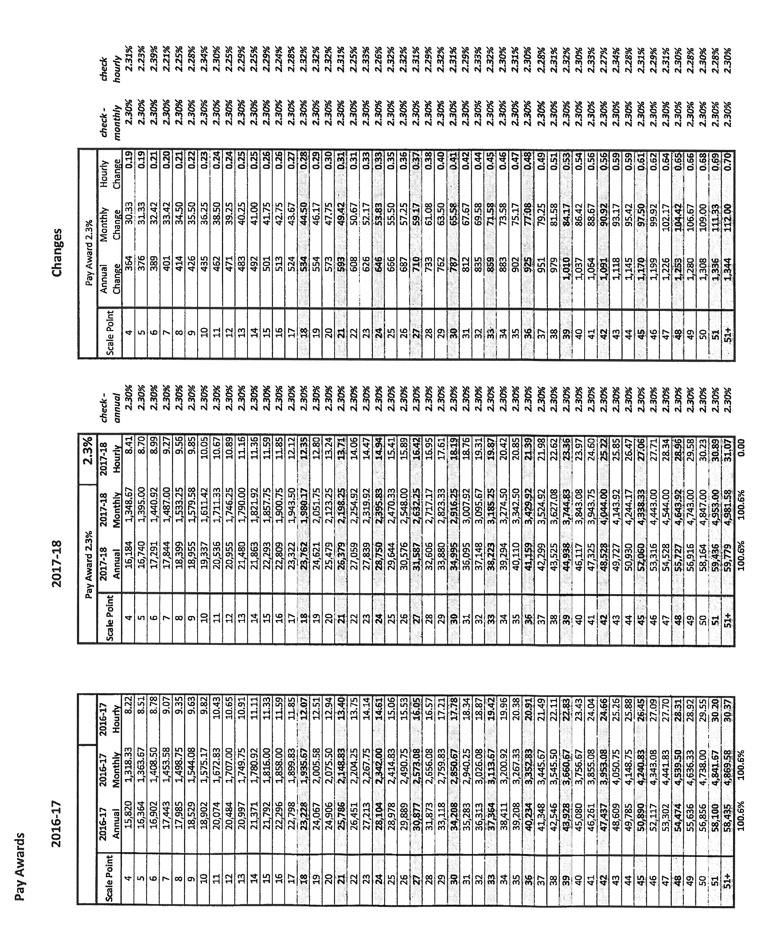

Item 8.3
PORT ST MARY COMMISSIONERS

DLO STAFF UPDATE

Mathew Shaw
Matthew has gratefully accepted the full time contract offered, it was signed on the 1st August and the probation period has been waived.

Chris Overs
Chris’ bail has been extended for a further month and his suspension extended to reflect this. Discussions are ongoing with MIRS in relation to any decisions to be made.

Item 11.1
