Freedom of Information Request IM4644181

Submitted 17th May 2023

INFORMATION REQUESTED
Re: Proposed Street Lighting Bay View Road Carpark.
I am requesting the following information.

1. How many official complaints regarding safety have been received, and do they pertain to the lack of lighting, or to the condition of the unsurfaced car park and access lane?

Response – in relation to Chapel Gate car park, the Board of Port St Mary Commissioners have received three complaints regarding safety, two regarding inadequate lighting, and one regarding the surface of the car park.

2. How many accidents or injuries have officially been reported?

Response – no accidents or injuries pertaining to Chapel Gate car park have been reported to the Board of Port St Mary Commissioners.

3. As Commissioner Gelling raised the issue of Nursery collections being of concern, has the Nursery considered installing an outdoor light themselves?

Response – Chapel Gate car park belongs to Port St Mary Commissioners and is not part of the nursery. The proprietors of the nursery have not discussed installing outdoor lighting on their premises with the Board of Port St Mary Commissioners. The Board cannot comment on the nursery’s operations and lighting strategy.

4. Has any survey been taken regards the amount of traffic the car park sees after 6pm, or on weekends?

Response – although a survey has not been carried out by Port St Mary Commissioners, it is hoped that investing in and improving the car park will increase the use and accessibility of the car park which is open twenty-four hours a day.

Port St Mary Commissioners continuously seek to improve and maintain their assets through the port with public lighting and car parks being part of this initiative. The illumination of car parks helps to improve visibility thus reducing the risk of accidents and criminal activity, and it enhances overall user experience. It is common practice for local authorities Island wide to prioritise adequate lighting in public spaces, including car parks. Any provision of lighting will be guided by various factors such as lighting standards, safety regulations and the specific needs of the car park.

Accordingly, per HSG 136 guidelines as proposed by the UK Health and Safety Executive and British standards BS EN 12464 and BS 5489:2013, a car park that is open to the public twenty-four hours a day should have adequate lighting, as advised by the Isle of Man Government’s Department of Infrastructure.

5. Has any environmental impact study on local wildlife been taken?

Response – with regards to Chapel Gate car park and at the point of responding to this FOI request, work on lighting is only at the proposal stage and a quote only has been requested for works. An environmental impact study on local wildlife has not been undertaken.

5. How much has the Commissioners budgeted for purchasing and installing the lighting, and what are the projected yearly running costs?
(Please note that in the FOI request the numbering had two 5’s, as such the numbering sequence received in the original email from Mr Helps has been retained).

Response - the cost to purchase and install the proposed lighting is £15,120 before VAT. The projected yearly running costs are approximately £170 per annum and this is subject to Manx Utilities Authority tariff movements.

6. What type of lighting and location(s) in the carpark are proposed? Such as height of lamps/types of bulb/PIR or shielded lights/hours of operation?

Response - the lighting scheme for Chapel Gate Car Park was designed to best achieve lighting 5lx average and 25% uniformity.

The fittings proposed are:

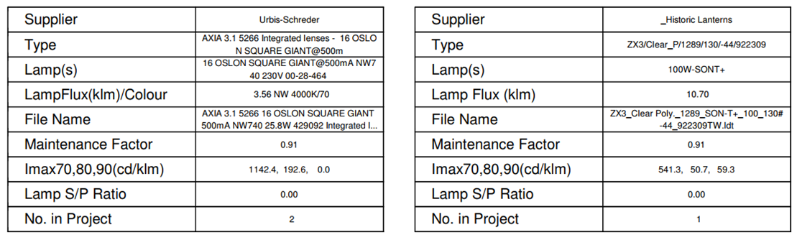

The layout is proposed as:
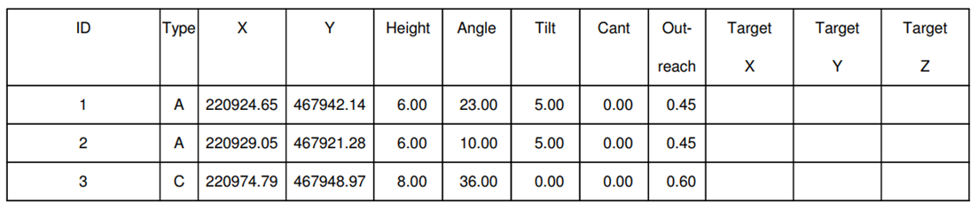
The hours of operation will be consistent with Port St Mary’s public lighting times which are at the time of responding to this freedom of information request:

Morning – 6am to dawn
Evening – dusk to 1am

The lighting times are subject to ad hoc requests from the Isle of Man Constabulary.

Further to the above and the conversation with Commissioner Gelling referenced in the freedom of information request, the Clerk of Port St Mary Commissioners consulted with Manx Utilities to explore options for minimising the impact of direct and ambient light whilst maintaining the goal of providing an adequately lit car park. Communication with Manx Utilities remains ongoing.

