Date: 20th October 2023

NOTICE OF ORDINARY BOARD MEETING

In accordance with Schedule 1 of the Local Government Act 1985, Notice is hereby given that the next Board Meeting of Port St Mary Commissioners will be held in the Board Room at the Town Hall on Wednesday 25th October 2023 at 7.00p.m. Private session of Port St Mary Commissioners will be held following conclusion of the Public Board Meeting.

- Only business of a formal nature as defined in the Agenda for the meeting which is set out below, may be discussed as defined in Port St Mary Commissioners Standing Orders governed by Section 27 of the Local Government Act 1985 [as amended by Section 8 Local Government Act 2006]. All Commissioners are urged to attend and bring with them their copy of Standing Orders.

Hayley Kinvig
Clerk

PORT ST MARY COMMISSIONERS
ORDINARY BOARD MEETING
25TH OCTOBER 2023
AGENDA – OPEN SESSION

 | Item Number |  | Item |  |  |  | Action Required
 | 1. |  | OPENING OF THE MEETING
 | 1.1 |  | Welcome, Apologies & Declarations |  |  |  | As required by Board members
 | 2. |  | MINUTES  Four Members who were present are required to approve Minutes
 | 2.1 |  | Minutes of the Ordinary Meeting held on the 4th October 2023 |  |  |  | For Board approval
 | 3. |  | MATTERS ARISING
 | 3.1 |  | Matters arising from previous meetings |  |  |  | Clerk to provide necessary updates
 | 4. |  | MOTIONS – None
 | 5. |  | FINANCE
 | 5.1 |  | Invoices for payment in October |  |  | For Board approval
 | 6. |  | PROJECTS
 | 6.1 |  | PSM Events |  |  |  | For Board discussion
 | 7. |  | HOUSING
 | 7.1 |  | Housing Officers Report |  |  | For Board discussion
 | 7.2 |  | Tenant Arrears Report |  |  | For Board discussion
8. |  | PUBLIC CORRESPONDENCE & COMMUNICATIONS
8.1 |  | Traffic Management Plan |  | For Board discussion & response
8.2 |  | Bus Service Complaint |  | For Board discussion & response
8.3 |  | Mobile Library |  | For Board discussion & response
8.4 |  | Policing Roadshows |  | For noting
8.5 |  | Windfarm Engagement |  | For Board response
9. |  | PLANNING MATTERS
9.1 |  | Planning Application |  |  | For Board discussion
9.2 |  | Planning Approvals |  |  | For Board discussion
9.3 |  | Planning Appeal |  |  | For Board discussion
10. |  | POLICY & RESOURCES
10.1 |  | Updated Declarations of Interests to be completed (LVW & CO’M) – to be tabled |  |  | Board to complete & return
10.2 |  | 3rd Supplemental Information |  |  | For Board discussion
10.3 |  | 2023/24 Meeting Dates |  |  | For noting
11. |  | PUBLIC CONSULTATIONS
11.1 |  | Isle of Man Strategic Plan Review |  | For Board response
11.2 |  | Highways Service Level Agreement |  | For Board response
12. |  | INVITATIONS
12.1 |  | Rushen & Arbory Parish Commissioners Civic Service |  | For Board response
12.2 |  | National Service of Remembrance |  | For Chairman response
13. |  | ANY OTHER BUSINESS OF AN URGENT NATURE  (BY PERMISSION OF THE CHAIR)

MATTERS ARISING & PUBLIC CORRESPONDENCE REPORT

Matters Arising
Telephone Kiosks – A meeting has been scheduled for after October half term.
Mariners Shelter – Following a discussion with Harbours, correspondence has been issued to the Department as requested.

Public Correspondence
Chief Constable meeting – A request to defer the meeting until 2024 was received.

Item 6.1
PORT ST MARY COMMISSIONERS

PROJECTS UPDATE
6.1 | Events  Remembrance Day  Arrangements are proceeding for the service on Saturday 10th November.  Christmas Market – The market will be held on Thursday 7th December 5-8pm. After a suggestion last year, traders are being requested to donate an item (as we don’t charge pitch fees), for a hamper which will then be raffled off on the night for charity. The Board are requested to discuss selected charities, the office have put forward the IOM Foodbank and the Salvation Army.  Christmas Carol Service – To be held on Tuesday 12th December at St Marys Church. Rushen Silver Band and Scoill Phurt Le Moirrey are both confirmed to participate.  Willow Lantern Making – As in the previous year, the Clerk would like to run a lantern making workshop in the Town Hall on Saturday 16th December 2-6pm. This event will be free to attend and was extremely well attended last year. The Arts Council provide the majority of materials, the cost on the events budget last year for PSMC was circa £100.

Item 7.1
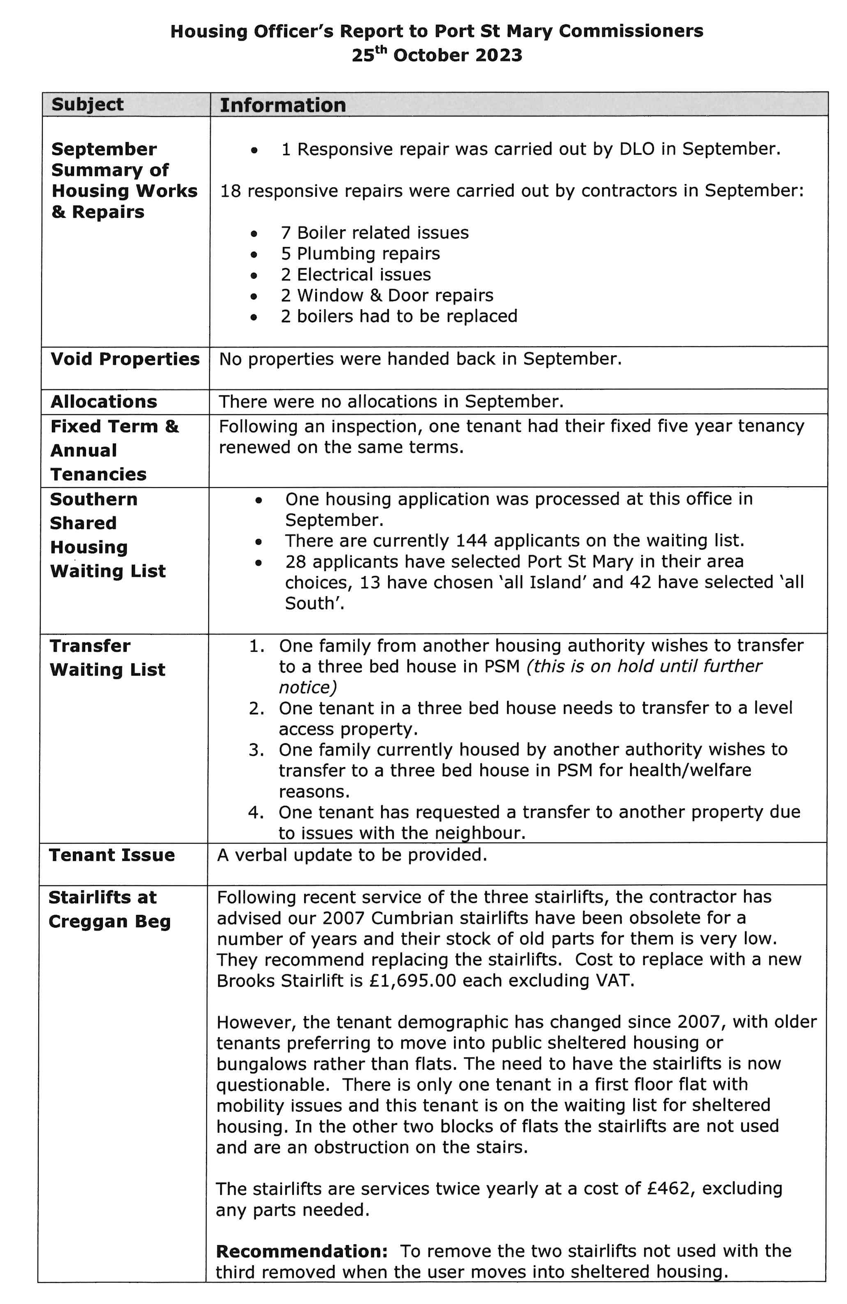

Item 8.1
PORT ST MARY COMMISSIONERS

PUBLIC CORRESPONDENCE
TRAFFIC MANAGEMENT PLANS

Dear All,

This email is to notify you of changes in relation to traffic management requests and how we propose moving forward with greater involvement from each local authority.

A document is has been drafted in how we envisage moving forward, and I have attached a “draft” assessment matrix, which sets out the criteria, which is expected to give an objective assessment. Schemes which score sufficiently high enough will be ranked alongside all the other service requests and put forward on future programmes of work as funding becomes available. By engaging with each authority, I will be asking you to identify your priority which best serves the community as a whole. Traffic Management interventions should consider all road users with specific consideration paid to encourage walking, cycling and creating a feeling of security within the road environment. Unnecessary difficulties for emergency service vehicles will be minimised, with accessibility for all appropriate modes of transport, including buses, remaining a key issue.

The need for change will be discussed fully and this process is intended to reduce singular requests, adopt a more sympathetic, translucent and forward thinking approach to traffic management improvements which will allow us to utilise our resources more effectively in addressing larger community schemes (subject to funding) to:

• Restrain traffic and safeguard the environment.
• Ensure a fair and consistent approach to the assessment and prioritisation of requests across the Island.
• Manage the expectations of our residents, MHKs and customers
• Improve pedestrian safety, accessibility and convenience
• Concerns of the community which are supported by local authority or political member/s

Please could I ask that you provide me with dates and times, either with the Clerks or Board, in order that I can fully explain the process. Please note safety critical defects will continue to be addressed via our customer services team highways@gov.im

Kind regards

Andrea

Andrea Rivers
Engagement Manager
Highway Services l Department of Infrastructure
Sea Terminal Building, Douglas, Isle of Man, IM1 2RF
Item 8.2
PORT ST MARY COMMISSIONERS

PUBLIC CORRESPONDENCE
BUS SERVICE

Sent: 26 September 2023 13:10
To: Port St Mary Commissioners <commissioners@portstmary.gov.im>
Subject: Busses to The Sound/Cregneash - Complaints

Dear Mrs. Williams,

I am writing to you today with a suggestion to improve the situation of public transport to The Sound and Cregneash.
As I do not have a car, I depend on public transport and have experienced numerous complaints of both tourists and locals about the fact that there are only limited bus connections - if at all - to two of our most wonderful heritage sites. This year, again, we had the busses going for a short period only and only at weekends or public holidays.
Many tourists arrive on the Island at a weekend and leave at the weekend as well. For those who stay for one week only, it is often too late to go to one of these sites, unless they are very keen walkers. Once they have made plans to go there, it's usually after their first weekend and they find out that they have no further chance to visit the sites. Anger, frustration and disappointment leads to the complaints you hear almost every time you stand at the bus stop waiting for transport to Pt. Erin or Douglas.

Obviously Bus Vannin doesn't want to operate the service any more because it doesn't pay the expenses. I can understand that. So my suggestion is as follows:
Would it be possible to run a community bus from Port St. Mary to the Sound on a charity/volunteers' basis? Two days per week with maybe three tours a day could help a lot and one of these days should obviously be a week day. Unfortunately I can't drive myself, but I would be happy to engage in such a project it in other ways.

I am aware that it would cost a lot of money - acquiring a mini van, paying taxes and insurance would be some of the cost I can think of right now. But I also think that Manx National Heritage who run Cregneash should contribute to the project, as it is in their interest to have people come to the place. Visit Isle of Man might be another supporter I can think of and who knows, maybe even the Sound Cafe might be willing to contribute.

I have spoken to Norman McGregor Edwards at the Commissioners' Service at Mount Tabor already and he advised me to write to you officially. I would be very pleased if you could support a project like this somehow. I am sending a copy of this email to Kathy Potter, a member of the Rushen Heritage Centre managment team, as she has been active in this matter for a long time now.

I am looking forward to hearing from you
Kind regards,
Christa Viohl

---
Christa-Marion Viohl

Item 8.3
PORT ST MARY COMMISSIONERS

PUBLIC CORRESPONDENCE
MOBILE LIBRARY

Sent: 19 October 2023 10:14
Subject: Mobile Library

Dear Ms Fargher,

I am writing to you on behalf of the Mobile & Family Library, to let you know about some of the services we provide.

As you may be aware, the Mobile Library visits residents all over the Island, focusing on those who are unable to access their local static libraries, including Port Erin Library, and offering a kerb-side service or personal visits. Our Home Library Service reaches over 70 individuals each month, in their own homes, providing books and conversation; also through our Home Library Service we deliver books to borrowers in many of the Island’s residential Homes, and visit sheltered housing complexes. Currently, we visit Marashen Crescent, Reayrt y Chrink, Millhope Close, and Cooil Veg, and we are available to visit any other sheltered housing you represent. We have an extensive collection of Large Print books and audio books for those who have declining eyesight.
Our Bibliotherapy Service uses our extensive book and artefact collection to work with groups of older residents, encouraging conversations and discussions which can help to keep minds active and is a valuable social activity. I have attached our leaflet for your information.

We hope to raise awareness of our services, and would be very grateful if you could refer us to any of your residents who may benefit from our services.

If you would like to visit our Mobile Library when it is out on its routes, please do let me know and we will be happy to organise this. I have attached a copy of our timetable, for reference.

The Family Library, including both the Mobile Library and Bibliotherapy Service, is a charity, and we continued to be pro-active in our fundraising, aided by the Scheinberg Family and partial funding from the Government. However, we are only able to keep our Island-wide services going if we continue to fundraise, and so I would also ask if your Housing Committee would consider any financial support for the ongoing services we provide.

Kind regards,

Item 8.4
PORT ST MARY COMMISSIONERS

PUBLIC CORRESPONDENCE
POLICING ROADSHOWS

Sent: Wednesday, October 18, 2023 3:57 PM
Subject: POLICING ROADSHOWS - Talk to us about your crime concerns

Dear Commissioners

I want to bring to your attention some upcoming events that may interest you and your constituents.
Communities are being encouraged to attend Policing Roadshows during November, where they can raise any problems with criminality or anti-social behaviour in their areas.
The Isle of Man Constabulary, Crimestoppers and the Department of Home Affairs will be hosting the four Roadshows, to hear directly from the public about the issues affecting them.
Feedback will be gathered on the current policing plan, as well as discussing an upcoming consultation on the Policing Plan for 2024-2025. Crimestoppers will also be discussing the work they do, as well as what it means to be a volunteer and how to help.

Anyone is welcome to attend any of the roadshows, which will be held in Peel, Castletown, Ramsey and Onchan:

• West: Thursday 9 November, QEII High School, 6pm – 8pm

• South: Monday 20 November, Castle Rushen High School, 6pm – 8pm

• North: Thursday 23 November, Ramsey Grammar School, 6pm – 8pm

• East: Wednesday 29 November, Sight Matters (Onchan), 6pm – 8pm
All of the venues are accessible, with car parks on site.

Item 8.5
PORT ST MARY COMMISSIONERS

PUBLIC CORRESPONDENCE
WINDFARM ENGAGEMENT

Sent: Tuesday, October 10, 2023 2:11 PM
To: Port St Mary Commissioners <commissioners@portstmary.gov.im>
Subject: MUA windfarm - early engagement meeting

Dear Port St Mary Commissioners,

I hope my email finds you well. You may be aware that Manx Utilities has appointed Wardell Armstrong (WA) to carry out environmental and technical studies for the proposed development of onshore renewable energy in the Isle of Man. The proposed 20MW onshore windfarm would require the development of an Environmental Impact Assessment (EIA) and Design stage over the next 2 years.

Prior to the start of the EIA studies and design, it is key for the team to liaise with local communities and people such as yourself to understand your views on the proposed development. We are keen to meet in person or hold a call to discuss the programme, at your convenience. Would you be available for a catchup with us? If so, please could you confirm your availability to meet on Thursday or Friday this week and we will gladly get that set up.

All the best,
Alex

Alex Cisneros | Associate Director – Social Specialist
Wardell Armstrong International Ltd
Baldhu House, Wheal Jane Earth Science Park, Baldhu, Truro, TR3 6EH

Item 9.1 - 9.3
PORT ST MARY COMMISSIONERS

PLANNING MATTERS

9.1 Planning Application
23/01160/B – Linden Cottage, Linden Avenue for the replacement of existing window with French Doors and decking to rear elevation.
9.2 Planning Approvals
23/00913/B – Galean, Athol Street for the erection of a single storey extension to the rear elevation.
23/00964/LAW – Onyx House, Shore Road, Underway for a Certificate of Lawful Development for the erection of a ground floor extension.
23/00930/B – Harbour View, Athol Street for the replacement of timber door with composite door and pvc top panel.
23/00839/B – Forrester House, The Promenade to replace 24 rotting and ill-fitting wooden windows and front door with upvc versions. On the front of the house, windows will be bottom opening casements as the existing wooden windows being replaced. At the rear, wooden windows (some sash) will all be replaced with bottom or top opening casements that match previously installed upvc windows. Front door to be replaced with door and side-lights similar to nearby properties (existing top light to be retained)
9.3 Planning Appeal
22/01294/B – 19 Rhenwyllan Close Appeal permitted by way of written representations against the refusal for material change of conservatory roof to solid flat roof, single storey rear extension to existing conservatory and installation of a flue.

Item 10.3
PORT ST MARY COMMISSIONERS

MEETING DATES FOR 2023/24

2023/24 Meeting Dates
8th November 2023 | Second meeting – may not be required
22nd November 2023
13th December 2023 | Only 1 meeting held in December
10th January 2024 | Second meeting – may not be required
24th January 2024
14th February 2024 | Second meeting – may not be required
28th February 2024
13th March 2024 | Second meeting – may not be required
27th March 2024
10th April 2024 | Second meeting – may not be required
24th April 2024
8th May 2024 | AGM Only

