PORT ST MARY COMMISSIONERS
AGM AGENDA
WEDNESDAY 10th MAY 2023
7 pm

- Apologies for absence

- Minutes of AGM 11th May 2022 - for noting

- Nominations for Annual or other Statutory Appointments:

3.1 Chairman
3.2 Vice Chairman

4. Appointments to other Statutory Boards (3 year term):

4.1 Southern Sheltered Housing Joint Board – due 2024 unless by resignation
4.2 Southern Civic Amenity Site Board – due 2024 unless by resignation
4.3 Southern Swimming Pool – due 2024 unless by resignation

5. To appoint annual representatives on the following:

  - IoM Municipal Association
  - Rushen Emergency Ambulance Committee
  - Southern Authorities Health Care Committee
  - Port St Mary & District Allotments Committee

6. Policy Matters:

6.1 Attendance Allowances – for information
6.2 Members Travel Allowances – for information
6.3 Standing Orders on Meetings – for review
6.4 Standing Orders on Contracts – for review
6.5 Bank Mandates – for approval if amendments are required

7. Reports

7.1 Suspension of Standing Orders Report – for approval
7.2 Attendance Report – for approval

8. Any Other Business by permission of the Chairman.

Item 6.1
PORT ST MARY COMMISSIONERS

MEMBERS’ ATTENDANCE ALLOWANCES ORDER

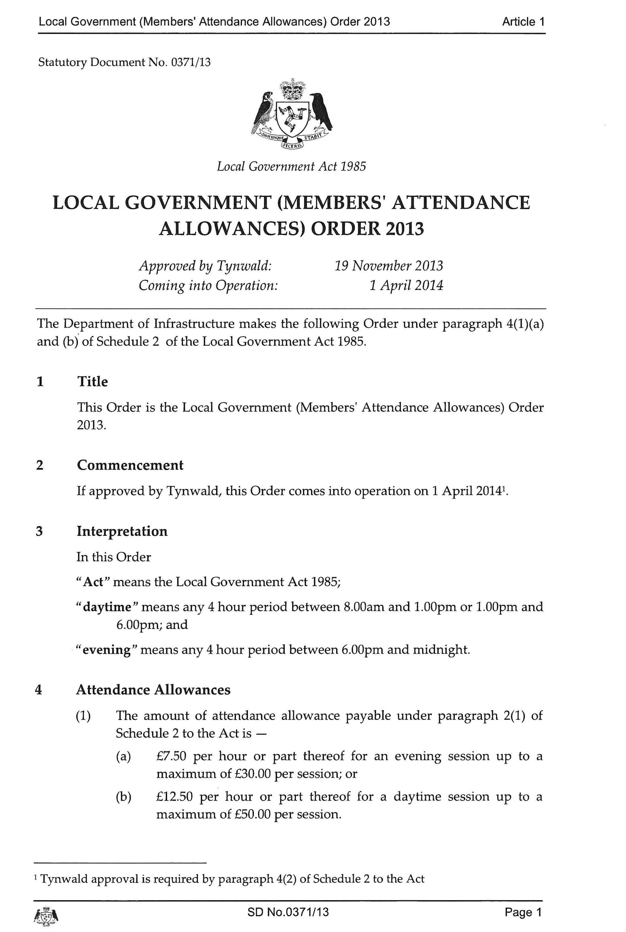
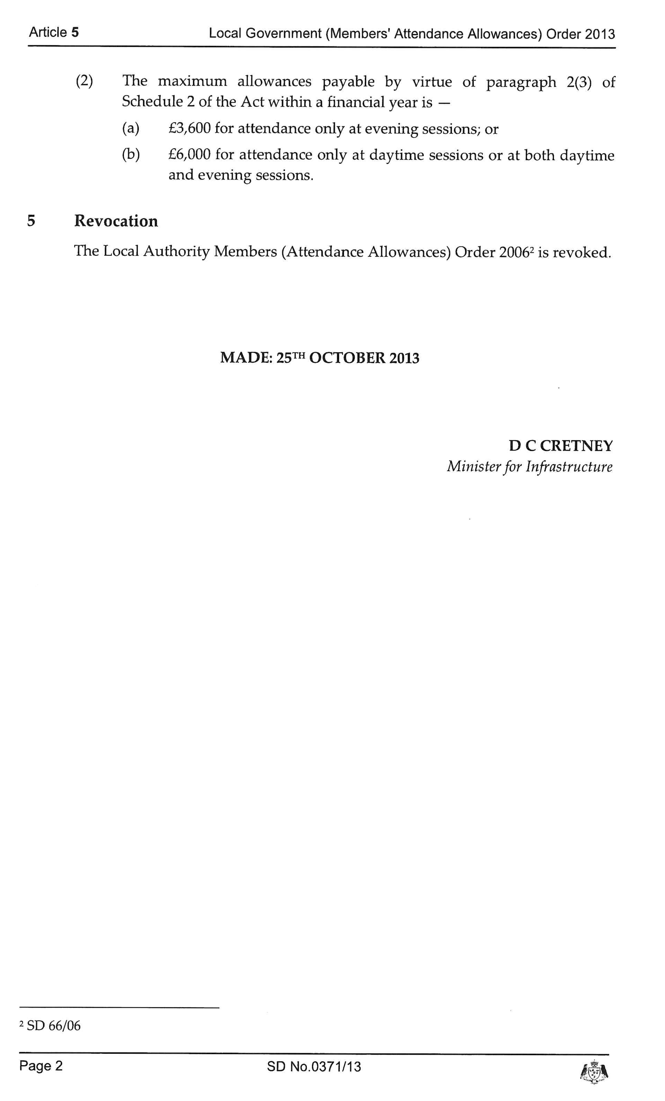
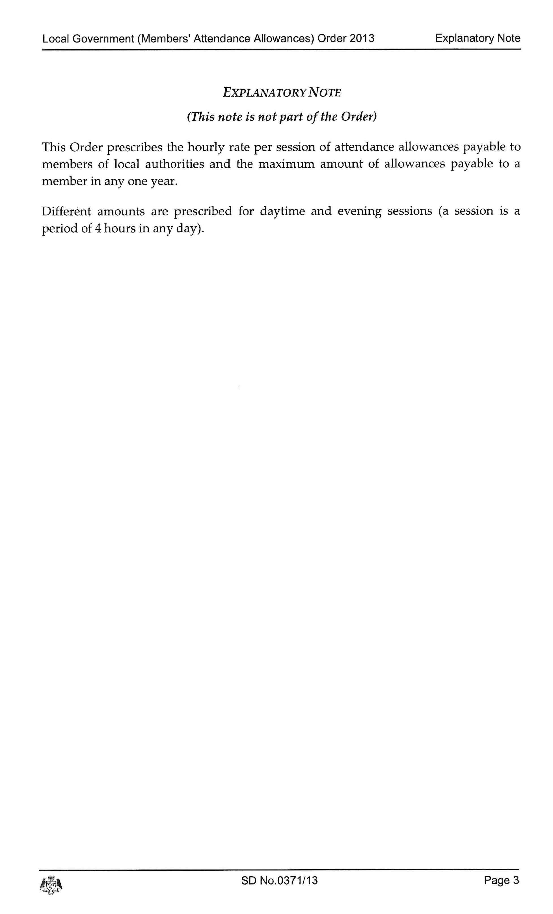

Item 6.2
PORT ST MARY COMMISSIONERS

MEMBERS’ TRAVEL ALLOWANCES ORDER

The below Order has been consulted on and is due to be revised and approved in Tynwald July 2023

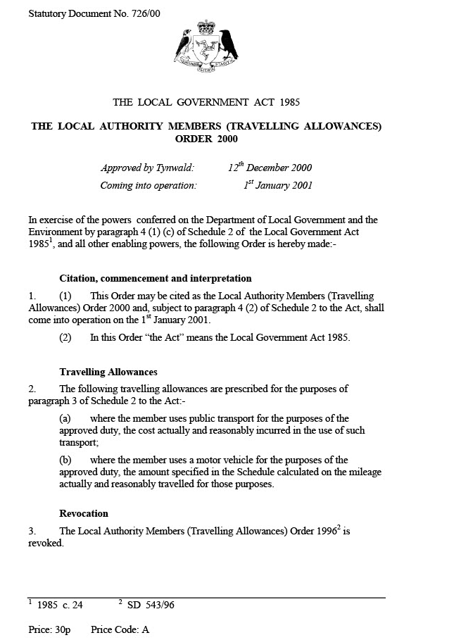
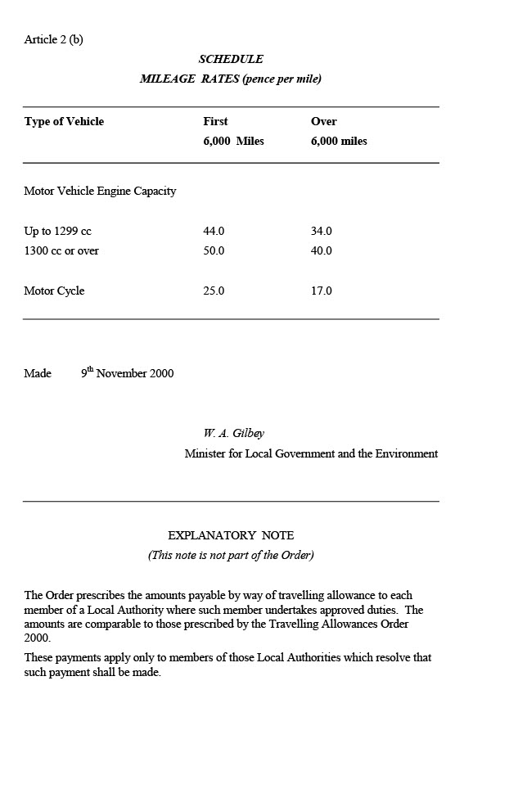
Item 6.3

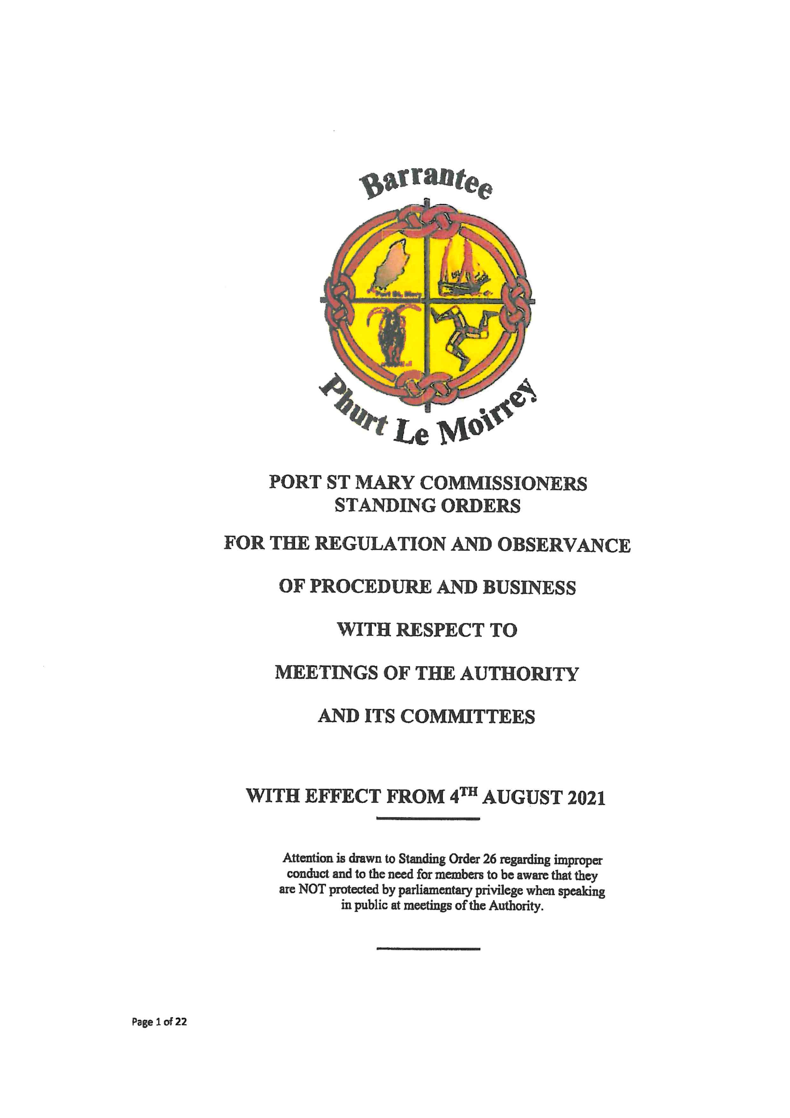

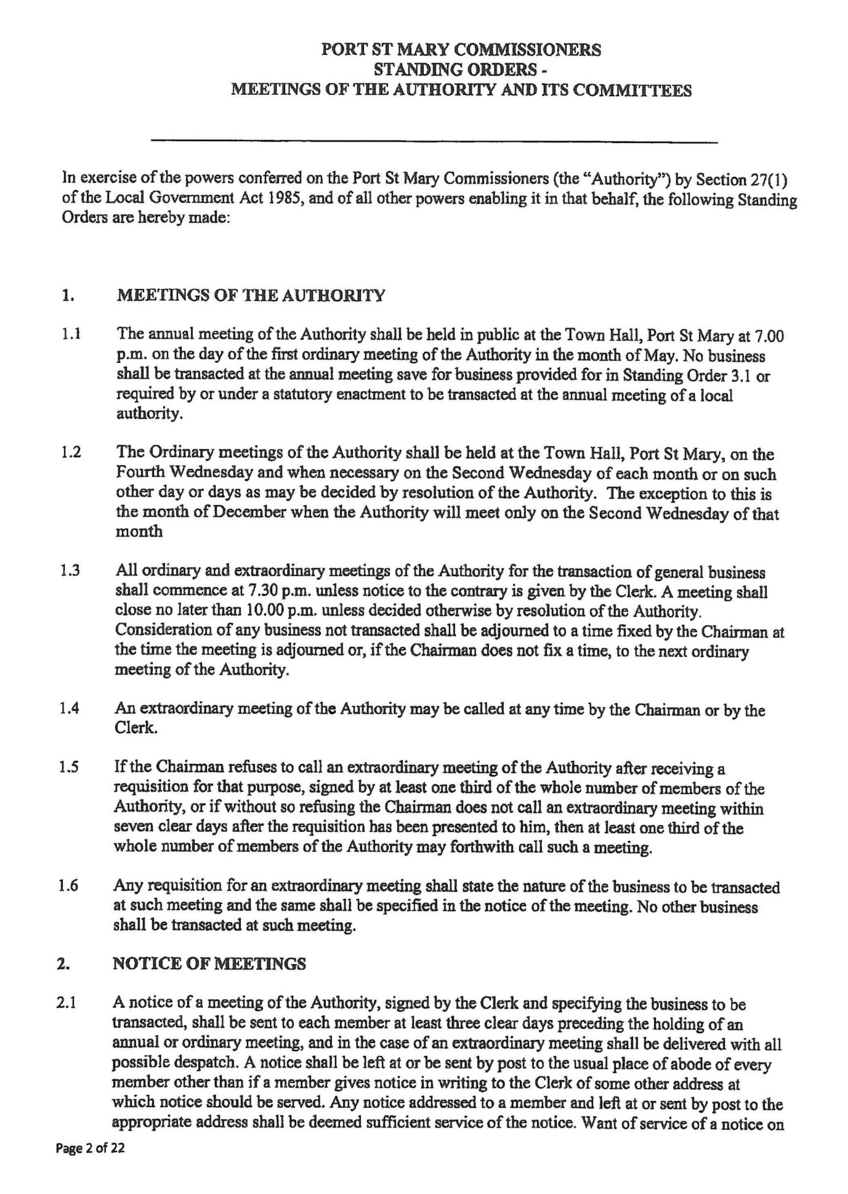

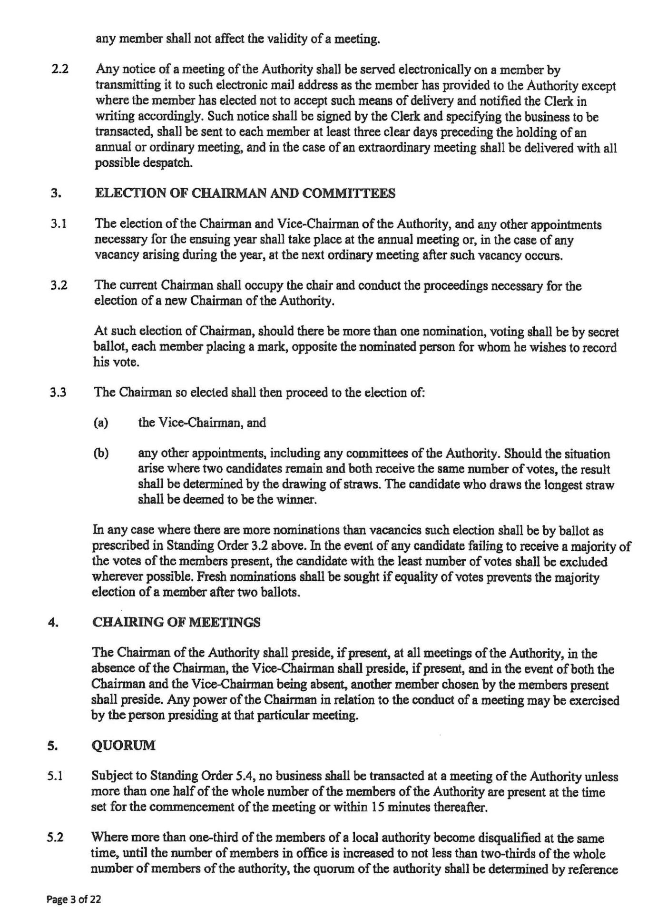

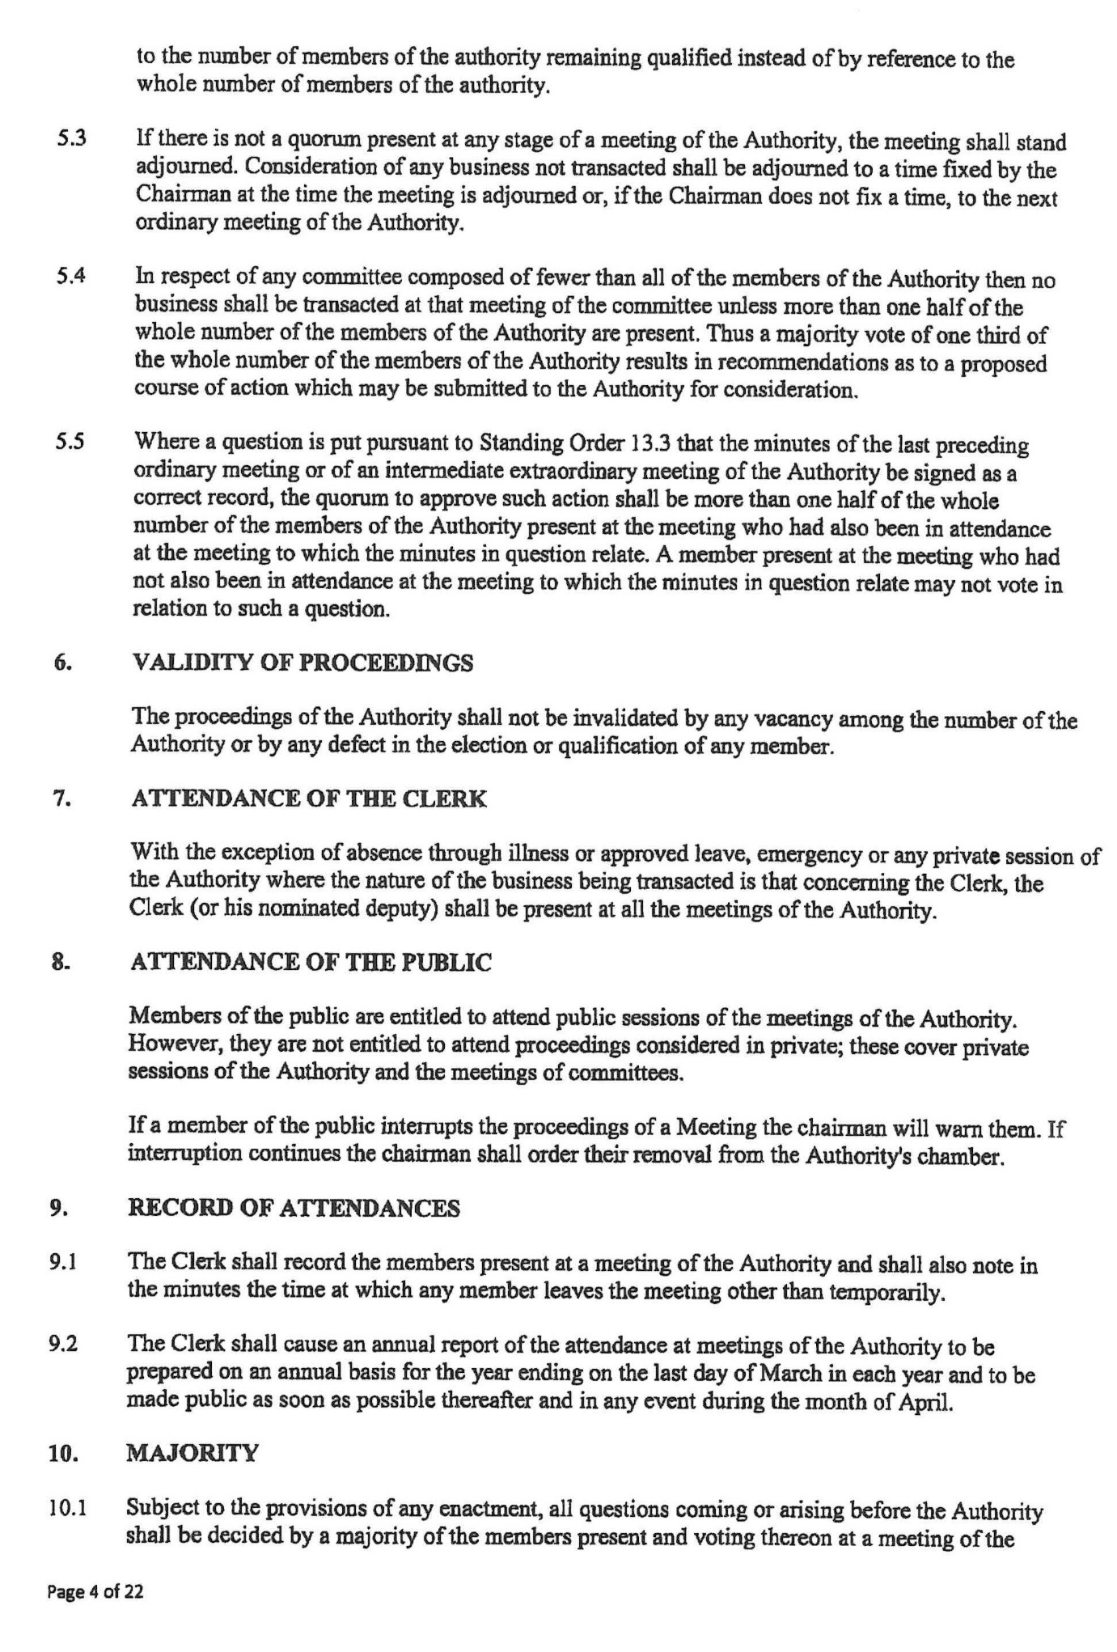

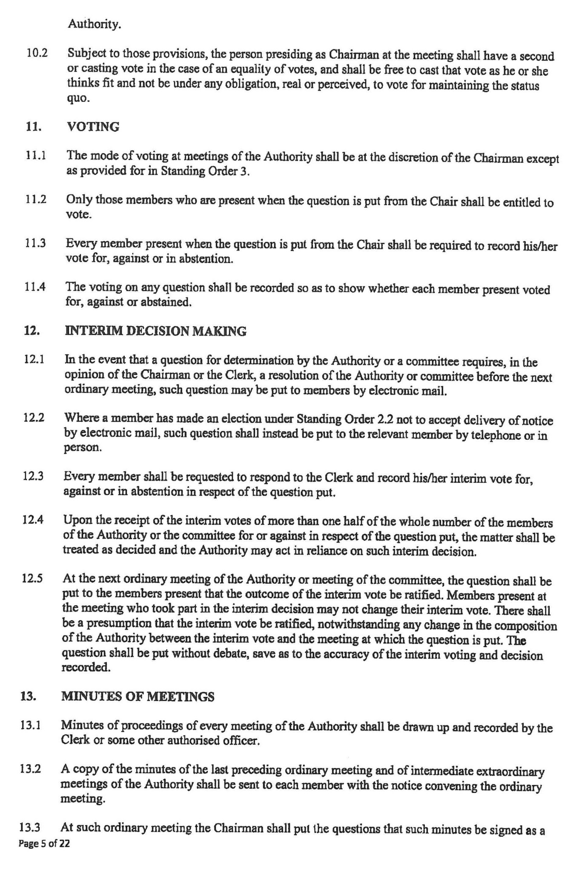

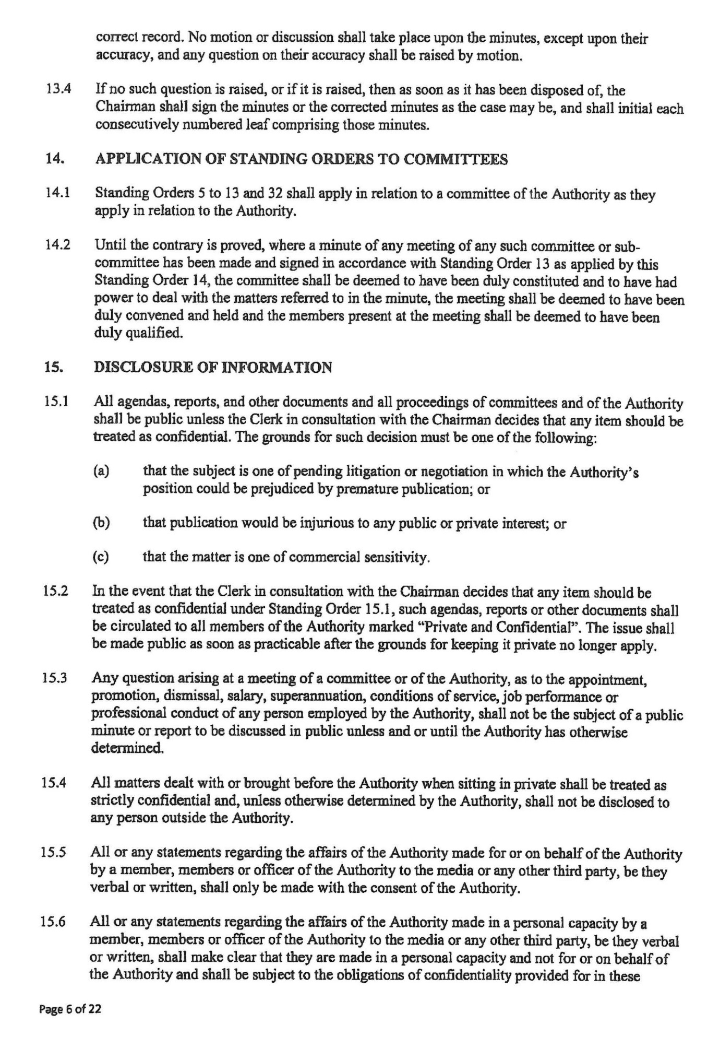

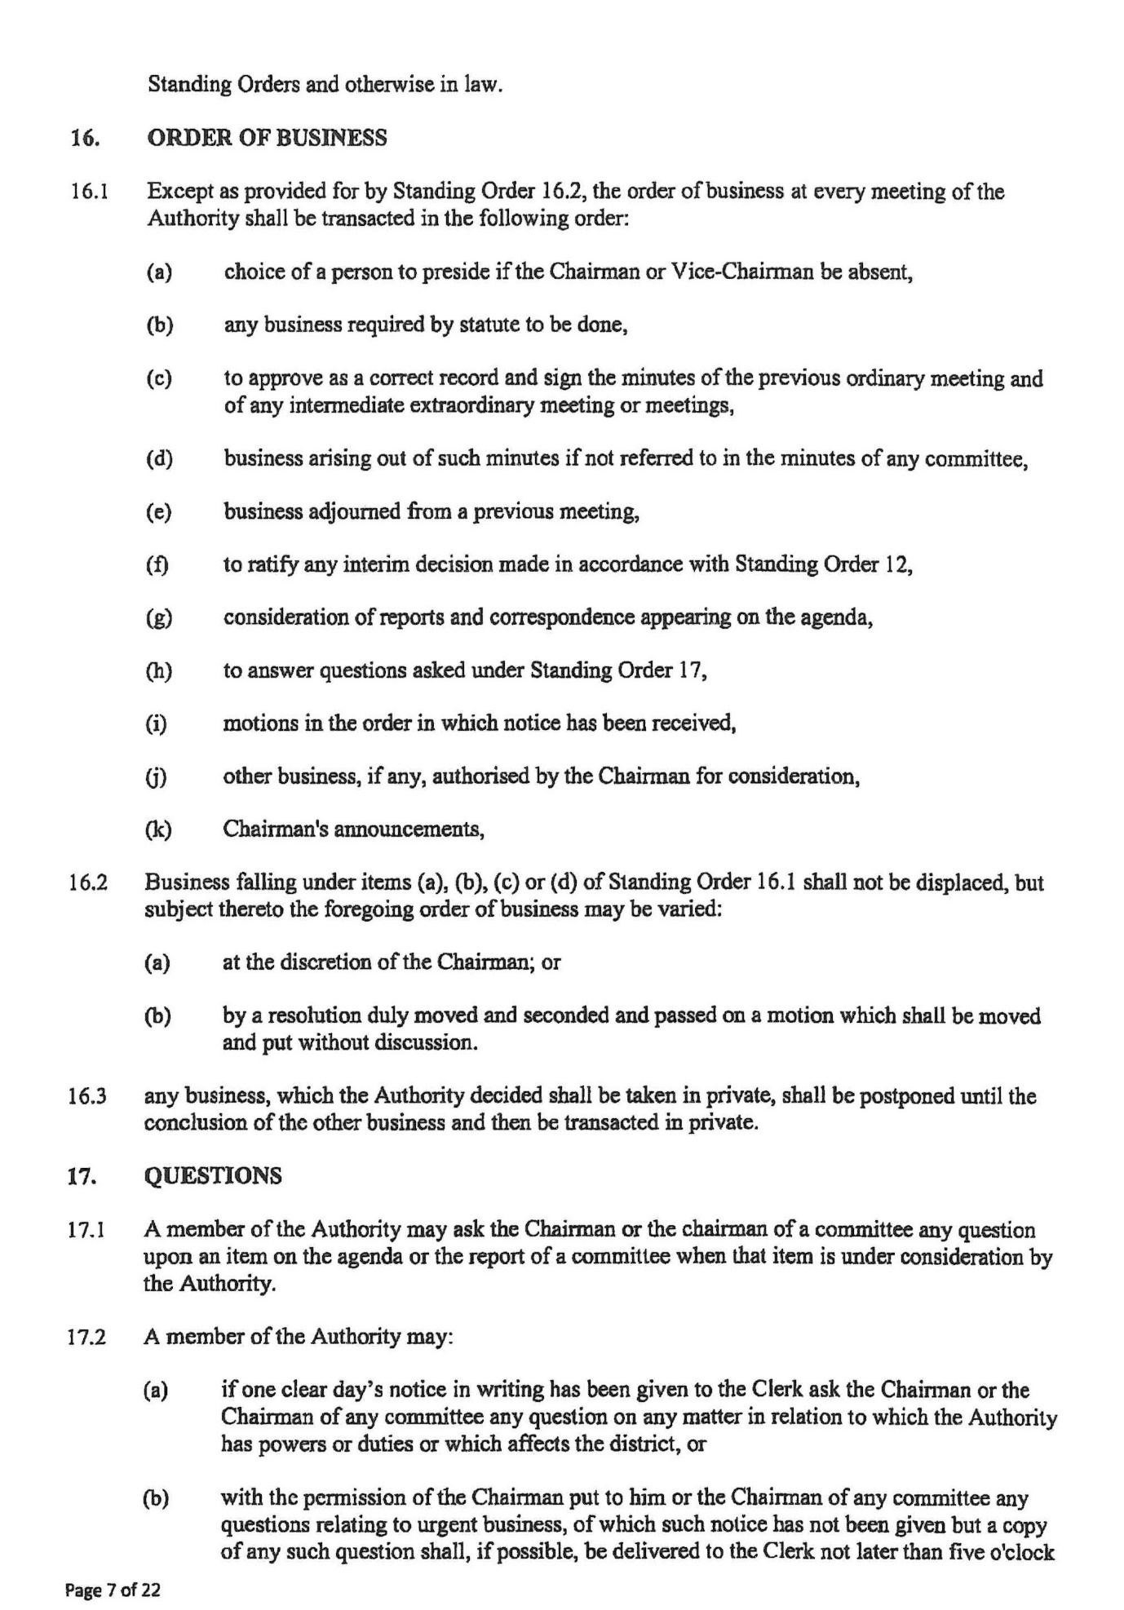

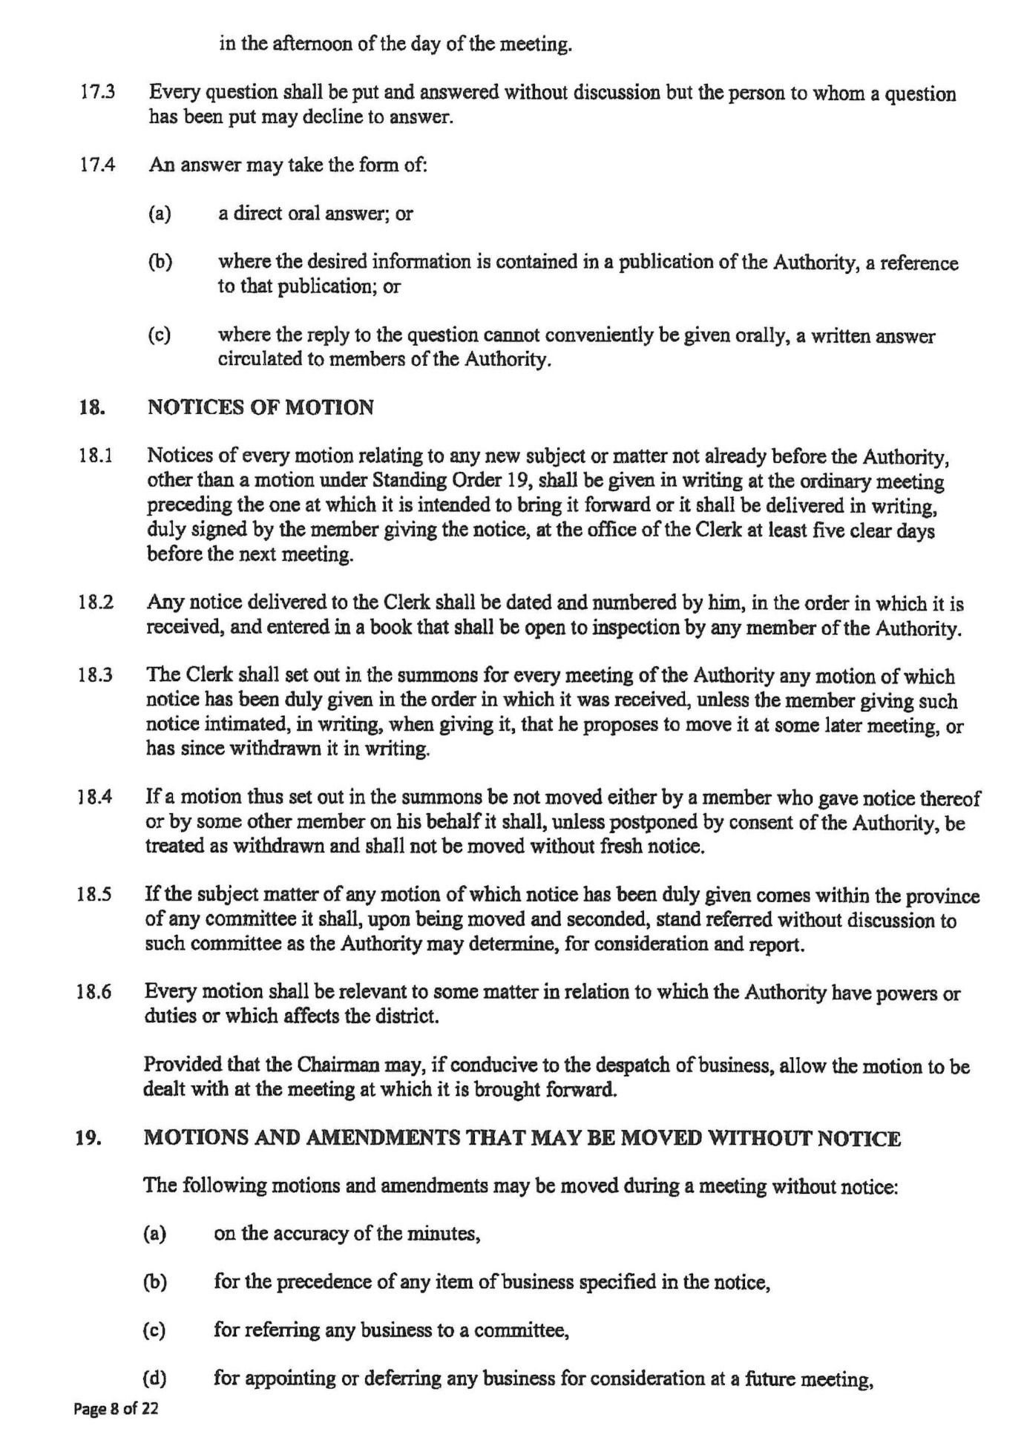

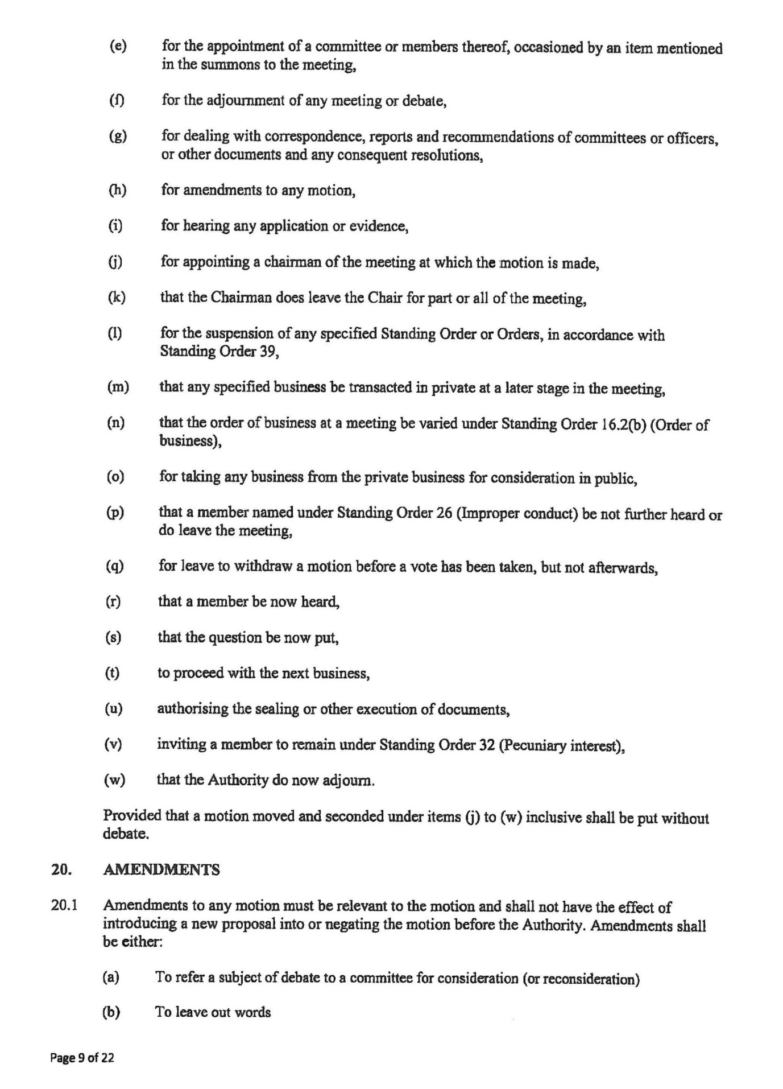

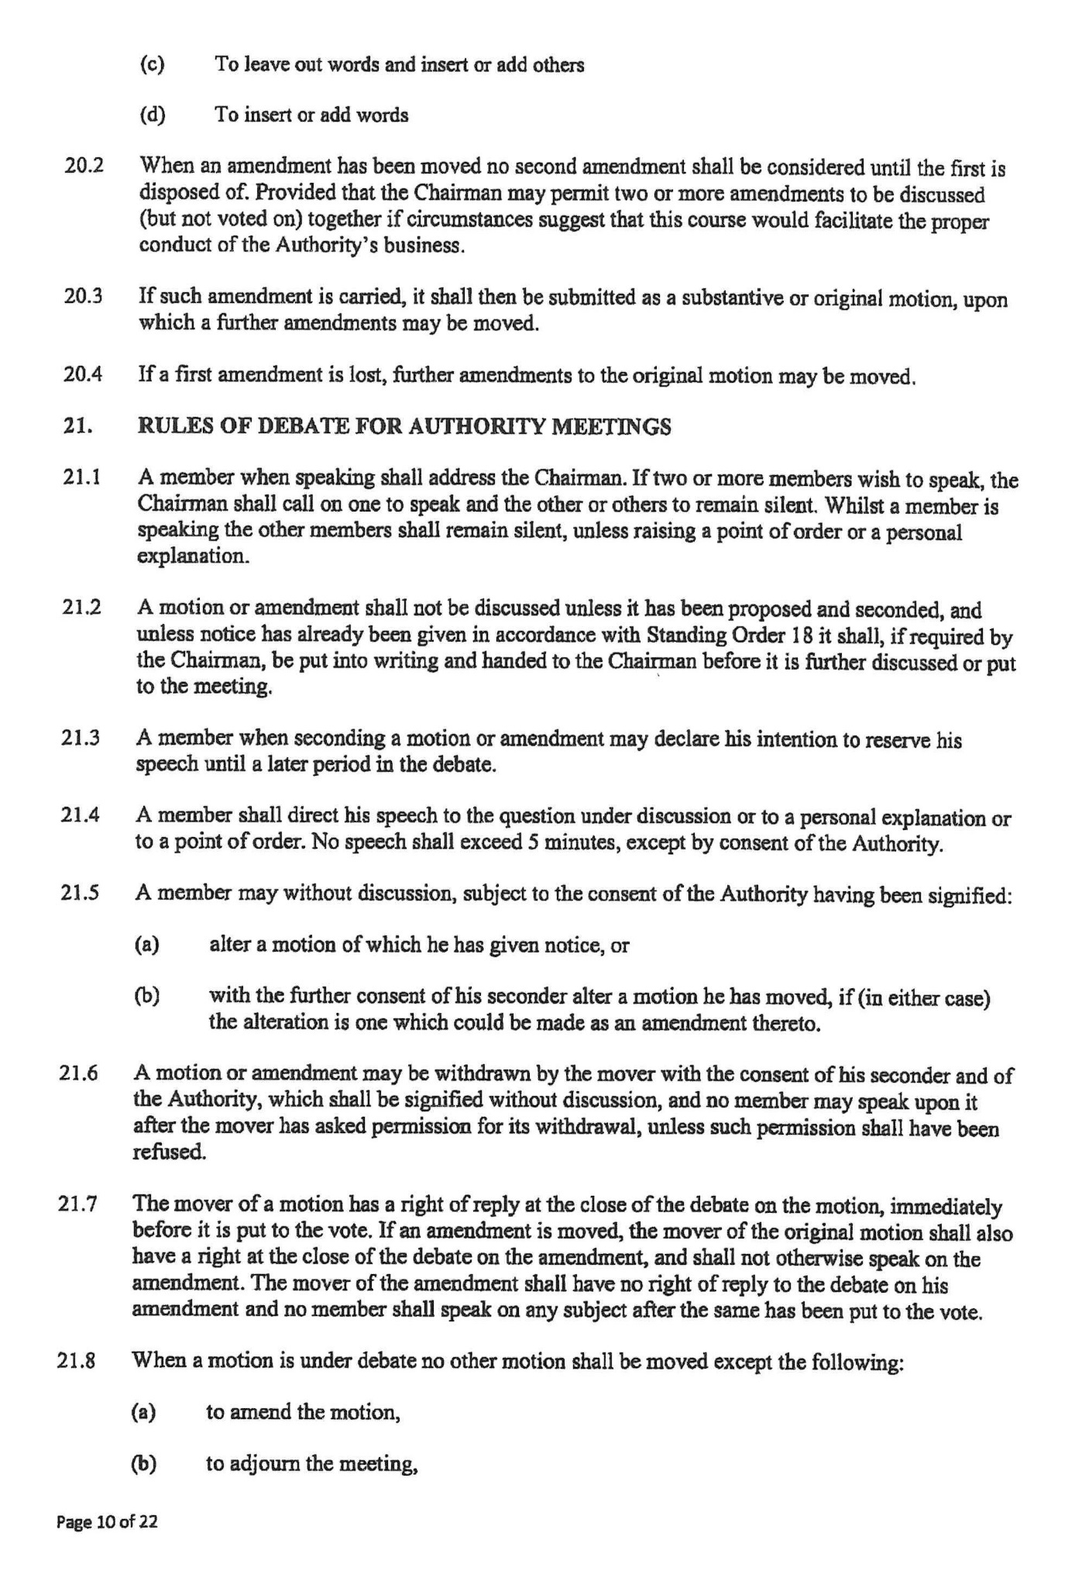

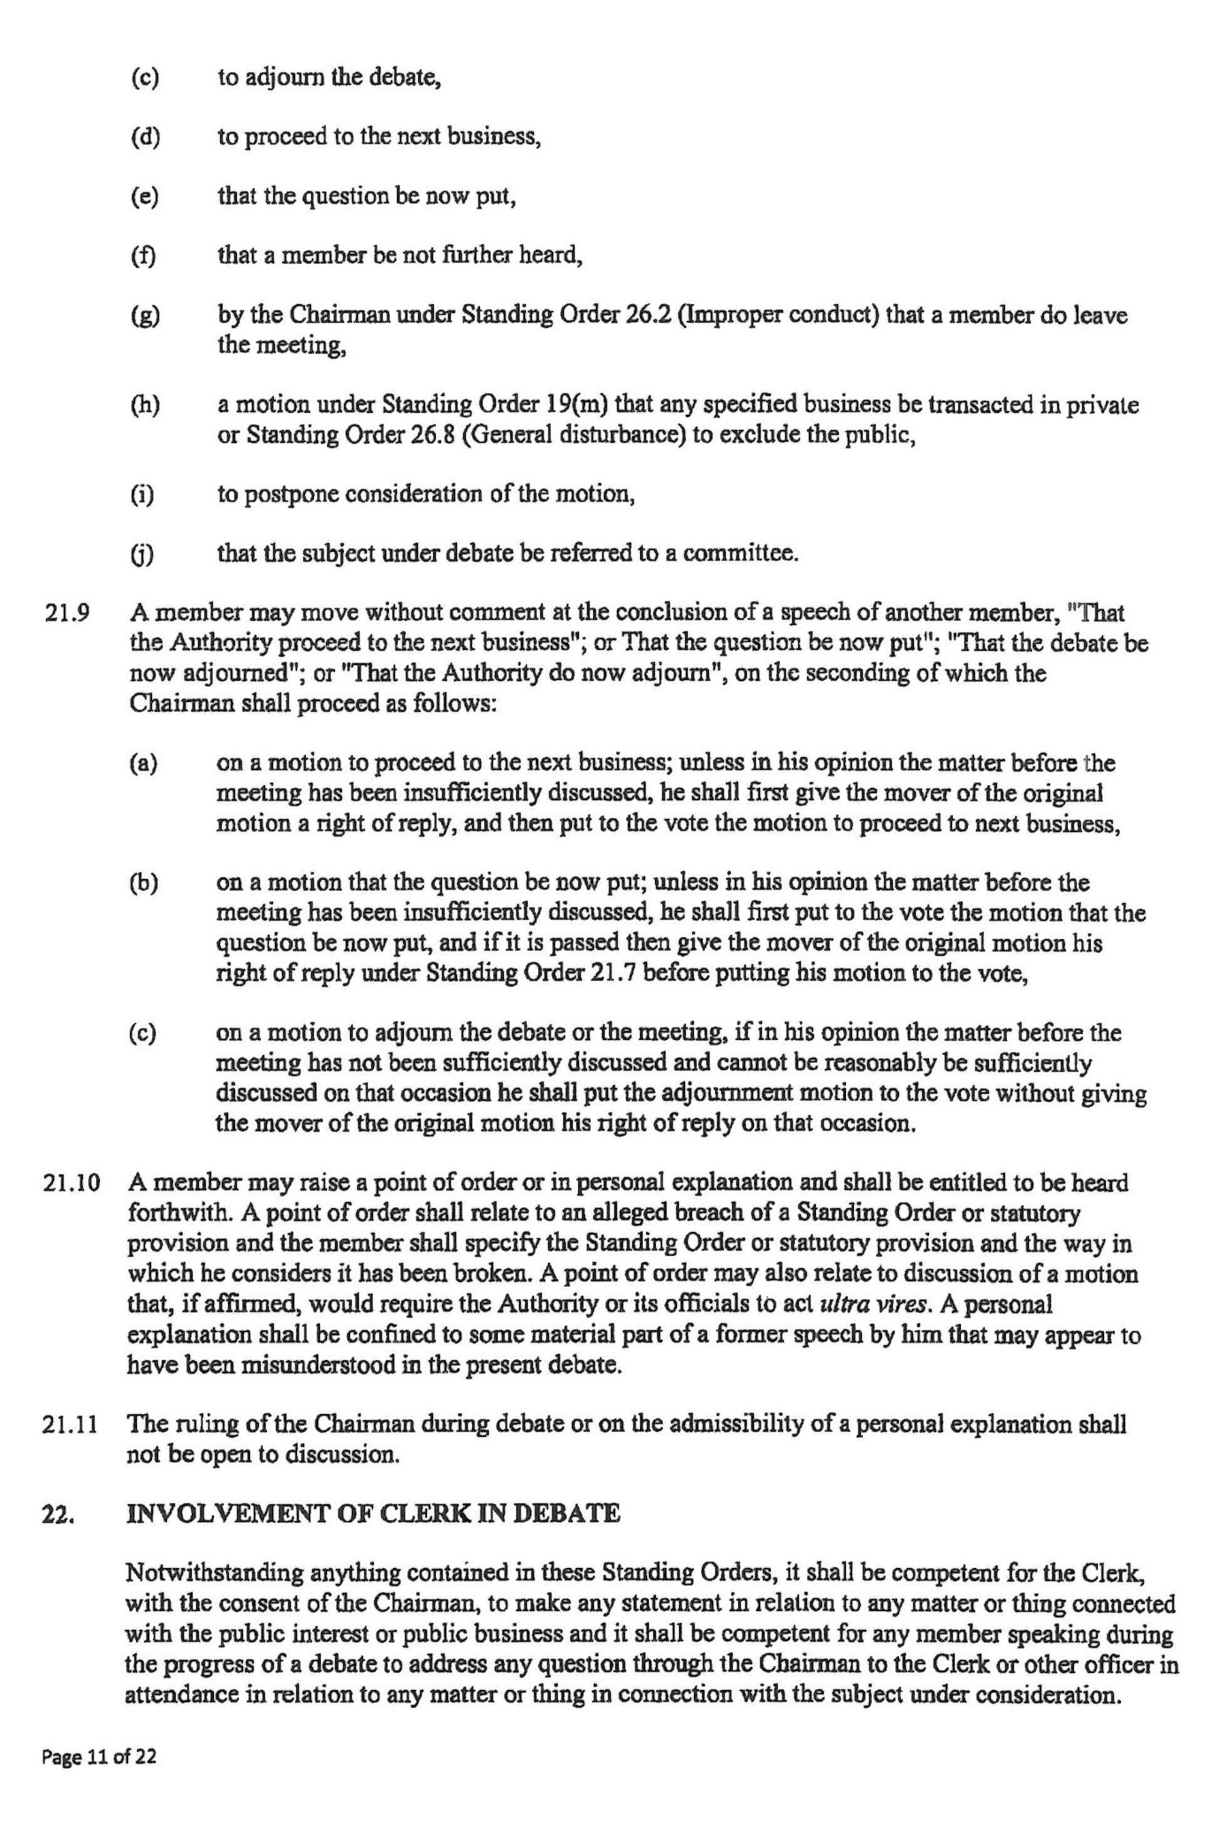

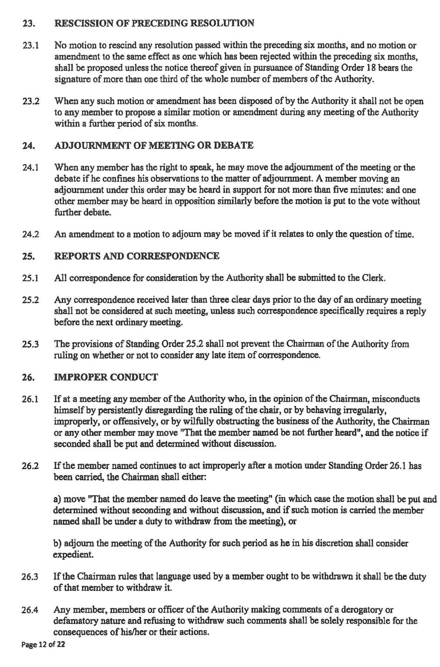
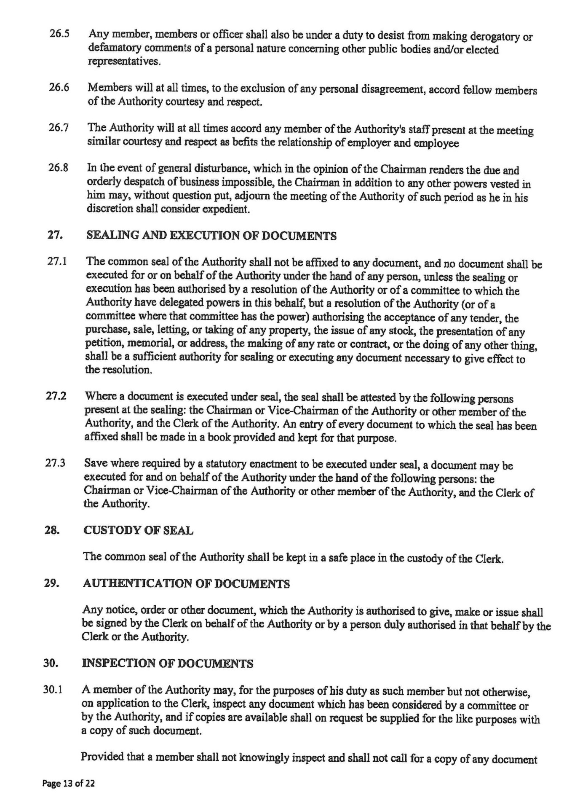

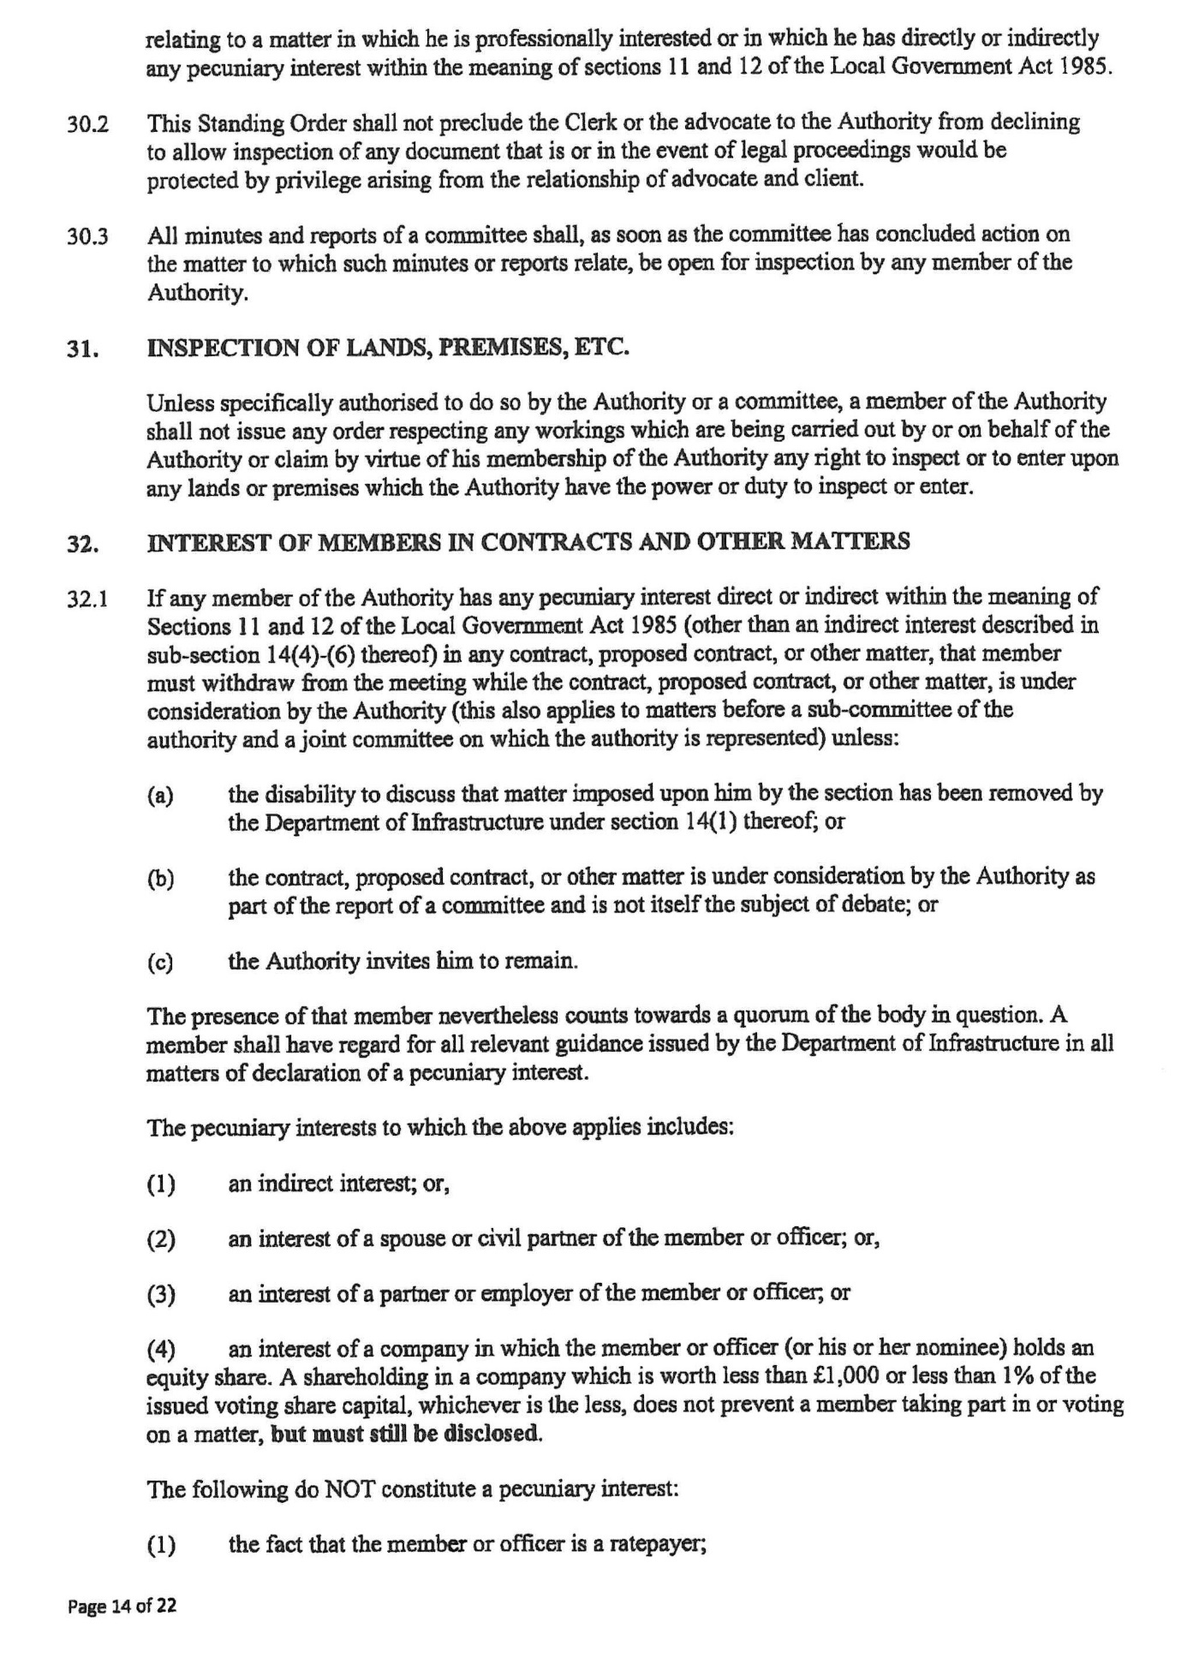

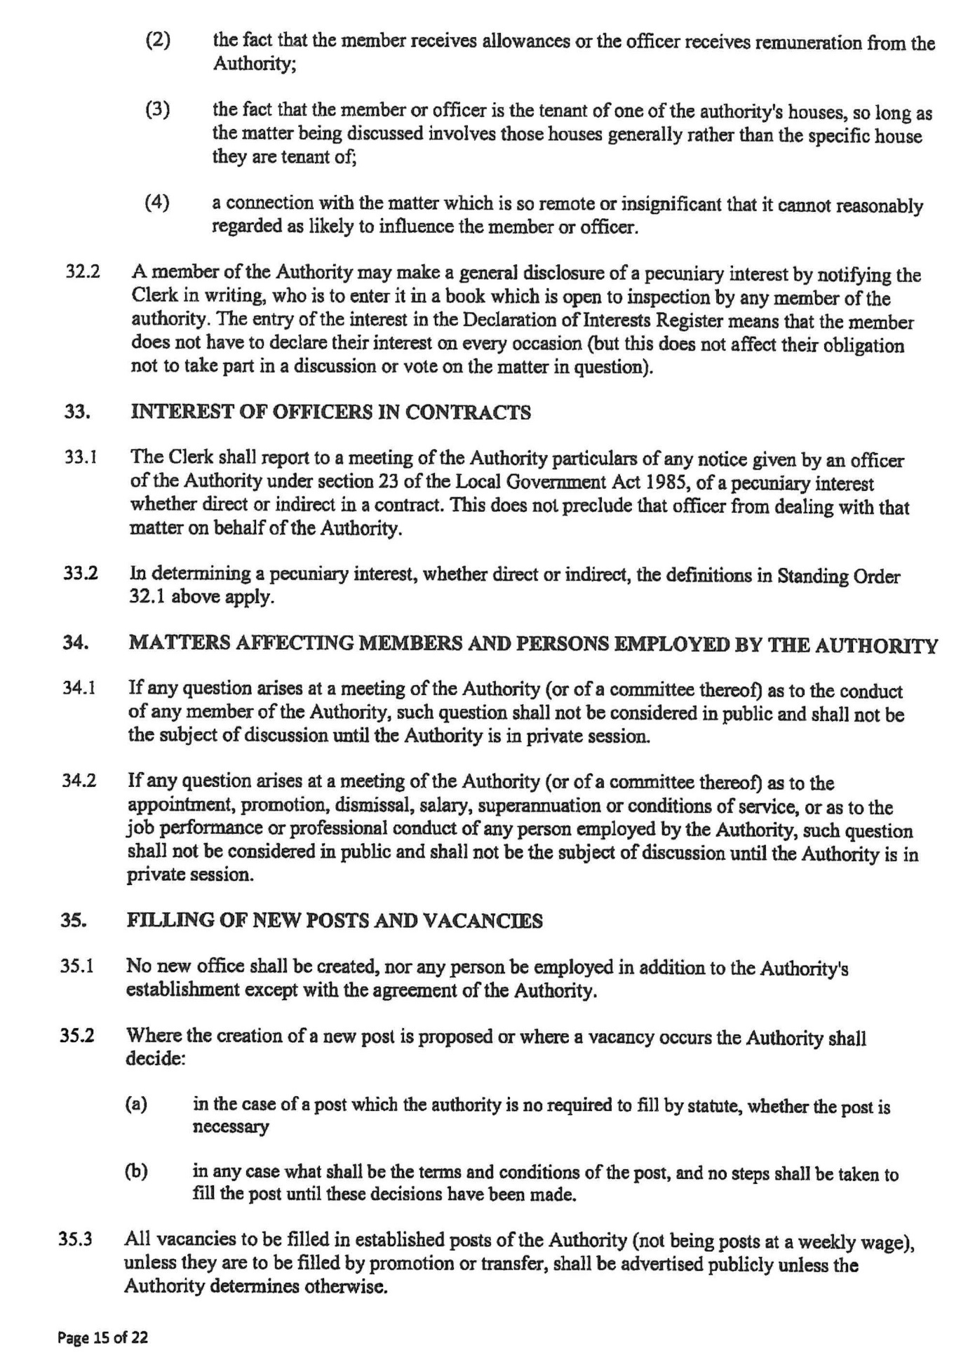

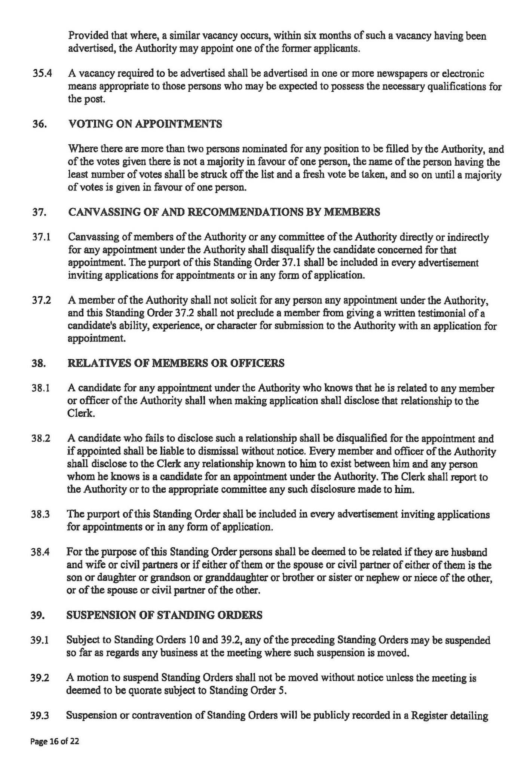

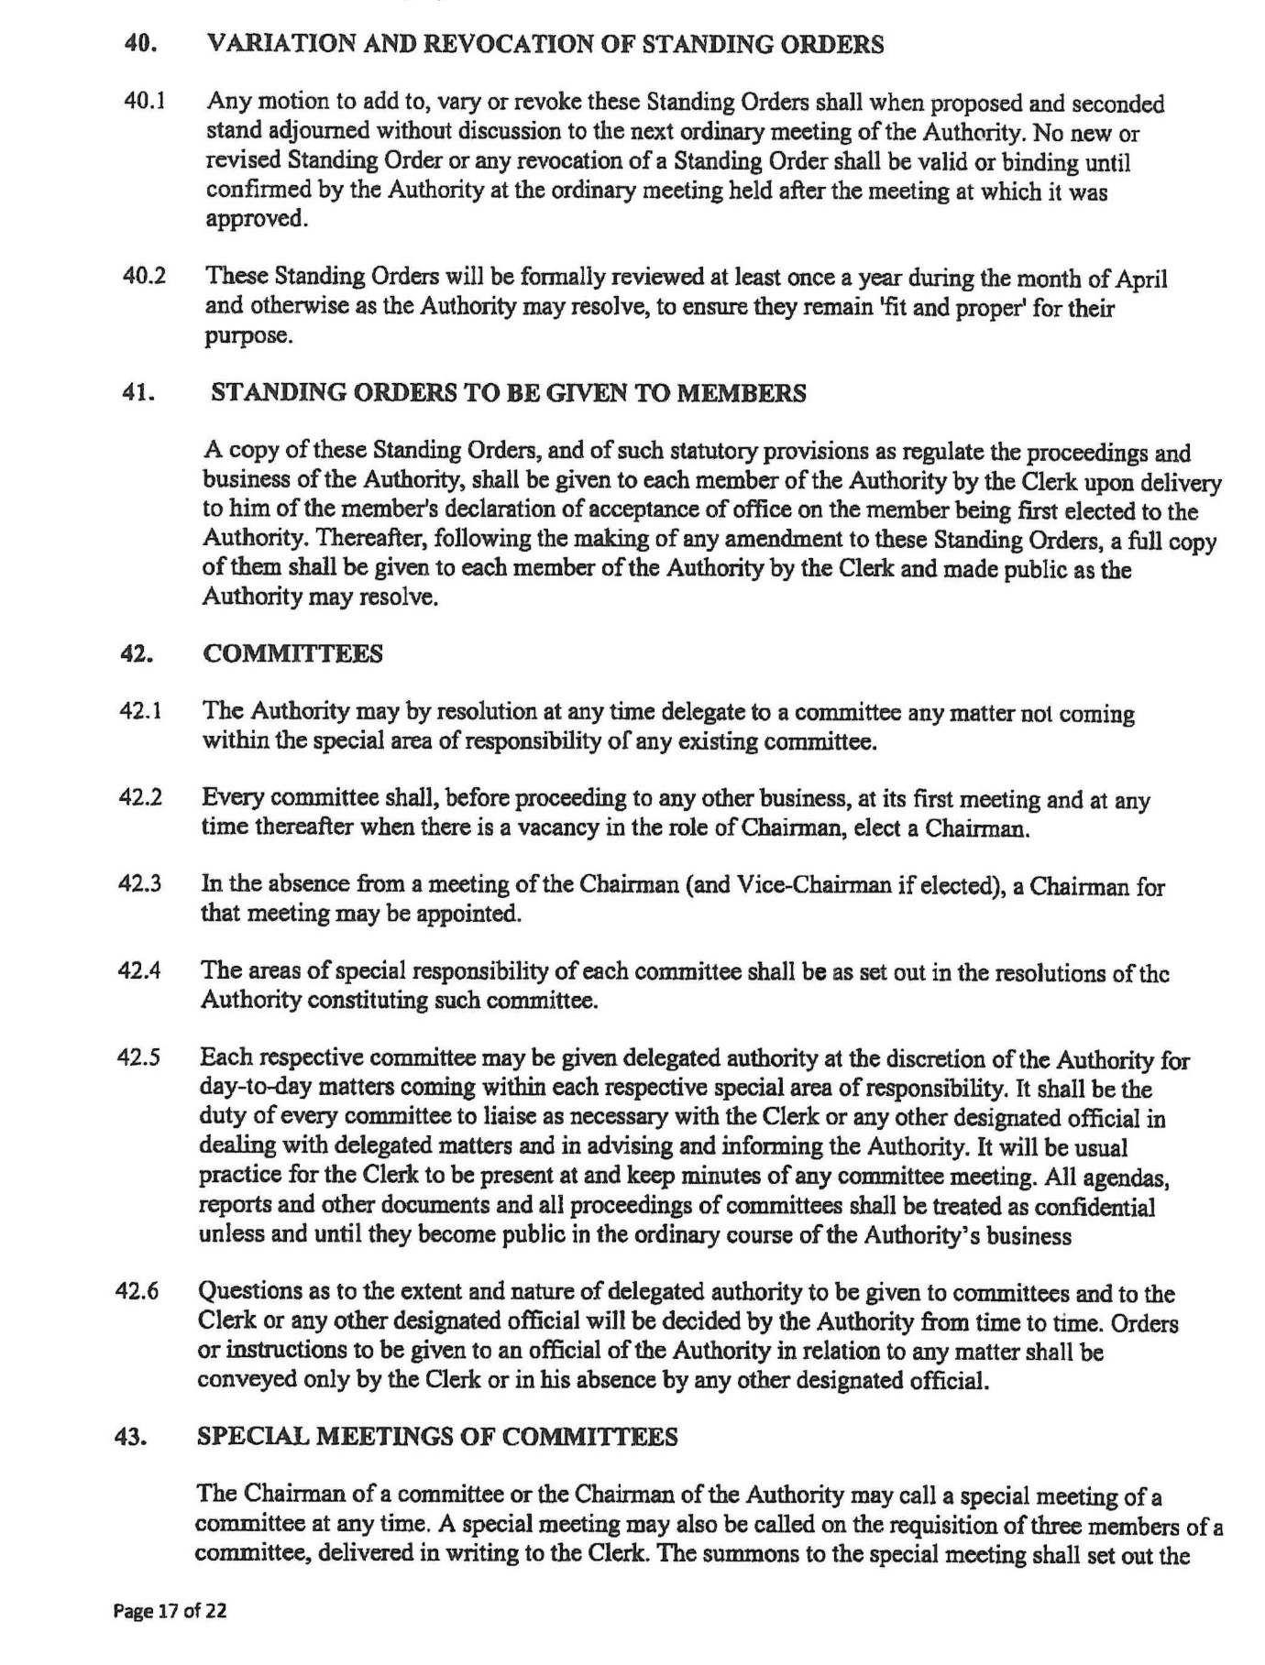

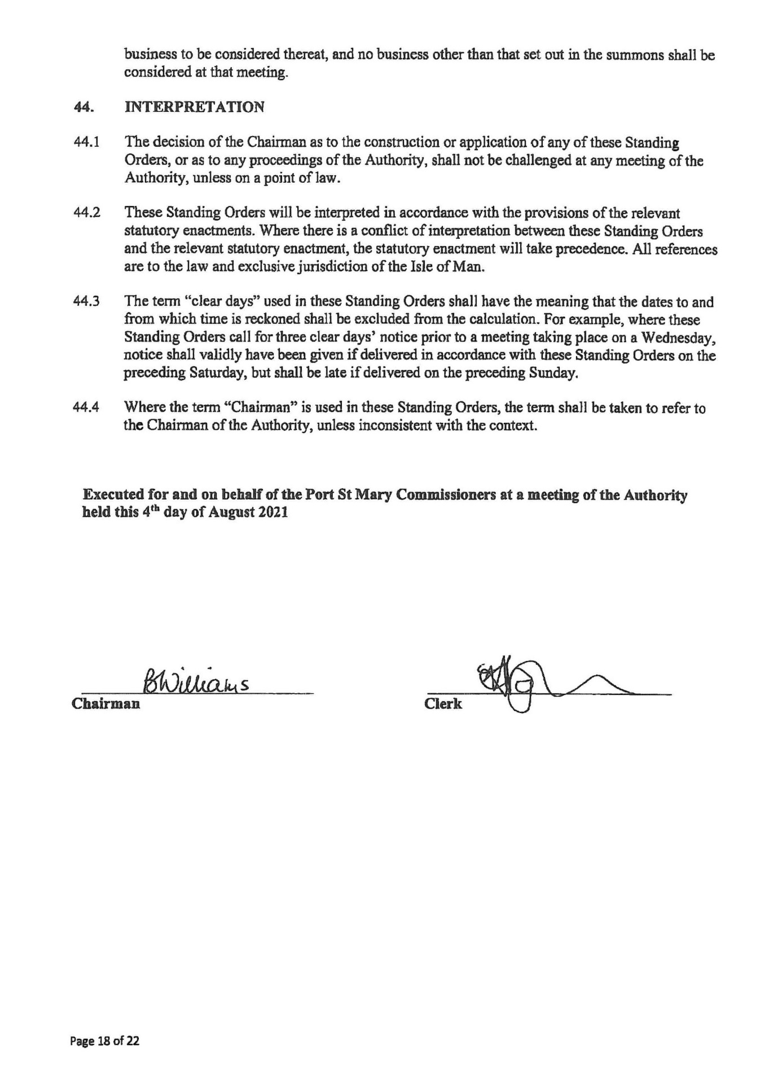
Item 6.4
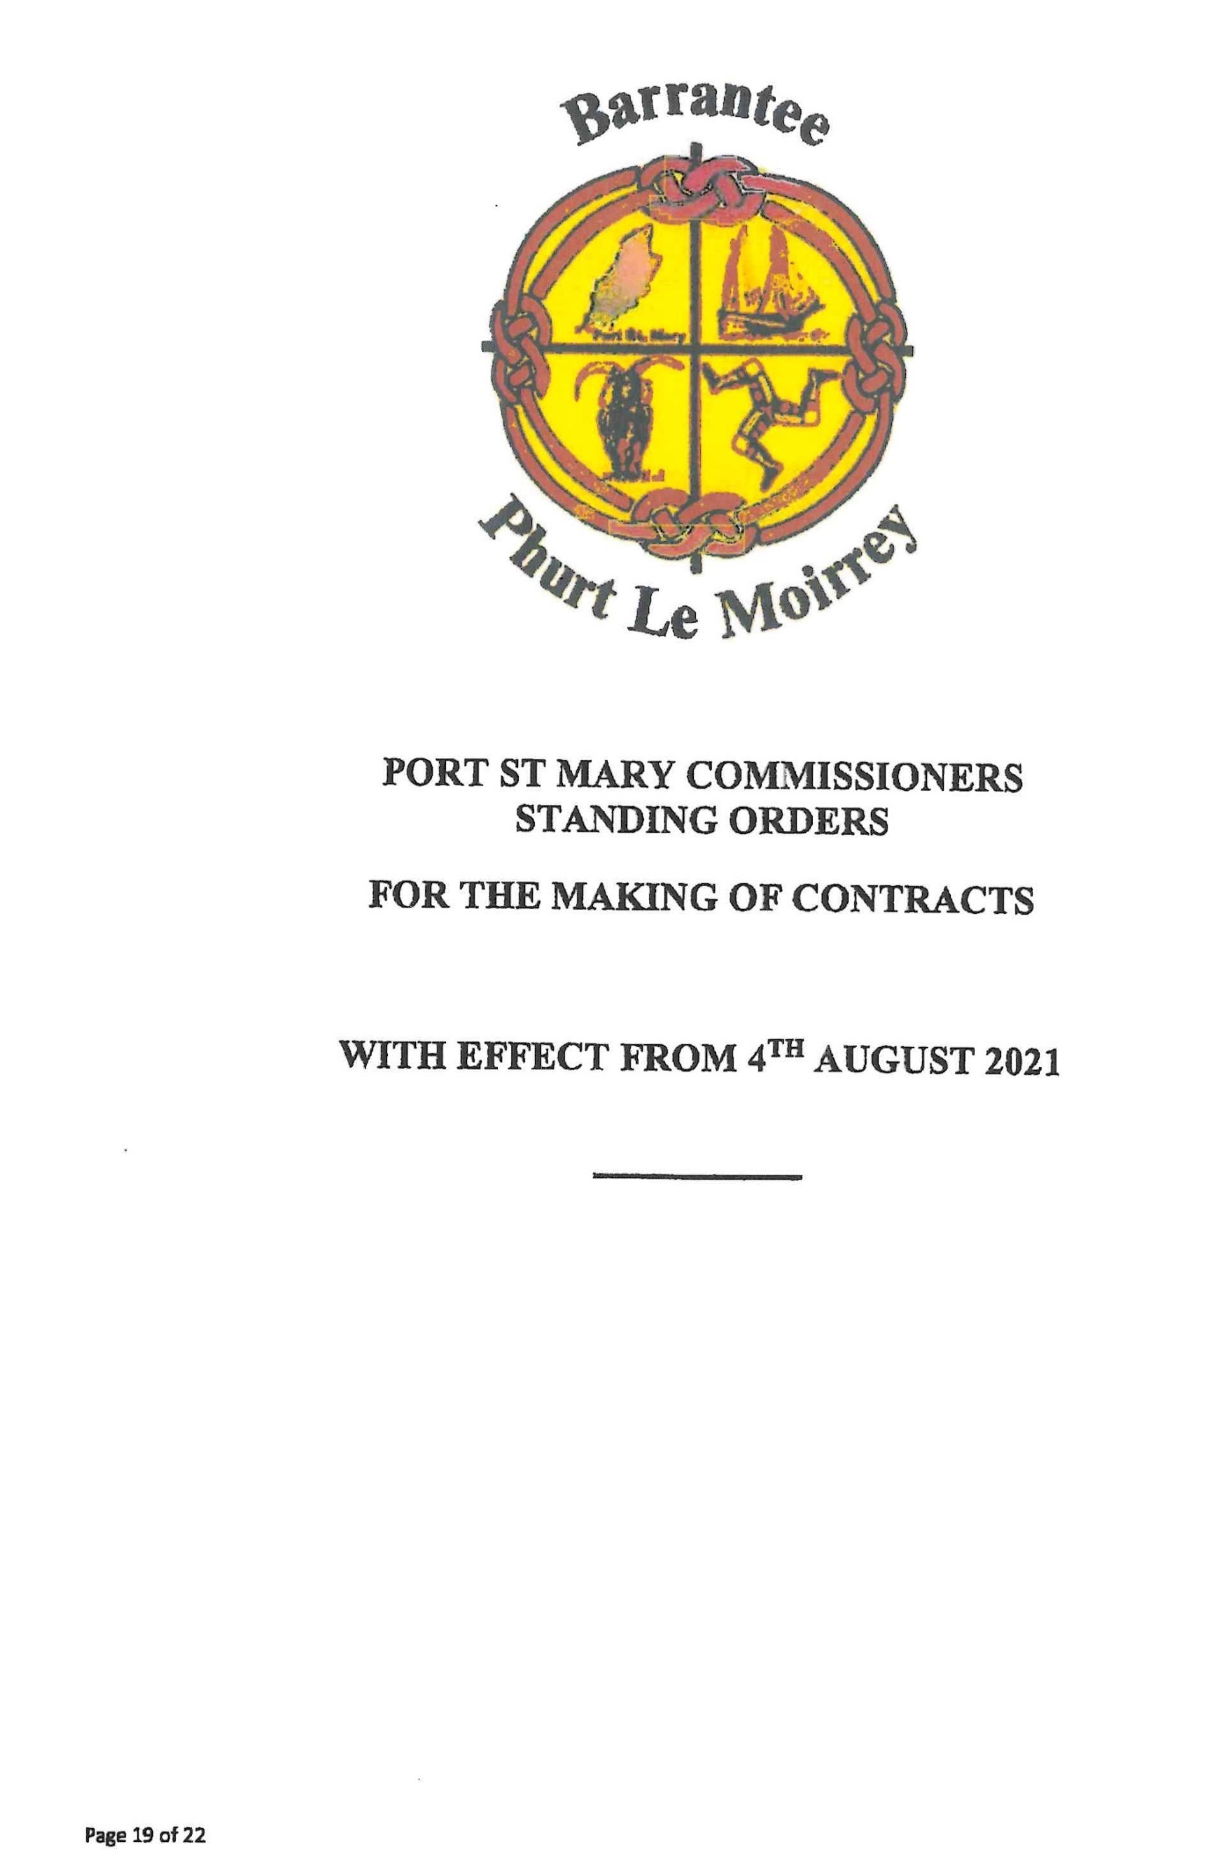

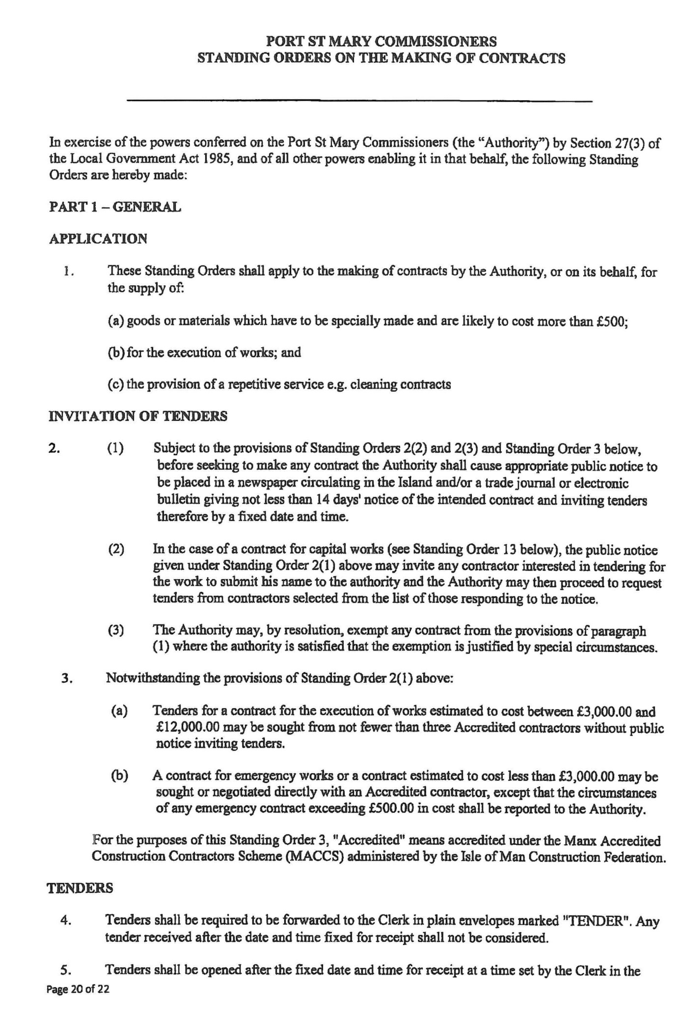

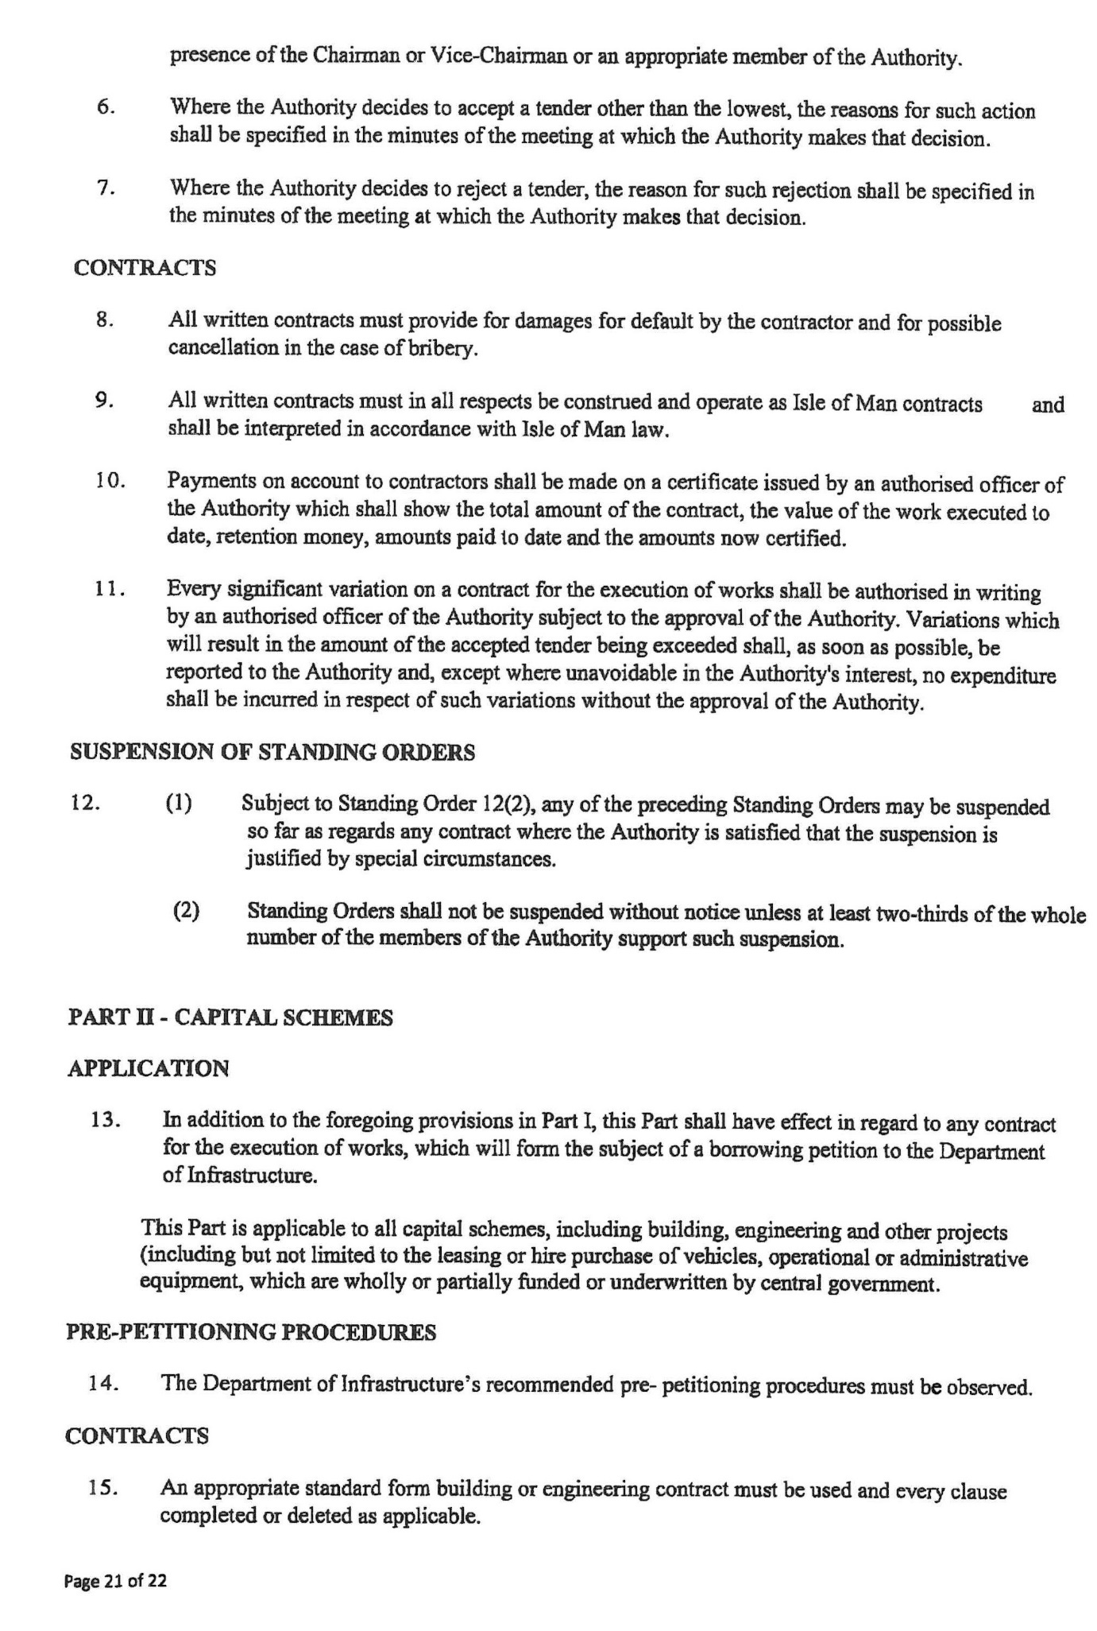
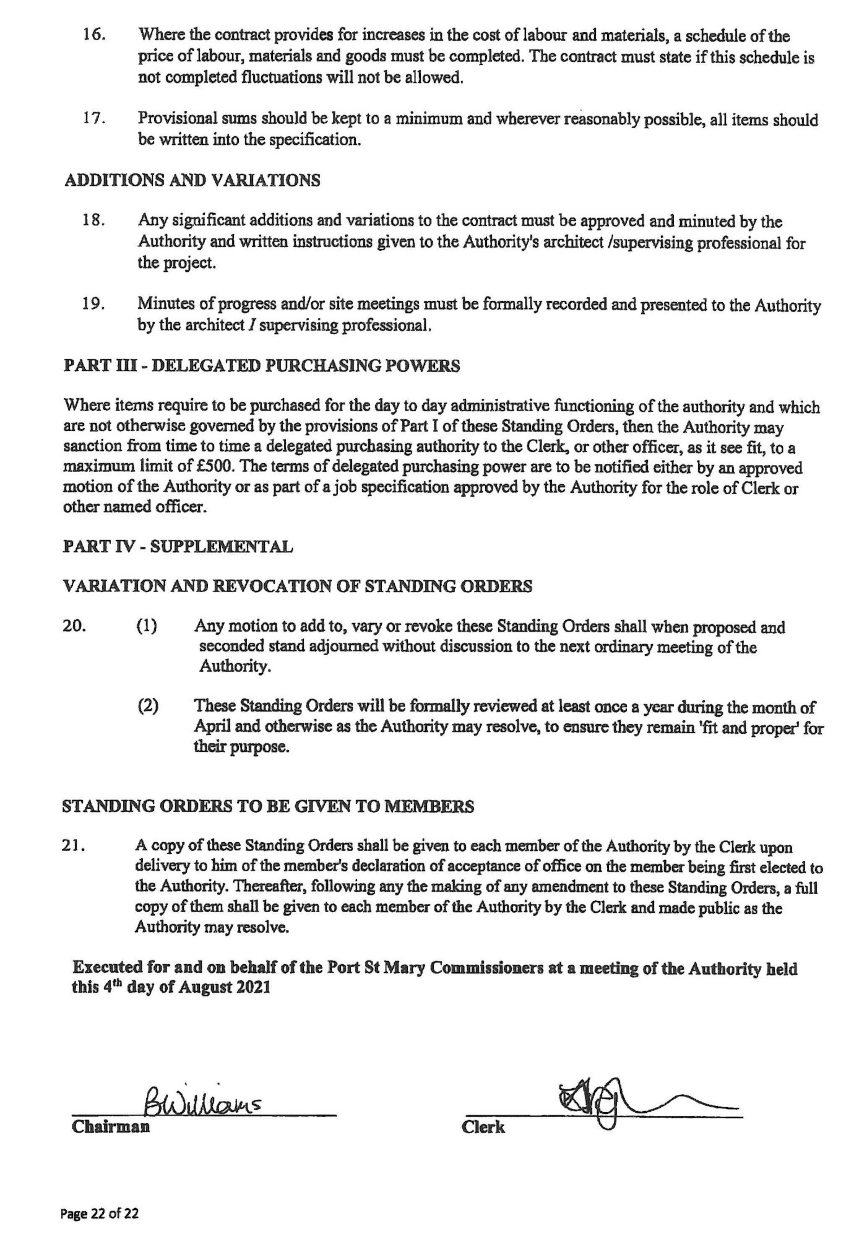
Item 6.5
PORT ST MARY COMMISSIONERS

BANK MANDATES

Any required amendments to the Bank Mandates are to be approved and the mandates signed.

Signatories required;
Chairman
Vice Chairman
Clerk

Item 7.1
Port St Mary Village Commissioners Board Meetings

Suspensions of Standing Orders on Meetings and on Contracts

Year ended 30th April 2023

Date of Meeting | Reason
Private Meeting  19th December 2022 | 8.1 Arqiva Lease – AG/NME requested to suspend Standing Orders to allow the previous decision regarding the Arqiva Lease to be discussed. All were in favour. Carried.  Arqiva Lease – HK to resend Arqiva Lease details to LVW and place on the January Agenda for discussion.

Item 7.2
