Date: 18th August 2023

NOTICE OF ORDINARY BOARD MEETING

In accordance with Schedule 1 of the Local Government Act 1985, Notice is hereby given that the next Board Meeting of Port St Mary Commissioners will be held in the Board Room at the Town Hall on Wednesday 23rd August 2023 at 7.00p.m. Private session of Port St Mary Commissioners will be held following conclusion of the Public Board Meeting.

- Only business of a formal nature as defined in the Agenda for the meeting which is set out below, may be discussed as defined in Port St Mary Commissioners Standing Orders governed by Section 27 of the Local Government Act 1985 [as amended by Section 8 Local Government Act 2006]. All Commissioners are urged to attend and bring with them their copy of Standing Orders.

Hayley Kinvig
Clerk

PORT ST MARY COMMISSIONERS
ORDINARY BOARD MEETING
23RD AUGUST 2023
AGENDA – OPEN SESSION

Item Number | Item |  | Action Required
1. | OPENING OF THE MEETING
1.1 | Welcome, Apologies & Declarations |  | As required by Board members
2. | MINUTES  Four Members who were present are required to approve Minutes
2.1 | Minutes of the Ordinary Meeting held on the 28th June 2023 |  | For Board approval
2.1 | Minutes of the Ordinary Meeting held on the 2nd August 2023 |  | For Board approval
3. | MATTERS ARISING
3.1 | Matters arising from previous meetings |  | Clerk to provide necessary updates
4. | MOTIONS – None
5. | FINANCE
5.1 | Invoices for payment in August | For Board approval
5.2 | Unpaid Rates Update | For Board discussion
6. | PROJECTS
6.1 | PSM Events |  | For Board discussion & approval
7. | HOUSING
7.1 | Housing Officers Report | For Board discussion
7.2 | Tenant Arrears Report | For Board discussion
8. | PUBLIC CORRESPONDENCE & COMMUNICATIONS
8.1 | Noise Nuisance Suspension | For noting
8.2 | Correspondence regarding wildflower areas | For Board discussion
8.3 | Flag request | For Board discussion
9. | PLANNING MATTERS
9.1 | Planning Applications |  | For Board discussion
9.2 | Planning Approvals |  | For Board discussion
10. | POLICY & RESOURCES
10.1 | 2nd Supplemental List 2023 |  | For Board discussion
10.2 | 2023/24 Meeting Dates |  | For noting
11. | PUBLIC CONSULTATIONS
11.1 | Access to cash survey | For Board response
11.2 | Isle of Man Strategic Plan Review | For Board response
11.3 | Amendments to the Planning Act and Secondary Legislation | For Board response
11.4 | Highways Service Level Agreement | For Board response
Item 3.1
PORT ST MARY COMMISSIONERS

MATTERS ARISING & PUBLIC CORRESPONDENCE REPORT

Matters Arising
Telephone Kiosks – HK to liaise with Rushen Primary School in the new school term. Painting & shelving has been instructed.
Food trailer at Kallow Point – A response is awaited.
Public Correspondence
Fire Concern – HK liaising with the Fire Department.
Weekend and overnight parking in residential areas – The requested response was issued.

Item 5.2
PORT ST MARY COMMISSIONERS

UNPAID RATES UPDATE

Below details an update on the unpaid rates situation for the prior year, as it stands there has been 22.62% reduction since February 2023.

Month Amount Movement Increase/reduction Percentage MoM Percentage overall
16/02/23 £34,533.13 - - - -
23/06/23 £29,842.58 £4,690.55 Reduction 13.58% 13.58%
17/08/23 £26,723.13 £3,119.45 Reduction 10.45% 22.62%

£7,810.00 recovered

Item 6.1
PORT ST MARY COMMISSIONERS

PROJECTS UPDATE
6.1 | Events  Christmas Carol Service – No further update available.  Civic Service – A date and time of 10th September at 10.30am has been agreed, the service will be held at Mt Tabor. AG has requested to do a reading. Caterers have been arranged, invites have been issued. Sheean Millish have been requested to participate; they will assist with hymns & Olivia Black will perform a solo number. The Board are required to discuss the Order of Service at the meeting (to be tabled).  Discussion to be had regarding Olivia’s songs.  Brig Lily – A dedication for the slab will beheld at 10am at the Memorial Garden ahead of the Civic Service on the 10th September.  Village in Bloom – Five entries were received, AG carried out the judging, to be discussed at the meeting.

Item 7.1

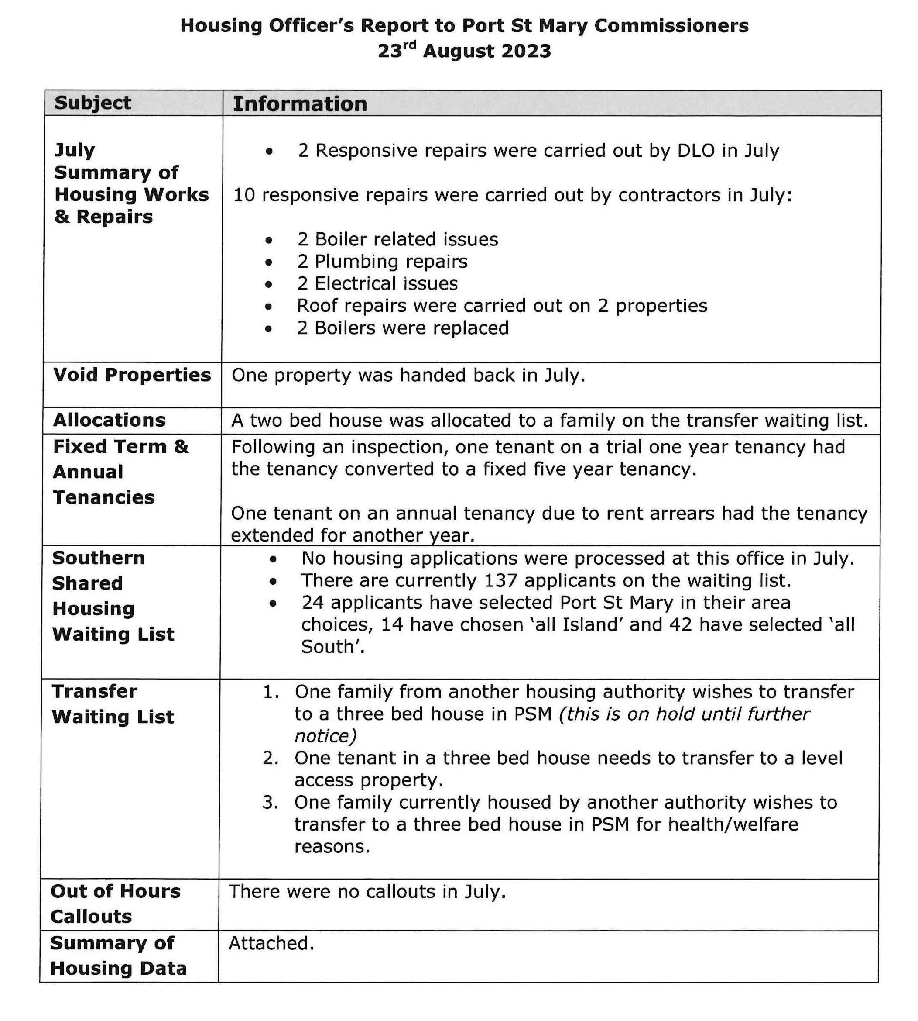
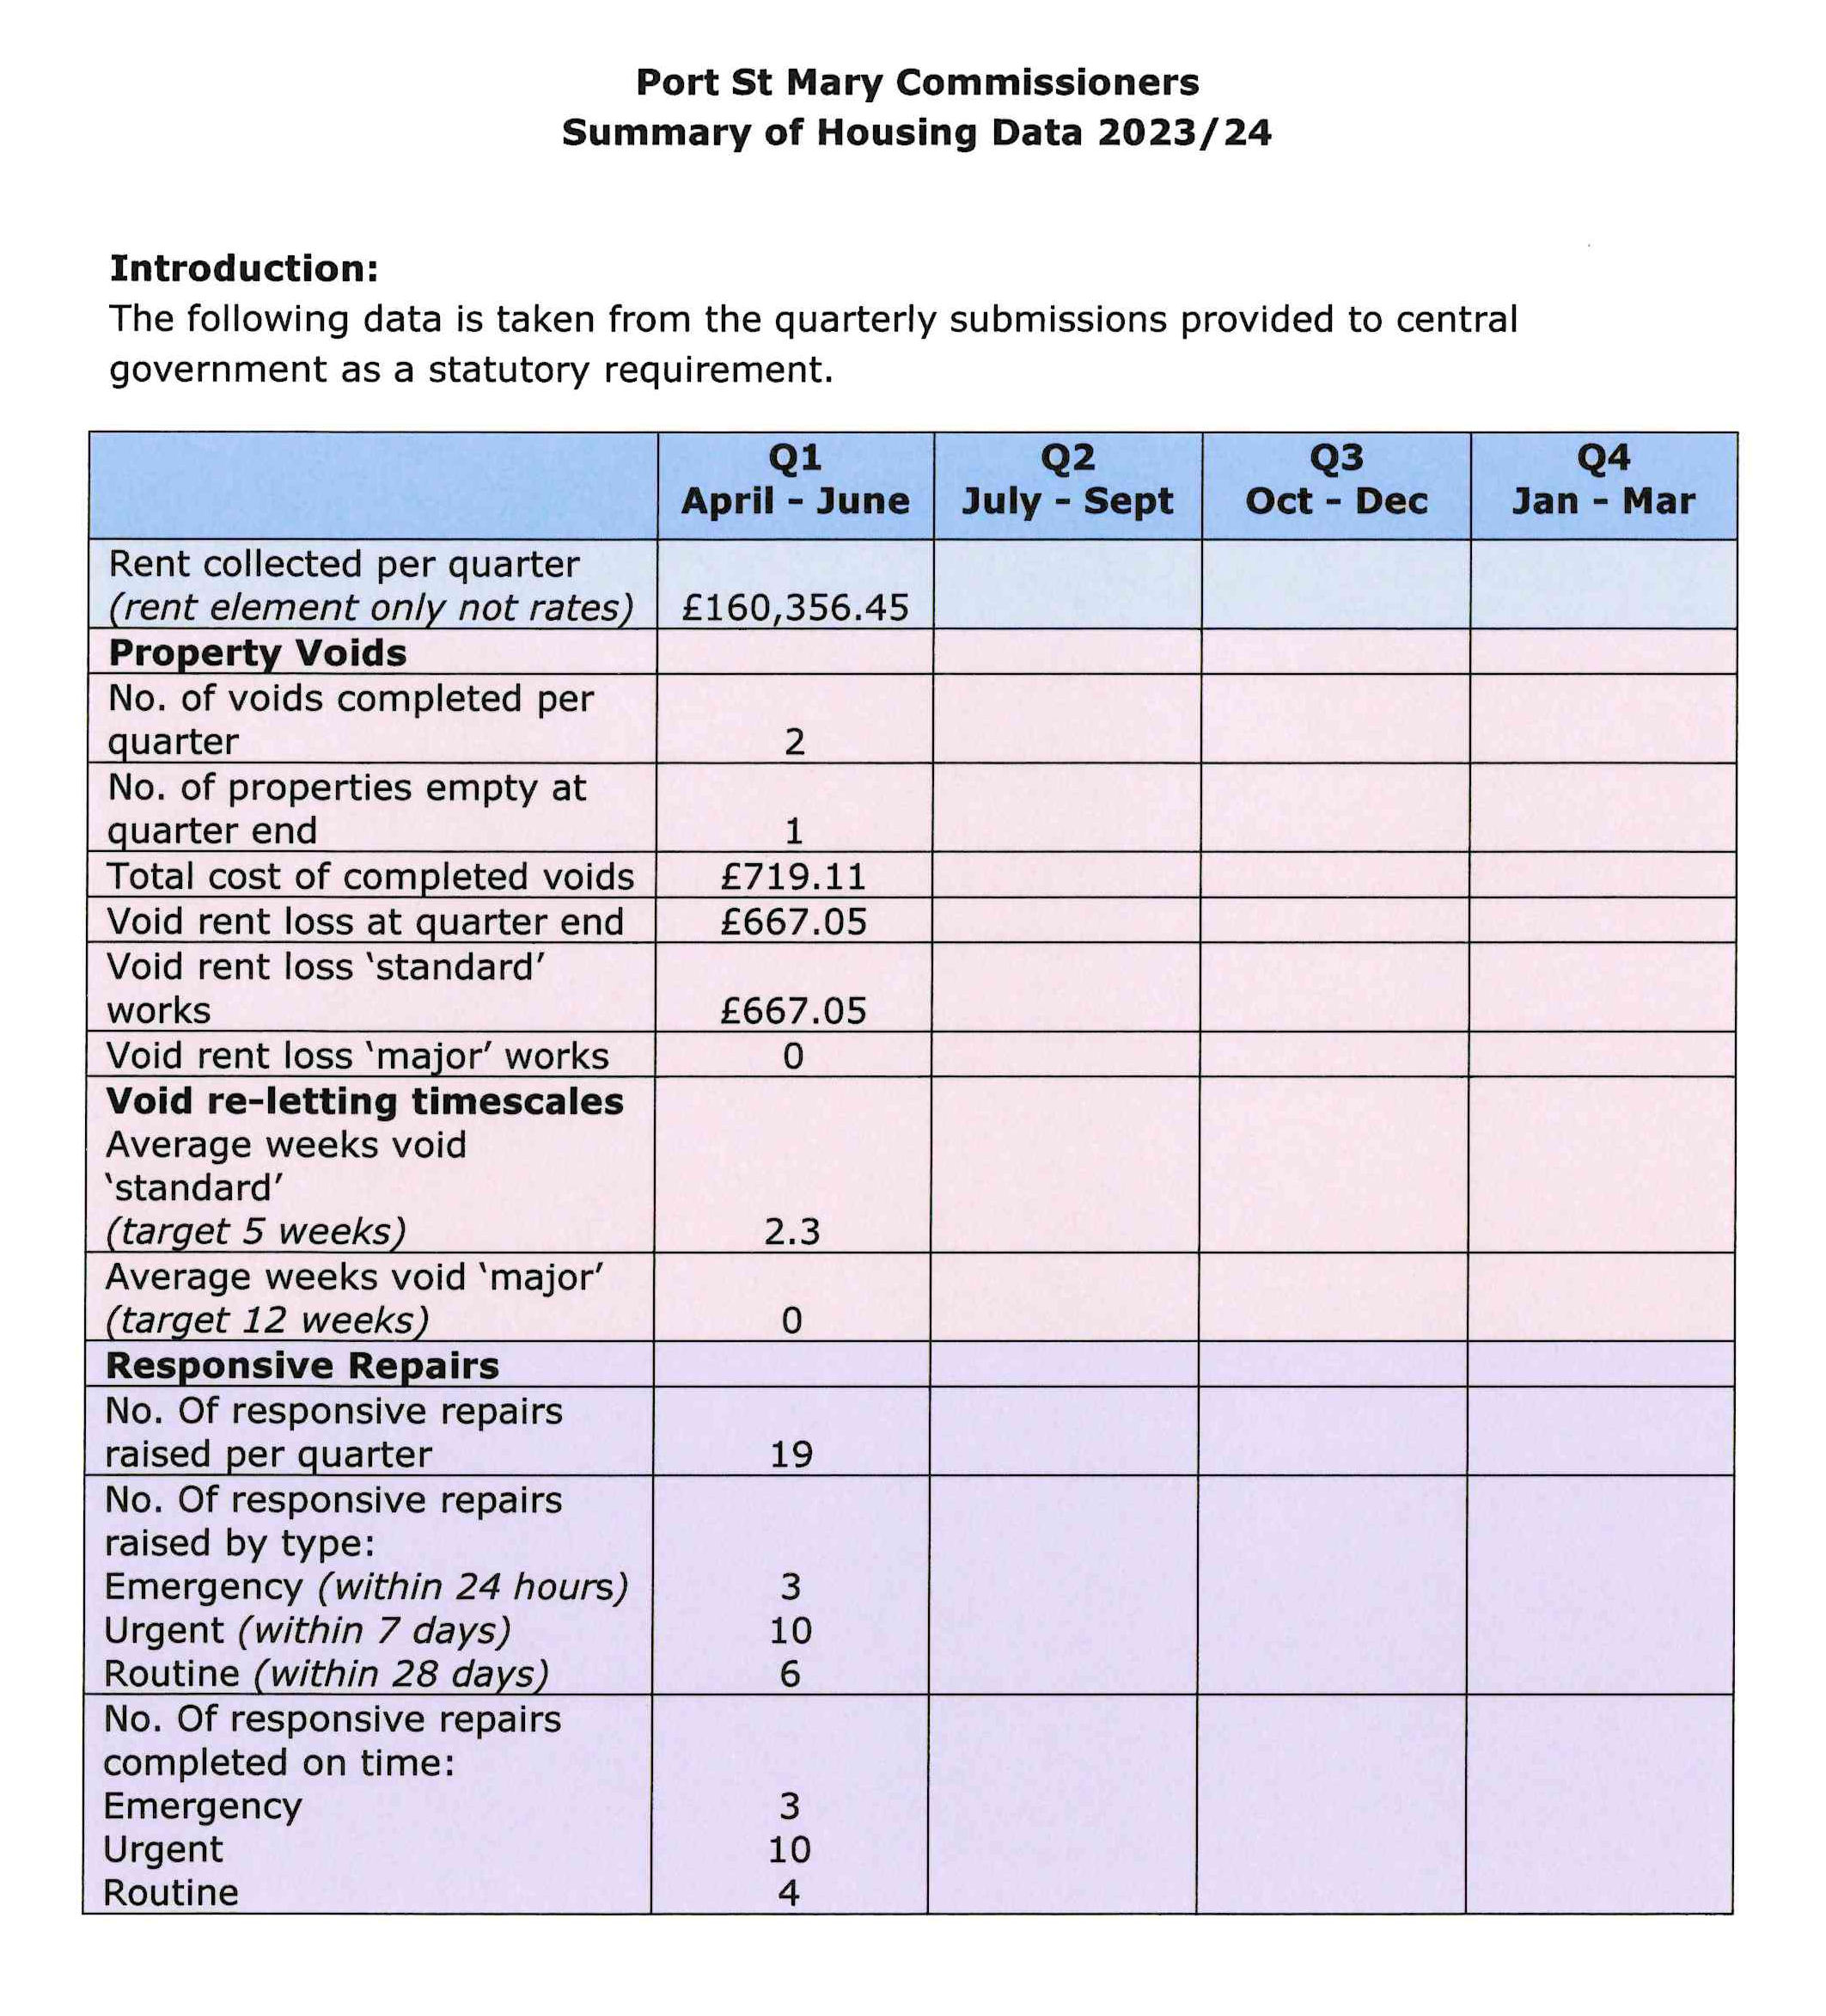

Item 8.1
PORT ST MARY COMMISSIONERS

PUBLIC CORRESPONDENCE
Sent: 26 July 2023 15:12
Subject: Extension to suspension of statutory nuisance investigation service

Dear Steve

Re: 6 Month extension the suspension of DEFAs statutory nuisance investigation service
Part 1 Public Health Act 1990

I write to advise that the Department recently reviewed the decision it made on the 8th December 2022 to suspend the investigation of all allegations of statutory nuisances so that its Environmental Health Team could focus on higher priority work.

Unfortunately the circumstances that led to the suspension have not improved and are unlikely to do so in the short term so the Department has reluctantly taken the decision to suspend the service for a further 6 months.

The Environmental Health Team will continue to investigate statutory nuisance cases that were commenced prior to the suspension of the service and they will continue to advise local authorities where they come across statutory nuisances in the course of their work to assist local authorities in the performance of their statutory duties under Part 1 of the Act.

As an alternative, Section 5 of the Act provides individuals with powers to take their own action in the criminal courts for a statutory nuisance. Individuals with property rights can also take action in the civil courts for private nuisance and Section 19 of the Dogs Act 1990 provides for any person to make a complaint to a court of summary jurisdiction that a dog causes a nuisance or annoyance to the inhabitants of the neighbourhood in which it is kept.

It should be noted that the Act does not place a duty on Local Authorities to investigate allegations of statutory nuisances.

I would be grateful if you could communicate this to all local authorities.

Your Sincerely

Kristian

Mr. Kristian Cowin MCIEH CEnvH
Head of Environmental Health
Item 8.3
PORT ST MARY COMMISSIONERS

PUBLIC CORRESPONDENCE

Sent: 15 August 2023 21:40
Subject: Request to Fly the Manx Red Ensign on Merchant Navy Day

Dear Clerks/Officials,
I hope this email finds you well. As Merchant Navy Day approaches on the 3rd of September, I am writing to you with a special request on behalf of our community.
Merchant Navy Day holds great significance in honouring the contributions and sacrifices of our maritime professionals. It serves as a reminder of their unwavering dedication and commitment to the maritime industry, both in times of war and peace. This year, we aim to make the day even more memorable by uniting as a community to show our support and gratitude.
We kindly request your participation in this endeavor by flying the Manx Red Ensign from your flag poles on Merchant Navy Day, 3rd September. This symbolic gesture will not only pay homage to the maritime heritage of the Isle of Man but also demonstrate our collective appreciation for the efforts of seafarers past and present.
Your involvement will contribute to fostering a sense of unity within our community and send a powerful message of gratitude to those who have served and continue to serve in the Merchant Navy. We believe that by coming together in this way, we can create a memorable and meaningful Merchant Navy Day celebration.
The Isle of Man King George’s Fund for Sailors (KGFS), has been supporting our seafaring community since 1972. In the UK the charity is also known as The Seafarers' Charity who also administers the Merchant Navy Day Fund. On the Isle of Man we intend to act as the official organiser of Merchant Navy Day.
Should you require a Manx Red Ensign, they can be purchased online here https://www.flyingcolours.org/isle-of-man-civil-ensign/
or you may be able to borrow one from the Isle of Man Ship Registry.
We would welcome any pictures you may want to take with your board members, we will of course share them on our social media platforms. Should you wish to post your own images, please be sure to tag us and we can share and celebrate your efforts. The hashtags for this campaign are #IoMMerchantNavyDay #IoMRedEnsign
Should we have enough uptake on participation and images of local authorities taking part, I will seek a spread in local newspapers to further share this celebration.
If you require any assistance or additional information, please do not hesitate to reach out to us. Your support is invaluable, and we are deeply grateful for your consideration of our request.
Thank you for your time and dedication to our community. We look forward to celebrating Merchant Navy Day with you.
Regards

Item 9.1 & 9.2
PORT ST MARY COMMISSIONERS

PLANNING MATTERS

9.1 Planning Applications
23/00930/B – Harbour View, Athol Street for the replacement of timber door with composite door and PVC top panel.

9.2 Planning Approvals
23/00704/C – Bay Cliff, 32 High Street for additional use of residential property (class 3.3) as tourist accommodation (class 3.6).
23/00713/B – The White Cottage, Four Roads for the fitting of a new window to the rear elevation of the kitchen and the replacement of six existing windows on the front elevation. All windows to be of timber construction and finished with white gloss paint.
23/00218/B – Ridgeway, Plantation Road for the installation of replacement roofs to dwelling

Item 10.2
PORT ST MARY COMMISSIONERS

MEETING DATES FOR 2023/24

2023/24 Meeting Dates
13th September 2023 | Second meeting – may not be required
27th September 2023
11th October 2023 | Second meeting – may not be required
25th October 2023
8th November 2023 | Second meeting – may not be required
22nd November 2023
13th December 2023
24th January 2024
28th February 2024
27th March 2024
24th April 2024
8th May 2024 - AGM
22nd May 2024
26th June 2024
24th July 2024
28th August 2024
25th September 2024
23rd October 2024
27th November 2024
11th December 2024

Item 11.3
PORT ST MARY COMMISSIONERS

PUBLIC CONSULTATION
Sent: 07 August 2023 14:59
Subject: Consultation - Amendments to the Planning Act and Secondary Legislation

Good afternoon,

I write to update that as part of the Built Environment Reform Programme , and to facilitate the Department of Environment, Food and Agriculture’s (DEFA) core functions (Registered Buildings) a consultation has been launched on proposed changes to the Town and Country Planning Act 1999. The consultation runs until the 27.10.23 and the details can be accessed via the Consultation Hub

In summary the changes will:
• provide clarity around the definition of development which will mean better understanding for building owners on what can and can’t be done without planning approval (these changes, together with planned secondary legislation, will provide an opportunity to ensure very minor works can be excluded from needing approval);
• remove the requirement for concurrent planning and registered building applications for the demolition of unregistered buildings in Conservation Areas which will streamline the administration of the planning process both for applicants and the Department;
• ensure routine maintenance works to roads and watercourses do not require planning approval;
• introduce enabling powers for the potential introduction of fees (through secondary legislation) in relation to discretionary services, such as the provision of pre-application advice;
• clarify the scope of Registrations for historic buildings to allow these to be amended and to allow for exclusions (having clearer and more targeted controls will remove unnecessary restrictions for owners of such buildings on making some types of changes) and make changes to the appeals process to simplify and streamline it;
• improve and future proof the provisions for Permitted Development Orders; and
• extend the current five year time limit for the implementation of Comprehensive Treatment Areas to 10 years as a pragmatic measure to allow more time for consideration of options.

The above will be supported by DEFA secondary legislation in relation to:
• the definition of development;
• updated Registered Buildings Regulations; and
• (potentially) fees order for discretionary services.

For more information contact Steve Butler (Lead Programme Officer, Built Environment Reform Programme) at stevebutlerdefa@gov.im

Kind regards,
Deputy Head of Technical Service and Customer Support
Department of Environment, Food & Agriculture (DEFA)
Murray House
Mount Havelock
Douglas

Item 11.4
PORT ST MARY COMMISSIONERS

HIGHWAYS SERVICE LEVEL AGREEMENT

Please note that following receipt of the below, to date 12 Local Authorities (including Port St Mary) have responded to the Department to advise that at no point in the meeting was it discussed that an agreement had been made and a final version would be issued.

Good afternoon

Please find attached the final version of the Highway Maintenance SLA and the meeting notes from the Keyll Darree meeting.

I would be grateful if you could distribute copies of both of the attached documents to your Commissioners.

Kind regards

Item 12.1
PORT ST MARY COMMISSIONERS
INVITATIONS

Civic Service
The Chairman, Mr J H Teare and Members of Lezayre Parish Commissioners cordially invite you to the
Annual Civic Service
To be held at
St Stephen’s Church, Sulby, Lezayre
On
Sunday 10th September 2023
at 11am
Chains of office may be worn.
Refreshments will be served after the Service in the Church.
RSVP to the Clerk, Mrs L Smith
Lezayre Parish Commissioners, Sulby Community Hall
Clenagh Road, Sulby, Lezayre.
Tel 890183 email lezayrecom@manx.net

