PORT ST MARY COMMISSIONERS
ORDINARY BOARD MEETING
31st MAY 2023
AGENDA – OPEN SESSION

Item Number | Item |  | Action Required
1. | OPENING OF THE MEETING
1.1 | Welcome, Apologies & Declarations |  | As required by Board members
2. | MINUTES  Four Members who were present are required to approve Minutes
2.1 | Minutes of the Ordinary Meeting held on the 21st February 2023 – 4 required to approve |  | For Board approval
2.2 | Minutes of the Ordinary Meeting held on the 29th March 2023 |  | For Board approval
2.3 | Minutes of the Ordinary Meeting held on the 26th April 2023 |  | For Board approval
2.4 | Minutes of the Annual General Meeting held on 10th May 2023 |  | For Board approval
3. | MATTERS ARISING
3.1 | Matters arising from previous meetings |  | Clerk to provide necessary updates
4. | MOTIONS – None
5. | FINANCE
5.1 | Invoices for payment in May | For Board approval
5.2 | Rates for payment in 2023/24 | For Board approval
5.3 | Street light replacements | For Board approval
6. | PROJECTS
6.1 | PSM Events |  | For Board discussion & approval
6.2 | Town Branding Project |  | For noting
6.3 | Amenities |  | For noting
7. | HOUSING
7.1 | Housing Officers Report | For Board discussion
7.2 | Tenant Arrears Report | For Board discussion
8. | PUBLIC CORRESPONDENCE & COMMUNICATIONS - None
8.1 | DEFA information regarding protected phone boxes | For Board discussion
8.2 | Correspondence received from Manxonia Limited | For Board discussion & response
8.3 | Grassland Management for Wildlife Information | For Board discussion
9. | PLANNING MATTERS
9.1 | Planning Applications |  | For Board discussion
9.2 | Planning Approvals |  | For Board discussion
10. | POLICY & RESOURCES
10.1 | Internal Audit Report |  | For Board discussion
10.2 | Attendance Allowance Report |  | For Board approval
10.3 | 1st Supplemental List 2023 |  | For noting
10.4 | Standing Orders |  | For Board approval
10.5 | 2023 Meeting Dates |  | For noting
11. | PUBLIC CONSULTATIONS
11.1 | Amendments to Public Sector Housing Income Thresholds (General Needs Housing) Local Authority Consultation Summary Report May 2023 | For noting
12. | INVITATIONS - None
13. | ANY OTHER BUSINESS OF AN URGENT NATURE  (BY PERMISSION OF THE CHAIR)

Item 3.1
PORT ST MARY COMMISSIONERS
MATTERS ARISING & PUBLIC CORRESPONDENCE REPORT

Matters Arising

General Bylaws – the draft is currently with the Attorney General’s Office for further comment.

IOM Electoral Commission consultation – The Board approved response was submitted.

Public Correspondence
Flower Festival, Kirk Christ Church – Mr & Mrs McGregor will be arranging the window display on behalf of PSMC.

Item 5.3
PORT ST MARY COMMISSIONERS

STREET LIGHT REPLACEMENTS

Good Afternoon,

We have recently attended the following street light that requires further attention following maintenance;

Street light location: PM254
Reported issues: Promenade, Port St Mary Bay
(Please see attached report for further details)

Please see option(s) and estimated costs below for replacement parts;

1) 70 W Gladstone fitting only ( No Arm) Inc. Installation - £1062.00 + VAT

Please advise if you would like us to progress with these works. If you have any queries please contact me on 693591.

Good Morning

We have recently attended the following street light that requires further attention following maintenance;

Street light location: PM149 – Plantation Road, opp Springfield
Reported issues:
(Please see attached report for further details)

Please see option(s) and estimated costs below for replacement parts;

1) New Axia 3.1 fitting only, Inc. Installation - £512.00 + VAT

Please advise if you would like us to progress with these works. If you have any queries please contact me on 693591.

Item 6.1-6.3
PORT ST MARY COMMISSIONERS

PROJECTS UPDATE
6.1 | Events  Christmas Carol Service – The date of 12th December has been confirmed with Rushen Silver Band. The Board are to consider other acts they wish to participate.  Civic Service – The Church have requested that the Parish choir sings at the service – to be discussed by the Board.  MQ3 – Discussion to be had regarding the service held on the 29th May.  Village in Bloom – The Board are requested to discuss and approve the below categories;  Commissioners Housing gardens  Best allotment  Commercial property  Private small garden  Private large garden  Church grounds
6.2 | Town Branding  Amendments to the map design are ongoing with the Department.  Highways have provided legal requirements for letter sizing on the welcome  sign, which has been ordered and will be fitted upon receipt.
6.3 | Amenities  The tender for the playpark flooring is ongoing.

Item 7.1
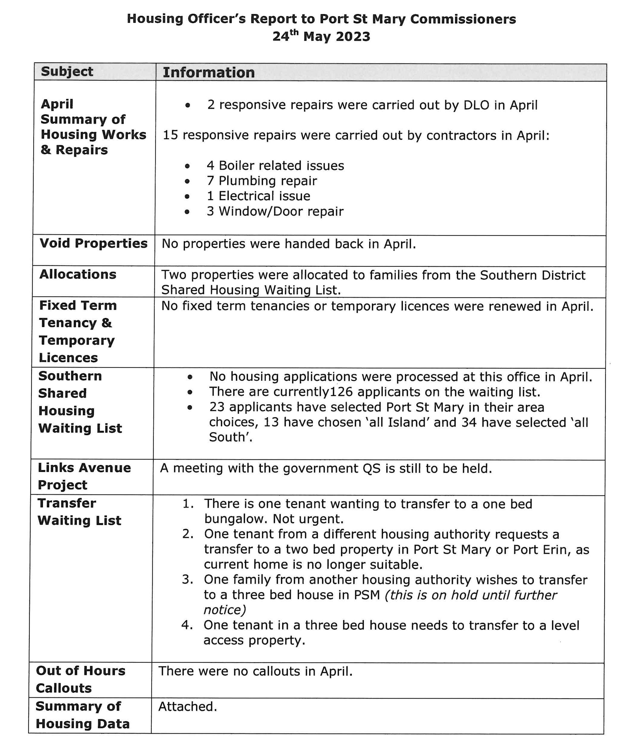
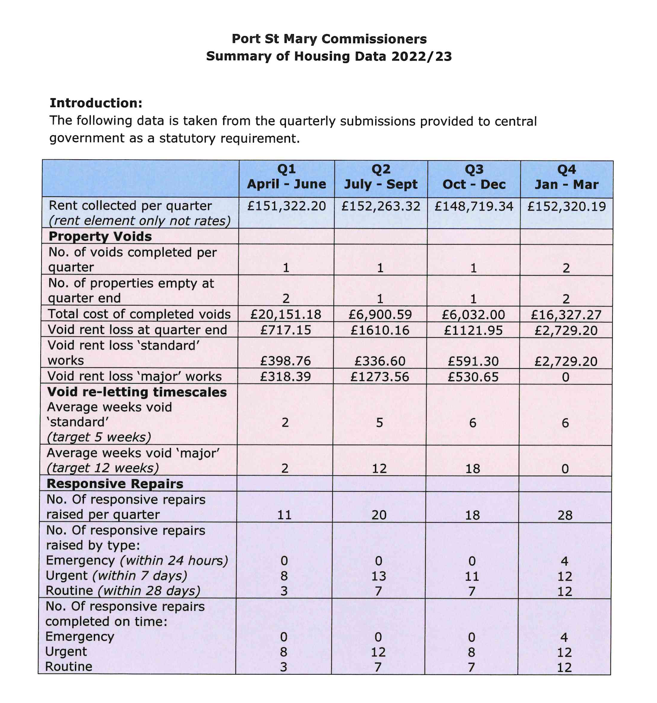
PLANNING MATTERS

9.1 Planning Applications
23/00401/B – Thornycroft, 8 Primrose Terrace for the erection of ground floor extension to rear and creation of off road parking apron.
23/00470/B – 9 Perwick Road for the erection of a dwelling with integrated garage, PV panels and heat pump.
22/01294/B – 19 Rhenwyllan Close for material change of conservatory roof to solid flat roof, single storey rear extension to existing conservatory and installation of a flue. Amended Plans received for information only, as deemed to be minor and unlikely to be noticeable.
23/00644/B – Ardane, Cronk Road for the replacement of existing timber and UPVC top opening casement windows with traditional timber sash windows.

9.2 Planning Approvals
23/00448/B – Sydney House, Athol Street for the installation of replacement front timber door to composite door with top-light into existing aperture.
23/00218/B – Ridgeway, Plantation Road for installation of replacement roofs to dwelling.
23/00219/B – Water Edge, 16 Lime Street for single storey kitchen extension & internal alterations to a private dwelling.
23/00353/B – Ivydene, Shore Road, Underway for removal of roof covering, removal of flat roofed dormer to the front elevation, replacement slate roof covering and three roof windows to the front elevation.

Item 10.2
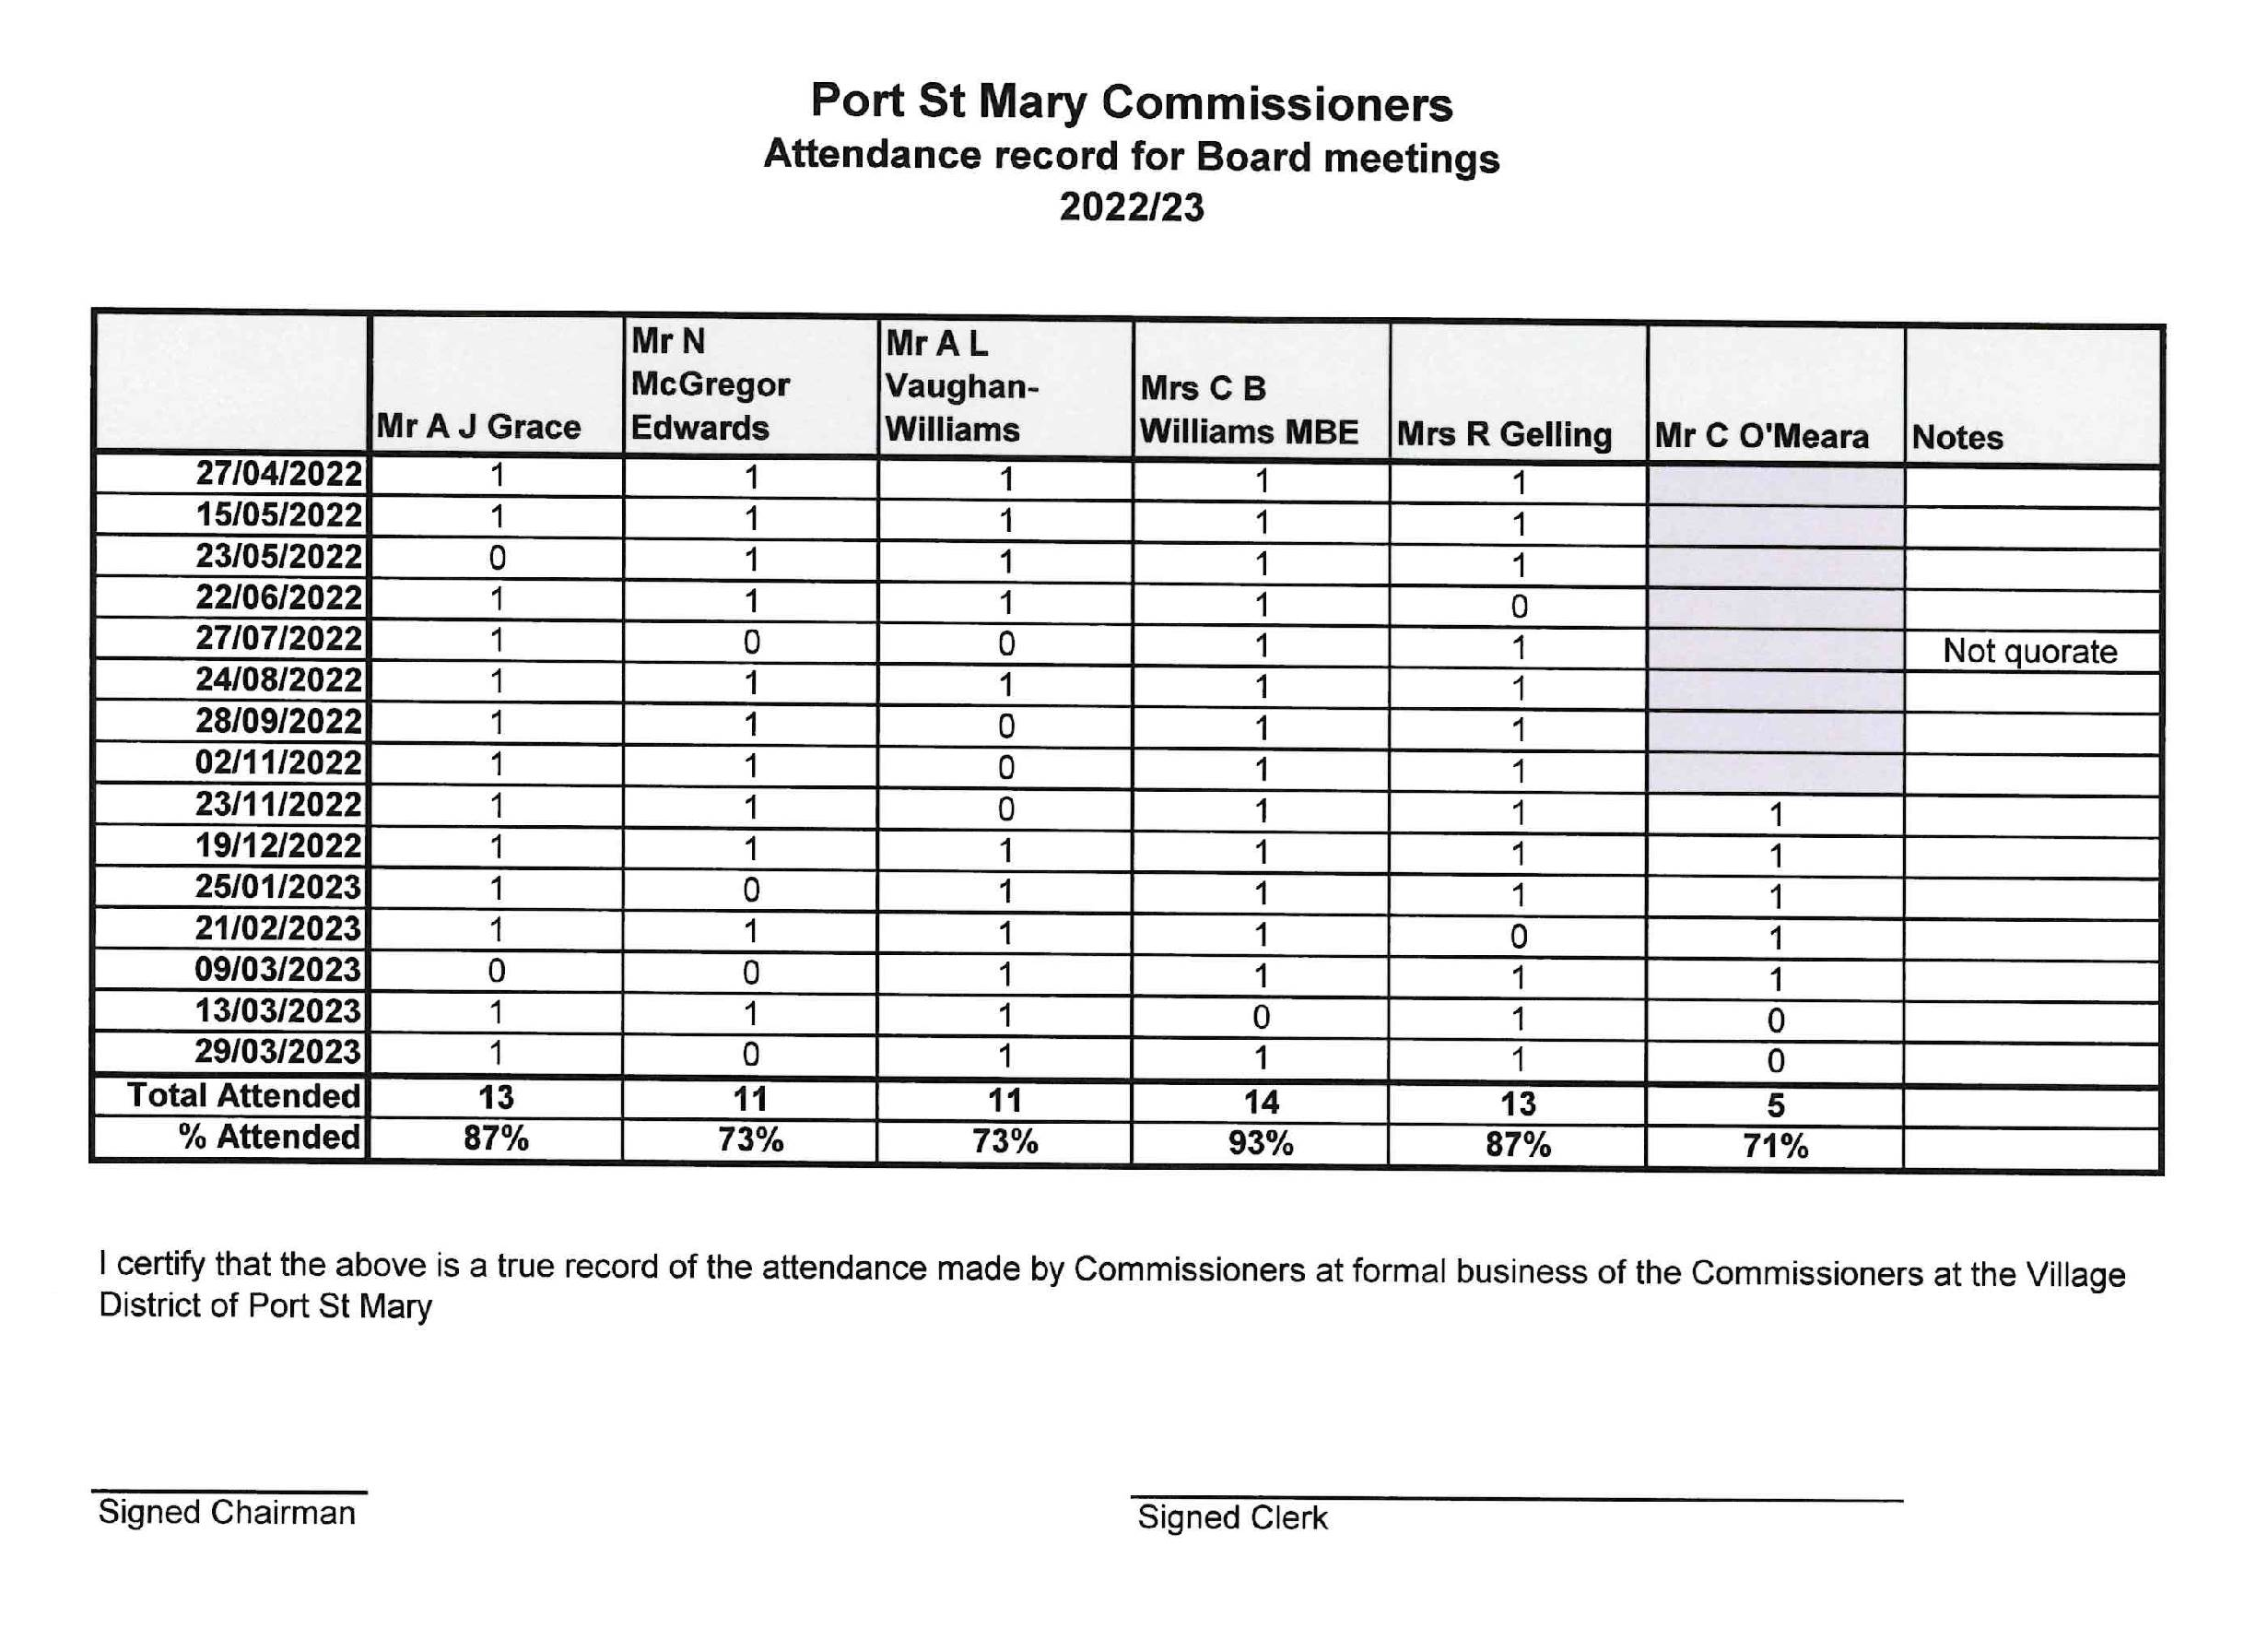
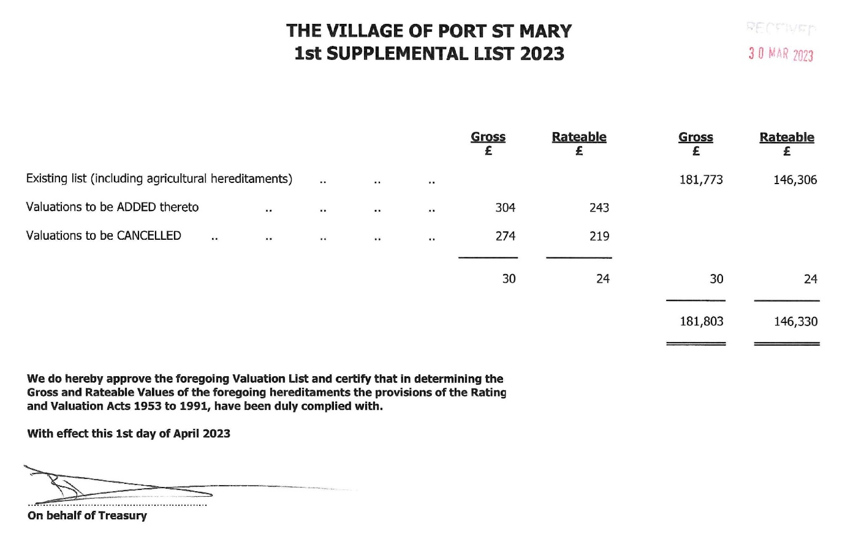

Item 10.4

PORT ST MARY COMMISSIONERS
STANDING ORDERS
FOR THE REGULATION AND OBSERVANCE
OF PROCEDURE AND BUSINESS
WITH RESPECT TO
MEETINGS OF THE AUTHORITY
AND ITS COMMITTEES

WITH EFFECT FROM 4TH AUGUST 2021

Attention is drawn to Standing Order 26 regarding improper
conduct and to the need for members to be aware that they
are NOT protected by parliamentary privilege when speaking
in public at meetings of the Authority.

PORT ST MARY COMMISSIONERS
STANDING ORDERS -
MEETINGS OF THE AUTHORITY AND ITS COMMITTEES
___________________________________________________________________

In exercise of the powers conferred on the Port St Mary Commissioners (the “Authority”) by Section 27(1) of the Local Government Act 1985, and of all other powers enabling it in that behalf, the following Standing Orders are hereby made:

MEETINGS OF THE AUTHORITY

The annual meeting of the Authority shall be held in public at the Town Hall, Port St Mary at 7.00 p.m. on the day of the first ordinary meeting of the Authority in the month of May. No business shall be transacted at the annual meeting save for business provided for in Standing Order 3.1 or required by or under a statutory enactment to be transacted at the annual meeting of a local authority.

The Ordinary meetings of the Authority shall be held at the Town Hall, Port St Mary, on the Fourth Wednesday and when necessary on the Second Wednesday of each month or on such other day or days as may be decided by resolution of the Authority. The exception to this is the month of December when the Authority will meet only on the Second Wednesday of that month

All ordinary and extraordinary meetings of the Authority for the transaction of general business shall commence at 7.30 p.m. unless notice to the contrary is given by the Clerk. A meeting shall close no later than 10.00 p.m. unless decided otherwise by resolution of the Authority. Consideration of any business not transacted shall be adjourned to a time fixed by the Chairman at the time the meeting is adjourned or, if the Chairman does not fix a time, to the next ordinary meeting of the Authority.

An extraordinary meeting of the Authority may be called at any time by the Chairman or by the Clerk.

If the Chairman refuses to call an extraordinary meeting of the Authority after receiving a requisition for that purpose, signed by at least one third of the whole number of members of the Authority, or if without so refusing the Chairman does not call an extraordinary meeting within seven clear days after the requisition has been presented to him, then at least one third of the whole number of members of the Authority may forthwith call such a meeting.

Any requisition for an extraordinary meeting shall state the nature of the business to be transacted at such meeting and the same shall be specified in the notice of the meeting. No other business shall be transacted at such meeting.

NOTICE OF MEETINGS

A notice of a meeting of the Authority, signed by the Clerk and specifying the business to be transacted, shall be sent to each member at least three clear days preceding the holding of an annual or ordinary meeting, and in the case of an extraordinary meeting shall be delivered with all possible despatch. A notice shall be left at or be sent by post to the usual place of abode of every member other than if a member gives notice in writing to the Clerk of some other address at which notice should be served. Any notice addressed to a member and left at or sent by post to the appropriate address shall be deemed sufficient service of the notice. Want of service of a notice on any member shall not affect the validity of a meeting.

Any notice of a meeting of the Authority shall be served electronically on a member by transmitting it to such electronic mail address as the member has provided to the Authority except where the member has elected not to accept such means of delivery and notified the Clerk in writing accordingly. Such notice shall be signed by the Clerk and specifying the business to be transacted, shall be sent to each member at least three clear days preceding the holding of an annual or ordinary meeting, and in the case of an extraordinary meeting shall be delivered with all possible despatch.

ELECTION OF CHAIRMAN AND COMMITTEES

The election of the Chairman and Vice-Chairman of the Authority, and any other appointments necessary for the ensuing year shall take place at the annual meeting or, in the case of any vacancy arising during the year, at the next ordinary meeting after such vacancy occurs.

The current Chairman shall occupy the chair and conduct the proceedings necessary for the election of a new Chairman of the Authority.
At such election of Chairman, should there be more than one nomination, voting shall be by secret ballot, each member placing a mark, opposite the nominated person for whom he wishes to record his vote.

The Chairman so elected shall then proceed to the election of:

the Vice-Chairman, and

any other appointments, including any committees of the Authority. Should the situation arise where two candidates remain and both receive the same number of votes, the result shall be determined by the drawing of straws. The candidate who draws the longest straw shall be deemed to be the winner.
In any case where there are more nominations than vacancies such election shall be by ballot as prescribed in Standing Order Error! Reference source not found..2 above. In the event of any candidate failing to receive a majority of the votes of the members present, the candidate with the least number of votes shall be excluded wherever possible. Fresh nominations shall be sought if equality of votes prevents the majority election of a member after two ballots.

CHAIRING OF MEETINGS
The Chairman of the Authority shall preside, if present, at all meetings of the Authority, in the absence of the Chairman, the Vice-Chairman shall preside, if present, and in the event of both the Chairman and the Vice-Chairman being absent, another member chosen by the members present shall preside. Any power of the Chairman in relation to the conduct of a meeting may be exercised by the person presiding at that particular meeting.

QUORUM

Subject to Standing Order 5.4, no business shall be transacted at a meeting of the Authority unless more than one half of the whole number of the members of the Authority are present at the time set for the commencement of the meeting or within 15 minutes thereafter.

Where more than one-third of the members of a local authority become disqualified at the same time, until the number of members in office is increased to not less than two-thirds of the whole number of members of the authority, the quorum of the authority shall be determined by reference to the number of members of the authority remaining qualified instead of by reference to the whole number of members of the authority.

If there is not a quorum present at any stage of a meeting of the Authority, the meeting shall stand adjourned. Consideration of any business not transacted shall be adjourned to a time fixed by the Chairman at the time the meeting is adjourned or, if the Chairman does not fix a time, to the next ordinary meeting of the Authority.

In respect of any committee composed of fewer than all of the members of the Authority then no business shall be transacted at that meeting of the committee unless more than one half of the whole number of the members of the Authority are present. Thus a majority vote of one third of the whole number of the members of the Authority results in recommendations as to a proposed course of action which may be submitted to the Authority for consideration.

Where a question is put pursuant to Standing Order 13.3 that the minutes of the last preceding ordinary meeting or of an intermediate extraordinary meeting of the Authority be signed as a correct record, the quorum to approve such action shall be more than one half of the whole number of the members of the Authority present at the meeting who had also been in attendance at the meeting to which the minutes in question relate. A member present at the meeting who had not also been in attendance at the meeting to which the minutes in question relate may not vote in relation to such a question.

VALIDITY OF PROCEEDINGS
The proceedings of the Authority shall not be invalidated by any vacancy among the number of the Authority or by any defect in the election or qualification of any member.

ATTENDANCE OF THE CLERK
With the exception of absence through illness or approved leave, emergency or any private session of the Authority where the nature of the business being transacted is that concerning the Clerk, the Clerk (or their nominated deputy) shall be present at all the meetings of the Authority.

ATTENDANCE OF THE PUBLIC
Members of the public are entitled to attend public sessions of the meetings of the Authority. However, they are not entitled to attend proceedings considered in private; these cover private sessions of the Authority and the meetings of committees.
If a member of the public interrupts the proceedings of a Meeting the chairman will warn them. If interruption continues the chairman shall order their removal from the Authority's chamber.

RECORD OF ATTENDANCES

The Clerk shall record the members present at a meeting of the Authority and shall also note in the minutes the time at which any member leaves the meeting other than temporarily.

The Clerk shall cause an annual report of the attendance at meetings of the Authority to be prepared on an annual basis for the year ending on the last day of March in each year and to be made public as soon as possible thereafter and in any event during the month of April.

MAJORITY

Subject to the provisions of any enactment, all questions coming or arising before the Authority shall be decided by a majority of the members present and voting thereon at a meeting of the Authority.

Subject to those provisions, the person presiding as Chairman at the meeting shall have a second or casting vote in the case of an equality of votes, and shall be free to cast that vote as he or she thinks fit and not be under any obligation, real or perceived, to vote for maintaining the status quo.

VOTING

The mode of voting at meetings of the Authority shall be at the discretion of the Chairman except as provided for in Standing Order 3.

Only those members who are present when the question is put from the Chair shall be entitled to vote.

Every member present when the question is put from the Chair shall be required to record his/her vote for, against or in abstention.

The voting on any question shall be recorded so as to show whether each member present voted for, against or abstained.

INTERIM DECISION MAKING

In the event that a question for determination by the Authority or a committee requires, in the opinion of the Chairman or the Clerk, a resolution of the Authority or committee before the next ordinary meeting, such question may be put to members by electronic mail.

Where a member has made an election under Standing Order 2.2 not to accept delivery of notice by electronic mail, such question shall instead be put to the relevant member by telephone or in person.

Every member shall be requested to respond to the Clerk and record his/her interim vote for, against or in abstention in respect of the question put.

Upon the receipt of the interim votes of more than one half of the whole number of the members of the Authority or the committee for or against in respect of the question put, the matter shall be treated as decided and the Authority may act in reliance on such interim decision.

At the next ordinary meeting of the Authority or meeting of the committee, the question shall be put to the members present that the outcome of the interim vote be ratified. Members present at the meeting who took part in the interim decision may not change their interim vote. There shall be a presumption that the interim vote be ratified, notwithstanding any change in the composition of the Authority between the interim vote and the meeting at which the question is put. The question shall be put without debate, save as to the accuracy of the interim voting and decision recorded.

MINUTES OF MEETINGS

Minutes of proceedings of every meeting of the Authority shall be drawn up and recorded by the Clerk or some other authorised officer.

A copy of the minutes of the last preceding ordinary meeting and of intermediate extraordinary meetings of the Authority shall be sent to each member with the notice convening the ordinary meeting.

At such ordinary meeting the Chairman shall put the questions that such minutes be signed as a correct record. No motion or discussion shall take place upon the minutes, except upon their accuracy, and any question on their accuracy shall be raised by motion.

If no such question is raised, or if it is raised, then as soon as it has been disposed of, the Chairman shall sign the minutes or the corrected minutes as the case may be, and shall initial each consecutively numbered leaf comprising those minutes.

APPLICATION OF STANDING ORDERS TO COMMITTEES

Standing Orders 5 to 13 and 32 shall apply in relation to a committee of the Authority as they apply in relation to the Authority.

Until the contrary is proved, where a minute of any meeting of any such committee or sub­ committee has been made and signed in accordance with Standing Order 13 as applied by this Standing Order 14, the committee shall be deemed to have been duly constituted and to have had power to deal with the matters referred to in the minute, the meeting shall be deemed to have been duly convened and held and the members present at the meeting shall be deemed to have been duly qualified.

DISCLOSURE OF INFORMATION

All agendas, reports, and other documents and all proceedings of committees and of the Authority shall be public unless the Clerk in consultation with the Chairman decides that any item should be treated as confidential. The grounds for such decision must be one of the following:

that the subject is one of pending litigation or negotiation in which the Authority’s position could be prejudiced by premature publication; or

that publication would be injurious to any public or private interest; or

that the matter is one of commercial sensitivity.

In the event that the Clerk in consultation with the Chairman decides that any item should be treated as confidential under Standing Order 15.1, such agendas, reports or other documents shall be circulated to all members of the Authority marked “Private and Confidential”. The issue shall be made public as soon as practicable after the grounds for keeping it private no longer apply.

Any question arising at a meeting of a committee or of the Authority, as to the appointment, promotion, dismissal, salary, superannuation, conditions of service, job performance or professional conduct of any person employed by the Authority, shall not be the subject of a public minute or report to be discussed in public unless and or until the Authority has otherwise determined.

All matters dealt with or brought before the Authority when sitting in private shall be treated as strictly confidential and, unless otherwise determined by the Authority, shall not be disclosed to any person outside the Authority.

All or any statements regarding the affairs of the Authority made for or on behalf of the Authority by a member, members or officer of the Authority to the media or any other third party, be they verbal or written, shall only be made with the consent of the Authority.

All or any statements regarding the affairs of the Authority made in a personal capacity by a member, members or officer of the Authority to the media or any other third party, be they verbal or written, shall make clear that they are made in a personal capacity and not for or on behalf of the Authority and shall be subject to the obligations of confidentiality provided for in these Standing Orders and otherwise in law.

ORDER OF BUSINESS

Except as provided for by Standing Order 16.2, the order of business at every meeting of the Authority shall be transacted in the following order:

choice of a person to preside if the Chairman or Vice-Chairman be absent,

any business required by statute to be done,

to approve as a correct record and sign the minutes of the previous ordinary meeting and of any intermediate extraordinary meeting or meetings,

business arising out of such minutes if not referred to in the minutes of any committee,

business adjourned from a previous meeting,

to ratify any interim decision made in accordance with Standing Order 12,

consideration of reports and correspondence appearing on the agenda,

to answer questions asked under Standing Order 17,

motions in the order in which notice has been received,

other business, if any, authorised by the Chairman for consideration,

Chairman's announcements,

Business falling under items (a), (b), (c) or (d) of Standing Order 16.1 shall not be displaced, but subject thereto the foregoing order of business may be varied:

at the discretion of the Chairman; or

by a resolution duly moved and seconded and passed on a motion which shall be moved and put without discussion.

any business, which the Authority decided shall be taken in private, shall be postponed until the conclusion of the other business and then be transacted in private.

QUESTIONS

A member of the Authority may ask the Chairman or the chairman of a committee any question upon an item on the agenda or the report of a committee when that item is under consideration by the Authority.

A member of the Authority may:

if one clear day’s notice in writing has been given to the Clerk ask the Chairman or the Chairman of any committee any question on any matter in relation to which the Authority has powers or duties or which affects the district, or

with the permission of the Chairman put to him or the Chairman of any committee any questions relating to urgent business, of which such notice has not been given but a copy of any such question shall, if possible, be delivered to the Clerk not later than five o'clock in the afternoon of the day of the meeting.

Every question shall be put and answered without discussion but the person to whom a question has been put may decline to answer.

An answer may take the form of:

a direct oral answer; or

where the desired information is contained in a publication of the Authority, a reference to that publication; or

where the reply to the question cannot conveniently be given orally, a written answer circulated to members of the Authority.

NOTICES OF MOTION

Notices of every motion relating to any new subject or matter not already before the Authority, other than a motion under Standing Order 19, shall be given in writing at the ordinary meeting preceding the one at which it is intended to bring it forward or it shall be delivered in writing, duly signed by the member giving the notice, at the office of the Clerk at least five clear days before the next meeting.

Any notice delivered to the Clerk shall be dated and numbered by him, in the order in which it is received, and entered in a book that shall be open to inspection by any member of the Authority.

The Clerk shall set out in the summons for every meeting of the Authority any motion of which notice has been duly given in the order in which it was received, unless the member giving such notice intimated, in writing, when giving it, that he proposes to move it at some later meeting, or has since withdrawn it in writing.

If a motion thus set out in the summons be not moved either by a member who gave notice thereof or by some other member on his behalf it shall, unless postponed by consent of the Authority, be treated as withdrawn and shall not be moved without fresh notice.

If the subject matter of any motion of which notice has been duly given comes within the province of any committee it shall, upon being moved and seconded, stand referred without discussion to such committee as the Authority may determine, for consideration and report.

Every motion shall be relevant to some matter in relation to which the Authority have powers or duties or which affects the district.
Provided that the Chairman may, if conducive to the despatch of business, allow the motion to be dealt with at the meeting at which it is brought forward.

MOTIONS AND AMENDMENTS THAT MAY BE MOVED WITHOUT NOTICE
The following motions and amendments may be moved during a meeting without notice:

on the accuracy of the minutes,

for the precedence of any item of business specified in the notice,

for referring any business to a committee,

for appointing or deferring any business for consideration at a future meeting,

for the appointment of a committee or members thereof, occasioned by an item mentioned in the summons to the meeting,

for the adjournment of any meeting or debate,

for dealing with correspondence, reports and recommendations of committees or officers, or other documents and any consequent resolutions,

for amendments to any motion,

for hearing any application or evidence,

for appointing a chairman of the meeting at which the motion is made,

that the Chairman does leave the Chair for part or all of the meeting,

for the suspension of any specified Standing Order or Orders, in accordance with Standing Order 40,

that any specified business be transacted in private at a later stage in the meeting,

that the order of business at a meeting be varied under Standing Order 16.2(b) (Order of business),

for taking any business from the private business for consideration in public,

that a member named under Standing Order 26 (Improper conduct) be not further heard or do leave the meeting,

for leave to withdraw a motion before a vote has been taken, but not afterwards,

that a member be now heard,

that the question be now put,

to proceed with the next business,

authorising the sealing or other execution of documents,

inviting a member to remain under Standing Order 32 (Pecuniary interest),

that the Authority do now adjourn.
Provided that a motion moved and seconded under items (j) to (w) inclusive shall be put without debate.

AMENDMENTS

Amendments to any motion must be relevant to the motion and shall not have the effect of introducing a new proposal into or negating the motion before the Authority. Amendments shall be either:

To refer a subject of debate to a committee for consideration (or reconsideration)

To leave out words

To leave out words and insert or add others

To insert or add words

When an amendment has been moved no second amendment shall be considered until the first is disposed of. Provided that the Chairman may permit two or more amendments to be discussed (but not voted on) together if circumstances suggest that this course would facilitate the proper conduct of the Authority’s business.

If such amendment is carried, it shall then be submitted as a substantive or original motion, upon which a further amendments may be moved.

If a first amendment is lost, further amendments to the original motion may be moved.

RULES OF DEBATE FOR AUTHORITY MEETINGS

A member when speaking shall address the Chairman. If two or more members wish to speak, the Chairman shall call on one to speak and the other or others to remain silent. Whilst a member is speaking the other members shall remain silent, unless raising a point of order or a personal explanation.

A motion or amendment shall not be discussed unless it has been proposed and seconded, and unless notice has already been given in accordance with Standing Order 18 it shall, if required by the Chairman, be put into writing and handed to the Chairman before it is further discussed or put to the meeting.

A member when seconding a motion or amendment may declare his intention to reserve his speech until a later period in the debate.

A member shall direct his speech to the question under discussion or to a personal explanation or to a point of order. No speech shall exceed 5 minutes, except by consent of the Authority.

A member may without discussion, subject to the consent of the Authority having been signified:

alter a motion of which he has given notice, or

with the further consent of his seconder alter a motion he has moved, if (in either case) the alteration is one which could be made as an amendment thereto.

A motion or amendment may be withdrawn by the mover with the consent of his seconder and of the Authority, which shall be signified without discussion, and no member may speak upon it after the mover has asked permission for its withdrawal, unless such permission shall have been refused.

The mover of a motion has a right of reply at the close of the debate on the motion, immediately before it is put to the vote. If an amendment is moved, the mover of the original motion shall also have a right at the close of the debate on the amendment, and shall not otherwise speak on the amendment. The mover of the amendment shall have no right of reply to the debate on his amendment and no member shall speak on any subject after the same has been put to the vote.

When a motion is under debate no other motion shall be moved except the following:

to amend the motion,

to adjourn the meeting,

to adjourn the debate,

to proceed to the next business,

that the question be now put,

that a member be not further heard,

by the Chairman under Standing Order 26.2 (Improper conduct) that a member do leave the meeting,

a motion under Standing Order 19(m) that any specified business be transacted in private or Standing Order 26.8 (General disturbance) to exclude the public,

to postpone consideration of the motion,

that the subject under debate be referred to a committee.

A member may move without comment at the conclusion of a speech of another member, "That the Authority proceed to the next business"; or That the question be now put"; "That the debate be now adjourned"; or "That the Authority do now adjourn", on the seconding of which the Chairman shall proceed as follows:

on a motion to proceed to the next business; unless in his opinion the matter before the meeting has been insufficiently discussed, he shall first give the mover of the original motion a right of reply, and then put to the vote the motion to proceed to next business,

on a motion that the question be now put; unless in his opinion the matter before the meeting has been insufficiently discussed, he shall first put to the vote the motion that the question be now put, and if it is passed then give the mover of the original motion his right of reply under Standing Order 21.7 before putting his motion to the vote,

on a motion to adjourn the debate or the meeting, if in his opinion the matter before the meeting has not been sufficiently discussed and cannot be reasonably be sufficiently discussed on that occasion he shall put the adjournment motion to the vote without giving the mover of the original motion his right of reply on that occasion.

A member may raise a point of order or in personal explanation and shall be entitled to be heard forthwith. A point of order shall relate to an alleged breach of a Standing Order or statutory provision and the member shall specify the Standing Order or statutory provision and the way in which he considers it has been broken. A point of order may also relate to discussion of a motion that, if affirmed, would require the Authority or its officials to act ultra vires. A personal explanation shall be confined to some material part of a former speech by him that may appear to have been misunderstood in the present debate.

The ruling of the Chairman during debate or on the admissibility of a personal explanation shall not be open to discussion.

INVOLVEMENT OF CLERK IN DEBATE
Notwithstanding anything contained in these Standing Orders, it shall be competent for the Clerk, with the consent of the Chairman, to make any statement in relation to any matter or thing connected with the public interest or public business and it shall be competent for any member speaking during the progress of a debate to address any question through the Chairman to the Clerk or other officer in attendance in relation to any matter or thing in connection with the subject under consideration.

RESCISSION OF PRECEDING RESOLUTION

No motion to rescind any resolution passed within the preceding six months, and no motion or amendment to the same effect as one which has been rejected within the preceding six months, shall be proposed unless the notice thereof given in pursuance of Standing Order 18 bears the signature of more than one third of the whole number of members of the Authority.

When any such motion or amendment has been disposed of by the Authority it shall not be open to any member to propose a similar motion or amendment during any meeting of the Authority within a further period of six months.

ADJOURNMENT OF MEETING OR DEBATE

When any member has the right to speak, he may move the adjournment of the meeting or the debate if he confines his observations to the matter of adjournment. A member moving an adjournment under this order may be heard in support for not more than five minutes: and one other member may be heard in opposition similarly before the motion is put to the vote without further debate.

An amendment to a motion to adjourn may be moved if it relates to only the question of time.

REPORTS AND CORRESPONDENCE

All correspondence for consideration by the Authority shall be submitted to the Clerk.

Any correspondence received later than three clear days prior to the day of an ordinary meeting shall not be considered at such meeting, unless such correspondence specifically requires a reply before the next ordinary meeting.

The provisions of Standing Order 25.2 shall not prevent the Chairman of the Authority from ruling on whether or not to consider any late item of correspondence.

IMPROPER CONDUCT

If at a meeting any member of the Authority who, in the opinion of the Chairman, misconducts himself by persistently disregarding the ruling of the chair, or by behaving irregularly, improperly, or offensively, or by wilfully obstructing the business of the Authority, the Chairman or any other member may move "That the member named be not further heard", and the notice if seconded shall be put and determined without discussion.

If the member named continues to act improperly after a motion under Standing Order 26.1 has been carried, the Chairman shall either:
- move "That the member named do leave the meeting" (in which case the motion shall be put and determined without seconding and without discussion, and if such motion is carried the member named shall be under a duty to withdraw from the meeting), or

- adjourn the meeting of the Authority for such period as he in his discretion shall consider expedient.

If the Chairman rules that language used by a member ought to be withdrawn it shall be the duty of that member to withdraw it.

Any member, members or officer of the Authority making comments of a derogatory or defamatory nature and refusing to withdraw such comments shall be solely responsible for the consequences of his/her or their actions.

Any member, members or officer shall also be under a duty to desist from making derogatory or defamatory comments of a personal nature concerning other public bodies and/or elected representatives.

Members will at all times, to the exclusion of any personal disagreement, accord fellow members of the Authority courtesy and respect.

The Authority will at all times accord any member of the Authority's staff present at the meeting similar courtesy and respect as befits the relationship of employer and employee

In the event of general disturbance, which in the opinion of the Chairman renders the due and orderly despatch of business impossible, the Chairman in addition to any other powers vested in him may, without question put, adjourn the meeting of the Authority of such period as he in his discretion shall consider expedient.

SEALING AND EXECUTION OF DOCUMENTS

The common seal of the Authority shall not be affixed to any document, and no document shall be executed for or on behalf of the Authority under the hand of any person, unless the sealing or execution has been authorised by a resolution of the Authority or of a committee to which the Authority have delegated powers in this behalf, but a resolution of the Authority (or of a committee where that committee has the power) authorising the acceptance of any tender, the purchase, sale, letting, or taking of any property, the issue of any stock, the presentation of any petition, memorial, or address, the making of any rate or contract, or the doing of any other thing, shall be a sufficient authority for sealing or executing any document necessary to give effect to the resolution.

Where a document is executed under seal, the seal shall be attested by the following persons present at the sealing: the Chairman or Vice-Chairman of the Authority or other member of the Authority, and the Clerk of the Authority. An entry of every document to which the seal has been affixed shall be made in a book provided and kept for that purpose.

Save where required by a statutory enactment to be executed under seal, a document may be executed for and on behalf of the Authority under the hand of the following persons: the Chairman or Vice-Chairman of the Authority or other member of the Authority, and the Clerk of the Authority.

CUSTODY OF SEAL
The common seal of the Authority shall be kept in a safe place in the custody of the Clerk.

AUTHENTICATION OF DOCUMENTS
Any notice, order or other document, which the Authority is authorised to give, make or issue shall be signed by the Clerk on behalf of the Authority or by a person duly authorised in that behalf by the Clerk or the Authority.

INSPECTION OF DOCUMENTS

A member of the Authority may, for the purposes of his duty as such member but not otherwise, on application to the Clerk, inspect any document which has been considered by a committee or by the Authority, and if copies are available shall on request be supplied for the like purposes with a copy of such document.
Provided that a member shall not knowingly inspect and shall not call for a copy of any document relating to a matter in which he is professionally interested or in which he has directly or indirectly any pecuniary interest within the meaning of sections 11 and 12 of the Local Government Act 1985.

This Standing Order shall not preclude the Clerk or the advocate to the Authority from declining to allow inspection of any document that is or in the event of legal proceedings would be protected by privilege arising from the relationship of advocate and client.

All minutes and reports of a committee shall, as soon as the committee has concluded action on the matter to which such minutes or reports relate, be open for inspection by any member of the Authority.

INSPECTION OF LANDS, PREMISES, ETC.
Unless specifically authorised to do so by the Authority or a committee, a member of the Authority shall not issue any order respecting any workings which are being carried out by or on behalf of the Authority or claim by virtue of his membership of the Authority any right to inspect or to enter upon any lands or premises which the Authority have the power or duty to inspect or enter.

INTEREST OF MEMBERS IN CONTRACTS AND OTHER MATTERS

If any member of the Authority has any pecuniary interest direct or indirect within the meaning of Sections 11 and 12 of the Local Government Act 1985 (other than an indirect interest described in sub-section 14(4)-(6) thereof) in any contract, proposed contract, or other matter, that member must withdraw from the meeting while the contract, proposed contract, or other matter, is under consideration by the Authority (this also applies to matters before a sub-committee of the authority and a joint committee on which the authority is represented) unless:

the disability to discuss that matter imposed upon him by the section has been removed by the Department of Infrastructure under section 14(1) thereof; or

the contract, proposed contract, or other matter is under consideration by the Authority as part of the report of a committee and is not itself the subject of debate; or

the Authority invites him to remain.
The presence of that member nevertheless counts towards a quorum of the body in question. A member shall have regard for all relevant guidance issued by the Department of Infrastructure in all matters of declaration of a pecuniary interest.

The pecuniary interests to which the above applies includes:
(1) an indirect interest; or,
(2) an interest of a spouse or civil partner of the member or officer; or,
(3) an interest of a partner or employer of the member or officer; or
(4) an interest of a company in which the member or officer (or his or her nominee) holds an equity share. A shareholding in a company which is worth less than £1,000 or less than 1% of the issued voting share capital, whichever is the less, does not prevent a member taking part in or voting on a matter, but must still be disclosed.

The following do NOT constitute a pecuniary interest:
- the fact that the member or officer is a ratepayer;
- the fact that the member receives allowances or the officer receives remuneration from the Authority;
- the fact that the member or officer is the tenant of one of the authority's houses, so long as the matter being discussed involves those houses generally rather than the specific house they are tenant of;
- a connection with the matter which is so remote or insignificant that it cannot reasonably regarded as likely to influence the member or officer.

A member of the Authority may make a general disclosure of a pecuniary interest by notifying the Clerk in writing, who is to enter it in a book which is open to inspection by any member of the authority. The entry of the interest in the Declaration of Interests Register means that the member does not have to declare their interest on every occasion (but this does not affect their obligation not to take part in a discussion or vote on the matter in question).

INTEREST OF OFFICERS IN CONTRACTS

The Clerk shall report to a meeting of the Authority particulars of any notice given by an officer of the Authority under section 23 of the Local Government Act 1985, of a pecuniary interest whether direct or indirect in a contract. This does not preclude that officer from dealing with that matter on behalf of the Authority.

In determining a pecuniary interest, whether direct or indirect, the definitions in Standing Order 32.1 above apply.

MATTERS AFFECTING MEMBERS AND PERSONS EMPLOYED BY THE AUTHORITY

If any question arises at a meeting of the Authority (or of a committee thereof) as to the conduct of any member of the Authority, such question shall not be considered in public and shall not be the subject of discussion until the Authority is in private session.

If any question arises at a meeting of the Authority (or of a committee thereof) as to the appointment, promotion, dismissal, salary, superannuation or conditions of service, or as to the job performance or professional conduct of any person employed by the Authority, such question shall not be considered in public and shall not be the subject of discussion until the Authority is in private session.

FILLING OF NEW POSTS AND VACANCIES

No new office shall be created, nor any person be employed in addition to the Authority's establishment except with the agreement of the Authority.

Where the creation of a new post is proposed or where a vacancy occurs the Authority shall decide:

in the case of a post which the authority is no required to fill by statute, whether the post is necessary

in any case what shall be the terms and conditions of the post, and no steps shall be taken to fill the post until these decisions have been made.

All vacancies to be filled in established posts of the Authority (not being posts at a weekly wage), unless they are to be filled by promotion or transfer, shall be advertised publicly unless the Authority determines otherwise.
Provided that where, a similar vacancy occurs, within six months of such a vacancy having been advertised, the Authority may appoint one of the former applicants.
  - A vacancy required to be advertised shall be advertised in one or more newspapers or electronic means appropriate to those persons who may be expected to possess the necessary qualifications for the post.

VOTING ON APPOINTMENTS
Where there are more than two persons nominated for any position to be filled by the Authority, and of the votes given there is not a majority in favour of one person, the name of the person having the least number of votes shall be struck off the list and a fresh vote be taken, and so on until a majority of votes is given in favour of one person.

CANVASSING OF AND RECOMMENDATIONS BY MEMBERS

Canvassing of members of the Authority or any committee of the Authority directly or indirectly for any appointment under the Authority shall disqualify the candidate concerned for that appointment. The purport of this Standing Order 38.1 shall be included in every advertisement inviting applications for appointments or in any form of application.

A member of the Authority shall not solicit for any person any appointment under the Authority, and this Standing Order 38.2 shall not preclude a member from giving a written testimonial of a candidate's ability, experience, or character for submission to the Authority with an application for appointment.

RELATIVES OF MEMBERS OR OFFICERS

A candidate for any appointment under the Authority who knows that he is related to any member or officer of the Authority shall when making application shall disclose that relationship to the Clerk.

A candidate who fails to disclose such a relationship shall be disqualified for the appointment and if appointed shall be liable to dismissal without notice. Every member and officer of the Authority shall disclose to the Clerk any relationship known to him to exist between him and any person whom he knows is a candidate for an appointment under the Authority. The Clerk shall report to the Authority or to the appropriate committee any such disclosure made to him.

The purport of this Standing Order shall be included in every advertisement inviting applications for appointments or in any form of application.

For the purpose of this Standing Order persons shall be deemed to be related if they are husband and wife or civil partners or if either of them or the spouse or civil partner of either of them is the son or daughter or grandson or granddaughter or brother or sister or nephew or niece of the other, or of the spouse or civil partner of the other.

SUSPENSION OF STANDING ORDERS

Subject to Standing Orders 10 and 40.2, any of the preceding Standing Orders may be suspended so far as regards any business at the meeting where such suspension is moved.

A motion to suspend Standing Orders shall not be moved without notice unless the meeting is deemed to be quorate subject to Standing Order 5.

Suspension or contravention of Standing Orders will be publicly recorded in a Register detailing when and for what purpose.

VARIATION AND REVOCATION OF STANDING ORDERS

Any motion to add to, vary or revoke these Standing Orders shall when proposed and seconded stand adjourned without discussion to the next ordinary meeting of the Authority. No new or revised Standing Order or any revocation of a Standing Order shall be valid or binding until confirmed by the Authority at the ordinary meeting held after the meeting at which it was approved.

These Standing Orders will be formally reviewed at least once a year during the month of April and otherwise as the Authority may resolve, to ensure they remain 'fit and proper' for their purpose.

STANDING ORDERS TO BE GIVEN TO MEMBERS
A copy of these Standing Orders, and of such statutory provisions as regulate the proceedings and business of the Authority, shall be given to each member of the Authority by the Clerk upon delivery to him of the member's declaration of acceptance of office on the member being first elected to the Authority. Thereafter, following the making of any amendment to these Standing Orders, a full copy of them shall be given to each member of the Authority by the Clerk and made public as the Authority may resolve.

COMMITTEES

The Authority may by resolution at any time delegate to a committee any matter not coming within the special area of responsibility of any existing committee.

Every committee shall, before proceeding to any other business, at its first meeting and at any time thereafter when there is a vacancy in the role of Chairman, elect a Chairman.

In the absence from a meeting of the Chairman (and Vice-Chairman if elected), a Chairman for that meeting may be appointed.

The areas of special responsibility of each committee shall be as set out in the resolutions of the Authority constituting such committee.

Each respective committee may be given delegated authority at the discretion of the Authority for day-to-day matters coming within each respective special area of responsibility. It shall be the duty of every committee to liaise as necessary with the Clerk or any other designated official in dealing with delegated matters and in advising and informing the Authority. It will be usual practice for the Clerk to be present at and keep minutes of any committee meeting. All agendas, reports and other documents and all proceedings of committees shall be treated as confidential unless and until they become public in the ordinary course of the Authority’s business

Questions as to the extent and nature of delegated authority to be given to committees and to the Clerk or any other designated official will be decided by the Authority from time to time. Orders or instructions to be given to an official of the Authority in relation to any matter shall be conveyed only by the Clerk or in his absence by any other designated official.

SPECIAL MEETINGS OF COMMITTEES
The Chairman of a committee or the Chairman of the Authority may call a special meeting of a committee at any time. A special meeting may also be called on the requisition of three members of a committee, delivered in writing to the Clerk. The summons to the special meeting shall set out the business to be considered thereat, and no business other than that set out in the summons shall be considered at that meeting.

INTERPRETATION

The decision of the Chairman as to the construction or application of any of these Standing Orders, or as to any proceedings of the Authority, shall not be challenged at any meeting of the Authority, unless on a point of law.

These Standing Orders will be interpreted in accordance with the provisions of the relevant statutory enactments. Where there is a conflict of interpretation between these Standing Orders and the relevant statutory enactment, the statutory enactment will take precedence. All references are to the law and exclusive jurisdiction of the Isle of Man.

The term “clear days” used in these Standing Orders shall have the meaning that the dates to and from which time is reckoned shall be excluded from the calculation. For example, where these Standing Orders call for three clear days’ notice prior to a meeting taking place on a Wednesday, notice shall validly have been given if delivered in accordance with these Standing Orders on the preceding Saturday, but shall be late if delivered on the preceding Sunday.

Where the term “Chairman” is used in these Standing Orders, the term shall be taken to refer to the Chairman of the Authority, unless inconsistent with the context.

Executed for and on behalf of the Port St Mary Commissioners at a meeting of the Authority held this 4th day of August 2021

______________________________ ________________________________
Chairman Clerk

Item 10.5
PORT ST MARY COMMISSIONERS

MEETING DATES FOR 2023

2023 Meeting Dates
14th June 2023 | Second meeting – may not be required
28th June 2023
12th July 2023 | Second meeting – may not be required
26th July 2023
9th August 2023 | Second meeting – may not be required
23rd August 2023
13th September 2023 | Second meeting – may not be required
27th September 2023
11th October 2023 | Second meeting – may not be required
25th October 2023
8th November 2023 | Second meeting – may not be required
22nd November 2023
13th December 2023

