Date: 17th March 2023

NOTICE OF ORDINARY BOARD MEETING

In accordance with Schedule 1 of the Local Government Act 1985, Notice is hereby given that the next Board Meeting of Port St Mary Commissioners will be held in the Board Room at the Town Hall on Tuesday 22nd March 2023 at 7.30 p.m. Private session of Port St Mary Commissioners will be held following conclusion of the Public Board Meeting.

- Only business of a formal nature as defined in the Agenda for the meeting which is set out below, may be discussed as defined in Port St Mary Commissioners Standing Orders governed by Section 27 of the Local Government Act 1985 [as amended by Section 8 Local Government Act 2006]. All Commissioners are urged to attend and bring with them their copy of Standing Orders.

Hayley Kinvig
Clerk

PORT ST MARY COMMISSIONERS
ORDINARY BOARD MEETING
22nd MARCH 2023
AGENDA – OPEN SESSION

Item Number | Item |  | Action Required
1. | OPENING OF THE MEETING
1.1 | Welcome, Apologies & Declarations |  | As required by Board members
2. | MINUTES
2.1 | Minutes of the Ordinary Meeting held on the 21st February 2023 |  | For Board approval
3. | MATTERS ARISING
3.1 | Matters arising from previous meetings |  | Clerk to provide necessary updates
4. | MOTIONS – None
5. | FINANCE
5.1 | Invoices for payment in March | For Board approval
5.2 | Purchase of double bin – Town Hall | For Board approval
6. | PROJECTS
6.1 | Amenities |  | For Board discussion
6.2 | PSM Events |  | For Board discussion & approval
6.3 | Town Branding Project |  | For noting
6.4 | Highways |  | For noting
6.5 | Coronation Mugs |  | For Board discussion
7. | HOUSING
7.1 | Housing Officers Report | For Board discussion
7.2 | Tenant Arrears Report | For Board discussion
8. | PUBLIC CORRESPONDENCE & COMMUNICATIONS
8.2 | 1st Supplemental List 2023 | For noting
9. | PLANNING MATTERS
9.1 | Planning Applications |  | For Board discussion
10. | POLICY & RESOURCES
10.1 | Strategy Document |  | For Board discussion & approval
10.2 | 2023 Meeting Dates |  | For noting
11. | PUBLIC CONSULTATIONS - None
12. | INVITATIONS - None
13. | ANY OTHER BUSINESS OF AN URGENT NATURE  (BY PERMISSION OF THE CHAIR)

Item 3.1
PORT ST MARY COMMISSIONERS
MATTERS ARISING & PUBLIC CORRESPONDENCE REPORT

Matters Arising
General Bylaws – The amendments have been made and the first draft has been issued to the LGU for comment.
Consultation on Local Authority Members (travelling allowances) Order 2023 – The response was issued.
Public Correspondence

Easter Festival - The response with an offer of assistance was issued.
Young Persons Representative – Commissioner Cubbon (Castletown Commissioners) was notified that CO’M would be the PSMC rep.

Item 5.1
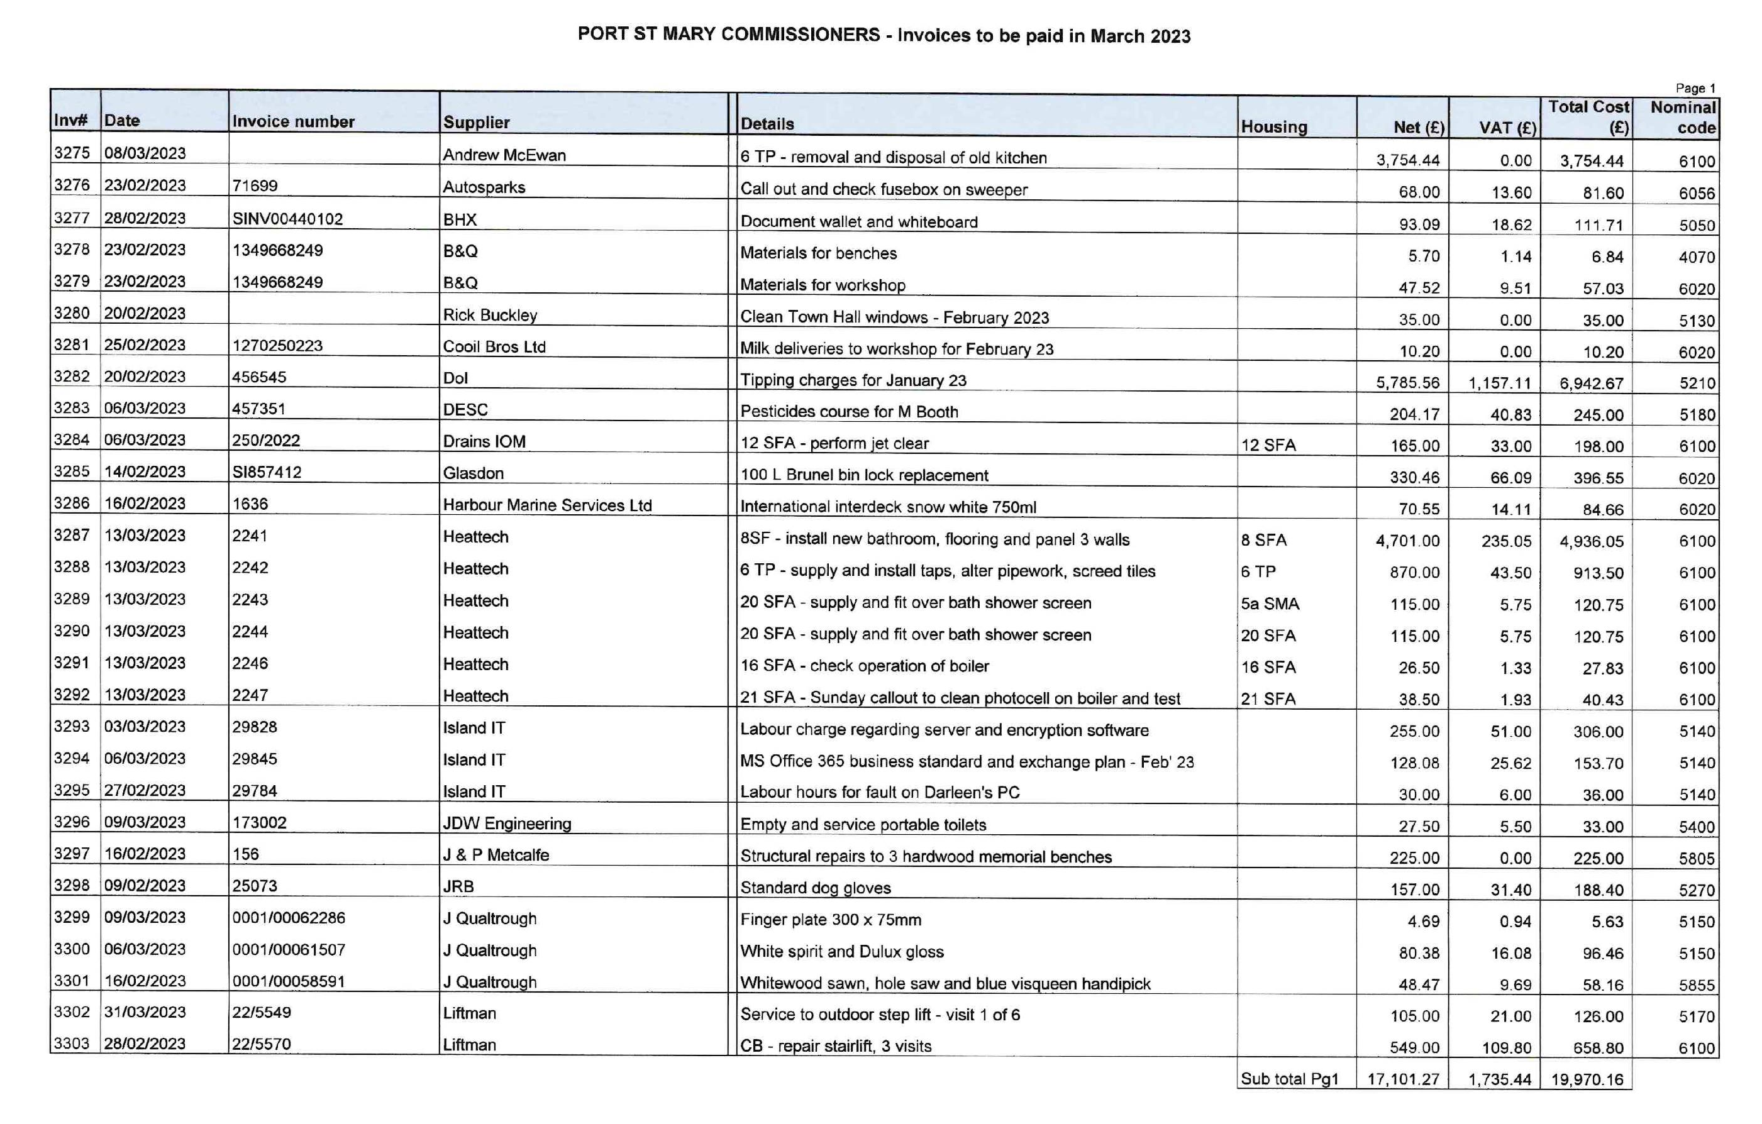
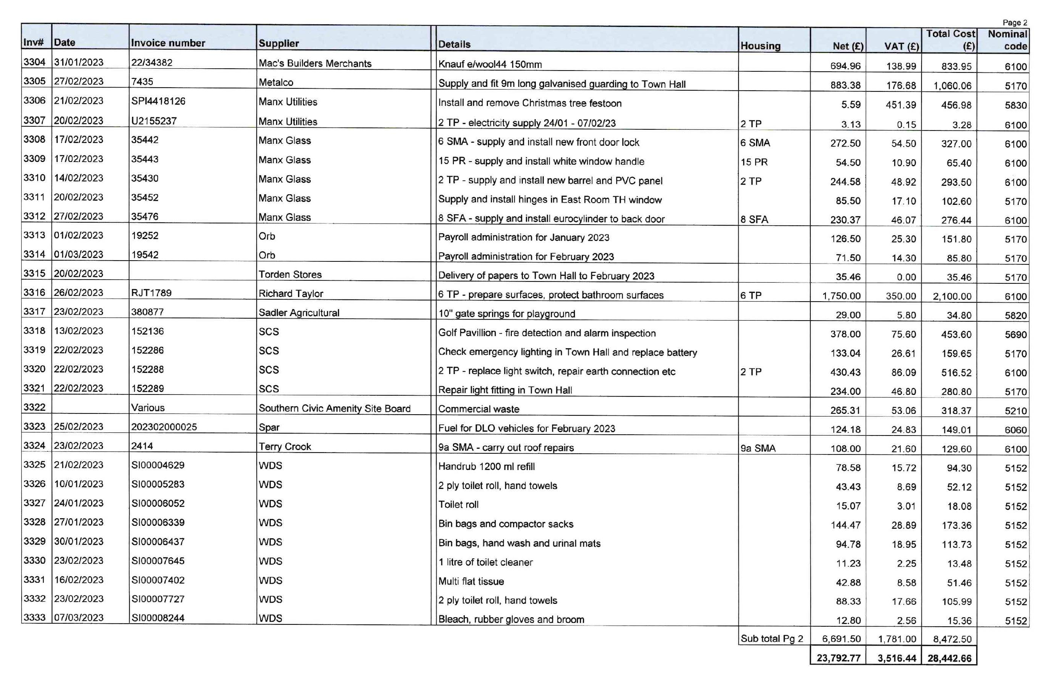

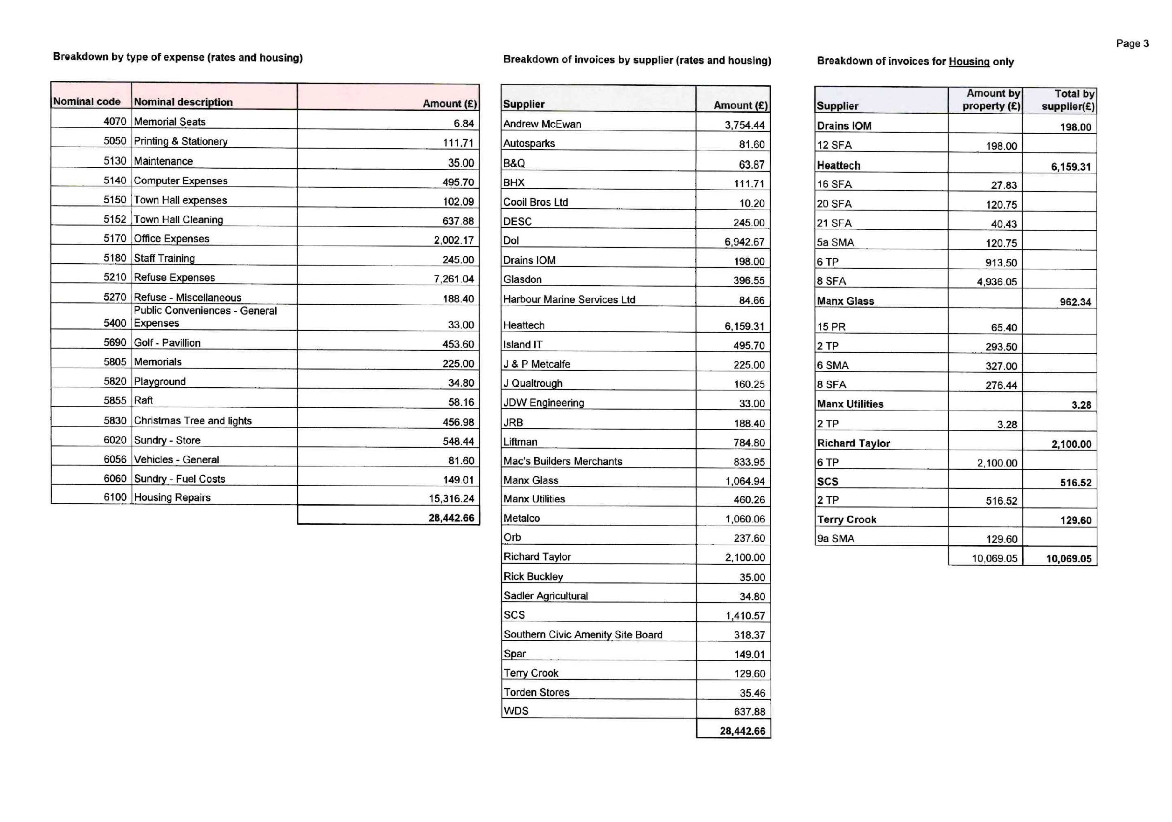

Item 5.2
PORT ST MARY COMMISSIONERS

PURCHASE OF DOUBLE BIN – TOWN HALL

The Board are requested to approve the purchase of the below double bin to replace the single bin outside the Town Hall. Flaps to prevent seagulls taking food from the bins will then be retrospectively fitted.

Item 6.1-6.5
PORT ST MARY COMMISSIONERS

PROJECTS UPDATE
6.1 | Amenities  Splash Park – No update available. Board to discuss if they would like to remove the item from the Agenda until a suitable location is found.
6.2 | Events  Christmas Carol Service – Following a meeting with the Reverend, a verbal update will be available at the meeting. The choir will be contacted once a date is confirmed.  Civic Service – Following a meeting with the Reverend, a verbal update will be available at the meeting.  MQ3 – The Board are requested to preapprove £50 donations for all participants. The service will be held at 2pm on Monday 29th May with the after refreshments being served at the Town Hall.
6.3 | Town Branding  Amendments to the map design are ongoing with the Department.
6.4 | Highways  High Street  The Department have been requested to install signage, failing their willingness to do so PSMC will install signage.
6.5 | Coronation Mugs  The last census provides the information that there are 280 under 16’s in PSM. The below bone china mug costs £12.40 each, the supplier has been asked to provide details of any discount for a bulk purchase and the response is below.  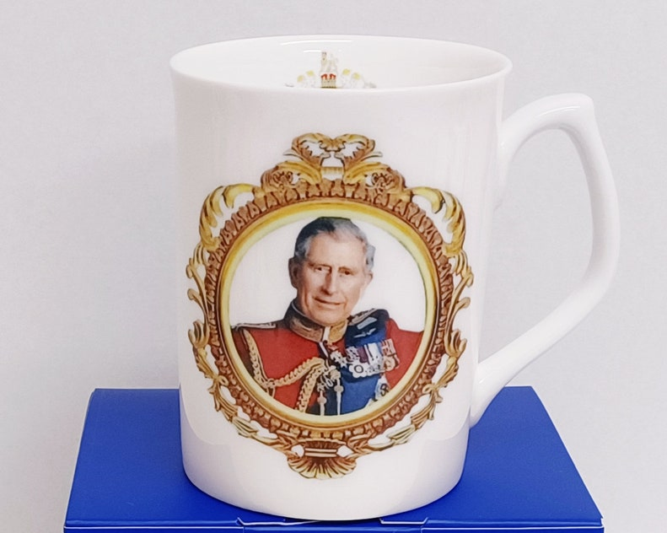  Hello Hayley,  Thanks for contacting us.  We can offer the following prices for Coronation Fine Bone China Mugs.  300 mugs @ £ 6.50 each  500 mugs @ £ 5.50 each  These prices include the following:  - Fine Bone China Mug of your choice  - Coronation Transfers  - Decoration and Firing in our ceramic kilns  - Presentation Box  - Free Postage to Isle of Man  Delivery times: 10 days after order confirmation.  I trust the above meets with your approval and look forward soon.  Kind regards

Item 7.1
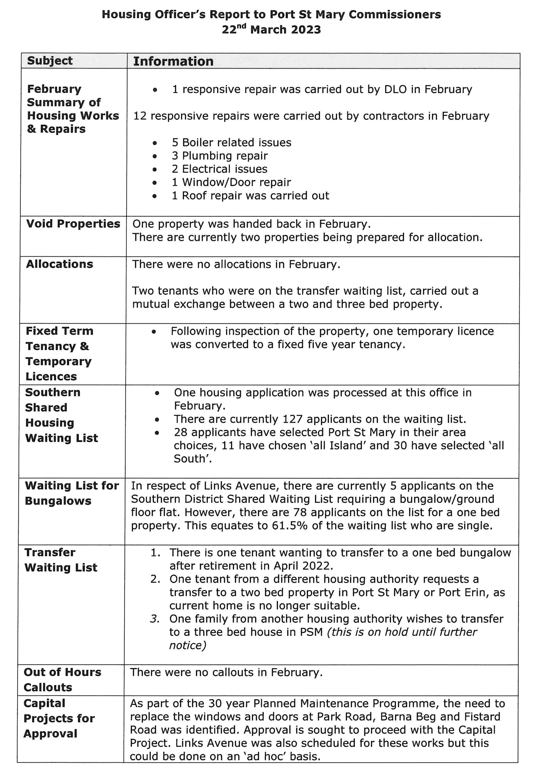
Item 7.2
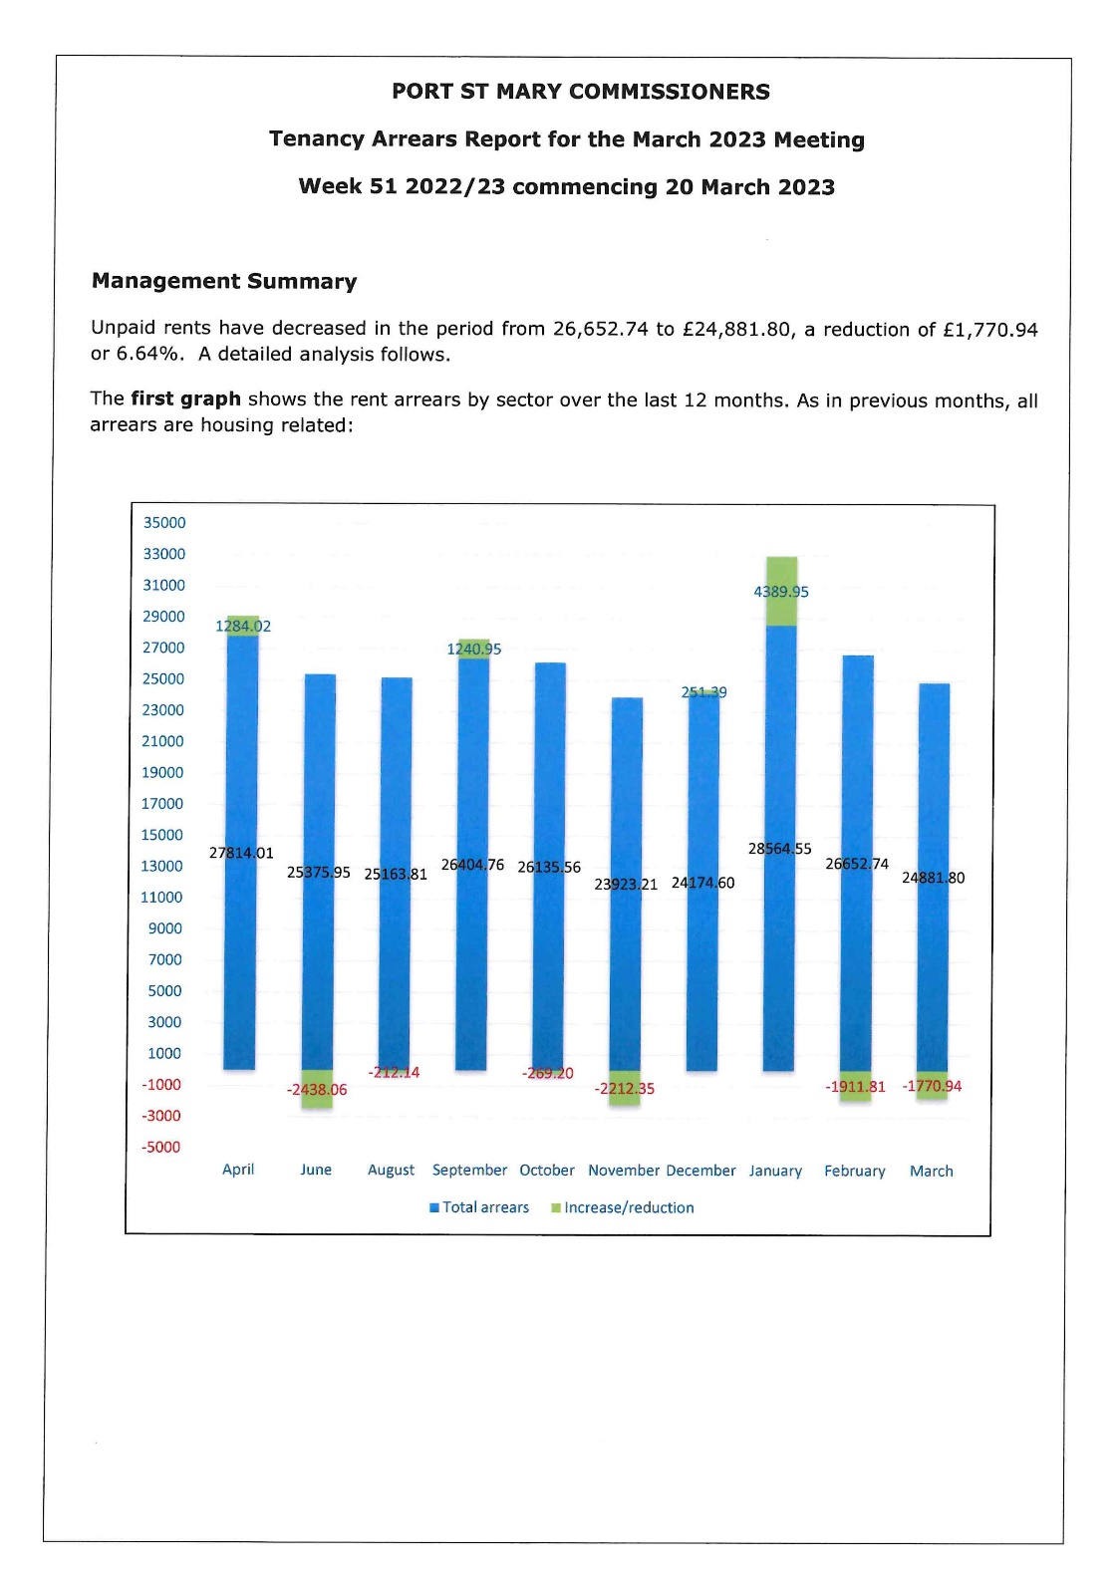
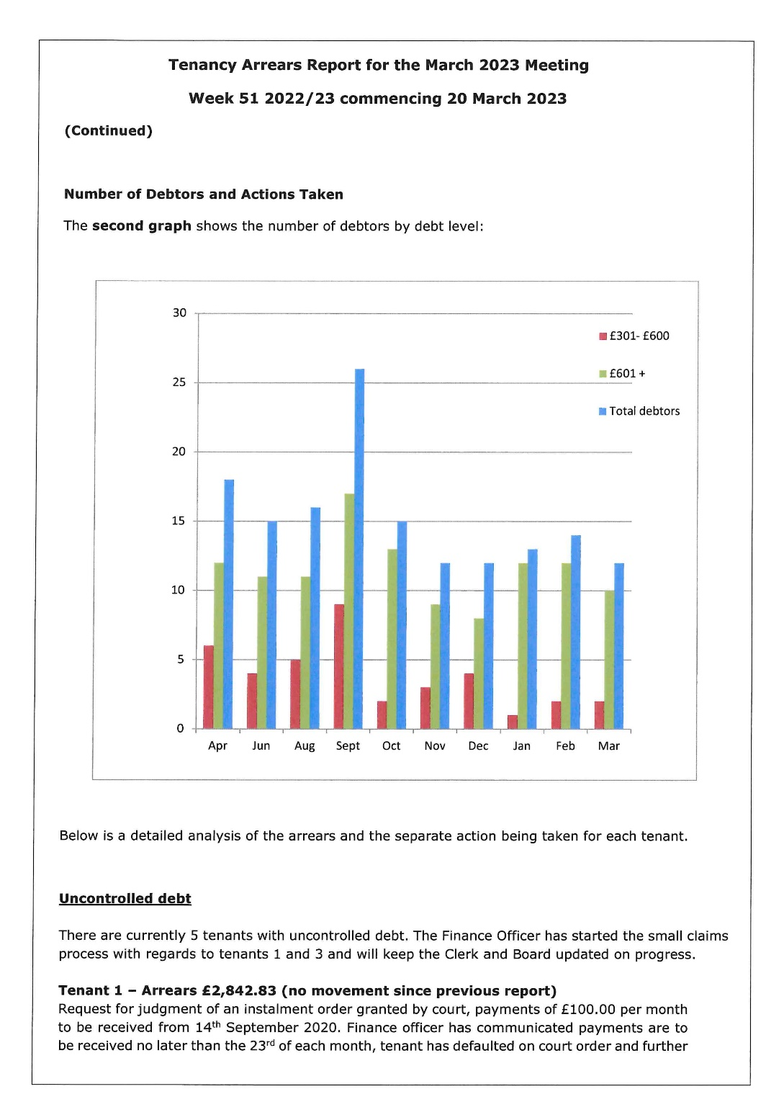
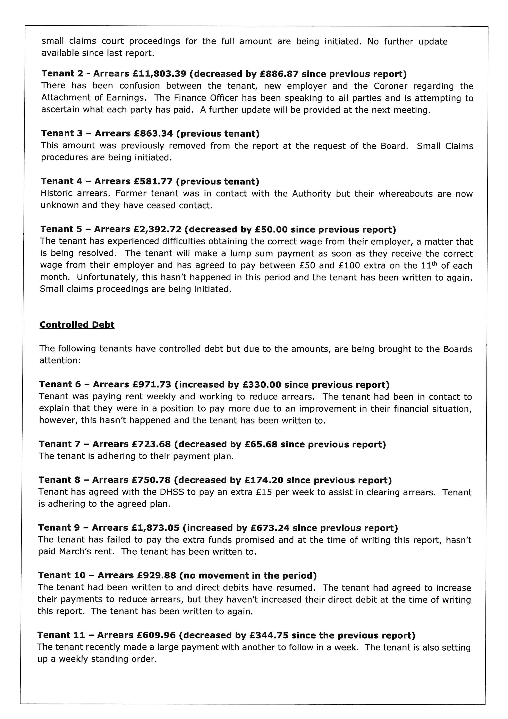
Item 8.1
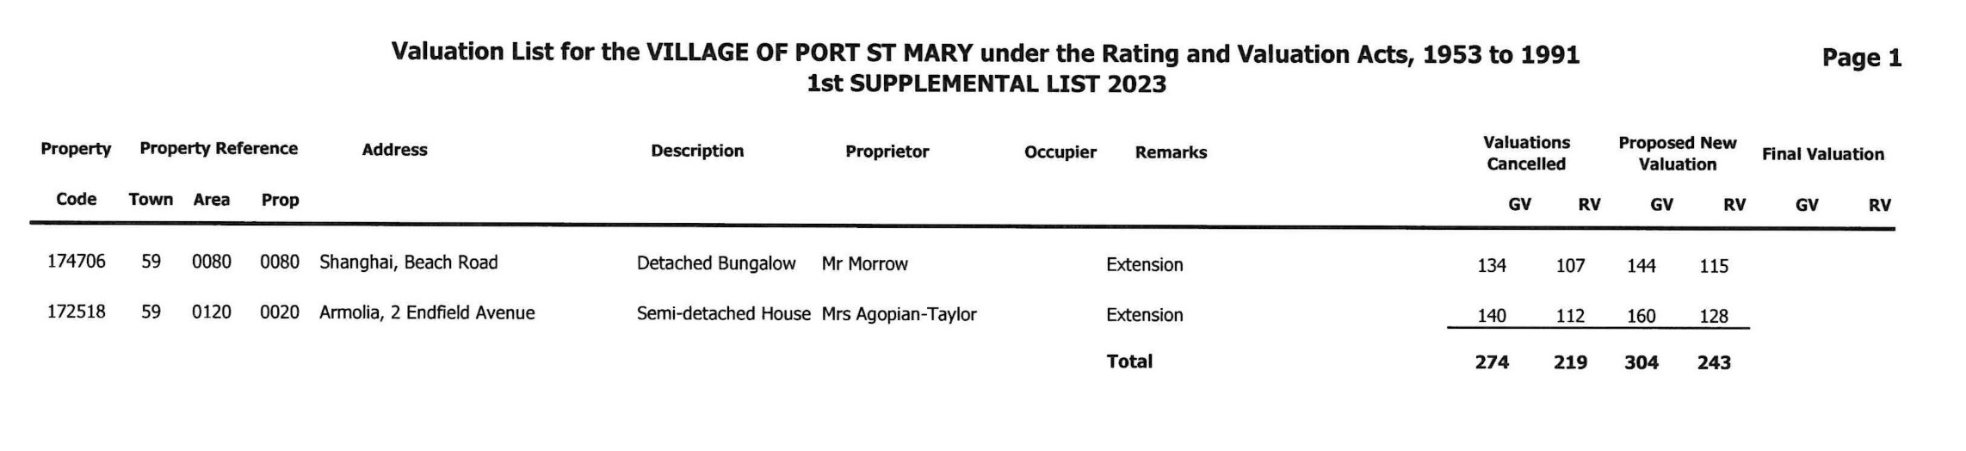

Item 9.1
PORT ST MARY COMMISSIONERS

PLANNING

Planning Applications
22/01552/D – Bay Queen, the Promenade for the creation of an illuminated site sales board. Amended plans submitted but not sent to this office. Can be viewed online.
23/00301/C – 15 Creggan Lea for the change of use to have additional use as tourism (AirBnB).
23/00218/B – Ridgeway, Plantation Road for the installation of replacement roofs to dwelling.
23/00219/B – Water Edge, 16 Lime Street for a single storey kitchen extension and internal alterations to a private dwelling.
23/00213/B – 9 Lime Street for installation of replacement windows to front and rear elevations and replacement front door.

Item 10.1
PORT ST MARY COMMISSIONERS

STRATEGY DOCUMENT
Following recent information received and discussed, the Board are requested to consider including adherence to the Seven Principles of Public Life (Nolan Principles) in their Strategy Document.

1.1 Selflessness
Holders of public office should act solely in terms of the public interest.

1.2 Integrity
Holders of public office must avoid placing themselves under any obligation to people or organisations that might try inappropriately to influence them in their work. They should not act or take decisions in order to gain financial or other material benefits for themselves, their family, or their friends. They must declare and resolve any interests and relationships.

1.3 Objectivity
Holders of public office must act and take decisions impartially, fairly and on merit, using the best evidence and without discrimination or bias.

1.4 Accountability
Holders of public office are accountable to the public for their decisions and actions and must submit themselves to the scrutiny necessary to ensure this.

1.5 Openness
Holders of public office should act and take decisions in an open and transparent manner. Information should not be withheld from the public unless there are clear and lawful reasons for so doing.

1.6 Honesty
Holders of public office should be truthful.

1.7 Leadership
Holders of public office should exhibit these principles in their own behaviour and treat others with respect. They should actively promote and robustly support the principles and challenge poor behaviour wherever it occurs.

Item 10.2
PORT ST MARY COMMISSIONERS

MEETING DATES FOR 2023

2023 Meeting Dates
12th April 2023 | Second meeting – may not be required
17th April 2023 | Southern Swimming Pool Meeting – Time & Agenda TBC
26th April 2023
10th May 2023 | AGM Only
24th May 2023
14th June 2023 | Second meeting – may not be required
28th June 2023
12th July 2023 | Second meeting – may not be required
26th July 2023
9th August 2023 | Second meeting – may not be required
23rd August 2023
13th September 2023 | Second meeting – may not be required
27th September 2023
11th October 2023 | Second meeting – may not be required
25th October 2023
8th November 2023 | Second meeting – may not be required
22nd November 2023
13th December 2023

