PORT ST MARY COMMISSIONERS
ORDINARY BOARD MEETING
2ND AUGUST 2023
AGENDA – OPEN SESSION

Item Number | Item |  | Action Required
1. | OPENING OF THE MEETING
1.1 | Welcome, Apologies & Declarations |  | As required by Board members
2. | MINUTES  Four Members who were present are required to approve Minutes
2.1 | Minutes of the Ordinary Meeting held on the 28th June 2023 |  | For Board approval
3. | MATTERS ARISING
3.1 | Matters arising from previous meetings |  | Clerk to provide necessary updates
4. | MOTIONS – None
5. | FINANCE
5.1 | Invoices for payment in July | For Board approval
6. | PROJECTS
6.1 | PSM Events |  | For Board discussion & approval
6.2 | Amenities |  | For noting
7. | HOUSING
7.1 | Housing Officers Report | For Board discussion
7.2 | Tenant Arrears Report | For Board discussion
8. | PUBLIC CORRESPONDENCE & COMMUNICATIONS
8.1 | Avian Influenza Update | For noting
8.2 | Strategic Plan | For Board discussion
8.3 | Weekend and Overnight Parking in Residential Areas | For Board discussion & response
9. | PLANNING MATTERS
9.1 | Planning Applications |  | For Board discussion
9.2 | Planning Approvals |  | For Board discussion
9.3 | Planning Appeals |  | For Board discussion
10. | POLICY & RESOURCES
10.1 | Local Authority Members Traveling Allowances Order 2023 |  | For Board discussion
10.2 | Standing Orders |  | For Board approval
10.3 | 2023 Meeting Dates |  | For noting
11. | PUBLIC CONSULTATIONS - None
12. | INVITATIONS - None
13. | ANY OTHER BUSINESS OF AN URGENT NATURE  (BY PERMISSION OF THE CHAIR)

Item 3.1
PORT ST MARY COMMISSIONERS

MATTERS ARISING & PUBLIC CORRESPONDENCE REPORT

Matters Arising
Telephone Kiosks – HK is liaising with Rushen Primary School. Quotes for suitable internal shelving and redecoration externally are awaited.
Heritage Rail Consultation – HK responded on behalf of the Board. HK to provide a verbal update following a meeting with stakeholders.

Item 6.1-6.2
PORT ST MARY COMMISSIONERS

PROJECTS UPDATE
6.1 | Events  Christmas Carol Service – No further update available.  Civic Service – A date and time of 10th September at 10.30am has been agreed, the service will be held at Mt Tabor. AG has requested to do a reading. Caterers have been arranged, initial emails requesting invited guests to save the date have been issued. Sheean Millish have been requested to participate. The Board are required to discuss hymns.  Brig Lily – A dedication for the slab will beheld at 10am at the Memorial Garden ahead of the Civic Service on the 10th September.  MQ3 – Further thank you correspondence is detailed below;  Subject: Mona's Queen service- thank you  Dear Hayley,  Please could you pass on my thanks to Bernadette and the other commissioners for their most kind and unexpected gesture of appreciation for the poem I read at this year’s memorial service and also for the lovely remarks? There was really no need as it was an honour to participate in this way at such a moving occasion. Like many others, I had a grandfather who worked on the Steam Packet. I never knew him but think he would have been pleased.  The exhibition was also stunning.  Of course I’d be very happy to be involved again next year if you would like- although it might be the same poem! I’ve pencilled in the date.  Best wishes  Annie  Village in Bloom – Five entries were received, AG carried out the judging, to be discussed at the meeting.
6.2 | Amenities  Tender for play park flooring ongoing.

Item 7.1
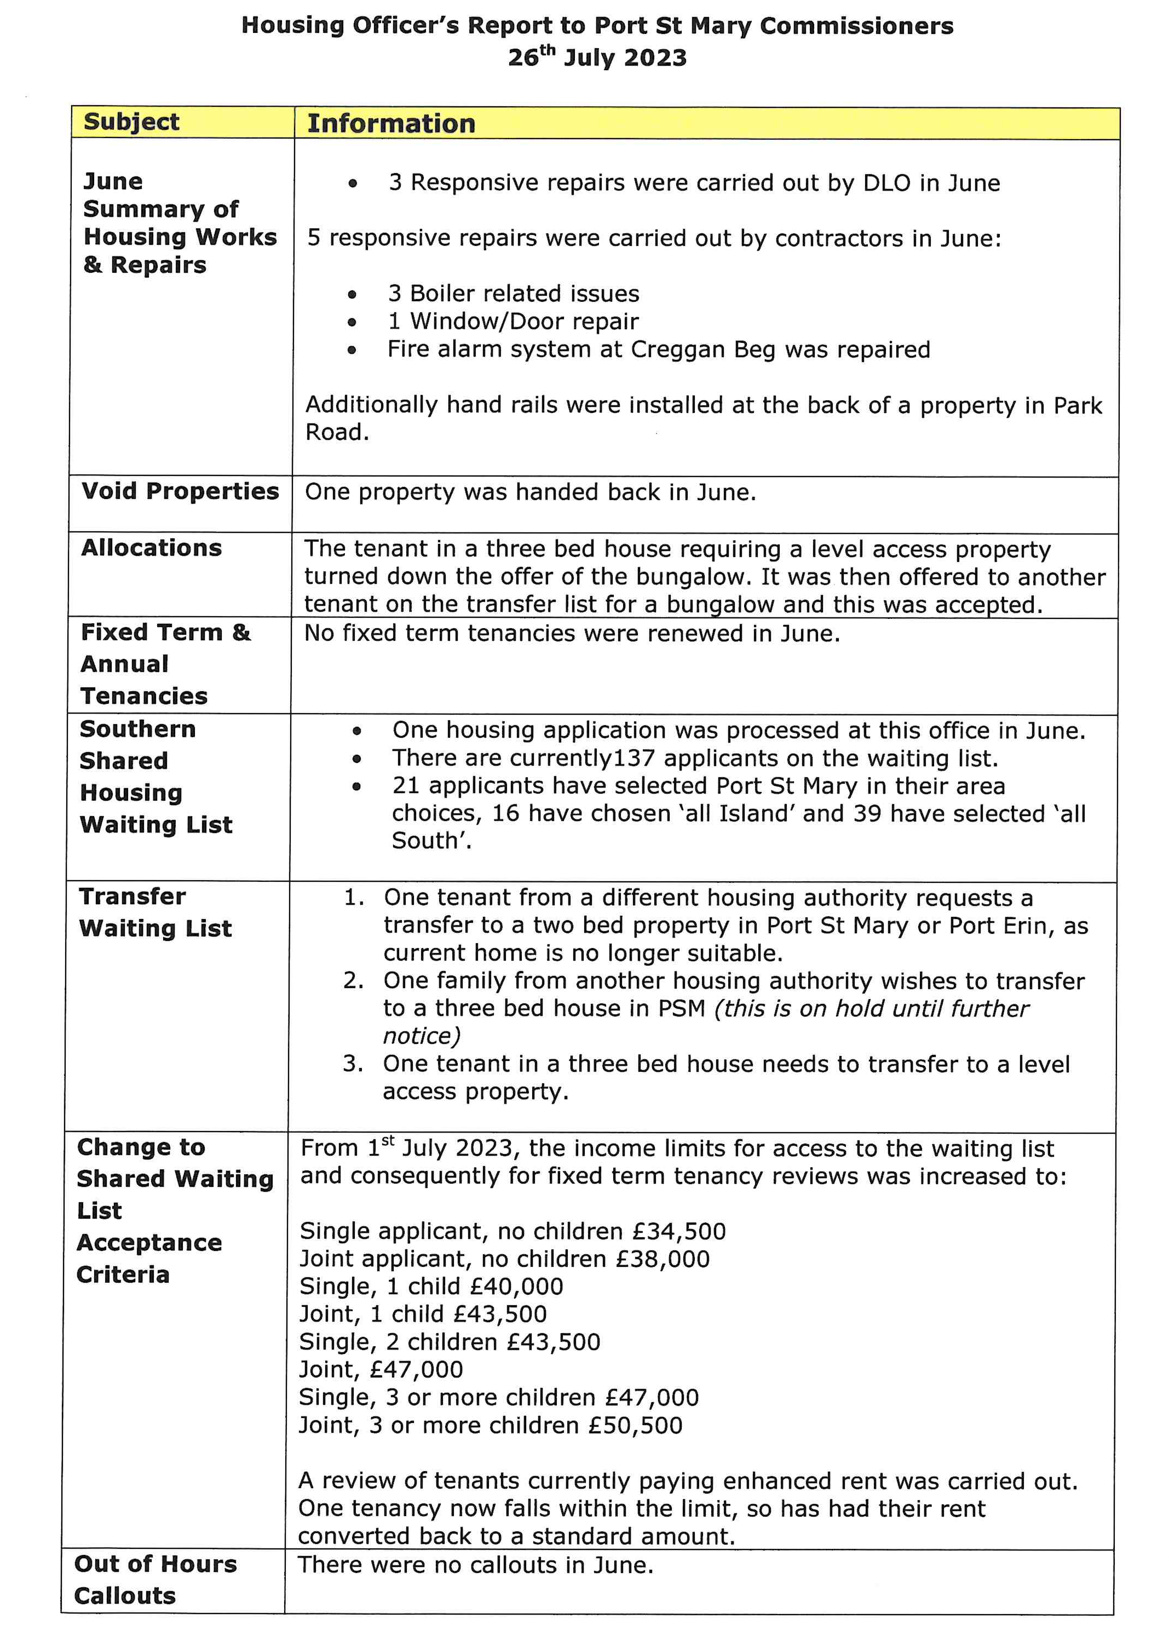

Item 8.1
PORT ST MARY COMMISSIONERS

PUBLIC CORRESPONDENCE

Sent: Monday, July 17, 2023 3:39 PM
Subject: avian influenza update

Dear All,

Unfortunately the wild dead guillemots collected from Port Erin last week, have tested positive for High Pathogenic Avian Influenza H5N1. Because these are wild birds restriction zones will not be put in place.
There are currently no avian influenza restrictions zones in place on the Isle of Man and the risk to human health is very low.
DEFA are strongly advising that bird keepers should remain vigilant by practicing good biosecurity and they should reduce any contact wild birds may have with kept birds. There is more information on our website https://www.gov.im/categories/business-and-industries/agriculture/types-of-notifiable-diseases/avian-influenza-bird-flu/#accordion (which will be updated shortly with the today’s information)
Avian Influenza is widespread in the UK see UK website for latest updates
Kind Regards

Chief Veterinary Officer

Animal Health, Regulation Directorate, Department of Environment, Food and Agriculture

Item 9.1 & 9.2
PORT ST MARY COMMISSIONERS

PLANNING MATTERS

Item 10.1
PORT ST MARY COMMISSIONERS

TRAVEL ALLOWANCES ORDER

Thu 20/07/2023 13:09

LocalAuthorityMembers(TravellingAllowances)Order2023.pdf
288 KB

Dear Clerks,

Please find attached the final version of the Local Authority Members (Travelling Allowances) Order 2023 that was approved yesterday at Tynwald.

Please be minded that the Order comes into operation on the 1st April 2024.

The reason for this, is to enable your authority to include the new allowances within your expenses in the new financial year so that you can budget for 2024.

Hope that this is satisfactory.

Kind regards
Administrative Officer l Local Government Team
Central Support and Change Division l Department of Infrastructure
Sea Terminal Building l Douglas l IM1 2RF l Tel 685900

Item 10.3
PORT ST MARY COMMISSIONERS

MEETING DATES FOR 2023

2023 Meeting Dates
9th August 2023 | Second meeting – may not be required
23rd August 2023
13th September 2023 | Second meeting – may not be required
27th September 2023
11th October 2023 | Second meeting – may not be required
25th October 2023
8th November 2023 | Second meeting – may not be required
22nd November 2023
13th December 2023

