Date: 17th November 2023

NOTICE OF ORDINARY BOARD MEETING

In accordance with Schedule 1 of the Local Government Act 1985, Notice is hereby given that the next Board Meeting of Port St Mary Commissioners will be held in the Board Room at the Town Hall on Wednesday 22nd November 2023 at 7.00p.m. Private session of Port St Mary Commissioners will be held following conclusion of the Public Board Meeting.

- Only business of a formal nature as defined in the Agenda for the meeting which is set out below, may be discussed as defined in Port St Mary Commissioners Standing Orders governed by Section 27 of the Local Government Act 1985 [as amended by Section 8 Local Government Act 2006]. All Commissioners are urged to attend and bring with them their copy of Standing Orders.

Hayley Kinvig
Clerk

PORT ST MARY COMMISSIONERS
ORDINARY BOARD MEETING
22ND NOVEMBER 2023
AGENDA – OPEN SESSION

Item Number | Item |  | Action Required
1. | OPENING OF THE MEETING
1.1 | Welcome, Apologies & Declarations |  | As required by Board members
2. | MINUTES  Four Members who were present are required to approve Minutes
2.1 | Minutes of the Ordinary Meeting held on the 25th October 2023 |  | For Board approval
3. | MATTERS ARISING
3.1 | Matters arising from previous meetings |  | Clerk to provide necessary updates
4. | MOTIONS – None
5. | FINANCE
5.1 | Invoices for payment in November | For Board approval
6. | PROJECTS
6.1 | PSM Events |  | For Board discussion
7. | HOUSING
7.1 | Housing Officers Report | For Board discussion
7.2 | Tenant Arrears Report | For Board discussion
8. | PUBLIC CORRESPONDENCE & COMMUNICATIONS
8.1 | Port Erin Commissioners re Members Expenses | For Board discussion
8.2 | Rushen Silver Band collection request | For Board discussion & response
9. | PLANNING MATTERS
9.1 | Planning Application |  | For Board discussion
9.2 | Planning Approvals |  | For Board discussion
10. | POLICY & RESOURCES
10.1 | 2023/24 Meeting Dates |  | For noting
11. | PUBLIC CONSULTATIONS
11.1 | Tynwald Commissioner – Consultation on Principles | For Board response
11.2 | Mooir Vannin Consultation – the Board are requested to have read the information on the link within the document prior to the meeting | For Board response
12. | INVITATIONS
12.1 | Parish of German Civic Service Invitation | For Chairman response
12.2 | Royal Artillery Association St Barbara’s Day Service Invitation | For Chairman response
12.3 | Tynwald Carol Service Invitation | For Board response
13. | ANY OTHER BUSINESS OF AN URGENT NATURE  (BY PERMISSION OF THE CHAIR)

Item 3.1
PORT ST MARY COMMISSIONERS

MATTERS ARISING & PUBLIC CORRESPONDENCE REPORT

Matters Arising
Strategic Plan Review – The Board response was submitted.
Highways Service Level Agreement – The Board response was submitted.

Public Correspondence
Bus Service Complaint – The complainant requested the correspondence in only shared with Rushen & Arbory Commissioners, this has been done.
Windfarm Engagement – Further correspondence below has been received.
To:​Hayley Kinvig​
Mon 30/10/2023 15:38
Dear Hayley,

No worries, I am glad we are in touch and thank you for the invite. I am not sure if I will be in the IOM in January, but I will discuss with the team to find an alternative as we are keen on meeting with you.

In the meantime, and I appreciate you and the Commissioners are busy for the rest of the year, perhaps a remote meeting through Teams / Zoom could be useful? We could accommodate to evening hours if it works for you, and I can gladly send the meeting link.

The intent behind the call is to set an initial point of contact for updates, present the planned studies and gather your insights on the studies and proposed development. Some of the preliminary studies may commence soon and the Environmental Impact Assessment would start early next year, so it would be useful for us to liaise remotely with you this year, but I understand if that is not feasible at this stage.

For transparency, we have already met (some in person and some remotely) with the Commissioners of Port Erin, Castletown and Arbory & Rushen, and we are still hoping to meet with Malew Commissioners.

Please let me know if the online meeting alternative could work, and if not, I can gladly come back with other options for a meeting next year.

All the best,
Alex

Item 6.1
PORT ST MARY COMMISSIONERS

PROJECTS UPDATE
6.1 | Events  Remembrance Day  Post event discussion to be had.  Christmas light switch on – Manxonia House tree  Friday 1st December – verbal update to be provided by RG & the Clerk  Christmas Market – The market will be held on Thursday 7th December 5-8pm.  Christmas Carol Service – To be held on Tuesday 12th December at St Marys Church 7.30pm. Further verbal update to be provided by the Clerk.  Willow Lantern Making – Lantern making workshop in the Town Hall on Saturday 16th December 2-6pm.

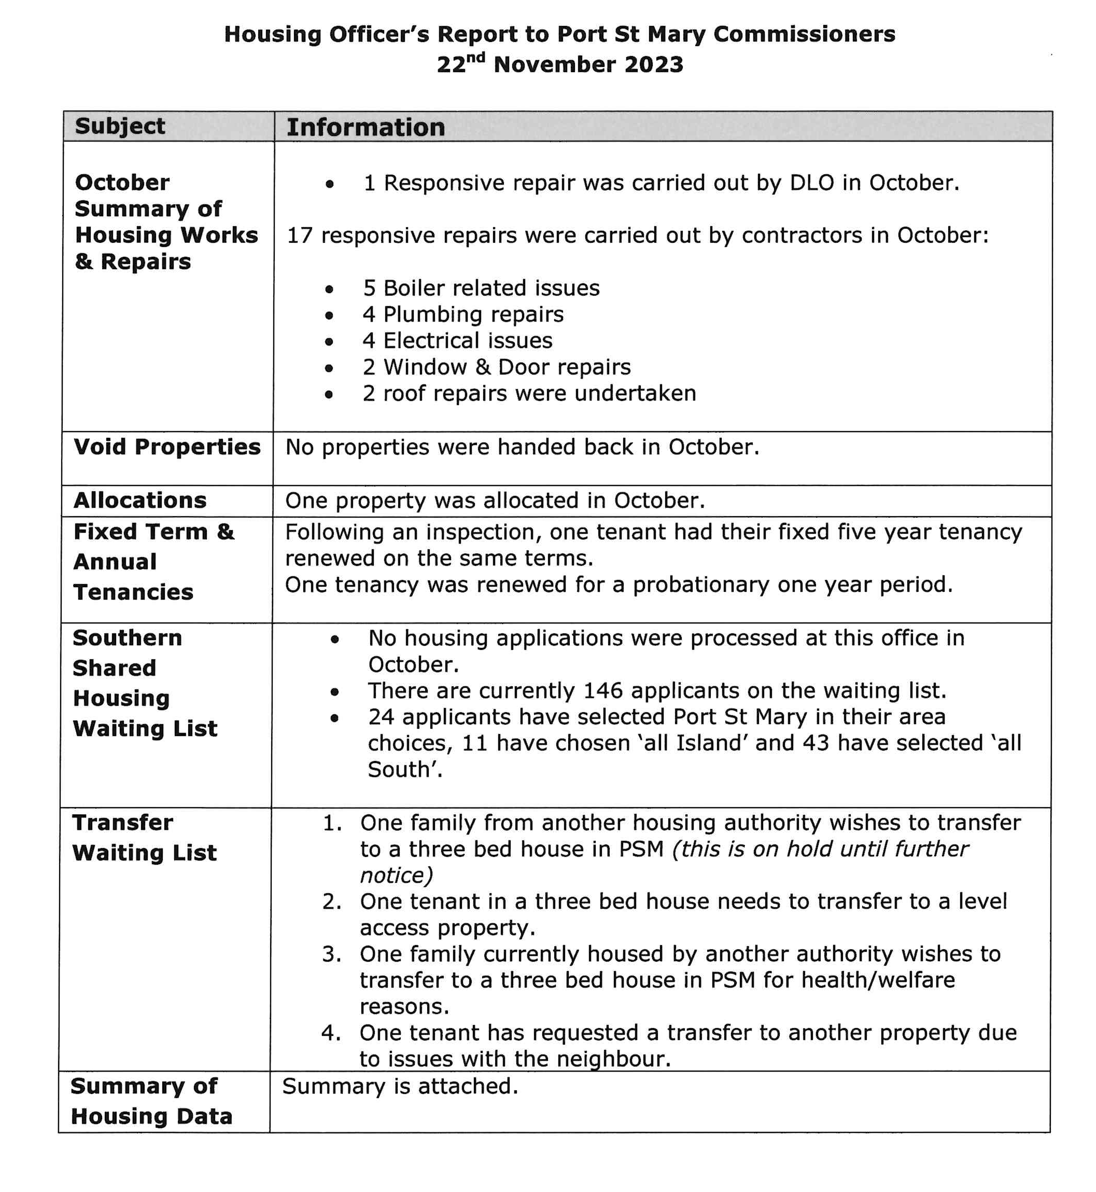

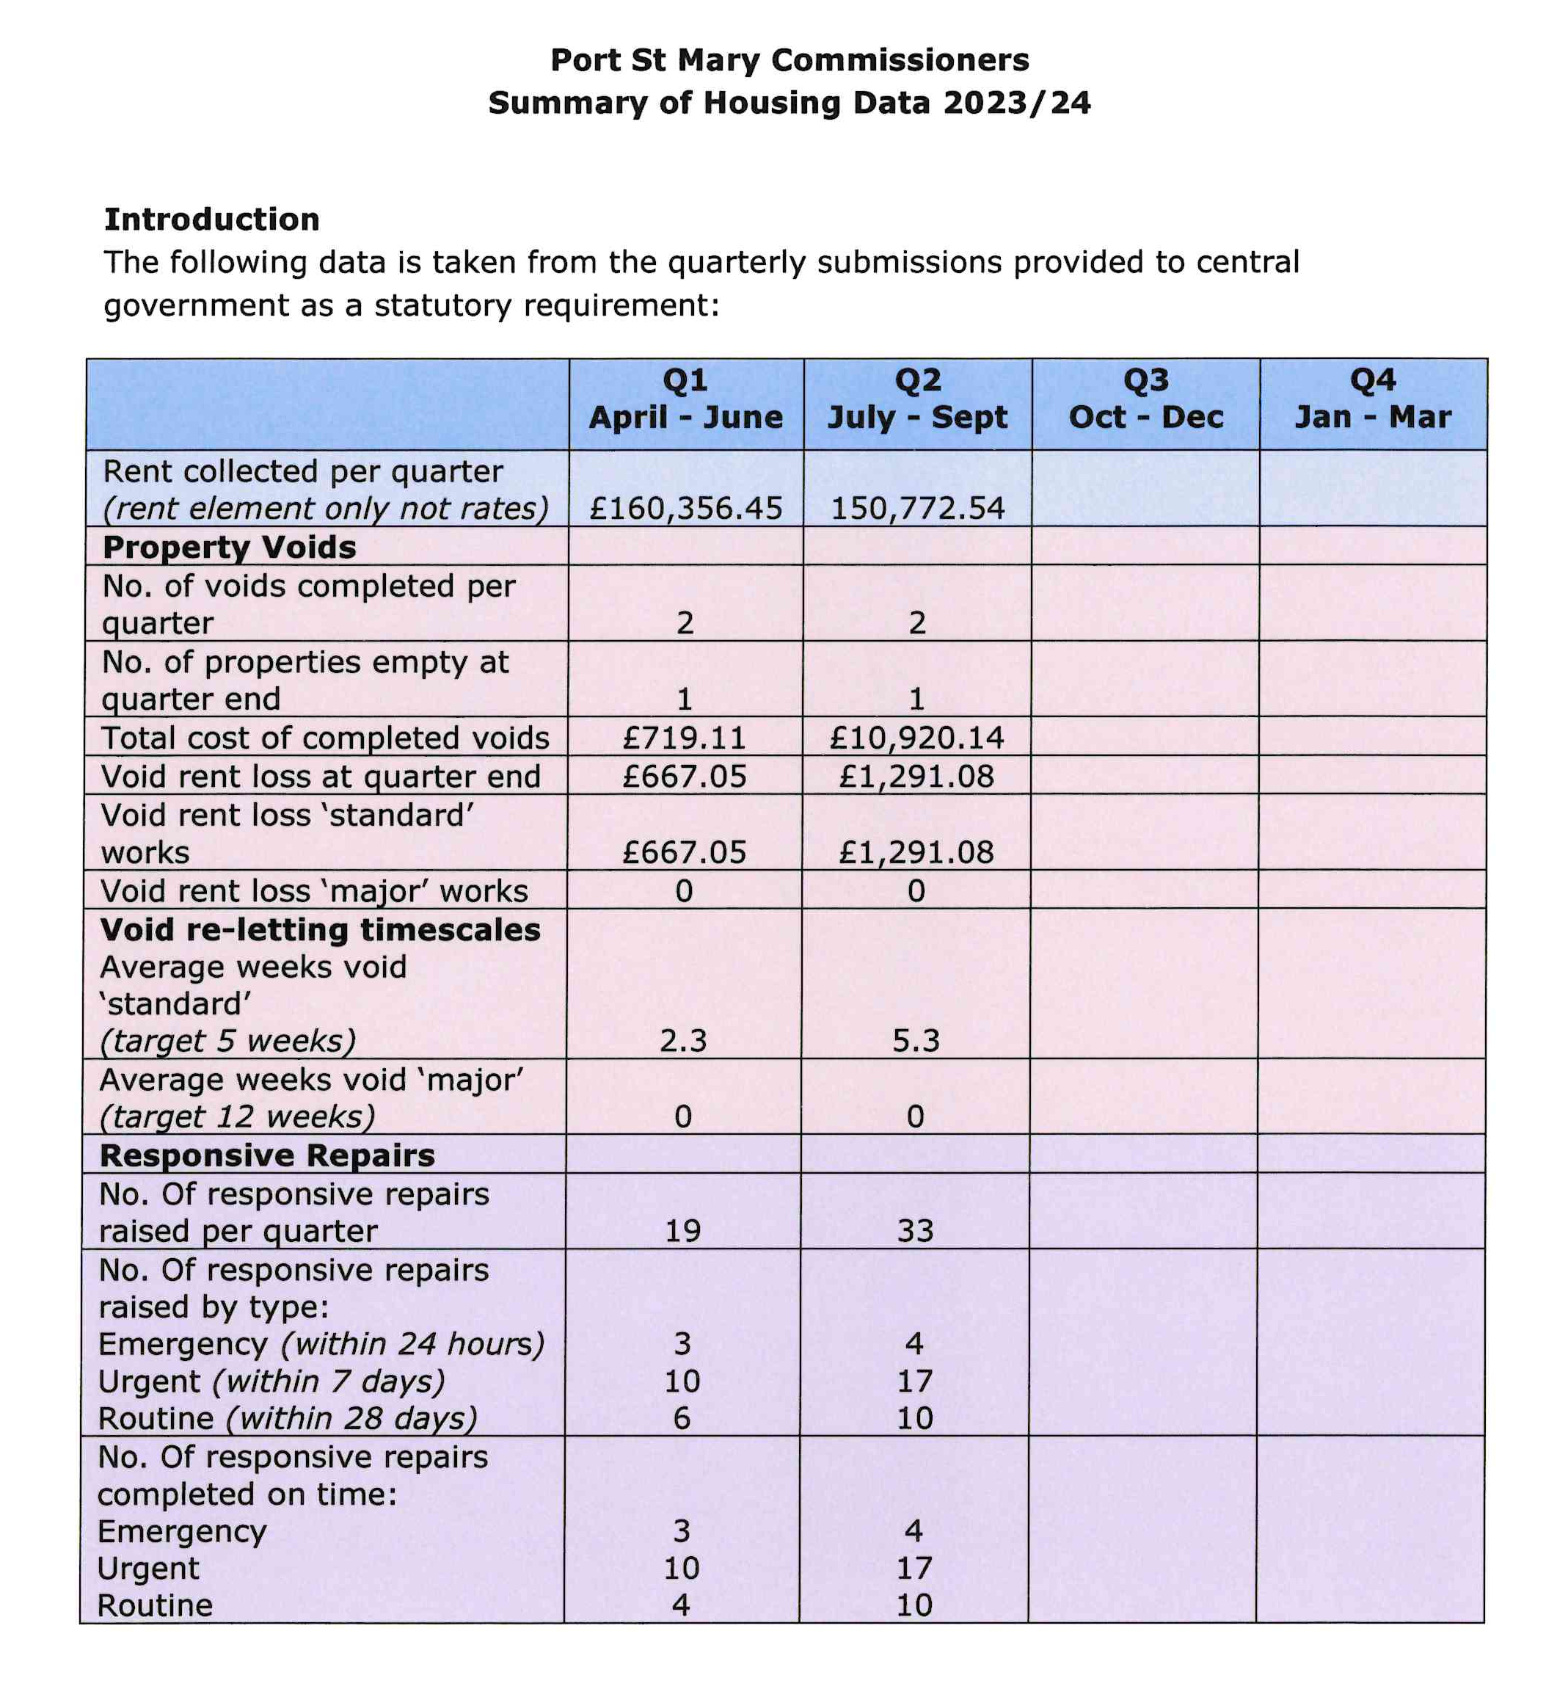

Item 8.1
PORT ST MARY COMMISSIONERS

PUBLIC CORRESPONDENCE

Jason Roberts
Wed 15/11/2023 15:28
Afternoon Steve/Nadia,

At the Board meeting of Port Erin Commissioners yesterday evening, the following notice of motion was passed:
That the board resolve to submit a request to the Department of Infrastructure for a review of the Local Government (Members’ Attendance Allowances) Order 2013 to be undertaken as this order was made more than a decade ago.
The rationale provided for the motion was that the attendance allowance rates have not been addressed for around 10 years and that with a review and increase of the allowance rates, this may encourage more people to stand for office in the future. The Consumer Price Index increase from November 2013 to date stands at 37.8 (121.0 to 158.8).

As such, please accept this email as a formal request by the Board of Port Erin Commissioners that the Department of Infrastructure undertakes a review of the Local Government (Members' Attendance Allowances) Order 2013 with a view to increasing the attendance allowance rates to a more realistic level.
The Board also asked for this request to be circulated to each of the other local authorities for reference, which has been done by blind copy.

Kind regards,
Jason

Jason Roberts
Clerk

Port Erin Commissioners
Tel: 01624 832298
Web: www.porterin.gov.im
Facebook: porterincoms
Twitter: porterincoms
Instagram: porterincoms

Item 8.2
PORT ST MARY COMMISSIONERS

PUBLIC CORRESPONDENCE
From: pkf@manx.net <pkf@manx.net>
Sent: Thursday, November 2, 2023 9:25 PM
To: Port St Mary Commissioners <commissioners@portstmary.gov.im>
Subject: Request for charitable collecting over festive period 2022

Good evening Port St Mary Commissioners.
On behalf of Rushen Silver Band, may I ask if the Commissioners would grant Rushen Silver Band permission to carry out house to house street collecting during the period 1st December 2023 to 25th December 2023 please.

As you will already be aware, the band does a lot of community based work in the south of the Island and the general public really enjoy hearing and listening to the Band. The festive period gives the band the opportunity to not only play to the public but also enables the band to do some fund raising of our own to make sure we can continue for a further 12 months realising the annual cost to run the band is now in the region of £7,000.

Many thanks for your help with this request.
Peter

Peter Faragher
Secretary – Rushen Silver Band
Manx Registered Charity No. 274 | www.rushensilverband.org.im

Item 9.1 - 9.2
PORT ST MARY COMMISSIONERS

PLANNING MATTERS

Item 10.3
PORT ST MARY COMMISSIONERS

MEETING DATES FOR 2023/24

2023/24 Meeting Dates
13th December 2023 | Only 1 meeting held in December
10th January 2024 | Second meeting – may not be required
24th January 2024
14th February 2024 | Second meeting – may not be required
28th February 2024
13th March 2024 | Second meeting – may not be required
27th March 2024
10th April 2024 | Second meeting – may not be required
24th April 2024
8th May 2024 | AGM Only

